**Collaborative Platform**

**Virtual Job Fair, Remote Judge and Mentoring Modules**

**Requirements Document**

Senior Project – Section U01

December 12th, 2014

**Members:**

**Spring 2014**  **Instructor:**

Henry M. Romero Masoud Sadjadi

Steven S. Sanabria

Lorenzo Sanchez **Mentor:**

Juan Caraballo

**Summer 2014**

Ramon Gomez

Jonathan Santiago

**Fall 2014**

Nicholas Madariaga

Jonathan Sanchez

**Spring 2015**

Adrian Alfonso

Jorge Travieso

*This page was intentionally left blank.*

Copyright © Florida International University 2014. All Rights Reserved. No part of the Virtual Job Fair Project or its documentation may be reproduced or modified without the express written consent of Florida International University.

# Abstract

The requirements document will reintroduce the basis of the problem to be solved, the current system, the project plan and the proposed system requirements. The first chapter will provide an overview of the problem. The second chapter will detail the current system that is being used by the individual modules of the collaborative platform. The third chapter of this document will cover the project plan for this requirement period.

In the fourth chapter of the requirements document, an overview of the functional and non-functional requirements will be found. This will include use cases on both security and non-security features and scenarios. This chapter will also cover the creation of UML drawings for these use case, class, and sequence diagrams. At the end of this document, a glossary is provided to define terms used within. Appendices will include all the use cases made, UML drawings to support use cases and a diary of meetings made.

**Table of Contents**

Abstract

1. Introduction

1.1 Problem Definition

1.2 Scope of the System

1.3 Definitions, Acronyms, and Abbreviations

1.4 Overview of Document

2. Current System

3. Project Plan

3.1 Project Organization

3.1.1 Project Personnel Organization

3.2 Work Breakdown

3.3 Cost Estimate

4. Proposed System Requirements

4.1 Functional Requirements

4.2 Analysis of System Requirements

4.2.1 Scenarios

4.2.2 Use Case Model

4.2.3 Static Model

4.2.4 Dynamic Model

5 Glossary

6 Appendix

6.1 Appendix A – Complete Use Cases

6.2 Appendix B – Use Case diagram using UML

6.3 Appendix C – Static UML diagram

6.4 Appendix D – Dynamic UML diagram

6.5 Appendix E – User Interface Design

6.6 Appendix F – Diary of Meetings

7. References

# Introduction

This first chapter will briefly state the current problem that needs to be solved and the general scope of the project. It will also cover miscellaneous project specific terms, acronyms and abbreviations. Finally, the last section within this chapter will provide a general overview of what this document entails.

## 1.1 Problem Definition

In the world today, for prospects of different companies, a common issue arises that could prevent them from getting a chance. From startups to large corporations, money can always be an issue. This can play a pivotal part in the hiring of future employees. The chance to be flown out of town to do an onsite visit can never happen if the budget doesn’t suffice for said company. With the Virtual Job Fair, the idea was to allow an interface for interviewers to communicate with potential new hires. At the moment, the virtual job fair is in need of some revamping. The plan will be to recast it within a collaborative platform along with the remote judge and mentor modules.

Professionals all over the world currently working in industry know the value of time. The senior project demonstrations normally bring many of these professionals to FIU to judge and grade students work. Many, however, due to time constraints or other simple logistics, cannot make their way onto FIUs campus to judge face to face. The solution to this problem could greatly benefit future students to get the most elaborate and complete reviews for their work. As it stands, for this senior project course, judges have to physically come to FIU in order to participate in the judging aspect for each student. We hope to integrate the current mobile judge application into the collaborative website, facilitating feedback retrieval from professionals and guests that may not be able to get to FIU.

Lastly, a key integration that is hoped to be built for the platform is a mentoring module. One of the key drawbacks of forum based assistantship/tutorials is a severe lack of responsiveness and/or initiative. One of the more urgent problems is the sometimes sluggish back and forth messaging with assigned mentors. The optimistic solution to this problem will be a platform that has a forum in which each user can interact in a plethora amount of ways; whether through video live chat, white board brainstorming, file sharing or simple messaging.

From the mentors’ perspective, the problem lies with time constraints in being able to effectively give back feedback or answer questions to mentees. They are also faced with the challenge of distance, in some cases they may not be able to meet face to face with their assigned mentees. The mentoring module will propose a solution that allows mentees to ask questions at their will, and have a sufficient amount of mentors that can answer these questions. This will facilitate the interaction between mentors and mentees via the internet – allowing the mentors to remotely answer questions without having to be there in person.

## 1.2 Scope of the System

The system will allow for an integration of three modules into one single collaborative platform. The system will allow users to register and log into the site and pick their main functionality. In some cases users can have various roles and thus will have multiple views available within the site. Each user will have a profile page and depending on their role, they will have a more detailed interaction for their account(s). For example, within the mentoring module there are three mentors: domain, project and personal. All types of mentors will be allowed to sync their profile with LinkedIn in order to upload a picture and provide a short bio, as well as any other related information.

The project mentor can see all of the projects they are mentoring and will have the ability to screen share, use a whiteboard, and other functionality that will be taken from the other two modules and be integrated within the mentoring module. They also have the ability to grab the project information directly from the senior project website. The domain mentors are mentors of specific skills. They will have the ability to add new domains and rate themselves accordingly. These additions will be approved or denied by the administrator before being updated on their profiles. They will have the functionality to see all tickets assigned, whether answered, dropped, or pending. From here, they can answer the questions, append comments, and in some cases they can delegate it to all other tier 1 mentors of that domain. They can also communicate within the internal mail service to other mentors.

The system will match the tickets created by mentees to the most appropriate domain mentors – those with the most expertise in that specific skill. If the system notices the inactivity on one of the ticket and notices that the last comment added to the ticket was not made by the assigned mentor, it proceeds to rank it to another mentor in the same tier. If this situation happens two more consecutives times for the same ticket, the system will have automatically notified the administrator for immediate resolution. Besides being able to append comments to tickets, the mentees will be able to attach files. Once these tickets have been answered, the mentees will be allowed to close the ticket or reject the answer provided. Another module of the platform is the remote judge. This will be an integration of the mobile app into a remote desktop available interface.

Within the remote judge the system will allow judges to properly judge a senior project student. This will be facilitated by allowing access to the students resume, a grading rubric, and a virtual whiteboard to express ideas or questions. The system will also have the ability to share screens between the judge and the student.

The system will allow self-registration for users and provide self-serve mentorship applications. These applications will provide options for manually selecting preferred choices and the option to defer selection to the system. The system will also allow for the recommendation of new domains. Submitted applications will be vetted by an admin. The admin will be able to approve/deny what he chooses and also send counter-offers back to the mentor.

The system will allow reporting mentees, mentors and tickets. Those reports will be available to the administrator in order to gather as much insight of the data as possible. Additionally the system will provide the administrator with a way of making a quantitative analysis of the utilization of the system via a dashboard. The utilization dashboard will include the following reports: Amount of tickets created, Amount of tickets closed, Average duration of a ticket, Average time a mentor takes to answer a ticket, Amount of tickets currently open, Amount of tickets that are currently closed. Also, as part of the analysis, the system will be able to analyze and pull the most frequent type of questions that mentees may ask.

In order to facilitate the interaction mentor-mentee, the system will support video conferences where the mentor and mentee can meet face to face and collaborate with tools such as screen sharing, whiteboard and chat. Those video conferences can be scheduled to take place instantly or in the future and it may include several participants.

## 1.3 Definitions, Acronyms, and Abbreviations

Definitions:

* **User** – A generalization given to all user groups.
* **Student** – Individual who is currently enrolled in the senior project class.
* **Project** **Mentor** – An individual who is assigned to overlook one or many senior projects.
* **Domain** **Mentor**– An individual with particular knowledge in a certain skill or language(2 Tiers)
* **Personal Mentor** –An individual that mentors only a single person – not limited to career advice.
* **Product owner**–The product owner represents the client and has enough domain knowledge to answer the questions the development team may have about the software product.
* **Mentee** - An individual that may request help or ask a question.
* **Administrator** –An individual assigned with administering the web portal.
* **Interviewer** – An individual from industry that can remotely interview potential employees.
* **Interviewee** – An individual and future prospect that may engage in the virtual job fair portal.
* **Application** - An application is an object that is created when a mentor makes preferred selections during registration (e.g a domain mentor chooses domains which the admin then has to approve/reject)

Acronyms:

* **SCIS** – School of Computing & Information Sciences
* **FIU** – Florida International University
* **ECS** – Engineering & Computing Sciences (Building)
* **JCCL** – John C. Comfort Laboratory
* **VJF** – Virtual Job Fair
* **MJ** –Mobile Judge
* **WP** – Web Platform
* **T1**- Tier 1 Domain Mentor
* **T2**- Tier 2 Domain Mentor
* **PM**- Project Mentor
* **DBMS** – Database Management System
* **SPW** - Senior Project Website
* **MM** - Mentor Module

Abbreviations:

* **N/A**

## 1.4 Overview of Document

The requirements document will continue to a detailed outline of the current systems limitations and problems. The third chapter of this document will cover the project plan for this requirements period. In the fourth chapter, an overview of the functional and non-functional requirements will be found. This will include use cases on both security and non-security features and scenarios. This chapter will also cover the creation of UML drawings for these use case, class, and sequence diagrams. The final two chapters will cover miscellaneous information regarding terms used within the document and all the drawings to go with the use cases defined in the system.

# Current System

The Virtual Job fair provides the interaction between students and employers. The students are able to upload their resumes and search for possible companies where they can apply for a job. Employers can look up possible candidates for a specific position. Also, employers can set up virtual interviews using the video chat and whiteboard features. There is no limitation and constraints on the current system, except for some features that need to be readjusted.

Referring to remote judge, what we have now is an implementation of a grading system that works only in mobile applications. The idea is, at the end of the spring project, to have this system fully integrated into the collaborative platform. As of now, judges are unable to grade students remotely and in order to watch a student present their project they have to be in that exact location. There is also a limited amount of information in the mobile judge application for the judge to obtain information on the student being evaluated.

The Collaborative Platform: Mentoring Module currently allows students, known as mentees, to interact with mentors who can be personal, project, or domain experts. This interaction is through tickets which are entered into the system by students. These tickets are initially sent to tier 1 domain mentors. If the ticket is not handled within the time limit the system will automatically reassign the ticket to another tier 1 domain mentor. A tier 1 domain mentor with a pending ticket has the option to defer the ticket to a specific tier 1 or tier 2 mentor or defer the ticket to the system for automatic reassignment. The system allows Mentors to see what tickets belong to them depending on the role that they have in the system (personal, project, domain). Many mentors are able to self-register, process that may reduce the amount of data entry performed by the administrator of the system.

The Collaborative Platform currently have some administrative limitations. The administrator does not have a way to infer information on the usage of the system (How many tickets have been or currently are open, How many tickets have been or currently have been closed, How long does it takes a mentor to answer a tickets, How long does it take the ticket to be closed). Additionally, there is no way for the administrator to gather details on the tickets, mentors and mentees. Last but not least, the system does not have a way to “suggest” the type of domain mentors that the administrator should incorporate.

The daily usage of the Collaborative Platform present some limitations. The interaction mentor-mentee is driven only via back and forth comments (plain text). Mentors and mentees does not have a way to interact faster. The interaction could be boosted by using a video conference where both sides can collaborate face to face, and use tools such as whiteboards and chats.

# Project Plan

This section describes the project plan which includes the project organization, in the software development process. The section 3.1.1 offers the project personal organization and the section 3.1.2 includes the hardware and software resources. Lastly, section 3.2 includes the identification of task, milestone and deliverables with a specific work breakdown and cost estimates.

## 3.1 Project Organization

This section will explain individual roles and assignment of responsibilities among team members. It will also give a detailed explanation for software and hardware components required to carry out the development of the system.

### Project Personnel Organization

For this project, each of three members will be in charge of adding at least two new pieces of functionality to the system.

Henry D. Muniz Romero will be responsible for developing an Internal Mail Service to use within the platform. In addition, will be responsible for the system notifications that keep the user in sync with what is happening in the platform. Finally, he will develop an administration menu for the System Administrator to manage users, invitations, domains, subdomains, and projects.

Lorenzo A. Sanchez My will be responsible to implement some functionalities of the mentoring subsystem such as allows users to create tickets, upload files for a ticket, append comments to a ticket, allow a project mentor to set up meeting with their respective mentees, allow administrator to monitor the upcoming meetings between project mentors and mentees. Also, write an algorithm that allows the system auto assign a ticket to the most appropriate domain mentor expert in the field based on domain specified in the ticket and mentor availability.

Steven S. Sanabria will be responsible for the user access point and registration subsystem. This includes the log in, log out and registration into the collaborative platform site. In addition, he is responsible for the user profile management; this includes allowing users to set up their availability, which will be vital in determining their allowable involvement. Domain mentors will be able to add domains and rate themselves for each skillset. Project mentors and Personal mentors will be able to select projects and mentees, respectively. Lastly, administrators will also be allowed to edit each user’s profile – as desired.

Ramon Gomez will be responsible to implement some functionalities of the mentoring subsystem such as allow domain mentors in tier 1 to escalate tickets when the question is beyond of what a tier 1 domain mentor should know. Also add priorities in the tickets. In addition, he is responsible to allow the system to automatically reassign the tickets when they are not answered based in its priority. Also, Ramon is responsible to allow mentee to assign tickets to his/her personal mentor and allow the personal mentors to make comment in tickets created by his/her mentees. Also Ramon is going to add new notifications to the system, for example new notifications are going to be sending when the ticket is closed, escalated or automatically reassigned.

Jonathan Santiago is responsible to integrate CP with SPW. He will be bringing projects and mentees (triggered automatically and manually) from SPW to CP and relate them accordingly. Also he will give the mentees the ability to login to CP using their FIU Google credentials just like they do in SPW. In addition Jonathan will improve the registration process by allowing the admin to register all types of types: project, domain and personal. The admin will also have the ability to edit the roles of any user. Jonathan will also be involved in improving the user interface in multiple sections of the system.

Nicholas Madariaga is responsible for developing the self-serve account registration and Mentorship Applications. A new access point will be provided for potential Mentors. The new registration form will store more the work experience and education of the Mentor. The mentorship applications will involve the different steps and layouts for each mentor role that is defined: project, personal, and domain expert. The Project Mentor Application provides detailed information on projects and the ability to select what projects the mentor is interested in or have them automatically assigned by the system. The Personal Mentor Application involves basic information and the ability to select what students he does wish to mentor and provides the option to defer selection to the system. The Domain Mentor Application will provide details of each domain and the ability to select what domains and subdomains they’re more knowledgeable in along with the ability to rate their proficiency. Client side validation and user verification will be provided for user registration and all Mentor Applications. Lastly, he will implement a way to handle any mentorship proposals sent by an admin. He will also be involved with fixing miscellaneous bugs that are found on the module. Throughout development User Experience is a primary focus. He will also have the role of being the tester and project manager for Jonathan Sanchez.

Jonathan Sanchez is responsible for an overhaul of the admin dashboard and new features - Users, Domain, Projects, Tickets, Invitation, and Application pages. The Users page will just get a look overhaul and an advanced search feature. Users will be clickable where a popup modal will show details relating to the user. The Domain page will be merged into one single page with a domain subsection and a subdomain subsection. Domains will be clickable where a popup modal will show details relating to the domain. The Projects page will have the same look as well and not much will be done beyond look update. Projects will be clickable where a popup modal will show details of project. The invites page will show any open invitations and clicking on an invite will show details as well as re-invites. There will be an addition to the “Manage” drop down; we will be adding “Tickets” and “Applications”. The tickets page will have a list of all tickets and an advanced search function. The Applications page will show any pending applications requiring the action of an admin. The visual aspects of these updates will primarily be focused on improving the User Experience and making things more intuitive. He will also have the role of being the tester and project manager for Nicholas Madariaga.

Adrian Alfonso is responsible for the administrator reporting functionality on Mentees, Mentors and Tickets. Each of those reports will only be accessible to the administrator. Every report will include information relevant (columns) to the querying entity (i.e. Tickets). The columns of every report can be clicked and the report will be sorted by that column. Each column the report will have a filter control that when the user inputs information will make the report to filter by that parameter. Each column of the report can be reordered via drag-drop. The user can scroll the report horizontally in order to see more columns. Additionally, there will be implemented an utilization dashboard where the administrator can visualize statistics on tickets in several ways. The statistics in that dashboard include: Amount of tickets created, amount of tickets closed, average time of ticket duration, average time of mentor to answer the ticket, tickets currently open and tickets unanswered. Each of those statistical visualization will be configured by the administrator following different dimensions (i.e. Tickets created by day, Tickets created by month, Tickets created by year, Tickets created by mentee, etc). Last but not least, the developer Adrian Alfonso will implement an analytical report that will suggest to the administrator what kind of mentors to find. That analytical report will pull all the tickets sub-domains for every mentee and it will suggest not only the most frequent sub-domains; it will also output the most frequent combinations of questions that a mentee may have.

Jorge Travieso is responsible for the Collaborative Tools that allows users among the system to easily schedule real-time videoconferences. The Collaborative Tools module will allow users to interact through audio, video and chat while they collaborate using a virtual whiteboard or share their screens. The users will be able to schedule the meetings in three different ways: on-demand, i.e., at the time being, ahead of time or from a ticket (mentors only). Every user will have access to this module from the main menu and will see a listing of today’s, upcoming and past meetings by navigating to it. Each meeting entry in the will display the basic information, i.e., subject, participants, notes, and time, along with a link to join the meeting and accept/reject invitation buttons. The participants will be classified into two groups: moderators and invitees. A moderator is the meeting creator and is the only one that can initiate a videoconference, cancel or delete it. On the other hand, invitees will receive an invitation from the moderator after the meeting is scheduled, with the option to accept or reject it. Any invitation that is accepted/rejected will be reflected on the meetings listing so that participants know the invitations status. In addition, moderators will be able to delete and cancel a meeting at any time. The meetings room will have a nice layout that allows multiple users to be shown on the left side of the screen while the center will be utilized to show a virtual whiteboard and the rightmost space will be used for a chat-room.

|  |  |  |
| --- | --- | --- |
| **Name** | **Roles** | **Assigned task based on functional requirements** |
| Lorenzo Sanchez | Developer / Team Leader | **Mentoring Subsystem.**   * Auto assign the most appropriate domain mentor to a ticket. * Allow administrator to reassign the ticket to other domain mentor. * Allow project mentor to retrieve the description of the projects assigned. * Allow project mentor to retrieve all the mentees for each project. * Allow project mentor to set up meetings with his/her mentees. * Allow project mentor to retrieve all the upcoming meetings. * Allow project mentor to assign ticket to other project mentor. * Allow project mentor to see the ticket created by their mentees. * Allow mentees to assign tickets to his/her project mentor. * Allow user create a ticket. * Allow user to select a specific domain for a new ticket. * Allow user to select a specific sub domain. * Allow user to upload file to a ticket. * Allow user to download file from a ticket. * Allow user to append comments to a ticket. * Allow user to retrieve all the details of the ticket of the ticket that he/she created or was assigned. * Allow user to close a ticket. * Allow user to reject a ticket. |
| Henry D. Muniz Romero | Developer / DB Admin | **Communication & Notification Subsystem**   * Allow users to send a message to another user. * Allow users to read a message. * Allow users to delete a message. * Send ticket due email notification. * Send new message email notification. * Send password change email notification. * Send profile change email notification. * Send ticket assigned email notification. * Send comment added to a ticket email notification.   **Mentoring Subsystem.**   * Allow System Administrators (SA) to create new administrators. * Allow SA to change user profile information and scope. * Allow SA to manage Domains and Sub-Domains. * Allow SA to disable and enable users. * Allow SA to send invitations * Allow SA to manage projects |
| Steven Sanabria | Developer / Web Master | **Registration and Access Point Subsystem**   * Allow the user to register. * Allow the user to log in. * Allow the user to log out. * Allow the user to retrieve forgotten password.   **Mentoring Subsystem**   * Allow users to edit their availability * Allow users to edit their photo * Allow project mentor to select desired projects * Allow personal mentor to select desired personal mentees * Allow domain mentors to add domain and expertise ratings * Allow administrators to view and edit user profiles |
| Ramon |  | **Mentoring Subsystem**   * Allow mentees to assign tickets to his/her personal mentor. * Allow personal mentor to see the ticket created by their mentees. * Allow personal mentor to comment the ticket created by their mentees. * Allow Domain mentor in tier 1 to escalate the ticket to a Domain Mentor in tier 2 * Allow user to select a specific priority for a new ticket. * Allow administrator to change the priority waiting time. * Allow the system to automatically reassign the tickets.   **Communication & Notification Subsystem**   * Send ticket closed email notification. * Send ticket not available mentor email notification in the Automatic Reassign. * Send ticket reassigned email notification to admin when the ticket was automatically reassigned three times. * Send ticket escalated email notification. |
| Jonathan Santiago |  | **Integration with SPW**   * Allow admin to import data from SPW manually * Allow the system to import data(students/projects) from SPW automatically * Allow senior project students to login with their FIU Google login credentials * Allow system to update reassign projects based on changes made in SPW * Allow system to update reassign mentors based on changes made in SPW   **Registration**   * Allow the admin to register mentors (project/domain/personal) * Allow admin to edit mentors roles * Allow mentors to login with credentials provided by admin |
| Nicholas Madariaga | Developer/  Tester/  Project Manager | **Self Serve Mentor Registration**   * Provide a separate access point for users without accounts * Allow users to register for an account themselves * Allow users to provide information about education and work experience * Allow users to apply for a Personal Mentorship * Allow users to apply for a Project Mentorship * Provide detailed information about mentees, projects and domains within their respective applications * Allow users to select projects and mentees manually or have the system select for them based on preferences * Allow users to apply for a Domain Mentorship * Allow users to set their proficiency within a Domain * Allow users to recommend new domains * Provide user verification for all appications * Provide client side validation for all forms   **Mentor Dashboard**   * Allow mentors to apply for new mentorships from and all-in-one Mentor Application portal * Allow mentors to begin their mentorships whenever approved by an admin * Allow mentors to look over counter-offers made by an admin * Allow mentors to accept or deny offers made by an admin |
| Jonathan Sanchez | Developer/  Tester/  Project Manager | **Admin Dashboard**   * Allow admin to view pending applications * Allow admin to invite Mentors through email * Allow admin to view open invitations/re-invites * Allow admin to send a re-invite * Allow admin to gain insight on site usage through admin dashboard * Allow admin to gain insight on a particular project * Allow admin to gain insight on a particular user * Allow admin to gain insight on a particular domain * Allow admin to gain insight on a particular subdomain * Allow admin to view tickets * Allow admin to manage tickets * Allow admin to use an advanced search for tickets. * Allow admin to customize the body of the message while sending an invite   **Admin Approval**   * Allow admin to approve/reject Projects in a Project Mentor Application * Allow admin to propose Projects in a Project Mentor Application * Allow admin to approve/reject Mentees in a Personal Mentor Application * Allow admin to propose Mentees in a Personal Mentor Application * Allow admin to approve/reject Domains in a Domain Mentor Application * Allow admin to propose Domains in a Domain Mentor Application * Allow admin to review domains recommended by mentor |
| Adrian Alfonso | Developer/  Tester/  Project  Manager | **Admin Reports**   * Allow admin to pull reports on mentors. * Allow admin to pull reports on mentees. * Allow admin to pull reports on Tickets. * Allow admin to research on the utilization of tickets created. * Allow admin to research on the utilization of tickets closed. * Allow admin to research on the utilization of tickets duration (time opened to closed) * Allow admin to research on the time that takes mentors to answer. * Allow admin to research on the tickets that are still open (may or may not be answered). * Allow admin to research on the tickets that are currently unanswered.   Allow admin to get system suggestion on what kind of mentors to find (based on frequent mentee subdomains). |
| Jorge Travieso | Developer/  Tester/ | **Collaborative Tools**   * Allow users to schedule meetings on-demand. * Allows users to schedule meetings ahead of time. * Allow mentors to schedule meetings from a ticket. * Allow users to see/hear each other during videoconferences. * Allow users to use the chat-room during videoconferences. * Allow users to have a whiteboard to draw and share it during videoconferences. * Allow users to share their screens with the other meeting participants. * Allow users to stop sharing their screens with the other meeting participants. * Allow users to invitee others during a videoconference. * Allow invitee to accept a video conference invitation * Allow invitee to reject a video conference invitation * Allow moderators to delete their videoconferences. * Allow moderators to cancel their videoconferences. |

## 3.2 Work Breakdown

Outlined below are the milestones required for the development of this web platform.

|  |  |  |
| --- | --- | --- |
| **Checkpoint** | **Description** | **Date** |
| **Milestone 1** | Feasibility and Project Plan | 2/3/2014 |
| **Milestone 2** | Requirements Document | 2/17/2014 |
| **Milestone 3** | Design Document | 3/3/2014 |
| **Milestone 4** | Testing Requirements | 3/31/2014 |
|  | **Implementation & Unit Testing** | 3/17/2014 |
|  | **Integration & System Testing** | 3/31/2014 |
| **Milestone 5** | Poster Due Date | 4/14-25/2014 |
|  | **Group Presentation** | 4/21/2014 |
|  | **Final Showcase** | 4/25/2014 |

**Version 2.0**

|  |  |  |
| --- | --- | --- |
| **Checkpoint** | **Description** | **Date** |
| **Milestone 1** | Feasibility and Project Plan | 7/7/2014 |
| **Milestone 2** | Requirements Document | 7/10/2014 |
| **Milestone 3** | Design Document | 7/12/2014 |
| **Milestone 4** | Testing Requirements | 7/13/2014 |
|  | **Implementation & Unit Testing** | 7/13/2014 |
|  | **Integration & System Testing** | 7/13/2014 |
| **Milestone 5** | Poster Due Date | 7/18/2014 |
|  | **Group Presentation** | 7/25/2014 |
|  | **Final Showcase** | 7/25/2014 |

**Version 3.0**

|  |  |  |
| --- | --- | --- |
| **Checkpoint** | **Description** | **Date** |
| **Milestone 1** | Feasibility and Project Plan | 12/10/2014 |
| **Milestone 2** | Requirements Document | 12/10/2014 |
| **Milestone 3** | Design Document | 12/10/2014 |
| **Milestone 4** | Testing Requirements | 12/10/2014 |
|  | **Implementation & Unit Testing** | 12/10/2014 |
|  | **Integration & System Testing** | 12/10/2014 |
| **Milestone 5** | Poster Due Date | 12/08/2014 |
|  | **Group Presentation** | 12/12/2014 |
|  | **Final Showcase** | 12/12/2014 |

**Version 5.0**

|  |  |  |
| --- | --- | --- |
| **Checkpoint** | **Description** | **Date** |
| **Milestone 1** | Feasibility and Project Plan | 4/20/2015 |
| **Milestone 2** | Requirements Document | 4/21/2015 |
| **Milestone 3** | Design Document | 4/22/2015 |
| **Milestone 4** | Testing Requirements | 4/22/2015 |
|  | **Implementation & Unit Testing** | 4/22/2015 |
|  | **Integration & System Testing** | 4/22/2015 |
| **Milestone 5** | Poster Due Date | 4/24/2015 |
|  | **Group Presentation** | 5/1/2015 |
|  | **Final Showcase** | 5/1/2015 |

Refer to the Gant below to see the other tasks to be performed in the project.

**Spring 2014**

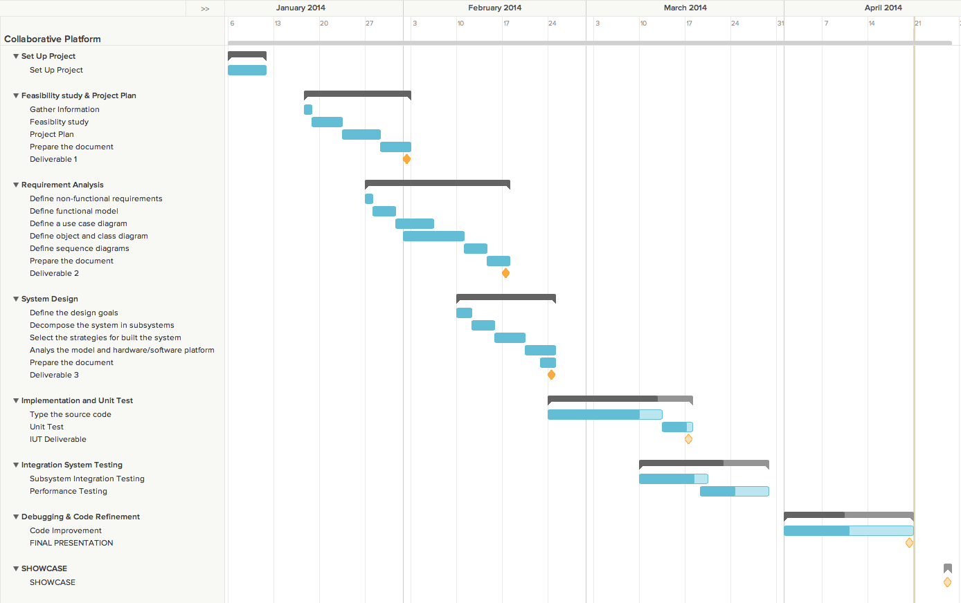

**Summer 2014**

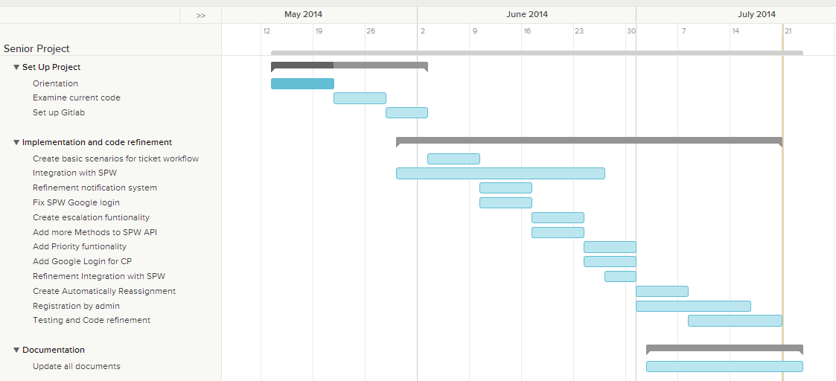

**Fall 2014**

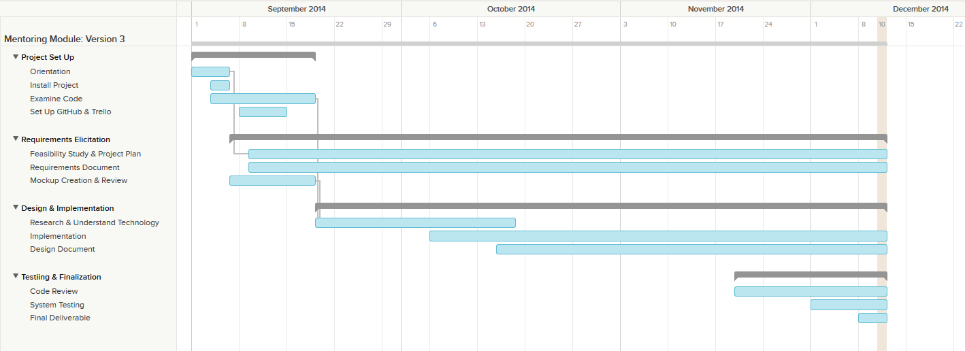

**Spring 2015**



3.3 Cost Estimate

The table below shows the estimate of the items and cost for the project.

|  |  |
| --- | --- |
| **Item** | **Item Cost** |
| Hardware (Personal Laptops) | $ 0.00 |
| Hardware (FIU Lab) | $ 0.00 |
| Software (Open Source) | $ 0.00 |
| Total Cost | $ 0.00 |

# Proposed System Requirements

This chapter introduces the functional requirements for the project in terms of functional requirements, describing the scenarios and non-functional requirements for each. In this section we have included the functional requirements already implemented in the Virtual Job Fair v2. All these functionalities will be part of the new collaborative platform.

## 4.1 Functional Requirements

**Project Mentoring Module Functional Requirements**

The system shall…

* Allow project mentor to set up a meeting from SPW with mentees without login into the mentoring module.
* Allow project mentor and mentee to start using the white board
* Allow project mentor and mentee to participate in a video conference
* Allow project mentor and mentee share files

**Domain Mentoring Module Functional Requirements**

The system shall…

* Auto assign the most appropriate domain mentor to a ticket.
* Allow administrator to reassign the ticket to other domain mentor.
* Allow project mentor to retrieve the description of the projects assigned.
* Allow project mentor to retrieve all the mentees for each project.
* Allow project mentor to set up meetings with his/her mentees.
* Allow project mentor to retrieve all the upcoming meetings.
* Allow project mentor to assign ticket to other project mentor.
* Allow project mentor to see the ticket created by their mentees.
* Allow mentees to assign tickets to his/her project mentor.
* Allow user create a ticket.
* Allow user to select a specific domain for a new ticket.
* Allow user to select a specific sub domain.
* Allow user to upload file to a ticket.
* Allow user to download file from a ticket.
* Allow user to append comments to a ticket.
* Allow user to retrieve all the details of the ticket of the ticket that he/she created or was assigned.
* Allow user to close a ticket.
* Allow user to reject a ticket.
* Allow System Administrators (SA) to create new administrators.
* Allow SA to change user profile information and scope.
* Allow SA to manage Domains and Sub-Domains.
* Allow SA to disable and enable users.
* Allow SA to send invitations
* Allow SA to manage projects
* Allow user to edit their availability
* Allow user to edit their photo
* Allow project mentor to select desired projects
* Allow personal mentor to select desired personal mentees
* Allow domain mentors to add domain and expertise ratings
* Allow administrators to view and edit user profiles
* Allow mentees to assign tickets to his/her personal mentor.
* Allow personal mentor to see the ticket created by their mentees.
* Allow personal mentor to comment the ticket created by their mentees.
* Allow Domain mentor in tier 1 to escalate the ticket to a Domain Mentor in tier 2
* Allow user to select a specific priority for a new ticket.
* Allow administrator to change the priority waiting time.
* Allow the system to automatically reassign the tickets.

**Mentor Module: Version 3**

The system shall...

* Allow a potential mentor to register for a mentor account from a new landing page.
* Allow a Project Mentor to apply by selecting projects they like or deferring the decision to the system.
* Allow a Personal Mentor to apply by selecting students they like or deferring the decision to the system.
* Allow a Domain Mentor to apply by selecting topics they’re proficient in.
* Allow a Domain Mentor to suggest new domains.
* Allow Project Mentor to approve/reject projects suggested by admin.
* Allow Domain Mentor to approve/reject topics suggested by admin.
* Allow Personal Mentor to approve/reject mentee suggested by admin.
* Allow admin to view pending applications
* Allow admin to approve/reject Projects in a Project Mentor Application
* Allow admin to propose Projects in a Project Mentor Application
* Allow admin to approve/reject Mentees in a Personal Mentor Application
* Allow admin to propose Mentees in a Personal Mentor Application
* Allow admin to approve/reject Domains in a Domain Mentor Application
* Allow admin to propose Domains in a Domain Mentor Application
* Allow admin to review domains recommended by mentor
* Allow admin to view open invitations/re-invites
* Allow admin to customize the body of the message while sending an invite
* Allow admin to send a re-invite
* Allow admin to gain insight on site usage through admin dashboard
* Allow admin to gain insight on a particular project
* Allow admin to gain insight on a particular user
* Allow admin to gain insight on a particular domain
* Allow admin to gain insight on a particular subdomain
* Allow admin to view tickets
* Allow admin to manage tickets
* Allow admin to use an advanced search for tickets.

**Mentor Module: Version 5**

The system shall...

* Allow admin to pull reports on mentors.
* Allow admin to pull reports on mentees.
* Allow admin to pull reports on Tickets.
* Allow admin to research on the utilization of tickets created.
* Allow admin to research on the utilization of tickets closed.
* Allow admin to research on the utilization of tickets duration (time opened to closed)
* Allow admin to research on the time that takes mentors to answer.
* Allow admin to research on the tickets that are still open (may or may not be answered).
* Allow admin to research on the tickets that are currently unanswered.
* Allow admin to get system suggestion on what kind of mentors to find (based on frequent mentee subdomains).
* Allow users to schedule meetings on-demand.
* Allows users to schedule meetings ahead of time.
* Allow mentors to schedule meetings from a ticket.
* Allow users to see/hear each other during videoconferences.
* Allow users to use the chat-room during videoconferences.
* Allow users to have a whiteboard to draw and share it during videoconferences.
* Allow users to share their screens with the other meeting participants.
* Allow users to stop sharing their screens with the other meeting participants.
* Allow users to invitee others during a videoconference.
* Allow invitee to accept a video conference invitation
* Allow invitee to reject a video conference invitation
* Allow moderators to delete their videoconferences.
* Allow moderators to cancel their videoconferences.

**Remote Judge Module Functional Requirements**

The current System Shall …

* Allow instructors to set the grading rubric.
* Allow judges to grade students based on the rubric.
* Allow students to view their scores.
* Allow judges and student to use video chat.

The new system shall …

* Allow judges to get rubric
* Allow judges to post grades
* Allow head professor to send invitation
* Allow show power point
* Allow judge and mentee to use video conference
* Allow judge and mentee to use the whiteboard

**Current Virtual Job Fair V2 System’s Functional Requirements**

The system shall…

* **Allow students and employers to register**
  + **Usability**: The register form is simple and easy to follow.
  + **Reliability**: The system should perform correctly 99% of the time.
  + **Performance**: The system should respond within 2 seconds.
  + **Supportability**: The system should be easy to maintain and make appropriate changes.
* **Allow students and employers to view respective profiles**
  + **Usability**: Data displayed in profiles is easy to follow. Students are only able to see their own profile and the employer ones. Employers can see all student profiles.
  + **Reliability**: The system should perform correctly 99% of the time.
  + **Performance**: The system should respond within 1 second.
  + **Supportability**: The system should be easy to maintain and make appropriate changes.
* **Allow students and employers to edit their basic profile information**
  + **Usability**: The edit form is simple and easy to follow.
  + **Reliability**: The system should perform correctly 99% of the time.
  + **Performance**: The system should respond within 1 second.
  + **Supportability**: The system should be easy to maintain and make appropriate changes.
* **Allow students and employers to take part in a video interview**
  + **Usability**: Starting a video interview is simple and understandable.
  + **Reliability**: The system should perform correctly 99% of the time.
  + **Performance**: The system should respond within 3 seconds when connecting.
  + **Supportability**: The system should be easy to maintain and make appropriate changes.
* **Allow students to upload a resume and video resume**
  + **Usability**: The upload form is simple and easy to follow.
  + **Reliability**: The system should perform correctly 99% of the time.
  + **Performance**: The system should respond within 1-5 seconds, depending on the file size.
  + **Supportability**: The system should be easy to maintain and make appropriate changes.
* **Allow students and employers to upload an image for their profile**
  + **Usability**: The upload form is simple and easy to follow.
  + **Reliability**: The system should perform correctly 99% of the time.
  + **Performance**: The system should respond within 1 second.
  + **Supportability**: The system should be easy to maintain and make appropriate changes.
* **Allow students to associate skills to their profile**
  + **Usability**: The ability to add skills to a profile is simple and understandable. It can be done by using LinkedIn connect or adding them manually.
  + **Reliability**: The system should perform correctly 99% of the time.
  + **Performance**: The system should respond within one 1 second.
  + **Supportability**: The system should be easy to maintain and make appropriate changes.
* **Allow students to add and delete education information**
  + **Usability**: The corresponding form is easy to complete and follow.
  + **Reliability**: The system should perform correctly 99% of the time.
  + **Performance**: The system should respond within 1 second.
  + **Supportability**: The system should be easy to maintain and make appropriate changes.
* **Allow students to add and delete experience information**
  + **Usability**: The corresponding form is easy to complete and follow.
  + **Reliability**: The system should perform correctly 99% of the time.
  + **Performance**: The system should respond within 1 second.
  + **Supportability**: The system should be easy to maintain and make appropriate changes.
* **Allow students to integrate with their LinkedIn account to provide education and experience information (security)**
  + **Usability**: The connection with LinkedIn should be easy to follow. Users will enter their LinkedIn credentials and get appropriate data that the user allowed.
  + **Reliability**: The system should perform correctly 99% of the time.
  + **Performance**: The system should respond within 1 second.
  + **Supportability**: The system should be easy to maintain and make appropriate changes.
* **Allow students to apply to open job postings and provide a cover letter**
  + **Usability**: Students are presented with a user-friendly interface that is easy to complete.
  + **Reliability**: The system should perform correctly 99% of the time.
  + **Performance**: The system should respond within 1 second.
  + **Supportability**: The system should be easy to maintain and make appropriate changes.
* **Allow students to reply to an employer’s message**
  + **Usability**: Students are presented with a clear and simple interface to send messages.
  + **Reliability**: The system should perform correctly 99% of the time.
  + **Performance**: The system should respond within 1 second.
  + **Supportability**: The system should be easy to maintain and make appropriate changes.
* **Allow students to search for jobs based on skills**
  + **Usability**: The search form is easy to follow and complete.
  + **Reliability**: The system should perform correctly 99% of the time.
  + **Performance**: The system should respond within 1 second.
  + **Supportability**: The system should be easy to maintain and make appropriate changes.
* **Allow employers to post jobs**
  + **Usability**: The post job form is easy to understand and complete.
  + **Reliability**: The system should perform correctly 99% of the time.
  + **Performance**: The system should respond within 1 second.
  + **Supportability**: The system should be easy to maintain and make appropriate changes.
* **Allow employers to close a job posting**
  + **Usability**: The closing of a post is easy to complete.
  + **Reliability**: The system should perform correctly 99% of the time.
  + **Performance**: The system should respond within 1 second.
  + **Supportability**: The system should be easy to maintain and make appropriate changes.
* **Allow employers to associate skills to a job posting**
  + **Usability**: the addition of skills to a post is simple to complete.
  + **Reliability**: The system should perform correctly 99% of the time.
  + **Performance**: The system should respond within 1 second when adding each skill.
  + **Supportability**: The system should be easy to maintain and make appropriate changes.
* **Allow employers to search for students based on skills**
  + **Usability**: The search form is simple to submit.
  + **Reliability**: The system should perform correctly 99% of the time.
  + **Performance**: The system should respond within 1 second.
  + **Supportability**: The system should be easy to maintain and make appropriate changes.
* **Allow employers to view student profiles**
  + **Usability**: The view of a student profile is easy to understand.
  + **Reliability**: The system should perform correctly 99% of the time.
  + **Performance**: The system should respond within one 1 second.
  + **Supportability**: The system should be easy to maintain and make appropriate changes.
* **Allow employers to send messages to students**
  + **Usability**: Employers are presented with a clear and simple interface to send messages.
  + **Reliability**: The system should perform correctly 99% of the time.
  + **Performance**: The system should respond within 1 second.
  + **Supportability**: The system should be easy to maintain and make appropriate changes.
* **Allow employers to give students a “virtual handshake” to show interest in the student**
  + **Usability**: The virtual handshake form is easy complete.
  + **Reliability**: The system should perform correctly 99% of the time.
  + **Performance**: The system should respond within 1 second.
  + **Supportability**: The system should be easy to maintain and make appropriate changes.
* **Allow an administrator to disable an account (security)**
  + **Usability**: Disabling a user is simple to complete.
  + **Reliability**: The system should perform correctly 99% of the time.
  + **Performance**: The system should respond within 1 second.
  + **Supportability**: The system should be easy to maintain and make appropriate changes.
* **Allow an administrator to close a job posting**
  + **Usability**: Closing a job post is simple to complete.
  + **Reliability**: The system should perform correctly 99% of the time.
  + **Performance**: The system should respond within 1 second.
  + **Supportability**: The system should be easy to maintain and make appropriate changes.
* **Allow an administrator to validate an employer registration (security)**
  + **Usability**: The validation of an employer is done by one click and is simple to complete.
  + **Reliability**: The system should perform correctly 99% of the time.
  + **Performance**: The system should respond within 1 second.
  + **Supportability**: The system should be easy to maintain and make appropriate changes.
* **Require a username and password to log into the system (security)**
  + **Usability**: This is required for a user to log in. Form is simple and easy to follow.
  + **Reliability**: The system should perform correctly 99% of the time.
  + **Performance**: The system should respond within 1 second.
  + **Supportability**: The system should be easy to maintain and make appropriate changes.
* **Encrypt the user password before storing into the database (security)**
  + **Usability**: Storing user password in a secure way without user intervention.
  + **Reliability**: The system should perform correctly 99% of the time.
  + **Performance**: The system should respond within 1 second.
  + **Supportability**: The system should be easy to maintain and make appropriate changes.
* **Require login before viewing user profiles (security)**
  + **Usability**: Security measure for system. Interface is simple to complete.
  + **Reliability**: The system should perform correctly 99% of the time.
  + **Performance**: The system should respond within 1 second.
  + **Supportability**: The system should be easy to maintain and make appropriate changes.
* **Allow users to create a new shared document.**
  + **Usability:** The document creation interface should be intuitive, easy to understand and navigate.
  + **Reliability:** The system should perform correctly 99% of the time.
  + **Performance:** The system should respond in less than 3 seconds.
  + **Supportability:** The system should be supported on Google Chrome version 29+ The system should be easily maintainable, allowing for improvements, corrections and adaptation in environment, requirement and/or specification changes.
* **Allow users to open a document.**
  + **Usability:** The document open interface should be intuitive, easy to understand and navigate.
  + **Reliability:** The system should perform correctly 99% of the time.
  + **Performance:** The system should respond in less than 3 seconds.
  + **Supportability:** The system should be supported on Google Chrome version 29+ The system should be easily maintainable, allowing for improvements, corrections and adaptation in environment, requirement and/or specification changes.
* **Allow users to share a document.**
  + **Usability:** The invitation should be transparent to the users upon document creation. The invitation interface on new documents should be easy to use.
  + **Reliability:** The system should perform correctly 99% of the time.
  + **Performance:** The system should respond in less than 1 seconds.
  + **Supportability:** The system should be supported on Google Chrome version 29+ The system should be easily maintainable, allowing for improvements, corrections and adaptation in environment, requirement and/or specification changes.
* **Allow users to delete a document.**
  + **Usability:** The document deletion interface should be intuitive, easy to understand and navigate.
  + **Reliability:** The system should perform correctly 99% of the time.
  + **Performance:** The system should respond in less than 1 second.
  + **Supportability:** The system should be supported on Google Chrome version 29+ The system should be easily maintainable, allowing for improvements, corrections and adaptation in environment, requirement and/or specification changes.
* **Allow users to import a document.**
  + **Usability:** The import document interface should be intuitive, easy to understand and navigate.
  + **Reliability:** The system should perform correctly 99% of the time.
  + **Performance:** The system should respond in less than 3 seconds.
  + **Supportability:** The system should be supported on Google Chrome version 29+ The system should be easily maintainable, allowing for improvements, corrections and adaptation in environment, requirement and/or specification changes.
* **Allow users to export a document.**
  + **Usability:** The export document interface should be intuitive, easy to understand and navigate.
  + **Reliability:** The system should perform correctly 99% of the time.
  + **Performance:** The system should respond in less than 3 seconds.
  + **Supportability:** The system should be supported on Google Chrome version 29+ The system should be easily maintainable, allowing for improvements, corrections and adaptation in environment, requirement and/or specification changes.
* **Allow users to rename document.**
  + **Usability:** The document rename interface should be intuitive, easy to understand and navigate.
  + **Reliability:** The system should perform correctly 99% of the time.
  + **Performance:** The system should respond in less than 3 seconds.
  + **Supportability:** The system should be supported on Google Chrome version 29+ The system should be easily maintainable, allowing for improvements, corrections and adaptation in environment, requirement and/or specification changes.
* **Allow users to save a shared document.**
  + **Usability:** The document saving interface should be intuitive, easy to understand and navigate.
  + **Reliability:** The system should perform correctly 99% of the time.
  + **Performance:** The system should respond in less than 3 seconds.
  + **Supportability:** The system should be supported on Google Chrome version 29+ The system should be easily maintainable, allowing for improvements, corrections and adaptation in environment, requirement and/or specification changes.
* **Maintain access boundaries between non-collaborating temporary accounts (security).**
  + **Usability:** Temporary accounts not related to a collaborating session shall have no access to that session’s documents.
  + **Reliability:** The system should perform correctly 99% of the time.
  + **Performance:** The system should respond in less than 1 second.
  + **Supportability:** The system should be supported on Google Chrome version 29+ The system should be easily maintainable, allowing for improvements, corrections and adaptation in environment, requirement and/or specification changes.
* **Allow FIU Computer Science Seniors to login using their FIU SCIS credentials**
  + **Usability:** The system should provide an easy and integrated login process for FIU SCIS Seniors using the school UNIX account.
  + **Reliability:** The system should perform correctly 99% of the time.
  + **Performance:** The system should respond in less than 1 second.
  + **Supportability:** The system should be supported on Google Chrome version 29+ The system should be easily maintainable, allowing for improvements, corrections and adaptation in environment, requirement and/or specification changes.
* **Allow users to share their screens**
  + **Usability**: User should be able to share their screens solely with mouse clicks
  + **Reliability**: The system should perform correctly 99% of the time.
  + **Performance**: The system should start streaming content in under 3 seconds
  + **Supportability**: Screen sharing page should be supported by Google Chrome versions 29 and up.
* **Allow users to view shared screens**
  + **Usability**: User should be able to watch a shared screen with single mouse click
  + **Reliability**: The system should perform correctly 99% of the time.
  + **Performance**: The system should start displaying the screen in under 2 seconds
  + **Supportability**: Screen sharing page should be supported by Google Chrome versions 29 and up.
* **Allow users to stop sharing their screens**
  + **Usability**: User should be able to stop sharing their screens with a single mouse click
  + **Reliability**: The system should perform correctly 99% of the time.
  + **Performance**: The system should stop the stream in under 1 second.
  + **Supportability**: Screen sharing page should be supported by Google Chrome versions 29 and up.
* **Allow employers to send SMS to students**
  + **Usability**: Sending an SMS should not take more than 15 seconds for a novice user.
  + **Reliability**: The system should perform correctly 99% of the time.
  + **Performance**: The SMS should be sent in under 2 seconds after user presses send
  + **Supportability**: Sending SMS page should be supported by IE, Firefox, Chrome and Safari.
* **Allow users to receive automatic email and SMS reminders**
  + **Usability**: Not applicable
  + **Reliability**: The system should perform correctly 99% of the time.
  + **Performance**: Users should receive a reminder 30 minutes before scheduled interview
  + **Supportability**: Not applicable
* **Allow users to confirm their phone numbers**
  + **Usability**: Confirming a phone number should take less than 30 seconds for inexperienced users
  + **Reliability**: The system should perform correctly 99% of the time.
  + **Performance**: Sending authentication code and validating it should take less than 2 seconds respectively.
  + **Supportability**: Confirm phone number page should be supported by IE, Firefox, Chrome and Safari
* **Allow students and employers to start using the whiteboard functionality**
  + **Usability:** Starting the whiteboard is a matter of clicking a button while interviewing, making it a fairly easy process to do
  + **Reliability:** The whiteboard tool should be available 90% of the time, since not every major/employer will use it
  + **Performance:** The whiteboard should be started within 1 second
  + **Supportability:** The system be supported by Chrome version 29 or above
* **Allow students and employers to upload an image to share during an interview**
  + **Usability:** if an image has been selected for uploading, actually uploading it to the system is as simple as click the “Submit Drawing” button, making it simple to use
  + **Reliability:** Uploading images should work 99% of the time, since it is a critical function of the image-sharing subsystem
  + **Performance:** Depending on its size, the maximum time it should take to upload an image should be 10 seconds
  + **Supportability:** The system be supported by Chrome version 29 or above
* **Allow students to view images uploaded by the other party in an interview**
  + **Usability:** viewing an image which has been uploaded already relies simply on clicking a “View Drawing” button, so it is fairly simple to use
  + **Reliability:** as uploading an image, viewing an image should be working 99% of the time, since it is a critical function of the image-sharing subsystem
  + **Performance:** depending on the size of the image, the maximum time it should take to view an uploaded image should be 10 seconds
  + **Supportability:** The system be supported by Chrome version 29 or above
* **Allow students and employers show or restore a whiteboard session**
  + **Usability:** starting a whiteboard session involves only clicking the “Whiteboard” button below the video chat section of the interview page, making it a simple process
  + **Reliability:** the whiteboard should be available 99% of the time, since it is a main feature of the system
  + **Performance:** displaying the whiteboard should take 1 second, since a default whiteboard is not preloaded with any information
  + **Supportability:** The system be supported by Chrome version 29 or above
* **Allow students and employers to select an image to upload to the server for sharing purposes**
  + **Usability:** selecting an image requires basic experience with a browsing dialog, which should be fairly common knowledge, making it a simple functionality
  + **Reliability:** the ability to select an image is critical to the image-sharing feature, so it should be available 99% of the time
  + **Performance:** since selecting an image does not depend on image size, this functionality should take less than 1 second
  + **Supportability:** The system be supported by Chrome version 29 or above
* **Allow students and employers to draw using the whiteboard**
  + **Usability:** drawing on the whiteboard simply requires to drag the mouse through the whiteboard’s area, which makes it a simple process
  + **Reliability:** without being able to draw in the whiteboard, the whiteboard serves no purpose, so drawing in the whiteboard should be available 99.99% of the time
  + **Performance:** since the whiteboard is self-contained and does not need any API calls, the drawing should take less than half a second
  + **Supportability:** The system be supported by Chrome version 29 or above
* **Allow students and employers to change the color of the drawing pencil tool**
  + **Usability:** changing the color is a matter of clicking on the new color desired, so it is fairly simple to do
  + **Reliability:** changing the color of the drawing tool is not of the utmost importance, so it is expected to work 90% of the time
  + **Performance:** since the whiteboard is self-contained and does not need any API calls, changing the color should take less than half a second
  + **Supportability:** The system be supported by Chrome version 29 or above
* **Allow students and employers to type text into the whiteboard**
  + **Usability:** typing text into the whiteboard requires clicking a button and typing text, so it is fairly simple to use
  + **Reliability:** since typing text is not the main whiteboard feature, it is expected to work 90% of the time
  + **Performance:** the text should appear in the whiteboard in less than three seconds
  + **Supportability:** The system be supported by Chrome version 29 or above
* **Allow students and employers to clear the drawings of the whiteboard**
  + **Usability:** Clearing the contents is a matter of clicking a single button, making it a fairly easy process to conduct
  + **Reliability:** It should be available 99% of the time that the whiteboard is being used, given that new drawings might be required
  + **Performance:** Whiteboard screen should be cleared out within 1 second
  + **Supportability:** The system be supported by Chrome version 29 or above
* **Allow students and employers to partially erase drawings from the whiteboard**
  + **Usability:** Partially erasing from the drawing is a matter of clicking a single button, drawing the cursor and releasing the click, making it a fairly easy process to conduct
  + **Reliability:** It should be available 99% of the time that the whiteboard is being used, given that a user might make a mistake while drawing or that new drawings might be required
  + **Performance:** selected sections should be erased within 1 second
  + **Supportability:** The system be supported by Chrome version 29 or above
* **Allow admin to pull reports on mentors.**
  + **Usability**: Pulling the report should be simple and easy to follow.
  + **Reliability**: The system should perform correctly 99% of the time.
  + **Performance**: The system should respond within 2 seconds.
  + **Supportability**: The system should be easy to maintain and make appropriate changes.
* **Allow admin to pull reports on mentees.**
  + **Usability**: Pulling the report should be simple and easy to follow.
  + **Reliability**: The system should perform correctly 99% of the time.
  + **Performance**: The system should respond within 2 seconds.
  + **Supportability**: The system should be easy to maintain and make appropriate changes.
* **Allow admin to pull reports on Tickets.**
  + **Usability**: Pulling the report should be simple and easy to follow.
  + **Reliability**: The system should perform correctly 99% of the time.
  + **Performance**: The system should respond within 2 seconds.
  + **Supportability**: The system should be easy to maintain and make appropriate changes.
* **Allow admin to research on the utilization of tickets created.**
  + **Usability**: Pulling the report should be simple and easy to follow.
  + **Reliability**: The system should perform correctly 99% of the time.
  + **Performance**: The system should respond within 2 seconds.
  + **Supportability**: The system should be easy to maintain and make appropriate changes.
* **Allow admin to research on the utilization of tickets closed.**
  + **Usability**: Pulling the report should be simple and easy to follow.
  + **Reliability**: The system should perform correctly 99% of the time.
  + **Performance**: The system should respond within 2 seconds.
  + **Supportability**: The system should be easy to maintain and make appropriate changes.
* **Allow admin to research on the utilization of tickets duration (time opened to closed)**
  + **Usability**: Pulling the report should be simple and easy to follow.
  + **Reliability**: The system should perform correctly 99% of the time.
  + **Performance**: The system should respond within 2 seconds.
  + **Supportability**: The system should be easy to maintain and make appropriate changes.
* **Allow admin to research on the time that takes mentors to answer.**
  + **Usability**: Pulling the report should be simple and easy to follow.
  + **Reliability**: The system should perform correctly 99% of the time.
  + **Performance**: The system should respond within 2 seconds.
  + **Supportability**: The system should be easy to maintain and make appropriate changes.
* **Allow admin to research on the tickets that are still open (may or may not be answered).** 
  + **Usability**: Pulling the report should be simple and easy to follow.
  + **Reliability**: The system should perform correctly 99% of the time.
  + **Performance**: The system should respond within 2 seconds.
  + **Supportability**: The system should be easy to maintain and make appropriate changes.
* **Allow admin to research on the tickets that are currently unanswered.**
  + **Usability**: Pulling the report should be simple and easy to follow.
  + **Reliability**: The system should perform correctly 99% of the time.
  + **Performance**: The system should respond within 2 seconds.
  + **Supportability**: The system should be easy to maintain and make appropriate changes.
* **Allow admin to get system suggestion on what kind of mentors to find (based on frequent mentee subdomains).**
  + **Usability**: Pulling the report should be simple and easy to follow.
  + **Reliability**: The system should perform correctly 99% of the time.
  + **Performance**: The system should respond within 2 seconds.
  + **Supportability**: The system should be easy to maintain and make appropriate changes.
* **Allow users to schedule meetings on-demand.**
  + **Usability**: The meeting should be easy to schedule.
  + **Reliability**: The system should perform correctly 99% of the time.
  + **Performance**: The system should respond within 2 seconds.
  + **Supportability**: The system should be easy to maintain and make appropriate changes.
* **Allows users to schedule meetings ahead of time.**
  + **Usability**: The meeting should be easy to schedule.
  + **Reliability**: The system should perform correctly 99% of the time.
  + **Performance**: The system should respond within 2 seconds.
  + **Supportability**: The system should be easy to maintain and make appropriate changes.
* **Allow mentors to schedule meetings from a ticket.**
  + **Usability**: The meeting should be easy to schedule.
  + **Reliability**: The system should perform correctly 99% of the time.
  + **Performance**: The system should respond within 2 seconds.
  + **Supportability**: The system should be easy to maintain and make appropriate changes.
* **Allow users to see/hear each other during videoconferences.**
  + **Usability**: The sound and video should be neat.
  + **Reliability**: The system should perform correctly 99% of the time.
  + **Performance**: The system should respond within 2 seconds.
  + **Supportability**: The system should be easy to maintain and make appropriate changes.
* **Allow users to use the chat-room during videoconferences.**
  + **Usability**: The chat should be present at all times.
  + **Reliability**: The system should perform correctly 99% of the time.
  + **Performance**: The system should respond within 2 seconds.
  + **Supportability**: The system should be easy to maintain and make appropriate changes.
* **Allow users to have a whiteboard to draw and share it during videoconferences.**
  + **Usability**: The chat should be present at all times.
  + **Reliability**: The system should perform correctly 99% of the time.
  + **Performance**: The system should respond within 2 seconds.
  + **Supportability**: The system should be easy to maintain and make appropriate changes.
* **Allow users to share their screens with the other meeting participants.**
  + **Usability**: The screenshare should present the drawings at all times.
  + **Reliability**: The system should perform correctly 99% of the time.
  + **Performance**: The system should respond within 2 seconds.
  + **Supportability**: The system should be easy to maintain and make appropriate changes.
* **Allow users to stop sharing their screens with the other meeting participants.**
  + **Usability**: The screen share should be easy to stop.
  + **Reliability**: The system should perform correctly 99% of the time.
  + **Performance**: The system should respond within 2 seconds.
  + **Supportability**: The system should be easy to maintain and make appropriate changes.
* **Allow users to invitee others during a videoconference.**
  + **Usability**: The invitation should be easy to perform.
  + **Reliability**: The system should perform correctly 99% of the time.
  + **Performance**: The system should respond within 2 seconds.
  + **Supportability**: The system should be easy to maintain and make appropriate changes.
* **Allow invitee to accept a video conference invitation.**
  + **Usability**: The invitees should receive and email where they are able to accept the invitation.
  + **Reliability**: The system should perform correctly 99% of the time.
  + **Performance**: The system should respond within 5 seconds.
  + **Supportability**: The system should be easy to maintain and make appropriate changes.
* **Allow invitee to reject a video conference invitation**
  + **Usability**: The invitees should receive and email where they are able to reject the invitation.
  + **Reliability**: The system should perform correctly 99% of the time.
  + **Performance**: The system should respond within 5 seconds.
  + **Supportability**: The system should be easy to maintain and make appropriate changes.
* **Allow moderators to delete their videoconferences.**
  + **Usability**: The invitation should be easy to delete.
  + **Reliability**: The system should perform correctly 99% of the time.
  + **Performance**: The system should respond within 2 seconds.
  + **Supportability**: The system should be easy to maintain and make appropriate changes.
* **Allow moderators to cancel their videoconferences.**
  + **Usability**: The system should provide an easy way to cancel the videoconference.
  + **Reliability**: The system should perform correctly 99% of the time.
  + **Performance**: The system should respond within 2 seconds.
  + **Supportability**: The system should be easy to maintain and make appropriate changes.

## 4.2 Analysis of System Requirements

This section contains all the functional specification, gathered from the scenarios.

### 4.2.1 Scenarios

**Registration:**

Mark is a computer science professor at Florida International University. He specializes in teaching data structures and algorithm techniques courses in Java. Every day Mark gets questions from various computer science students in the senior project class, specifically related to Java and algorithms. After responding to some students via email and office hours he realizes that he needs to find a faster and more efficient way to reply. The next day he decides to stop by the office of the professor for the senior project course, Dr. Masoud Sadjadi. He talks to Masoud and asks if there is a simpler way to address the questions to his students. Masoud sends an email to Mark so that he can register within the collaborative platform. Mark clicks on the link through his email and goes to the registration page on the website.

Mark fills in his information, email address, password and other necessary credentials. Below he sees a section asking him to request a role within the website. The roles he sees are employer, interviewee, and administrator, as well as project, domain, and personal mentors among others. While hovering over each role he sees a short description of expected contribution and responsibilities. Remembering his discussion with Masoud regarding possible roles, he clicks to request the position of a domain mentor. From here Mark is requested to fill out his potential profile.

**Integration with SPW**

**Automatic Sync CP with SPW**

John is a student registered in Senior Project class. In the first day of class Professor Masoud Sadjadi advises students to choose a project using the Senior Project Website. John is able to login to SPW using FIU Google credentials (he is in the flat file used by SPW for validation) and chooses a project. The same day at midnight an automated routine brings students and projects (both associated with each other) from Senior Project Website to Collaborative Platform. The next day Masoud Sadjadi advises students that they can start using Collaborative Platform to communicate with their project mentors and also they’ll be able to post general questions for domain mentors to answer. John goes to the Collaborative Platform website and is able to login using his FIU Google credentials. John is now able to use Collaborative Platform.

**Changes in SPW reflect in CP**

For some reason John has changed his project in SPW He logs in to CP and he sees he is still associated with his old project. The same day at midnight a routine brings new students and projects as well as updates from SPW to CP. The next day John logs in to CP using his FIU Google credentials and he goes to hi profile and sees he now associated with his new project and consequently with his new project mentor.

**Manual Sync CP with SPW**

For some reason the automated routine that syncs CP with SPW failed and the students need to start using the platform immediately. Professor Sadjadi logs in using his administrator credentials. On his home screen he clicks on a button labeled “Sync with SPW” which trigger the routine that migrates data from SPW to CP. Now the students are able to login to CP and they are associated with the projects they chose in SPW.

**Registration**

Mark is a computer science professor at Florida International University. He specializes in teaching data structures and algorithm techniques courses in Java. He has also been involved in multiple research projects. Masoud talks to him about his senior project class and asks him if he wants to be a project/domain/personal mentor and Mark agrees. Masoud also says to Mark he will be able to easily communicate with his mentees and other students using the mentoring subsystem of Collaborative platform. Masoud asks Mark for his email and tells him soon he will be getting an email with his credentials to login.

Masoud goes ahead and logins to the website and goes to the “Add user” screen. There he fills out Mark’s information like first name, last name, username and email and selects the roles he wants Mark to be When Masoud clicks next he is taken to a wizard where he will be able to choose how he wants Mark to participate in the system. There will be a screen for each role:

* On the project mentor screen he will have option to select the projects and max ticket for the new user.
* On the domain mentor screen he will be able to choose the domain/subdomain, rating and tier for the new user.
* On the personal mentor screen he will be able to choose the mentees and max hours for the new user.

Once Masoud reaches the last screen he will be able to submit the form and complete the registration. This will trigger an email to the Mark with his credentials to login.

**Mentoring Module, Domain Mentor:**

**-**Continuation from Registration-

Mark is then greeted by a new screen where he sees the ability to add a picture of himself, give a detailed biography on previous jobs and also create a list of domains. Next to the blank picture finds and clicks on the “Sync with LinkedIn” button so that he can more easily fill out the necessary information. He completes the sync and finds his photo and job history on his potential profile page filled out. On the right he sees a table with a long list of suggested domains based on his skills from LinkedIn. From this list he is requested to specify a condensed list of domains that he wishes to mentor for. From here he gives each domain an expertise level ranging from one to ten, ten being at an expert level. He sees a short description for expertise level; 1-2 poor, 5-6 average, and 9-10 outstanding knowledge.

Next to the table he fills out an availability section detailing how many maximum issues he wishes to respond to on a monthly basis, the lower limit being 1. After setting up the page he clicks to send it for approval from the administrator.

-Assume to be approved-

Mark is a newly registered domain mentor as approved by the administrator. Based on the provided work experience and qualifications, Masoud, the administrator, has selected Mark to be a Tier 2 mentor. Mark receives this acceptance email requesting further action via email. He clicks on the email and is directed to his profile page where he can accept or decline the approval supplied by the administrator. Mark, happy with the approval of listed domains and ranking in the tier 2 mentor table, accepts the approval and completes the full registration process into the mentoring module.

-Assume issue has been assigned-

Mark checks his email one Saturday afternoon and finds an email from the collaborative platform. In it he sees that he has been assigned two issues. He clicks on the link and it directs him to his homepage within the mentoring module. Here he sees his queue with the two outstanding issues, one for Java another for C++. He clicks on the java issue, a question that has been pushed up by a tier 1 mentor, John. Mark, being that he has over 20 years of experience with java, easily answers the issue and sends it back to John.

Once back on the homepage, Mark glances at his issue queue and sees the java question he just answered has been grayed out and says “answered”. He then clicks on the “pending” C question to see if he can answer it. Mark finds the question very ambiguous and thus cannot fully propose a resolution. He chooses to append a comment on the issue to see if he can clarify the question proposed. Michael, the originator of the question, clarifies the question to Mark and sends it back. Mark sees it and unfortunately still cannot fully give an answer. He decides to open the issue and reroute it to one of his colleagues, Jason, who he feels may be more capable of answering the C issue. Mark could have also messaged Jason for help, but as Mark was already a little overloaded with work, decided to simply reroute the ticket to Jason as it was his expertise. (In which case messages could be accessed via the message tab)

-Assume another issue has been assigned-

-Assume request for new domain-

Clarke is a professor originally from UCLA in California. Clarke is also a registered domain mentor who has previous experience teaching in Ruby on Rails (RoR). Clarke has been approached a few times by different students requesting for some help with RoR. He decides that it would be beneficial to add it to his list of known domains for any future questions asked by potential and current mentees. Clarke goes to his profile page and finds the table with domains and expertise levels. He clicks to add domain and writes in the drop down, “Ruby on Rails”. He selects an expertise level of 7 as he has about 6 years of industry knowledge as well as educational research experience with the language. Once done, he clicks to add and confirms to send it to the administrator to be approved.

-Domain Mentor Tier 1 has similar functionality with the exception of being able to escalate an issue as described to a Tier 2 mentor. –

**More Scenarios:**

**Scenario 1**

1a. The system automatically assigned Paul’s ticket to a domain mentor in tier 1 of such domain. Then, the system sent a notification email to the assigned mentor. Jonathan the domain mentor, to whom the ticket was assigned, for whatever reason he is unsure of what to do. He decides to reassign the ticket to the administrator. He clicked in the reassign button and a window appears to write a comment, where he can explain the reason for reassigning the ticket. The comment is created and the system reassigns the ticket to the administrator. The system sends three notification emails. One notification is for the administrator. Another email is sent to the mentee, to let him know about the changes made. And finally to Jonathan, the domain mentor, who reassigned the ticket, to let him know that the ticket is now out of his queue. Then, the administrator is going to decide what to do next with the ticket.

1b. Alternately, Jonathan if he is unsure of how to best respond or can’t in a reasonable time, he can just pass on the ticket so the system can reassign it to the next capable person on the queue if there is one and if not it will go to the administrator. The system is going to send three notification emails. One notification is for the person to whom the ticket was reassigned by the system. Another email is sent to the mentee, to let him know about the changes made. And finally to Jonathan, the domain mentor, who reassigned the ticket, to let him know that the ticket is now out of his queue.

**Scenario 2**

The system automatically assigned Paul’s ticket to a domain mentor in tier 1 of such domain. Then, the system sent a notification email to the assigned mentor. Jonathan the domain mentor, to whom the ticket was assigned, decides to manually reassign the question to Mark. Jonathan took that step because he feels that Mark is more capable of answering that issue. He clicks on the reassign button, a new screen opens and he selects Mark’s name from the combo box. He creates a comment and clicks OK. Then, the comment is created and the system reassigns the ticket to Mark. Also, the system is going to send three notification emails. One notification is for Mark, the new mentor to whom the ticket was reassigned. Another email is sent to the mentee, to let him know about the changes made. And finally to Jonathan, the domain mentor, who reassigned the ticket, to let him know that the ticket is now out of his queue.

**Scenario 3**

The system automatically assigned Paul’s ticket to a domain mentor in tier 1 of such domain. Then, the system sent a notification email to the assigned mentor. Jonathan the domain mentor, to whom the ticket was assigned, chooses the ticket from his queue and answers Paul’s question. At this time, the system creates a notification for the mentee, to let him know that a comment was added to the ticket. Paul, the mentee, is not satisfied with the answer given by Jonathan, and creates a comment to the ticket clarifying the question. Jonathan, the mentor, creates another comment in response to Paul’s comment. Again, the system creates a notification for the mentee, to let him know that a new comment was added to the ticket. Finally, the mentee, still unsatisfied with the comment received, decided to reject the ticket. He clicked in the reject button and a window appears to write a comment, where he can explain the reason for rejecting the ticket. The comment is created and now, the ticket can be reassigned only by the administrator. The system sent two notification emails. One is for the mentor, to whom the ticket was previously assigned, to notify him about the rejection of the ticket. And, another email is for the administrator, to notify him that the ticket was rejected. Then, the administrator is going to decide what to do next with the ticket.

**Scenario 4**

The system automatically assigned Paul’s ticket to a domain mentor in tier 1 of such domain. Then, the system sent a notification email to the assigned mentor. Jonathan the domain mentor, to whom the ticket was assigned, chooses the ticket from his queue and answers Paul’s question. Consequently, the system creates a notification for the mentee, to let him know that a comment was added to the ticket. Paul was satisfied with the response received and decided to manually change the ticket status to close. A notification is sent to the mentor letting him know that the ticket was closed.

**Scenario 5**

The ticket created by Paul, was assigned to a domain mentor in tier 1 of such domain. Then, the system sent a notification email to the assigned mentor. Fifteen minutes later, the mentee found the answer in his programming book by himself. He returned to the Collaborative Platform website and decided to close manually the ticket without been answered. . A notification is sent to the mentor letting him know that the ticket was closed.

**Scenario 6**

The system automatically assigned Paul’s ticket to a domain mentor in tier 1 of such domain. Then, the system sent a notification email to the assigned mentor. Jonathan is the domain mentor, to whom the ticket was assigned. Robert is Paul’s personal (or could be a project mentor) mentor. For that reason, he also is able to see Paul’s ticket (not on his queue… his queue only has tickets that are assigned to him not that he can view). Robert knows further info that may be helpful to assist in answering the question, then, he chose Paul’s ticket and created a comment for the ticket. Consequently, the system creates two notifications. One is for the mentee, to let them know that a comment was added to the ticket. And, another is for the domain mentor, to inform him that a comment was added to his assigned ticket. Jonathan, who is working the issue that is on his queue now has additional information to help him respond to Paul.

**Scenario 7 (escalation)**

The system automatically assigned Paul’s ticket to a domain mentor in tier 1 of such domain. Then, the system sent a notification email to the assigned mentor. Jonathan the domain mentor, to whom the ticket was assigned, decides to manually escalate the ticket to a mentor in tier 2. Jonathan took that step because the question is beyond of what a tier 1 should know. He clicks on the escalate button, and a new screen opens and he clicks in the ok button to proceed with the escalation. The system creates a new ticket with all the comments that already exist in the original ticket. Jonathan the domain mentor in tier 1 appears as the creator of the new ticket and the system assigns the ticket to mentor in tier 2 of such domain and the original ticket and this new ticket are cross linked by comment created by the system. Then, the system sent a notification email to the assigned mentor in tier 2.

After this point, the relation between a tier 1 and a tier 2 mentor, it is going to be similar to the relation between a mentee and a tier 1 mentor. Therefore, the basic scenarios are going to apply to the ticket created by the mentor in tier 1 and assigned to a mentor in tier 2.

The mentor in tier 2 can see all the comments made on that ticket. After analyzed them all, he answered the ticket. The system creates a notification for the domain mentor in tier 1, to let him know that a comment was added to the ticket. The domain mentor in tier 1 sees the solution, and answers the ticket created by the mentee based in the solution given by the mentor in tier 2. The system creates a notification for the mentee, to let him know that a comment was added to the ticket. Paul, the mentee, was satisfied with the response received and decided to manually change the ticket status to close. The domain mentor in tier 1 sees that the mentee closed the original ticket and he received a notification about this action. He manually closed his ticket and the mentor in tier 2 also received a notification letting him know that the ticket was closed.

**Mentoring Module, Project/Personal Mentor:**

**-**Assume to be past first page of registration-

Bryan is a software development manager at UIF Technologies. He has a few side projects going besides work and wishes to be more involved with students at the local university. He is contacted by Masoud to join as a potential project mentor within the platform. Bryan is linked by email from Masoud and passes the first page of registration. Once entering basic credentials and password he is greeted with a page displaying all the projects drawn from the senior project website. Here he can see the project info; students signed up, skills related to the project, and client. He also sees an availability section asking him to detail his weekly availability as well as the desired number of projects. On the project selection he sees two tables. One asks him to rate the projects he’s interested in; 1-5, 1 being low and 5 being high. The other simply asks him to click whichever projects he does NOT want to mentor. He decides to simply click that he does not want to do mobile applications and will mentor 2 projects this semester.

-Assume to be approved-

Bryan is a newly approved and registered project mentor within the collaborative platform. He has been assigned 2 projects, one cloud computing and another for the senior project website. He has communicated a few times with his mentees and notices he has an email with a pending issue. Bryan clicks the issue via email and is brought back to his home page with a question from a mentee asking “what is the difference between public and private cloud systems?” Bryan finds this question a little vague and chooses to add a comment to the ticket, “which type of public and which type of private cloud systems?”

John, the mentee that originated the issue, clarifies the question and then Bryan quickly sends a response back. Bryan notices that he also had the ability to drop the question if he so deemed it unnecessary. Bryan also notices on his homepage an access point to see the work submitted in forms of deliverables from the project he is mentoring.

-Assume to have deliverable submitted-

Bryan receives an email from the platform alerting him that one of the projects he is mentoring has submitted a deliverable. Upon reading the deliverable and closely analyzing much of the information, he realizes that he needs to set up a meeting with the projects student contributors (mentees). Bryan goes to his homepage and selects the meetings tab. From here he requests a virtual meeting and selects a date and time for the students in the cloud computing project.

-Assume to be in a meeting-

Bryan is in a meeting with his project mentees. He chooses to begin with a quick video chat to ask if there are any questions. Once having jotted down a few notes he chooses to go down the list one by one. Bryan then uses the virtual white board to tell his mentees a specific pseudo code for an algorithm they need more information on. After writing it on the whiteboard, they are still left a little confused. Bryan, choosing to be nice, uses the ability to share screens as he writes down a few samples of code for the algorithm. Bryan then receives a question regarding a previous ticket that was assigned. He goes to the tickets tab and clicks on resolved, finds the “Systems” issue and quickly brushes up the teams understanding. Once the idea was fully grasped from his mentees, he asks them to submit a sample via the file sharing functionality within the module.

-Personal Mentor has similar functionality with the exception of the meeting rooms and selection of students as opposed to projects-

**More scenarios:**

**Scenario 1**

1a. Paul assigns his ticket to Jack (personal or project mentor). Then, the system sent a notification email to the assigned mentor. Jack the project or personal mentor, to whom the ticket was assigned, for whatever reason he is unsure of what to do. He decides to reassign the ticket to the administrator. He clicked in the reassign button and a window appears to write a comment, where he can explain the reason for reassigning the ticket. The comment is created and the system reassigns the ticket to the administrator. The system sends three notification emails. One notification is for the administrator. Another email is sent to the mentee, to let him know about the changes made. And also, to Jack the personal or project mentor, who reassigned the ticket, to let him know that the ticket is now out of his queue. Then, the administrator is going to decide what to do next with the ticket.

1b. Alternately, Jack if he is unsure of how to best respond or can’t in a reasonable time, he can just pass on the ticket so the system can reassign it to the next capable person on the queue if there is one and if not it will go to the administrator. . The system is going to send three notification emails. One notification is for the person to whom the ticket was reassigned by the system. Another email is sent to the mentee, to let him know about the changes made. And finally, to Jack the personal or project mentor, who reassigned the ticket, to let him know that the ticket is now out of his queue.

**Scenario 2**

Paul assigns his ticket to Jack (personal or project mentor). Then, the system sent a notification email to the assigned mentor. Jack the project or personal mentor, to whom the ticket was assigned, decides to manually reassign the question to Mark. Jack took that step because he feels that Mark is more capable of answering that issue. He clicks on the reassign button, a new screen opens and he selects Mark’s name from the combo box. He creates a comment and clicks OK. Then, the comment is created and the system reassigns the ticket to Mark. Also, the system is going to send three notification emails. One notification is for Mark, the new mentor to whom the ticket was reassigned. Another email is sent to the mentee, to let him know about the changes made. And finally, to Jack the project or personal mentor, who reassigned the ticket, to let him know that the ticket is now out of his queue.

**Scenario 3**

Paul assigns his ticket to Jack (personal or project mentor). Then, the system sent a notification email to the assigned mentor. Jack the project or personal mentor, to whom the ticket was assigned, chooses the ticket from his queue and answers Paul’s question. Consequently, the system creates a notification for the mentee, to let him know that a comment was added to the ticket. Paul, the mentee, is not satisfied with the answer given by Jack, and creates a comment to the ticket clarifying the question. Jack, the mentor, creates another comment in response to Paul’s comment. Again, the system creates another notification for the mentee, to let him know that another comment was added to the ticket by Jack. Finally, the mentee, still unsatisfied with the comment received, decided to reject the ticket. He clicked in the reject button and a window appears to write a comment, where he can explain the reason for rejecting the ticket. The comment is created and now, the ticket can be reassigned only by the administrator. The system sent two notification emails. One is for the mentor, to whom the ticket was previously assigned, to notify him about the rejection of the ticket. And, another email is for the administrator, to notify him that the ticket was rejected. Then, the administrator is going to decide what to do next with the ticket.

**Scenario 4**

Paul assigns his ticket to Jack (personal or project mentor). Then, the system sent a notification email to the assigned mentor. Jack the project or personal mentor, to whom the ticket was assigned, chooses the ticket from his queue and answers Paul’s question. Consequently, the system creates a notification for the mentee, to let him know that a comment was added to the ticket. Paul was satisfied with the response received and decided to manually change the ticket status to close. A notification is sent to the mentor letting him know that the ticket was closed.

**Scenario 5**

The ticket created by Paul, was assigned to a personal or project mentor. Then, the system sent a notification email to the assigned mentor. Fifteen minutes later, the mentee found the answer in his programming book by himself. He returned to the Collaborative Platform website and decided to close manually the ticket without been answered. A notification is sent to the mentor letting him know that the ticket was closed.

**Scenario 6**

Paul assigns his ticket to Bob (project mentor). Then, the system sent a notification email to the assigned mentor. Robert is Paul’s personal mentor. For that reason, he also is able to see Paul’s ticket (not on his queue… his queue only has tickets that are assigned to him not that he can view). Robert knows further info that may be helpful to assist in answering the question, then, he chose Paul’s ticket and created a comment for the ticket. Consequently, the system creates two notifications. One is for the mentee, to let them know that a comment was added to the ticket. And, another is for the project mentor, to inform him that a comment was added to his assigned ticket. Bob, who is working the issue that is on his queue now has additional information to help him respond to Paul.

**Mentoring Module, Mentee:**

-Assume to be registered-

John is a student within the senior project course at FIU. He is doing some work with Java and has a few questions regarding the languages functionality. He logs into the platform and is greeted by his homepage. Here he chooses the option to create a new ticket. From the pop up menu he create the title with “Java – multi threading” and specifies the filter for Java. In addition to the details within the ticket, he decides to include a short clip of the source code he is working with. John attaches the source code file and submits the ticket into the system.

-Assume to have ticket answered-

John receives an email from the collaborative platform. Within the email he reads that a ticket has been answered. Delighted to find the answer to an issue he had asked, John clicks the link to take him to his homepage. Here he sees his queue of issues with the Java question marked as answered. John opens the ticket to see the resolution and is indeed pleased with the solution. He then accepts the answer and closes the issue ticket.

**Administrator:**

-Assume to have pending registrations-

Masoud is the head professor for the computer science senior project course. He also works as the administrator for the collaborative platform, given their close interaction. Masoud checks his email to see that he has a few pending registrations for new members within the platform. The first he opens is Mark, a well-known and brilliant professor with a specific expertise in algorithms and Java. Upon opening his profile page, Masoud glances over his credentials and approves Mark to be a Tier 2 Domain Mentor.

The second on his list of registrations is Luke. Luke is a young professional within the software engineering field. Masoud had previously assigned Luke to be a Tier 1 Domain mentor with specializations in C++, C#, and Operating Systems. Luke, however, disapproved with Masoud and felt that he should have been assigned to be a Tier 2 mentor. Luke opened negotiations with Masoud and has since sent him the most recent registration to be approved. Masoud opens the registration to see Luke’s new credentials specifying a more detailed background within the domains and approves his request to be bumped up into Tier 2.

-Assume to have multiple approved profiles-

Masoud logs in one day and decides to take a look over the registered users within the collaborative platform. Once logged in, he clicks on the profiles tab and is greeted with a list of registered users. For each user that Masoud clicks on, via a given list, he is allowed to see what roles they have signed up for, their domain, projects, personal mentees, and other related information per each specific user. From here, if the administrator finds it necessary, he can edit the information in any way he wants, or simply delete the user if they are no longer active or wish to leave.

-Assume pending domain approval -

Masoud receives an email from the collaborative platform system informing him there has been a request to add a new domain to the database. He opens the email and finds that the request is from Clarke. Clarke is a professor originally from UCLA in California who has previous experience teaching in Ruby on Rails (RoR). Masoud knowing the importance of the now widely used scripting language decides that he feels comfortable with Clarke’s expertise level in the language and approves it to be added for future mentors to list as well.

-Superpower View-

When Masoud logs into the system he has the ability to view anything he wishes. Masoud decides to take a look at the entire ticket queue and see the statuses on each assigned ticket for completion. On one ticket for PHP, he realizes that the ticket has gone stale without an answer for two days. Although the assigned mentor had replied with a comment, they never posted an actual solution. To expedite the resolution, Masoud reassigns the ticket to another mentor so that it can be answered. When doing so, he also has the ability to upload files, append comments, or even close, accept and cancel the issue. Afterwards, he decides to then take a look at the project mentors and any current or future meetings. Masoud clicks on the meetings tab and is greeted with a new page showing him the complete list of meetings that have been scheduled.

**Scenario**

Administrators are the only users that can manage the ticket‘s priorities. When the administrator logs into the system, he has the ability to view or update the priorities of the tickets by clicking on the “Priorities” button. When he clicks in the “Priorities” button, the “Manage Priorities” screen opens. From this screen, he can select any of the existing priorities and update the number of hours, for which the system should be waiting for a mentor’s answer, before automatically reassign a ticket with that particular priority.

**Remote Judge Module**

Robert sends an invitation by email to Jimmy to serve as a judge for the Senior Project Showcase.  This email contains instructions and conditions to be followed

Jimmy accepts and is redirected to the registration page of the judges’ website to fill information required such as title, affiliation, etc. Then, a list of current enrolled students is loaded in another screen where the judge selects any student that cannot be graded by him/her due to conflict of interests.

Jimmy accepts and in a next page is prompted to type a password. When he presses a “Done” button a message appears communicating the satisfactory conclusion of the task.

Jimmy logs back to his email to find the username and confirmed password to access the website and informing the day, time and place of the event.

The day of the event, Jimmy logs from his/her computer into the Collaborative Platform website using the information provided in the email. Then he sees a button that reads ‘Remote Judge’ that he press in and a page with several capabilities will appear before his/her eyes. A the list of students currently enrolled in the Senior Project course is there as well as several buttons containing a whiteboard, desktop sharing, video conference and a Google docs.

Jimmy selects student  John from a list containing current Senior Project students and their assigned projects, which automatically makes the web page to be uploaded with  a list  filled with questions (rubric) provided by  Robert the administrator. Then, he proceeds to initiate a video conference with John, who is ready to present at that moment. While John is presenting and interacting with Jimmy, he at the same time is grading John’s performance and in a point Jimmy does not understand John press a button to make use of screen sharing that in unison with an sketch done in the platform’s whiteboard leaves Jimmy astonished.

Jimmy assigns a grade per question in the judges interface and chooses provide comments before clicking the submit button communicating the message to the website administrator who proceeds to authenticate the grade which makes John very happy at the same moment in time at the event.

**Mentoring Module: Version 3 Scenarios**

**Mentor Account Registration**

* Scenario 1: Email Invitation

Dr. Steven Bruhl logs into his email and finds an email from the Collaborative Platform. He opens it and sees that it is an invitation to be a Mentor for the Mentoring Module sent by his good friend Masoud. After reading the description Dr. Bruhl decides to click the link and check it out. His browser then loads up the Collaborative Platform landing page. He reads the descriptions of the Collaborative Platform, the Mentoring Module and the expectations of a mentor. He loves the idea and immediately clicks sign-up.

He is taken to the account registration page. Dr. Bruhl proceeds to fill out his desired account info including his email, username and password. He then proceeds to fill out his current employment information and then the details of his highest degree. He clicks the Next button and a verification modal appears. He overlooks his information and realizes he misspelled his name. He then clicks the back button to close the modal. He fixes the spelling on his name and clicks Next again. he verifies the updated information and then clicks the Submit button. He is then immediately logged in and taken to the Mentor Application Portal.

* Scenario 2: No Invite

Prof. Benny Hannah has been hearing more and more about the famous Collaborative Platform. He decides to go to the website and see it for himself. On the login page he sees a link labelled Register. He clicks it and is taken to the Collaborative Platform landing page. he reads a bit more about the Platform and decides to sign up. He clicks the button and is taken to the account registration page.

Prof. Hannah then quickly fills out his account, work and education information. He clicks the Next button and triggers some errors. He sees that he has not entered in a starting year for his latest job and his password confirmation does not match the original. He enters in the starting data and retypes in his password and password confirmation. He clicks next and the verification modal is loaded. He looks over his information and is satisfied. He clicks submit and finds himself logged into his new account and at the Mentor Application Portal.

* Scenario 3: Cancellation

Kenny Powers, Senior Mobile App Developer from Company X, has received an email invitation from the Collaborative Platform. He clicks the link and finds himself on the landing page. He is pressed for time and quickly skims over the descriptions. He clicks Sign Up and is taken to the account registration page. He looks at his clock and sees that he does not have enough time to fill out this form. He clicks the Cancel button and is taken back to the log in page. He then closes his browser and gets back to work knowing he can always use his email invitation to come back.

**Personal Mentor Application**

* Scenario 1: Full Application

Dr. Steve Bruhl just finished creating his account and is at the Mentor Application Portal. He reads the description for a Personal Mentor. He has always wanted a fresh student to mentor so he clicks on the Personal Mentor portrait and is redirected to the Personal Mentor Application page.

Dr. Bruhl reads the instructions and sees he can choose students from the list provided. He hovers over the information icon above the list and reads how it works. Now with an understanding of how the list works he filters the list by university by clicking the appropriate header. He scrolls down to the section of FIU students and sees that one of his old students Timmy Turner is there on the list. He hovers over his name to make sure its him. Timmy uploaded a picture of himself so Dr. Bruhl recognized him right away. He clicks his name and Timmy is moved to the column of selections.

Dr. Bruhl does not recognizing any of the other students but still wants another Mentee. He goes to the system pick column and sets the criteria for one more student from FIU. Satisfied, Steven clicks the Next button and a verification modal appears. He verifies his information and then clicks Submit. He is redirected back to the Mentor Application Portal. He sees on the Personal Mentor Application column that his application is pending.

* Scenario 2: Partial Application

Prof. Benny Hannah is browsing the Mentor Application Portal. He decides to apply for personal mentorship by clicking the apply button. he sees the list of Mentees but does not recognize any of them. He instead decides to have the system pick a Mentee for him from FIU. He clicks next and a warning pops up saying that he must select at least one student from the list or have at least 1 student assigned to him. He sees that he forgot to fill in the system pick amount field. He enters the number 1 and then clicks next again. A verification modal appears and Prof. Hannah reads over the summary and clicks Submit. He is redirected back to the Mentor Application Portal. He sees on the Personal Mentor Application column that his application is pending acceptance.

* Scenario 3: Cancelled Application

Kenny Powers finally had time to finish registering for an account. He finds himself at the Mentor Application Portal and clicks Apply on the first button he sees. He is taken to the Personal Mentor Application page. He does not recognize any of the students on the list nor is he pleased with any of the Universities with participating Mentees. Being unsatisfied with the options presented grumpy Mr. Powers clicks the Cancel button and is taken back to the Mentor Application Portal.

**Project Mentor Application**

* Scenario 1: Full Application

Dr. Steve Bruhl just finished applying for some Personal Mentorships and can barely contain his excitement. He then reads the description of project mentorships and really likes the idea of being able to act as a mentor for a whole project. The clicks the Project Mentor portrait and is redirected to the Project Mentor Application page.

Dr. Bruhl reads the instructions and sees he can choose projects from the list provided. He hovers over the information icon above the list and reads how it works. Now with an understanding of how the list works he begins to read the description of every project on the list! He sees that one of the projects has his favorite student Timmy Turner as a mentee. He clicks on the project, “Collaborative Platform: Version 4” and it is moved to the column of selections.

Dr. Bruhl, as excited as he may be, wants to dedicate his time to only one project so he leaves the system pick amount at 0. Then he clicks the next button, looks over the summary and changes his mind. He immediately clicks the back button and sets the system pick amount to 5. He could never pass on an opportunity like this! He clicks next again, goes over the summary and clicks Submit. He finds himself back at the Mentor Application Portal. He sees on the Project Mentor Application column that his application is pending acceptance.

* Scenario 2: Partial Application

Prof. Benny Hannah is browsing the Mentor Application Portal. He decides to apply for project mentorship by clicking the corresponding apply button. He sees the list of Projects and reads the descriptions of a few. The “Collaborative Platform: Version 4” catches his eye and he selects it. Satisfied with his selection he clicks Next. A verification modal appears and Prof. Hannah reads over the summary and clicks Submit. He is redirected back to the Mentor Application Portal. He sees on the Project Mentor Application column that his application is pending acceptance.

* Scenario 3: Cancelled Application

Kenny Powers, displeased with his last attempt at applying for mentorship and running short on time as usual, quickly selects the next application.He is taken to the Project Mentor Application page. He starts to read over some of the project descriptions but he doesn’t really have the time to read them. He decides instead that he would like to have the system pick a project for him. He clicks Next and a warning appears telling him to either select a project from the list or elect to have the system choose one for him. Upset that a machine was telling him what to do Kenny furiously clicks the Cancel button and is redirected to the Mentor Application Portal.

**Domain Mentor Application**

* Scenario 1: Full Application

Dr. Steve Bruhl has applied for two different mentorships and is on Cloud 9. He sees that there is one type of mentorship left. He then reads the description of domain mentorships and then clicks the Domain Mentor portrait. He is redirected to the Domain Mentor Application page.

Dr. Bruhl reads the instructions and sees that in order to pick a domain he must set his proficiency on the desired Domain. Being an expert on Programming Languages, Dr. Bruhl sets his proficiency for the Programming Languages Domain to 10. He clicks on the Programming Languages link and the table expands to show its Subdomains. Dr. Bruhl is well versed in many programming languages and sets his proficiency for each.

He then scrolls to the bottom and fills in the field for tickets per month. He confidently puts down that he wants 50 tickets per month. He could answer these tickets with one hand tied behind his back, he is a doctor after all. Then Dr. Bruhl clicks the next button, verifies the submitted information and clicks Submit. He is redirected to the Mentor Application Portal and sees that he has an application of every type pending. He clicks the Done button and is redirected to the homepage.

* Scenario 2: Partial Application

Prof. Benny Hannah is browsing the Mentor Application Portal. He decides to apply for domain mentorship by clicking the corresponding apply button. He sees the list of Domains and reads the descriptions of a few. A few catch his eye and he expands them to see what Subdomains they offer. Prof. Hannah hasn’t been coding as often as he used to se he elects to only apply for the general Programming Languages Domain and puts a proficiency of 7. He also feels he has the skills needed to answer general Biology questions as well and sets his proficiency to 5 on that one. Satisfied he then clicks the Next button. A verification modal appears and Prof. Hannah reads over the summary and clicks Submit. He is redirected back to the Mentor Application Portal. He sees on the Project Mentor Application column that his application is pending acceptance.

* Scenario 3: Cancelled Application

Kenny Powers, now livid from his failed attempts to apply, quickly selects the next application. He is taken to the Domain Mentor Application page. He starts to read over some of the Domain descriptions and realizes that he has no time at all for this. He quickly clicks the Cancel button and is redirected to the Mentor Application Portal.

**Manage Users:**

Scenario 1: Perform search on Users to find all Mentors.

Admin, Martin Lawrence, decides to see the list of all users who have the following roles: domain mentor, personal mentor, and project mentor. The admin selects the appropriate checkboxes based on the defined criteria explained before. Martin then selects the search button and the table is regnerated with the requested information. Martin now can see the information needed and can proceed to click on details of the user to see any additional details.

Scenario2: Find Mentee “Jonathan Sanchez” to see how the student is using the system.

Admin, Martin Lawrence decides to see how the mentee “ Jonathan Sanchez “ is using the system. He will proceed to the Manage->Users page and select “Mentee” from the basic search function and clicks search. The admin can now see users that have the mentee roles. Martin would now like to search in the provided Name field. Martin types “Jona” and hits the return key. The table is regenerated with the requested data and find the User he was look for. Martin then clicks on the eyeball which will cause a Modal to open. Then admin can now see how “Jonathan” is using the system by seeing how many tickets have been opened, how many tickets have been closed, who their personal mentors are, who their project mentors are, what project they’re assigned to, what meetings they have had as well as any future meetings. Martin Lawrence then closes the modal by clicking outside of the modal instead of the provided “X” - close button.

**Manage Projects:**

Scenario 1: Find Mentor Module v3 and gain insight on system usage.

Admin, Martin Lawrence, continues to dig into the system data to gain information. Now he is looking for how a particular group assigned to project: Mentor Module. He clicks on Manage->Projects and used the provided search function on ‘Title’. He enters the name and finds the needed project. Martin proceeds to click on the eyeball to get more details. The system provides a modal with the insight he is looking for. The modal provides information such as, what mentors are assigned to the project, what mentees are working on the projects (as well as the ability to click on a user to see their individual profile page), and what meetings are scheduled with the project members, and any tickets that have originated from users within the project. Martin sees that the members of the project have had significant amount of meetings and is satisfied with the usage of the system. He then decides to give everyone on the team an A on project/mentor communication.

**Manage Applications**

Scenario 1: View Applications

Admin, Martin Lawrence, has no idea how many applications are pending and would like to see them to perform his duties. Martin then selects Manage->application from the dropdown and is redirected to a view where he can see a list of all pending applications. Martin sees that there are only 3 applications and that their submission dates are from 2 hours ago so decides to postpone the approval because he has other urgent matters to attend to.

Scenario 2: Accept / Reject Roles

Admin, Martin Lawrence, decides to go into the application submitted by Mentor, Michael Faterno. The admin opens his applications through Scenario 1 and clicks on the eyeball to view the details of the application. At this point the admin sees that Mr. Faterno has submitted applications for all three roles and proceeds to evaluate all selections. Martin approves Michael Faterno all requested items because of his significant experience and exposure in the industry. Since all items have been agreed to the Mentor submits the applications and the system will then check to see if any items are pending approvals on the mentor side (this only occurs if the admin proposes new items). The application is the marked as closed and Martin calls Michael up to give him the good news.

Scenario 2 : Cancel Application process

Admin, Martin Lawrence decides to go into the application of Mentor, Charles Xavier to review items but then suddenly receives an urgent call. The mentor can simply select the cancel button at the bottom of the form or press the back button in the browse. Martin can now go handle the urgent matter reported by his wife, Jennifer Lawrence.

**Mentoring Module: Version 5 Scenarios**

**Scenario 1: Pull Mentor Reports.**

The administrator, Masoud Sadjadi, decides to log into the Collaborative Platform. He needs to retrieve all the mentors that are disabled. Masoud goes to the menu reports and then clicks on the sub-menu mentor. The system shows a big list of mentors with the most relevant information of each mentor. Masoud doesn’t want all the mentors so he goes and to a filter right below the column header “Mentor disabled” and selects “Yes”. The system refresh the report, now showing only those mentors that are disabled. Masound needs to inspect the emails of those mentors and realize that it would be nice to have a list sorted alphabetically by their email. He clicks on the column header “Mentor Email” and the system refresh the list, now sorted by the mentors’ email. Last but not least Masoud decides to display the email as the first column of the report. He simply drags the column header “Mentor Email” and drops it in the first column header of the report; after that, the system refresh the list, now in the way that the administrator want.

**Scenario 2: Pull Mentee Reports.**

The administrator, Masoud Sadjadi, decides to log into the Collaborative Platform. He needs to retrieve all the mentees from FIU. Masoud goes to the menu reports and then clicks on the sub-menu Mentee. The system shows a big list of mentees with the most relevant information of each mentee. Masoud doesn’t want all the mentrees so he goes and to a filter right below the column header “Mentee University” and selects “FIU”. The system refresh the report, now showing only those mentees that are from FIU. Masound needs to inspect the names of those mentees and realize that it would be nice to have a list sorted alphabetically by their names. He clicks on the column header “Mentee Name” and the system refresh the list, now sorted by the mentees name. Last but not least Masoud decides to display the name as the first column of the report. He simply drags the column header “Mentee Name” and drops it in the first column header of the report; after that, the system refresh the list, now in the way that the administrator want.

**Scenario 3: Pull Ticket Reports.**

The administrator, Masoud Sadjadi, decides to log into the Collaborative Platform. He needs to retrieve all the tickets created on January 1rst, 2015. Masoud goes to the menu reports and then clicks on the sub-menu Ticket. The system shows a big list of tickets with the most relevant information of each ticket. Masoud doesn’t want all the tickrets so he goes and to a filter right below the column header “Created Date” and selects “01/01/2015”. The system refresh the report, now showing only those tickets that are from created on that date. Masound needs to review the status of those tickets and realize that it would be nice to have a list sorted alphabetically by the ticket status. He clicks on the column header “Ticket Status” and the system refresh the list, now sorted by the ticket status. Last but not least Masoud decides to display the mentor of the ticket as the second column of the report. He simply drags the column header “Assigned To” and drops it in the second column header of the report; after that, the system refresh the list, now in the way that the administrator want.

**Scenario 4: Pull amount of tickets created every day during last year.**

The administrator, Masoud Sadjadi, decides to log into the Collaborative Platform. He wants to see the trend of tickets created every day during last year. Masound goes to the menu reports and then clicks on the sub-menu Utilization Dashboard. The system shows three required inputs in order to pull the desired report. Masoud selects the report type “Tickets Created” and then selects by Day; he is happy with the default report format (chart) and he leave it untouched. Automatically the system refresh, showing a bar chart with the historical amount of tickets created per day. The administration only wants that chart with the information of the year 2014 so he inputs the “from” filter with 1/1/2014 and the “to” filter with 12/31/2014; the system refresh and shows a chart with the information that he is interested. The administrator is happy with the quantitative information that he sees but now he wants to pull the tickets that apply to the conditions that he just filtered. He simply change the report format to “details” and the system switch from the chart to a list of tickets according to the conditions and report that he selected.

**Scenario 5: Pull amount of tickets closed monthly during this year.**

The administrator, Masoud Sadjadi, decides to log into the Collaborative Platform. He wants to see the trend of tickets created every month in the current year (2015). Masound goes to the menu reports and then clicks on the sub-menu Utilization Dashboard. The system shows three required inputs in order to pull the desired report. Masoud selects the report type “Tickets Closed” and then selects by Month; he is happy with the default report format (chart) and he leave it untouched. Automatically the system refresh, showing a bar chart with the historical amount of tickets closed per month. The administration only wants that chart with the information of the current year 2015 so he inputs the “from” filter with 1/1/2015; the system refresh and shows a chart with the information that he is interested. The administrator is happy with the quantitative information that he sees but now he wants to pull the tickets that apply to the conditions that he just filtered. He simply change the report format to “details” and the system switch from the chart to a list of tickets according to the conditions and report that he selected.

**Scenario 6: Pull Average ticket duration per sub-domain for the project mentor Juan Caraballo.**

The administrator, Masoud Sadjadi, decides to log into the Collaborative Platform. He wants to see the on average how long does it takes for a ticket to be closed per sub-domain for the mentor Juan Caraballo. Masound goes to the menu reports and then clicks on the sub-menu Utilization Dashboard. The system shows three required inputs in order to pull the desired report. Masoud selects the report type “AVG ticket Duration” and then selects by sub-domain; he is happy with the default report format (chart) and he leave it untouched. Automatically the system refresh, showing a bar chart with the average hours it takes to close tickets per each subdomain. The administration only wants to pull that chart with the averages for the mentor Juan Caraballo so he inputs the filter “Assigned Project Mentor” with Juan Caraballo; the system refresh and shows a chart with the information that he is interested. The administrator is happy with the quantitative information that he sees but now he wants to pull the tickets that apply to the conditions that he just filtered. He simply change the report format to “details” and the system switch from the chart to a list of tickets according to the conditions and report that he selected.

**Scenario 7: Pull Average time mentor to answer per Mentee for the Assigned Mentor Juan Caraballo.**

The administrator, Masoud Sadjadi, decides to log into the Collaborative Platform. He wants to see the on average how long does it takes for a ticket to be answered per mentee for the mentor Juan Caraballo. Masound goes to the menu reports and then clicks on the sub-menu Utilization Dashboard. The system shows three required inputs in order to pull the desired report. Masoud selects the report type “AVG ticket mentor to answer” and then selects by Mentee; he is happy with the default report format (chart) and he leave it untouched. Automatically the system refresh, showing a bar chart with the average hours it takes a mentor to answer a ticket per all the mentees. The administration only wants to pull that chart with the averages for the mentor Juan Caraballo so he inputs the filter “Assigned Project Mentor” with Juan Caraballo; the system refresh and shows a chart with the information that he is interested. The administrator is happy with the quantitative information that he sees but now he wants to pull the tickets that apply to the conditions that he just filtered. He simply change the report format to “details” and the system switch from the chart to a list of tickets according to the conditions and report that he selected.

**Scenario 8: Pull Amount to tickets currently open per assigned mentor.**

The administrator, Masoud Sadjadi, decides to log into the Collaborative Platform. He wants to see the amount of tickets that are currently open for each mentor. Masound goes to the menu reports and then clicks on the sub-menu Utilization Dashboard. The system shows three required inputs in order to pull the desired report. Masoud selects the report type “Tickets currently open” and then selects by Assigned Mentor; he is happy with the default report format (chart) and he leave it untouched. Automatically the system refresh, showing a bar chart with the amount of tickets that are currently active per every assigned mentor. The administrator is happy with the quantitative information that he sees but now he wants to pull the tickets that apply to the conditions that he just filtered. He simply change the report format to “details” and the system switch from the chart to a list of tickets according to the conditions and report that he selected.

**Scenario 9: Pull Amount to tickets currently unanswered per assigned mentee.**

The administrator, Masoud Sadjadi, decides to log into the Collaborative Platform. He wants to see the amount of tickets that are currently unanswered for each mentee. Masound goes to the menu reports and then clicks on the sub-menu Utilization Dashboard. The system shows three required inputs in order to pull the desired report. Masoud selects the report type “Tickets unanswered” and then selects by Mentee; he is happy with the default report format (chart) and he leave it untouched. Automatically the system refresh, showing a bar chart with the amount of tickets that hasn’t been answered per mentee. The administrator is happy with the quantitative information that he sees but now he wants to pull the tickets that apply to the conditions that he just filtered. He simply change the report format to “details” and the system switch from the chart to a list of tickets according to the conditions and report that he selected.

**Scenario 10: Pull Amount frequent mentee Sub-Domains.**

The administrator, Masoud Sadjadi, is researching what kind of domain mentors he should be looking for. He goes to the menu reports and then clicks on the sub-menu Frequent Mentee Sub-Domains. Automatically the system shows a page with a list with the top 10 (default) most frequent combination of sub-domains. The list is ordered by the sub-domain frequency and it also tells what kind of sub-domain question are commonly asked by a mentee. Masoud sees that the row of the report says JavaScript and HTML and now he knows that he should be prioritize finding mentors with knowledge of JavaScript and HTML over all other sub-domains.

### 4.2.2 Use Case Model

The use case diagram provides a graphical picture about the functionalities of the Collaborative Platform and its relation with the actors, for our purpose we are showing the two new modules: Mentoring and Remote Judge. The Virtual Job Fair was not include in this document but you can find the link to it, in the Reference section. (Refer to Appendix B)

### 4.2.3 Static Model

**Mentoring**

This model proposed the classes that need to be implemented for the mentoring module. The diagram follows the UML notation to allow future senior students project get familiar with it. (Refer to Appendix C)

**Remote Judge**

This model proposed the classes that need to be implemented for the remote judge. The diagram follows the UML notation to allow future senior students project get familiar with it. (Refer to Appendix C)

### 4.2.4 Dynamic Model

In our sequence diagrams we show how is the sequence of events for each use case, in some cases the use case is initiated by the user, in only one case a use case is initiated by the Senior Project Website, which is a subsystem. There is some cases that the use case need to communicate with the databases, these action will be performed by a Class Controller called Data Access. Every sequence diagram follows the UML notation. (Refer to Appendix D)

# Glossary

Definitions:

* **User** – A generalization given to all user groups including those without accounts.
* **Student** – Individual who is currently enrolled in the senior project class.
* **Mentorship** - is a personal developmental relationship in which a more experienced or more knowledgeable person helps to guide a less experienced or less knowledgeable person.
* **Mentor** - An Individual with a Collaborative Platform account seeking Mentorship.
* **Project** **Mentor** – An individual who is assigned to overlook one or many senior projects.
* **Domain** **Mentor**– An individual with particular knowledge in a certain skill or language(2 Tiers)
* **Personal Mentor** –An individual that mentors only a single person – not limited to career advice.
* **Mentee** - An individual that may request help or ask a question.
* **Administrator** –An individual assigned with administering the web portal.
* **Interviewer** – An individual from industry that can remotely interview potential employees.
* **Interviewee** – An individual and future prospect that may engage in the virtual job fair portal.
* **Application** - A form containing information provided by a Mentor seeking a Mentorship.
* **System Pick** - An automated selection done by the system.
* **Project** - A collaborative enterprise composed of students with the purpose of achieving a goal. Currently only refers to projects from the Senior Project

Website Acronyms:

* **SCIS** – School of Computing & Information Sciences
* **FIU** – Florida International University
* **ECS** – Engineering & Computing Sciences (Building)
* **JCCL** – John C. Comfort Laboratory
* **VJF** – Virtual Job Fair
* **MJ** –Mobile Judge
* **WP** – Web Platform
* **T1**- Tier 1 Domain Mentor
* **T2**- Tier 2 Domain Mentor
* **PM**- Project Mentor
* **DBMS** – Database Management System

Abbreviations:

* **N/A**

# Appendix

Since the collaborative platform has gone through several revisions, as of Fall 2014 we are changing up the naming conventions of items in the Appendix. All artifacts starting with CP will have been created in either version 1 or 2. All new artifacts will be labeled CPv5 to make it apparent that this was newly added for version 5. We will also try and make it apparent if this new artifact updates or makes significant changes to an existing artifact from a previous version. We hope future versions will continue with the convention to make this document about the collaborative platform as a whole while also accentuating what has been added by the newest team of developers.

## 6.1 Appendix A – Complete Use Cases

**6.1.1 Use Cases for Collaborative Platform Versions 1 & 2**

|  |  |
| --- | --- |
| **Use Case ID** | **CP-001 Set Up meeting from SPW** |
| **Description** | Allow Project mentor to set up a meeting from the SPW |
| **Actor** | SPW |
| **Pre-conditions** | 1. Project mentor request a meeting with their respective mentees in the SPW |
| **Steps** | 1. The use case begins when the system receives a set up a meeting request from the SPW. 2. The system validates that the information sent is enough to set up a meeting. 3. The system validates if the mentees exist in the system. 4. The system set up a meeting and sends a notification to the users about the new meeting. 5. The use case ends after the notification is send out. |
| **Post-conditions** | 1. The notification will appear In the appointments list for the project mentor and mentee |
| **Exceptions** | No Exceptions |

|  |  |
| --- | --- |
| **Use Case ID** | **CP-002 Start using the white board** |
| **Description** | Allow Project mentor and mentee to start using the white board feature |
| **Actor** | Project mentor, mentees |
| **Pre-conditions** | 1. Projector mentor and mentee are successfully logged onto the collaborative platform. 2. Meeting has been schedule |
| **Steps** | 1. The use case begins when either project mentor or mentee click on the white board button. 2. The system calls the white board feature. 3. The use case finish when project mentor or mentee close the white board |
| **Post-conditions** | 1. User is able to share the white board |
| **Exceptions** | User tries to share the white board while is used by other. |

|  |  |
| --- | --- |
| **Use Case ID** | **CP-003 Participate in a video conference** |
| **Description** | Allow Project mentor and mentee to participate in a video conference |
| **Actor** | Project mentor, mentees |
| **Pre-conditions** | 1. Projector mentor and mentee are successfully logged onto the collaborative platform. 2. Meeting has been schedule |
| **Steps** | 1. The use case begins when either project mentor or mentee click on the video conference button. 2. The system calls the video conference feature. 3. The use case finish when project mentor or mentee close the video conference |
| **Post-conditions** | 1. The User will be able to perform video conference |
| **Exceptions** | No Exceptions |

|  |  |
| --- | --- |
| **Use Case ID** | **CP-004 Share Files** |
| **Description** | Allow Project mentor and mentee share files |
| **Actor** | Project mentor, mentees |
| **Pre-conditions** | Projector mentor and mentee are logged into the project mentoring module.  Meeting has been schedule |
| **Steps** | 1. The use case begins when either project mentor or mentee click on the file share button. 2. The system will call the file system. 3. The user has to select from the file system the file that He/she wants to share. 4. The user click on the Ok button. 5. The use case ends after the file has been sent. |
| **Post-conditions** | 1. User share a file |
| **Exceptions** | User tries to share a file while other user is using the file sharing feature |

|  |  |
| --- | --- |
| **Use Case ID** | **CP-005 Register User** |
| **Description** | Allow the user to register |
| **Actor** | User |
| **Pre-conditions** | User is at the registration screen |
| **Steps** | 1. The use case begins when the user clicks on the register button.  2. The system will call to open registration screen.  3. The user will enter the registration info required.  4. The user will click the confirm button.  5. The system will send a request to register.  6. The system will respond with a confirmation popup.  7. The user will confirm by clicking yes.  8. The use case ends when the registration is sent to the database. |
| **Post-conditions** | User is registered |
| **Exceptions** | User is already registered via email provided. |

|  |  |
| --- | --- |
| **Use Case ID** | **CP-006 User Login** |
| **Description** | Allow the user to login |
| **Actor** | User |
| **Pre-conditions** | User is a the home page screen |
| **Steps** | 1. The use case begins when the user clicks on the login button.  2. The system will to open the login screen.  3. The user will fill in their credentials  4. The user will then click the sign in button.  5. The system will send a request to verify credentials.  6. The user case ends when the user is logged in. |
| **Post-conditions** | User is logged into the system |
| **Exceptions** | User enters invalid inputs |

|  |  |
| --- | --- |
| **Use Case ID** | **CP-007 User Logout** |
| **Description** | Allow the user to logout |
| **Actor** | User |
| **Pre-conditions** | User is logged in |
| **Steps** | 1. The use case begins when the user clicks on the logout button.  2. The system will send a request to logout and ask for confirmation.  3. The user will click yes  4. The system will end the session upon confirmation.  5. The system will redirect to the main page.  6. The use case ends when the user is logged out. |
| **Post-conditions** | User is logged out of the system. |
| **Exceptions** |  |

|  |  |
| --- | --- |
| **Use Case ID** | **CP-008 Reset Password** |
| **Description** | Allow the user to reset password |
| **Actor** | User |
| **Pre-conditions** | User is at login screen |
| **Steps** | 1. The use case begins when the user clicks on reset password button.  2. The system will send a request to reset  3. The user confirm security questions to their account  4. The system will verify credentials  5. The user will input a new password  6. The system will save the new password and send to the database  7. The use case ends when the user has a new password. |
| **Post-conditions** | User has new password stored in database |
| **Exceptions** | User does not verify security questions |

|  |  |
| --- | --- |
| **Use Case ID** | **CP-009 Add Domain** |
| **Description** | Allow the domain mentor to add a new domain |
| **Actor** | Domain Mentor |
| **Pre-conditions** | Domain Mentor is logged in and at their home profile page |
| **Steps** | 1. The use case begins when the domain mentor clicks on the add domain button.  2. The system will request the domain addition pop up.  3. The domain mentor then selects a domain or types a new one.  4. The system responds with an expertise box.  5. The domain mentor selects the appropriate expertise level for the new domain.  6. The domain mentor then clicks the add button.  7. The system requests approval and shows a confirmation screen.  8. The domain mentor confirms and clicks yes.  9. The system requests the domain to be stored for approval  10. The use case ends when the domain is added to the users table. |
| **Post-conditions** | Domain is pending approval on users domain table. |
| **Exceptions** | Domain is already on list, domain does not get approved. |

|  |  |
| --- | --- |
| **Use Case ID** | **CP-010 Retrieve project information from the SPW** |
| **Description** | Allow project info to be retrieved from SPW |
| **Actor** | Project Mentor |
| **Pre-conditions** | Project Mentor is logged in and at Project View screen |
| **Steps** | 1. The use case begins when the project mentor clicks on the Retrieve project info button.  2. The system sends a request and asks for confirmation.  3. The project mentor confirms and clicks yes.  4. The system establishes a link and requests a fetch of information from SPW.  5. The project info is then saved into the database  6. The use case ends when the project info is updated and displayed on the mentors screen. |
| **Post-conditions** | Project info has been successfully retrieved from SPW |
| **Exceptions** | Project not on SPW |

|  |  |
| --- | --- |
| **Use Case ID** | **CP-011 Create a question** |
| **Description** | Allow mentee to create a ticket |
| **Actor** | Mentee |
| **Pre-conditions** | Mentee is logged in and at the mentee screen. |
| **Steps** | 1. The use case begins when the mentee clicks on the create ticket button.  2. The system requests to show the ticket creation view.  3. The mentee fills out the information on the ticket.  4. The mentee hits the create button.  5. The system requests the ticket be stored in the database.  6. The use case ends when a success popup for the ticket creation is shown. |
| **Post-conditions** | Ticket is created and stored in the database. |
| **Exceptions** | N/A |
| **Use Case ID** | **CP-006 User Login** |
| **Description** | Allow the user to login |
| **Actor** | User |
| **Pre-conditions** | The user is at the login screen |
| **Steps** |  |
| **Post-conditions** | The user is logged into the system in their appropriate view. |
| **Exceptions** |  |

|  |  |
| --- | --- |
| **Use Case ID** | **CP-012 Retrieve skill-set/domain expertise from their Linkedln account** |
| **Description** | Allow users to sync their profile page with LinkedIn |
| **Actor** | User |
| **Pre-conditions** | User is on the second page of registration for their specific profile |
| **Steps** | 1. The use case begins when the user clicks on the sync profile with LinkedIn button.  2. The system then request a confirmation popup.  3. The user confirms and clicks yes.  4. The system requests information from the LinkedIn API.  5. The information is stored is then stored into the database.  6. The use case ends when the users profile is updated with their respective LinkedIn information. |
| **Post-conditions** | Users information has been retrieved from LinkedIn |
| **Exceptions** | User does not have LinkedIn, user inputs incorrect credentials |

|  |  |
| --- | --- |
| **Use Case ID** | **CP-013 Matching Tickets** |
| **Description** | Allow matching the ticket with the most relevant domain mentor |
| **Actor** | System |
| **Pre-conditions** | 1. Mentee is successfully logged onto the collaborative platform. 2. Mentee has been clicked the button new ticket. |
| **Steps** | 1. The uses case begins when the mentee click the create button on the new ticket window. 2. The system shall verified if any field related to filter has been selected. 3. If any of the option was selected, then the system shall search in the database for most relevant domain mentor to answer the question. 4. The system shall create a notification box notifying if the operation was successfully complete 5. The use case finish when the system returns the result of the search |
| **Post-conditions** | 1. The ticket can be created and assign to the domain mentor |
| **Exceptions** | The mentee typed in other fields a topic, which any domain mentor is related to. |

|  |  |
| --- | --- |
| **Use Case ID** | **CP-014 Assign Ticket** |
| **Description** | Allow domain mentor to delegate the ticket to other domain mentor |
| **Actor** | Domain mentor |
| **Pre-conditions** | 1. Domain mentor is successfully logged onto the collaborative platform. 2. Ticket is assigned to a Domain mentor 3. The domain mentor opened the ticket assigned from the tickets queue |
| **Steps** | 1. The use case begins when the domain mentor clicks on the button delegate question. 2. The system shall to create a new box with a list of all domain mentors in the correspondent queue. 3. The domain mentor selects the domain mentor who will be delegate the question. 4. The domain mentor clicks on the Ok button to send the ticket. 5. The system shall create a box with the notification that the delegate process was successfully done. 6. The use case ends when the domain mentor clicks Ok in the notification box. |
| **Post-conditions** | 1. The ticket is removed from the domain mentors queue list 2. The system sends a notification to the domain mentor that a new ticket was assigned and needs his attention. |
| **Exceptions** | The domain mentor can click on the cancel button. |

|  |  |
| --- | --- |
| **Use Case ID** | **CP-015 Append comment to a ticket** |
| **Description** | Allow project mentor and mentees to append comments to a ticket |
| **Actor** | Project Mentor, Mentee |
| **Pre-conditions** | 1. Both users are successfully logged onto the collaborative platform system. 2. The ticket was already created. 3. The ticket is pending for answer. |
| **Steps** | 1. The use case begins when the project mentor or mentee click in the pending ticket in the ticket list on the domain mentoring module window. 2. The system shall create a box with the ticket description and a comment box. 3. The project mentor and mentee start typing into the comment box. 4. The Project or mentee click on the Add comment button. 5. The system shall to append the comment to the ticket in the DB. 6. The system shall notify that the append operation was successfully done. |
| **Post-conditions** | 1. Comment is append to a ticket an is ready to view by the Domain mentor. 2. The system shall notify the domain mentor that a comment was appended to a pending ticket that is on his queue. |
| **Exceptions** | The project mentor or mentee can click in the cancel button |

|  |  |
| --- | --- |
| **Use Case ID** | **CP-016 Attach file to a ticket** |
| **Description** | The system shall allow attach file to a ticket |
| **Actor** | Mentee |
| **Pre-conditions** | 1. The mentee is successfully logged onto the collaborative platform system.3 2. The mentee has click on the new ticket button on the domain mentoring window. |
| **Steps** | 1. The use case begins when mentee clicks on the browse button on the new ticket window. 2. The system shall to create a box with the file system. 3. The mentee selects the desired file and clicks ok. 4. The path of the file is uploaded in the filed text field. |
| **Post-conditions** | 1. The file is attached to the new ticket |
| **Exceptions** | The mentees can clicks on the cancel button. |

|  |  |
| --- | --- |
| **Use Case ID** | **CP-017 Send new message** |
| **Description** | Allow user to send a message to another user |
| **Actor** | User |
| **Pre-conditions** | 1. The User is logged in |
| **Steps** | 1. The use case begin when the user click the message tab on his main page. 2. The system will change to the user mail view 3. The user will click the new message button 4. The system will pop up a new message form. 5. The user will click the To: button and a new search form will pop up for the user to select the receiver from the user list. 6. The user selects the receiver or receivers. 7. The user clicks the select button. 8. The search form close and the user gets bag to the new message form. 9. The user will type the message on the text box. 10. The user will click the send button. 11. The user will send the message to the receiver/s |
| **Post-conditions** | * 1. The messages gets send to the specified receiver/s |
| **Exceptions** | 1. The User cancels the messages before sending. |

|  |  |
| --- | --- |
| **Use Case ID** | **CP-018 Read message** |
| **Description** | Allow user to read a message from his/her queue |
| **Actor** | User |
| **Pre-conditions** | 1. The user is logged in. |
| **Steps** | 1. The use case begin when the user click the message tab on his main page. 2. The system will change to the user mail view 3. The user will select a messages from his queue. 4. The system will display the message on the bottom portion of the user mail view. |
| **Post-conditions** | 1. The message is marked as read on the database. 2. The font bold status is changed to false |
| **Exceptions** | 1. There are not messages on the user queue. |

|  |  |
| --- | --- |
| **Use Case ID** | **CP-019 Delete Message** |
| **Description** | Allow user to delete a message from his/her/queue |
| **Actor** | User |
| **Pre-conditions** | 1. The user is logged in |
| **Steps** | 1. The use case begin when the user click the message tab on his main page. 2. The system will change to the user mail view 3. The user will click the delete button on the right column of the message row. 4. The system will display a confirmation window asking for user confirmation. 5. The user will confirm the deletion. |
| **Post-conditions** | 1. The message is marked as deleted on the database. 2. The message is deleted from the mail view. |
| **Exceptions** | 1. There are not messages on the user queue. |

|  |  |
| --- | --- |
| **Use Case ID** | **CP-020 New Message Notification** |
| **Description** | Allow user to be notified upon message reception |
| **Actor** | System |
| **Pre-conditions** | 1. The user is logged in . 2. The user received a new message |
| **Steps** | 1. The use case begin when an user sends a messages. 2. The system will crate and Messages object. 3. The system will change the messages link on the receiver user side. |
| **Post-conditions** | * 1. The messages link changed from Message to Message* |
| **Exceptions** | 1. No Exceptions will be accepted |

|  |  |
| --- | --- |
| **Use Case ID** | **CP-021 Drop a ticket** |
| **Description** | Allow the administrator to drop (cancel) a ticket |
| **Actor** | Administrator |
| **Pre-conditions** | 1. The administrator is logged it. 2. The administrator already opened a ticket |
| **Steps** | 1. The use case begin when the administrator select a ticket that will be dropped. 2. The administrator changes the status to Drop or Cancel in the drop down list that identify the ticket status. 3. The administrator click the save button. |
| **Post-conditions** | * 1. The ticket will be marked as dropped or cancelled on the system DB |
| **Exceptions** | * 1. The administrator does not save the changes on the ticket. |

|  |  |
| --- | --- |
| **Use Case ID** | **CP-022 Ticket Due Notification** |
| **Description** | Alerts the system administrators to be notified when a ticket has being on a domain mentor queue for more than three calendar days without changing the status. |
| **Actor** | System |
| **Pre-conditions** | 1. The ticket has being on the domain mentor queue for more than 3 calendar days without status change. |
| **Steps** | 1. The uses case begins went the system trigger that handles the ticket due date is set to true. 2. The system will create a Notification object. 3. The system will send the notification to the administrators. |
| **Post-conditions** | 1. The administrator receive the system notification |
| **Exceptions** | 1. Non ticket triggers the due date. |

|  |  |
| --- | --- |
| **Use Case ID** | **CP-023 Close a ticket** |
| **Description** | Allow domain mentors to close a ticket as resolved. |
| **Actor** | Domain mentors |
| **Pre-conditions** | * 1. The above users had already logged in.   2. . The above users had opened a ticket. |
| **Steps** | 1. The above users will select resolved status from the status drop down list. 2. The above users will click the save button. 3. The ticket status will change resolved. |
| **Post-conditions** | 1. The ticket status is change on the Database to resolved 2. Users related to the ticket will receive notification on the status change |
| **Exceptions** | 1. The above users does not click the save button. |

|  |  |
| --- | --- |
| **Use Case ID** | **CP-024 Comment Added Notification** |
| **Description** | Notify users related to a ticket when comments are added to it by other users. |
| **Actor** | System |
| **Pre-conditions** | 1. User has added a comment to a ticket. |
| **Steps** | 1. The use case begin when the user that added a comment to a ticket hit the save button the ticket form. 2. The system will create a notification object. 3. The system will send this notification to the other user related to this ticket. Excluding the system administrators. |
| **Post-conditions** | 1. The user receive a notification message |
| **Exceptions** | 1. The user does not save the changes on the ticket. |

|  |  |
| --- | --- |
| **Use Case ID** | **CP-025 Accept Answer** |
| **Description** | Allow mentees to accept an answer to a ticket proposed by the domain mentor. |
| **Actor** | Mentee |
| **Pre-conditions** | 1. The mentee is logged in the platform 2. The domain mentor changed the ticket status to Answered |
| **Steps** | 1. The use case begin when the mentee open a ticket with status Answered 2. The mentee change the status of the ticket to answer accepted. 3. The mentee click the Save button |
| **Post-conditions** | 1. The ticket status will change to answer accepted |
| **Exceptions** | 1. The mentee did not change the status to Accepted. |

|  |  |
| --- | --- |
| **Use Case ID** | **CP-026 Decline Answer** |
| **Description** | Allow mentees to decline an answer to a ticket proposed by the domain mentor. |
| **Actor** | Mentee |
| **Pre-conditions** | 1. The mentee is logged in the platform 2. The domain mentor changed the ticket status to Answered |
| **Steps** | 1. The use case begin when the mentee open a ticket with status Answered 2. The mentee will write a comment on a ticket 3. The mentee changes the status to pending. 4. The mentee click the Save button. |
| **Post-conditions** | 1. The ticket status will change to pending. 2. The system will notify the domain mentor. |
| **Exceptions** | 1. The mentee do not add a comment to the ticket that he/she will decline |

|  |  |
| --- | --- |
| **Use Case ID** | **CP-027 view Score** |
| **Description** | Allow students to view their scores |
| **Actor** | Student |
| **Pre-conditions** | 1. The judges must have been assigned to students and they must have given grade to the students they were assigned. The grade must be posted by the admin. |
| **Steps** | 1. The student is logged in into the system. 2. The student grades must be posted already on the student’s home page. |
| **Post-conditions** | 1. The student is able to see the score. |
| **Exceptions** |  |

|  |  |
| --- | --- |
| **Use Case ID** | **CP-028 set Grade** |
| **Description** | Allow judge to grade an student during and after presentation |
| **Actor** | Judge |
| **Pre-conditions** | The judge must have assigned students. |
| **Steps** | 1. The judge is logged in into the system 2. The judge sees a list of all his/her assigned students who are ready to receive a grade. 3. The judge then, selects a student from the list and proceeds to grade him/her. 4. The judge completes and submits the grading form. 5. The judge receives a confirmation page of what he/she sent to the student. |
| **Post-conditions** | 1. The judge must have the student on their projects |
| **Exceptions** |  |
|  |  |
| **Use Case ID** | **CP-029**  **register Students** |
| **Description** |  |
| **Actor** | Student |
| **Pre-conditions** | The students must be enrolled into the CIS4911 and their emails set on the database. Also the student must have replied to registration email sent by the admin of the judges’ website. |
| **Steps** | 1. Student is on the registration page  2. The student selects and confirms the password.  3. The student receives the confirmation of registration. |
| **Post-conditions** | Student has been registered and is able to use the system. |
| **Exceptions** |  |

|  |  |
| --- | --- |
| **Use Case ID** | **CP-030 Set Student Preference** |
| **Description** |  |
| **Actor** | Judge |
| **Pre-conditions** | The judge is already registered and is logged into his/her page |
| **Steps** | 1. The judge clicks the ‘Show Students’ button.  2. For each conflict student the judge selects.  3. The judge submits the selection. |
| **Post-conditions** | Any Conflict of student/judge will be on the database. |
| **Exceptions** |  |

|  |  |
| --- | --- |
| **Use Case ID** | **CP-031 Share Screen** |
| **Description** | Allow a user to share a screen |
| **Actor** | Student, Judge, Mentor, Mentee |
| **Pre-conditions** | - User is logged in into the platform and is authenticated on the judges’ website  -  User is in the homepage  -  Presentation has been scheduled  -  Notification for the judging presentation is displayed for both involved parts  -  Other user involved in interview is not sharing screen |
| **Steps** | 1. User clicks on scheduled presentation notification  2. Used is redirected to the presentation page.  3. User clicks on share screen button |
| **Post-conditions** | User is able to share his/her screen and database is updated with required information |
| **Exceptions** | User tries to share screen while the other part is sharing in a different presentation |

|  |  |
| --- | --- |
| **Use Case ID** | **CP-032 View Screen Share** |
| **Description** | User can star screen share session |
| **Actor** | Student, Judge, Mentor, Mentee |
| **Pre-conditions** | -          User is logged in into the platform and is authenticated on the judges’ website  -          User is in the homepage  -          Presentation has been scheduled.  -          Notification for the presentation is displayed for both involved parties  -          The other user involved in the presentation is sharing a screen |
| **Steps** |  |
| **Post-conditions** | User is able to view screen shared by other by his/her counterpart |
| **Exceptions** | the other user is not sharing the a screen |
| **Use Case ID** | **CP-033 End Screen Sharing** |
| **Description** |  |
| **Actor** | Student, Judge, Mentor, Mentee |
| **Pre-conditions** | -  User is logged in into the platform and is authenticated on the judges’ website  -  User is in the presentation portal  - User is sharing screen |
| **Steps** | - User clicks on end screen sharing |
| **Post-conditions** | -           User is not sharing screen  -          System information is updated to allow other party to share screen  -          Other party involved will not continue to see live feed from user screen |
| **Exceptions** |  |

|  |  |
| --- | --- |
| **Use Case ID** | **CP-034 Create new document** |
| **Description** | Allows user to create a new document |
| **Actor** | Student, Judge, Mentor, Mentee |
| **Pre-conditions** | -           User is logged in into the platform and is authenticated on the judges’ website  -          User is participating in a presentation |
| **Steps** | User clicks on Collaborative Editor          2. User clicks on create new document button          3. The new document editing session is started |
| **Post-conditions** | -          User is on the collaborative platform portal  -          A new document is being displayed |
| **Exceptions** | Connection error |

|  |  |
| --- | --- |
| **Use Case ID** | **CP-035 Share active document** |
| **Description** | Allow users to invite another user to a shared document |
| **Actor** | Student, Judge, Mentor, Mentee |
| **Pre-conditions** | 1. User is logged in 2. User is on the collaborative platform portal 3. User has at least one document to share |
| **Steps** | 1. User clicks on Collaborative editor 2. User clicks on share document button 3. Invitation is sent to other user 4. Other user receives notification 5. Other user joins the shared document session |
| **Post-conditions** | 1. User clicks on the judges portal 2. User is on the shared document session |
| **Exceptions** | 1. Connection error 2. Other user not available |
| **Use Case ID** | **CP-036 Delete shared document** |
| **Description** |  |
| **Actor** | Student, Judge, Mentor, Mentee |
| **Pre-conditions** | 1. User is logged in 2. User is on the judges portal 3. User has at least one document to delete |
| **Steps** | 1.      User clicks on Collaborative Editor  2.      User clicks on the manage documents button  3.      User selects a document from documents list  4.      User clicks on the delete document button  5.      User is presented with a confirmation dialog  6.      User confirms deletion of file  7.      Document is deleted |
| **Post-conditions** | 1. User is on the collaborative platform portal |
| **Exceptions** | 1.      Connection Error  2.      User did not select a document to delete |

|  |  |
| --- | --- |
| **Use Case ID** | **CP-037 Import Document** |
| **Description** | Allow a user to import a document |
| **Actor** | Student, Judge, Mentor, Mentee |
| **Pre-conditions** | 1.   User is logged in  2.   User is on the collaborative portal  3.   User has at least one document to import |
| **Steps** | 1.      User clicks on Collaborative Editor  2.      User clicks on import document button  3.      User chooses file to import and drags it over the import document area  4. The document is imported into the system |
| **Post-conditions** | 1. User is on the collaborative portal having either an interview, a session or a presentation |
| **Exceptions** | 1.      Connection Error  2.      File is not a valid document |

|  |  |
| --- | --- |
| **Use Case ID** | **CP-038 Rename Document** |
| **Description** | Allow user to rename a document |
| **Actor** | Student, Judge, Mentor, Mentee |
| **Pre-conditions** | 1.    User is logged in  2.   User is on the collaborative portal having scheduled either a presentation, a session or an interview  3.   User has at least one document to rename |
| **Steps** | 1.      User clicks on Collaborative Editor  2.      User clicks on the manage documents button  3.      User clicks on document to rename  4.      User clicks on the rename document button  5.      Rename dialog appears  6.      User chooses new document name  7.      The document name is changed |
| **Post-conditions** | User is on the collaborative portal having either an interview, a session or a presentation |
| **Exceptions** | Connection error |
| **Use Case ID** | **CP-039 Save Document** |
| **Description** | Allow a user to save a document |
| **Actor** | Student, Judge, Mentor, Mentee |
| **Pre-conditions** | 1.    User is logged in  2.   User is on the collaborative portal having scheduled either a presentation, a session or an interview  3.   User has at least one document to save |
| **Steps** | 1.      User clicks on save document link  2.      The User is notified  3.      document is saved |
| **Post-conditions** | User is on the collaborative portal having either a presentation, a session or an interview |
| **Exceptions** | 1.      Connection Error  2.      There are no active documents to save |

|  |  |
| --- | --- |
| **Use Case ID** | **CP-040 Open Document** |
| **Description** | Allows a user to open a document |
| **Actor** | Student, Judge, Mentor, Mentee |
| **Pre-conditions** | 1.    User is logged in  2.   User is on the collaborative portal having scheduled either a presentation, a session or an interview  3.   User has at least one document to open |
| **Steps** | 1.      User clicks on Collaborative Editor  2.      User clicks on manage documents  3.      User clicks on document to open  4.      User clicks on the open document button  5.      Document is loaded into the Editor |
| **Post-conditions** | User is on the collaborative portal having either a presentation, a session or an interview |
| **Exceptions** | 1.      Connection Error  2.      There are no active documents to open |

|  |  |
| --- | --- |
| **Use Case ID** | **CP-041 Export Document** |
| **Description** | Allow users to export a document |
| **Actor** | Student, Judge, Mentor, Mentee |
| **Pre-conditions** | 1.    User is logged in  2.   User is on the collaborative portal having scheduled either a presentation, a session or an interview  3.   User has at least one document to export |
| **Steps** | 1.      User clicks on Collaborative Editor  2.      User clicks on the manage documents button  3.      User clicks on document to export  4.      User clicks on export document  5.      User receives the document as a file |
| **Post-conditions** | User is on the collaborative portal having either a presentation, a session or an interview |
| **Exceptions** | 1.      Connection Error  2.      There are no active documents to export |

|  |  |
| --- | --- |
| **Use Case ID** | **CP-042 Upload Image** |
| **Description** | Upload a previously-selected image to the server during  an interview, presentation or a session |
| **Actor** | Student, Judge, Mentor, Mentee |
| **Pre-conditions** | 1. A presentation, an interview, or a session is active 2. A whiteboard session has been started 3. An image has been selected for submission, according to the previous use case |
| **Steps** | 1.      The user shall click on the “Submit Drawing” button on top of the whiteboard  2.      The system shall upload the image  3.      The system shall let the user know whether the image was uploaded successfully by displaying a message below the “Choose File” button |
| **Post-conditions** | The file was successfully uploaded to the server and can be viewed by either user |
| **Exceptions** | 1. In step 2 of the even flow section, if the file was not one of the following types: “.gif”, “.jpeg”, “.jpg”, “.pjpeg”, “.x-png”, or “.png”, then the system will display an error message below the “Choose File” button asking the user to upload a different file |

|  |  |
| --- | --- |
| **Use Case ID** | **CP-043 View uploaded image** |
| **Description** | view a previously-uploaded image specific to an interview, a session, or a presentation |
| **Actor** | Student, Judge, Mentor, Mentee |
| **Pre-conditions** | 1.  A presentation, an interview, or a session is active  2.  A whiteboard session has been started  3.  An image has been successfully submitted by either user and is ready to be seen |
| **Steps** | 1.   The user shall click on the “View Drawing” button, located below the “Choose File” button  2.   The system shall display the uploaded image below the whiteboard, ready for viewing |
| **Post-conditions** | The file was successfully uploaded to the server and can be viewed by either user |
| **Exceptions** | In step 2, if the image could not be retrieved for any reason, the system will display an error message below the “Choose File” button |

|  |  |
| --- | --- |
| **Use Case ID** | **CP-044 Show or Restore Whiteboard** |
| **Description** | Places the whiteboard view in the shared presentation screen |
| **Actor** | Student, Judge, Mentor, Mentee |
| **Pre-conditions** | 1.  A interview session is active  2.  The whiteboard is not showing in the shared presentation screen. It is either blank or occupied by a different feature |
| **Steps** | 1. The user shall click in the blue “Whiteboard” button below the video chat |
| **Post-conditions** | The whiteboard is now showing in the shared screen for the user who clicked on the “Whiteboard” button |
| **Exceptions** |  |

|  |  |
| --- | --- |
| **Use Case ID** | **CP-045 Select upload image** |
| **Description** | Select an image to upload to the server during a live interview to share it with the other user |
| **Actor** | Student, Judge, Mentor, Mentee |
| **Pre-conditions** | 1.      Either an interview, a presentation, or a session is active  2.      A whiteboard session has been started |
| **Steps** | 1.      User shall click on “Choose File” button on top of the whiteboard  2.      User shall browse for the image in his local drive and click on the “Open” button to upload it after clicking on the right file  3.      The system shall display the file name in the text box next to the “Choose File” button |
| **Post-conditions** | The file is ready for upload to the system |
| **Exceptions** |  |

|  |  |
| --- | --- |
| **Use Case ID** | **CP-046 Draw with pencil** |
| **Description** | Allows actor to draw on the whiteboard using the pencil functionality |
| **Actor** | Student, Judge, Mentor, Mentee |
| **Pre-conditions** | 1.  A presentation, an interview, or a session is active  2.  A whiteboard session has already been started |
| **Steps** | 1.   The user shall click on the “Color” button on the left hand side of the whiteboard in the shared interview screen.  2.   The user shall select the color of the pencil from any of the following colors: red, green, blue, black, yellow, brown or purple, clicking on the button corresponding to the color he/she would like to use |
| **Post-conditions** | There will be a drawing on the whiteboard available for saving and viewing |
| **Exceptions** | In step 2, user clicks outside of the color palette, and the color is not changed |

|  |  |
| --- | --- |
| **Use Case ID** | **CP-047 Type text into the whiteboard** |
| **Description** | Allows a user to type text into the whiteboard |
| **Actor** | Student, Judge, Mentor, Mentee |
| **Pre-conditions** | 1.  A presentation, an interview, or a session is active  2.  A whiteboard session has already been started |
| **Steps** | 1.      Use case begins when, on the whiteboard screen, the actor clicks on the “Pencil” option on the left-hand side  2.      From the sub-menu that pops up, the user shall click on the “Text” option  3.      The user shall click anywhere on the whiteboard screen where he/she wants the text to show  4.      The system shall display a window with a text box, and the user shall type the text that will appear  5.      Use case ends when the user presses “OK” after entering the text |
| **Post-conditions** | The text the user typed will appear on the screen where the user initially clicked before typing the text |
| **Exceptions** | 1.      In step 2, if the user clicks on the whiteboard when the sub-menu is showing, the current whiteboard feature selected will be used  2.      In step 4, if the user clicks “Cancel” instead of “OK”, the window will disappear, and no text will be shown |

|  |  |
| --- | --- |
| **Use Case ID** | **CP-048 Clear contents of whiteboard** |
| **Description** | Allows users to clear the current contents of the whiteboard |
| **Actor** | Student, Judge, Mentor, Mentee |
| **Pre-conditions** | 1.  A presentation, an interview, or a session is active  2.  A whiteboard session has already been started |
| **Steps** | 1.      Use case begins when, on the whiteboard screen, the actor clicks on the “Menu” option on the left-hand side  2.       From the sub-menu that pops up, the user shall click on “Clear”  3.      The system shall display a pop-up message confirming if the user wants to continue  4.      Use case ends when user clicks “OK” on the pop-up |
| **Post-conditions** | The whiteboard screen is cleared |
| **Exceptions** | In step 4, if the user clicks on “Cancel”, the whiteboard contents will not be cleared, and the whiteboard screen will be shown again |

|  |  |
| --- | --- |
| **Use Case ID** | **CP-049 Erase from the whiteboard** |
| **Description** | Allow users to clear to partially erase drawings |
| **Actor** | Student, Judge, Mentor, Mentee |
| **Pre-conditions** | 1.  A presentation, an interview, or a session is active  2.  A whiteboard session has already been started |
| **Steps** | 1.   Use case begins when, on the whiteboard screen, the actor clicks on the “Pencil” option on the left-hand side  2.   From the sub-menu that pops up, the user shall click on “Eraser”  3.   The user shall click in the whiteboard location where he/she would like to start erasing  4.   The user shall drag the cursor to where he/she wants to erase from the whiteboard  5.   Use case ends when the user releases the click |
| **Post-conditions** | The drawing on the whiteboard screen is partially erased |
| **Exceptions** | In step 4, if the user drags the cursor beyond the boundaries of the share screen interview, the whiteboard contents will stop being erased and the use case will end |

|  |  |
| --- | --- |
| **Use Case ID** | **CP-050 Assign tickets to his/her personal mentor.** |
| **Description** | The mentee is able to assign a ticket directly to his/her personal mentor |
| **Actor** | Mentee |
| **Pre-conditions** | * Mentee has logged into the system * Mentee has click in the New Ticket button. |
| **Steps** | 1. The use case begins when the mentee click on the submit button 2. The System validates the inputs 3. The system verified if the personal mentor was selected 4. The System search for the personal mentor information 5. The use case finish when the system returns the personal mentor |
| **Post-conditions** | 1. The Ticket can be created along with the personal mentor 2. The system send a notification to the assigned personal mentor |
| **Exceptions** | - |

|  |  |
| --- | --- |
| **Use Case ID** | **CP-051 Edit Priority** |
| **Description** | Allow Admin to update priorities |
| **Actor** | Admin |
| **Pre-conditions** | * Admin is in his home page (Dashboard) |
| **Steps** | 1. Use case begins when the admin clicks on Priorities button. 2. Admin sets new time interval for ticket reassignment. 3. Use case ends when the admin clicks on save. |
| **Post-conditions** | The new time interval will be updated in the database. |

|  |  |
| --- | --- |
| **Use Case ID** | **CP-052 Ticket Escalate** |
| **Description** | The domain mentor in tier 1 is able to escalate a ticket. |
| **Actor** | Domain mentor tier 1 |
| **Pre-conditions** | * Domain mentor has logged into the system * A ticket is pending. * The domain mentor has click on the ticket to view the details. |
| **Steps** | 1. The use case begins when the mentor clicks on the escalation button 2. The system creates a new ticket with all the comments that already exist in the original ticket and assigns the new ticket to mentor in tier 2. 3. A comment created by the system is added to the original ticket and to the new one linking both tickets**.** |
| **Post-conditions** | 1. A new Ticket is created and assigned to a domain mentor tier 2 2. The system send a notification to the assigned domain mentor tier 2 |
| **Exceptions** | -If you are not a domain mentor in tier 1 |

|  |  |
| --- | --- |
| **Use Case ID** | **CP-053 Import data from SPW automatically** |
| **Description** | At midnight data from SPW should be imported to CP automatically |
| **Actor** | System |
| **Pre-conditions** | * N/A |
| **Steps** | 1. The use case begins when the cron job is triggered at midnight 2. The system request the data through the SPW API 3. The SPW API retrieves the data |
| **Post-conditions** | 4. The database is populated |
| **Exceptions** | 1. The SPW API could be down causing an exception |

|  |  |
| --- | --- |
| **Use Case ID** | **CP-054 Allow Mentees to login suing their FIU Google credentials** |
| **Description** | Students imported from SPW (mentees) should be able to login using their FIU Google credentials |
| **Actor** | Mentee |
| **Pre-conditions** | * The mentee should be in the login page |
| **Steps** | 1. The use case begins when the mentee clicks on the “FIU Login” button located in the login page 2. The system takes the mentee to the Google authentication page 3. The mentee enters his/her FIU email credentials 4. Google verifies the credentials are correct |
| **Post-conditions** | 5. The mentee is taken to his home page (dashboard) |
| **Exceptions** | 1. The Google API could be down causing an exception |
| **Use Case ID** | **CP-055 Import data from SPW manually** |
| **Description** | The admin should be able to import data from SPW manually |
| **Actor** | Admin |
| **Pre-conditions** | * The admin is in his home page(dashboard) |
| **Steps** | 1. The use case begins when the admin clicks the “Sync with SPW” button located in his dashboard 2. The system request the data through the SPW API 3. The SPW API retrieves the data |
| **Post-conditions** | 4. The database is populated |
| **Exceptions** | 1. The SPW API could be down causing an exception |

|  |  |
| --- | --- |
| **Use Case ID** | **CP-056 Allow the admin to register mentors (project/domain/personal)** |
| **Description** | The admin should be able to register mentors |
| **Actor** | Admin |
| **Pre-conditions** | * The admin is in his home page (dashboard) |
| **screenSteps** | 1. The use case begins when the admin goes to “Manage users ” and click on “Add user” 2. The admin inputs the basic information for the new user and clicks next. 3. The admin is taken to a wizard where he sets the roles 4. The admin clicks submit |
| **Post-conditions** | 5. The new user is added to users list  6. The system sends an email to the new user with his/her credentials |
| **Exceptions** | 7. The user might already exists, but that’s taken care of in the first screen |

**6.1.2 Use Cases for Collaborative Platform Version 3**

|  |  |
| --- | --- |
| **Use Case ID** | **CPv3-001 Self Registration for CP Account** |
| **Update for** | **CP-005 Register User** |
| **Description** | A User registers with the Collaborative Platform to create an account. |
| **Actor** | User |
| **Pre-conditions** | * User has received an email invitation from the Collaborative Platform. |
| **Steps** | 1. The use case begins when the User clicks the link provided and is redirected to the new_user_landing_page 2. The User then clicks the Sign-Up button and is redirected to the registration_page 3. The User then fills in desired account information. 4. The User then fills in desired personal information 5. The User then clicks the next button and the registration_verification_modal is loaded. 6. The User then verifies that the data entered was correct 7. The use case ends when the User then clicks the Submit button and is redirected to the mentor_application_portal_page |
| **Post-conditions** | * A new User is added to the database * The new User is logged in to the system |
| **Alternative Actions** | 1. At step 2 the User could click the cancel button and be redirected back to the new_user_landing_page 2. At step 6 the user could click the back button and close the modal to view the registration_page to make changes to his information |
| **Exceptions** | * The User does not fill in a required field * The User attempts to register with an email address that is associated with an existing account * The User attempts to register with an username that is associated with an existing account |

|  |  |
| --- | --- |
| **Use Case ID** | **CPv3-002 Apply for Personal Mentorship** |
| **Update for** | **_____** |
| **Description** | A Mentor applies for a Personal Mentorship. |
| **Actor** | Mentor |
| **Pre-conditions** | * Mentor is logged into the Collaborative Platform * Mentor is at the mentor_application_portal_page |
| **Steps** | 1. The use case begins when the Mentor clicks the Personal Mentor portrait and is redirected to the personal_mentor_application_page 2. The Mentor then selects desired Mentees from the list provided 3. The Mentor then selects desired System Pick criteria 4. The Mentor then clicks the next button and is the personal_mentor_application_verification_modal is loaded 5. The Mentor then verifies that the data entered is correct 6. The use case ends when the Mentor clicks the submit button and is redirected back to the mentor_application_portal_page |
| **Post-conditions** | * A new Application is added to the database * The user and system picks are added to the database |
| **Alternative Actions** | 1. At step 1 the Mentor may click the apply button located beneath the Personal Mentor description 2. At step 2 the Mentor may hover over a Mentee from the list to see more information about them 3. At step 2 the Mentor may click a column header to filter by Name or University 4. At step 4 the Mentor could click the cancel button and be redirected back to the mentor_application_portal_page 5. At step 6 the Mentor could click the back button and be redirected back to the personal_mentor_application_page |
| **Exceptions** | * The Mentor submits an empty application * The Mentor has selected too many Mentees * The Mentor selects no Mentees * The Mentor selects no system picks * The Mentor enters an invalid number of system picks |

|  |  |
| --- | --- |
| **Use Case ID** | **CPv3-003 Search for User(s)** |
| **Update for** | **_____** |
| **Description** | Admin wants to search for specific user(s) based on some predefined criteria. |
| **Actor** | Admin |
| **Pre-conditions** | * User is logged in as admin * The Admin is on the manage_users_page * The page defaults to selections on   + Filter Type: Project Mentor, Personal Mentor, Domain Mentor, Student   + Filter Status: Active |
| **Steps** | 1. The use case begins when the Admin selects from the different Filter Types as query requires (ProjMentor, PersMentor, DomMentor, Student). 2. The Admin then selects to filter Status (active and/or disabled) 3. The use case ends when the filter results are displayed on the page. |
| **Post-conditions** | * The filtered results have been rendered on the table. |
| **Alternative Actions** | * None |
| **Exceptions** | * None |

|  |  |
| --- | --- |
| **Use Case ID** | **CPv3-004 Apply for Project Mentorship** |
| **Update for** | **_____** |
| **Description** | A Mentor applies for a Project Mentorship. |
| **Actor** | Mentor |
| **Pre-conditions** | * Mentor is logged into the Collaborative Platform * Mentor is at the mentor_application_portal_page |
| **Steps** | 1. The use case begins when the Mentor clicks the Project Mentor portrait and is redirected to the project_mentor_application_page 2. The Mentor then selects desired Project from the list provided 3. The Mentor then selects desired System Pick criteria 4. The Mentor then clicks the next button and the project_mentor_application_verification_modal is loaded 5. The Mentor then verifies that the data entered is correct 6. The use case ends when the Mentor clicks the submit button and is redirected back to the mentor_application_portal_page |
| **Post-conditions** | * A new Application is added to the database * The user and system picks are added to the database |
| **Alternative Actions** | 1. At step 1 the Mentor may click the apply button located beneath the Project Mentor description 2. At step 2 the Mentor may hover over a Project from the list to see more information 3. At step 4 the Mentor could click the cancel button and be redirected back to the mentor_application_portal_page 4. At step 6 the Mentor could click the back button and be redirected back to the project_mentor_application_page |
| **Exceptions** | * The Mentor submits an empty application * The Mentor has selected too many Projects * The Mentor selects no Projects * The Mentor selects no system picks * The Mentor enters an invalid number of system picks |

|  |  |
| --- | --- |
| **Use Case ID** | **CPv3-005 Allow admin to view pending application** |
| **Update for** | **_____** |
| **Description** | Admin wants to see what applications are pending admin’s approval/review. |
| **Actor** | Admin |
| **Pre-conditions** | * Actor is logged in as admin * There are active applications requiring admins approval |
| **Steps** | 1. The use case beings when the admin clicks on the Manage_Applications link from the dropdown. 2. The system then queries the database to check for outstanding applications and displays the result 3. The admin now can click on any application to take action. 4. The use case ends when the admin clicks on an application |
| **Post-conditions** | * The results have been rendered on the table. |
| **Alternative Actions** | 1. none |
| **Exceptions** | * The Admin does not have any pending applications. |

|  |  |
| --- | --- |
| **Use Case ID** | **CPv3-006 Apply for Domain Mentorship** |
| **Update for** | **_____** |
| **Description** | A Mentor applies for a Domain Mentorship. |
| **Actor** | Mentor |
| **Pre-conditions** | * Mentor is logged into the Collaborative Platform * Mentor is at the mentor_application_portal_page |
| **Steps** | 1. The use case begins when the Mentor clicks the Domain Mentor portrait and is redirected to the Domain_mentor_application_page 2. The Mentor then enters his proficiency for desired Domains 3. The Mentor then clicks the recommend new domain button 4. The Mentor then fills in the information for the recommended domain 5. The Mentor then enters how many tickets he desires per month 6. The Mentor then clicks the next button and the domain_mentor_application_verification_modal is loaded 7. The Mentor then verifies that the data entered is correct 8. The use case ends when the Mentor clicks the submit button and is redirected back to the mentor_application_portal_page |
| **Post-conditions** | * A new Application is added to the database * Domain and subdomain picks are added to the database |
| **Alternative Actions** | 1. At step 1 the Mentor may click the apply button located beneath the Domain Mentor description 2. At step 2 the Mentor may hover over a Domain from the list to activate the domain_info_modal to see more information 3. At step 2 the Mentor may expand or collapse domains from the list to view subdomains 4. At step 5 the Mentor could recommend another domain 5. At step 6 or 8 the Mentor could click the cancel button and be redirected back to the mentor_application_portal_page 6. At step 8 the Mentor could click the back button and be redirected back to the domain_mentor_application_page |
| **Exceptions** | * The Mentor submits an empty application * The Mentor has selected too many Domains * The Mentor enters invalid data * The Mentor tries to recommend a domain without filling in the required fields for the previous recommended domain |

|  |  |
| --- | --- |
| **Use Case ID** | **CPv3-007 Allow admin to gain insight on a particular user** |
| **Update for** | **_____** |
| **Description** | The admin wants to gain insight on how a particular user is utilizing the system. |
| **Actor** | Admin |
| **Pre-conditions** | * The user is logged on as admin * The admin is on the manage_users_page |
| **Steps** | 1. The use case begins when the admin clicks on the ‘details’ button depicted with an eyeball icon. 2. The system will open a modal with the following information:    1. Project Mentor User: what projects are being mentored    2. Personal Mentor User: what menttes are being mentored    3. Domain Mentor: What domains/subdomains are being mentored. Changes are allowed directly to the data.    4. Mentee: What mentors they have and what project they belong to.    5. Tickets belonging to user (created or assigned to)    6. Meetings relating to user 3. The use case ends when the admin clicks on the exit icon on the modal. |
| **Post-conditions** | * The modal is closed and the view that the admin had before the modal is restored. |
| **Alternative Actions** | 1. Step 1: The admin right clicks the ‘eyeball’ and selects open in new tab. This will skip the modal and render the page in a new tab. |
| **Exceptions** | * The user has no roles. * The user has no tickets * the user is not a project mentor * the user is not a personal mentor * the user is not a domain mentor * the user is not a mentee * the user has no meetings |

|  |  |
| --- | --- |
| **Use Case ID** | **CPv3-008 Add a Domain/Sub-Domain** |
| **Update for** | **Add a domain** |
| **Description** | The admin wants to add a domain/sub-domain to the system. |
| **Actor** | Admin |
| **Pre-conditions** | * The user is logged on as admin * The admin is on the manage_domain_page |
| **Steps** | 1. The use case begins when the admin clicks on “Add New Domain” 2. The system will then render a new page for input form the admin. 3. The admin enters the appropriate data (Domain name, description, need, amount, proficiency cutoff). 4. The admin then clicks on submit 5. The use case ends when the domain has been added to the database. |
| **Post-conditions** | * The database has been updated with new domain. |
| **Alternative Actions** | 1. Step 1 - The admin clicks on “Add new subdomain” 2. Step 4 - The admin failed to fill in one of the required fields at which time validation will prevent submission. |
| **Exceptions** | * None |

|  |  |
| --- | --- |
| **Use Case ID** | **CPv3-009 Allow admin to gain insight on a particular domain** |
| **Update for** | **_____** |
| **Description** | The admin wants to see the status of a particular domain and gain insight. |
| **Actor** | Admin |
| **Pre-conditions** | * The user is logged on as admin * The admin is on the manage_domain_page |
| **Steps** | 1. The use case begins when the admin clicks on the eyeball for a particular domain 2. A pop-up Modal will appear with the Details of the domain. (Name, Members Needed, Actual, Need, Description, Proficiency Cutoff, a list of tickets that have the domain listed, a list of all mentors currently mentoring the domain) 3. The use case ends when the admin clicks on “Close”. |
| **Post-conditions** | * The modal closes and the domain_page view is restored. |
| **Alternative Actions** | 1. Step 2 - The admin can right click the eyeball and selects open in new tab. The system will generate a new page with same information instead of a modal. |
| **Exceptions** | * The domain has not tickets relating to it * The domain has no mentors for it. |

|  |  |
| --- | --- |
| **Use Case ID** | **CPv3-010 Allow admin to gain insight on a particular subdomain** |
| **Update for** | **_____** |
| **Description** | The admin wants to see the status of a particular subdomain and gain insight. |
| **Actor** | Admin |
| **Pre-conditions** | * The user is logged on as admin * The admin is on the manage_domain_page |
| **Steps** | 1. The use case begins when the admin clicks on the eyeball for a particular subdomain 2. A pop-up Modal will appear with the Details of the domain. (Name, Members Needed, Actual, Need, Description, Proficiency Cutoff, a list of tickets that have the subdomain listed, a list of all mentors currently mentoring the subdomain) 3. The use case ends when the admin clicks on “Close”. |
| **Post-conditions** | * The modal closes and the domain_page view is restored. |
| **Alternative Actions** | 1. Step 2 - The admin can right click the eyeball and selects open in new tab. The system will generate a new page with same information instead of a modal. |
| **Exceptions** | * The subdomain has not tickets relating to it * The subdomain has no mentors for it. * The parent domain has been deleted, null would appear for domain. |

|  |  |
| --- | --- |
| **Use Case ID** | **CPv3-011 Allow admin to view tickets** |
| **Update for** | **_____** |
| **Description** | The admin would like to access and view all tickets in the system |
| **Actor** | Admin |
| **Pre-conditions** | * The user is logged on as admin * The admin is on homepage |
| **Steps** | 1. The use case begins when the mentor clicks on the dropdown menu and selects “Manage” -> “Tickets” 2. The system will then render a page with a sortable/searchable list of all tickets in the system. 3. THe use case ends after the page is rendered completely. |
| **Post-conditions** | * None |
| **Alternative Actions** | 1. None |
| **Exceptions** | * There are no tickets in the system. |

|  |  |
| --- | --- |
| **Use Case ID** | **CPv3-012 Allow admin to manage tickets** |
| **Update for** | **_____** |
| **Description** | The admin wants to delete, view or update a ticket that is currently in the system. |
| **Actor** | Admin |
| **Pre-conditions** | * The user is logged on as admin * The admin is on the manage_tickets_page |
| **Steps** | 1. The use case begins when the admin identifies that ticket in question 2. The admin selects the trash icon to delete the entry. 3. The use case ends when the ticket is deleted from the system |
| **Post-conditions** | * The ticket has been removed from the database and the table has been refreshed. |
| **Alternative Actions** | 1. At step 2 the admin can select to view the ticket, which would open a modal with details regarding ticket.    1. The admin selects the eyeball icon    2. The modal is rendered 2. At step 2, the admin can select to update the ticket    1. The admin selects the pencil (update) icon.    2. The update page is rendered. |
| **Exceptions** |  |

|  |  |
| --- | --- |
| **Use Case ID** | **CPv3-013 Allow admin to use an advanced search for tickets** |
| **Update for** | **_____** |
| **Description** | The admin is curious and would like to search through tickets based on some parameters. |
| **Actor** | Admin |
| **Pre-conditions** | * The user is logged on as admin * The admin is on the manage_tickets_page |
| **Steps** | 1. The use case begins when the admin clicks on the “advanced search” link 2. A new section will appear allowing the admin to input specific parameters relating to tickets (e.g. date create, date closed, assigned to, created by - all elements in the ticket can be filtered and searched) 3. The admin then clicks on submit button 4. The use case ends when the results are displayed in the gridview. |
| **Post-conditions** | * The results are displayed in the gridview |
| **Alternative Actions** | None |
| **Exceptions** | * There are no tickets. |

|  |  |
| --- | --- |
| **Use Case ID** | **CPv3-013 Allow admin to use an advanced search for tickets** |
| **Update for** | **_____** |
| **Description** | The admin is curious and would like to search through tickets based on some parameters. |
| **Actor** | Admin |
| **Pre-conditions** | * The user is logged on as admin * The admin is on the manage_tickets_page |
| **Steps** | 1. The use case begins when the admin clicks on the “advanced search” link 2. A new section will appear allowing the admin to input specific parameters relating to tickets (e.g. date create, date closed, assigned to, created by - all elements in the ticket can be filtered and searched) 3. The admin then clicks on submit button 4. The use case ends when the results are displayed in the gridview. |
| **Post-conditions** | * The results are displayed in the gridview |
| **Alternative Actions** | None |
| **Exceptions** | * There are no tickets. |

|  |  |
| --- | --- |
| **Use Case ID** | **CPv3-014 Allow admin to approve/reject items in an application** |
| **Update for** | **_____** |
| **Description** | The admin is reviewing an application (personal, project, or domain) |
| **Actor** | Admin |
| **Pre-conditions** | * The user is logged on as admin * The admin is on the manage_applications_page |
| **Steps** | 1. The use case begins when the admin clicks on one of the availilbe application. 2. The admin then is presented with all available applications relating to the user. 3. The admin now has the ability to accept/reject all items that have a status of “proposed by system” and “proposed by mentor” 4. There is a counter to keep track that all items have been selected. Once all items have an appropriate choice the submit button is eligible for click. 5. The use case ends when the admin has selected the submit button at the bottom of the page. |
| **Post-conditions** | * All items that have been rejected will get updated to status “Rejected” * All items that have been accepted will get updated to status “ Accepted” and will also create an entry into the appropriate table to make the selection live. * The parent of the pick application has been update to “Mentor” or will change to “Closed” if there are no pending items. |
| **Alternative Actions** | In step 3, the admin has the ability to click cancel and return to the view of applications. |
| **Exceptions** | * There are no picks availible for selection yet the parent application has a status of “Admin” |

|  |  |
| --- | --- |
| **Use Case ID** | **CPv3-015 Allow admin to propose items in an application** |
| **Update for** | **_____** |
| **Description** | The admin is reviewing an application (personal, project, or domain) |
| **Actor** | Admin |
| **Pre-conditions** | * The user is logged on as admin * The admin is on the manage_applications_page |
| **Steps** | 1. The use case begins when the admin wants to propose new items in each application. 2. The admin selects a mentee from the dropdown list in the personal mentor application section 3. The admin clicks submit and the entry gets submitted. 4. The admin then selects a project in the project mentor application section 5. The admin clicks submit and the entry gets submitted 6. The admin then selects a domain the domain application mentor section and enters a proficiency. 7. The admin clicks submit and the entry gets submitted 8. The use case ends when the admin has no more proposals. |
| **Post-conditions** | * The personal mentor proposal creates an entry with selected mentee and status of “Proposed by Admin” * The project mentor proposal creates an entry with selected project and status of “Proposed by Admin” * The domain mentor proposal creates an entry with selected domain and status of “Proposed by Admin” |
| **Alternative Actions** | * In step 4 the admin can end the use case by not submitting anything else. * In Step 6 the admin can end the use case by not submitting anything else. |
| **Exceptions** | * None |

|  |  |
| --- | --- |
| **Use Case ID** | **CPv3-016 Respond to Mentorship Offer** |
| **Update for** | **_____** |
| **Description** | A mentor is offered a mentorship by an admin |
| **Actor** | Mentor |
| **Pre-conditions** | * The user is logged on as mentor * The admin proposed an offer to the mentor * The user is on the mentor_home_page |
| **Steps** | 1. The use case begins when the mentor clicks on an offer and is redirected to the mentorship_offer_page 2. The mentor clicks accept for each offer 3. The mentor clicks submit 4. The use case ends when the mentor is redirected to the mentor_home_page |
| **Post-conditions** | * The offered mentorships are added to the database * Accepted offers go immediatly go live |
| **Alternative Actions** | 1. At step 2 the mentor could decide to reject an offer |
| **Exceptions** | * Mentor attempts to submit without either accepting or rejecting each offer |

|  |  |
| --- | --- |
| **Use Case ID** | **CPv3-017 Allow admin to view open invitations/re-invites** |
| **Update for** | **_____** |
| **Description** | The admin would like to see how many re-invitations have been sent. |
| **Actor** | Admin |
| **Pre-conditions** | * The user is logged on as admin * The admin is on the manage_invitations_page |
| **Steps** | 1. The use case begins when the admin selects an invitation. 2. The system will render a modal with re-invitation details. 3. The use case ends when the admin closes the modal |
| **Post-conditions** | * None |
| **Alternative Actions** | * None |
| **Exceptions** | * None |

|  |  |
| --- | --- |
| **Use Case ID** | **CPv3-018 Allow admin to send a custom invite** |
| **Update for** | **_____** |
| **Description** | The admin woud liek to send an invite but would like to edit the default template before email is sent out to potential mentor |
| **Actor** | Admin |
| **Pre-conditions** | * The user is logged on as admin * The admin is on the manage_invitations_page |
| **Steps** | 1. The use case begins when the admin create new invitation 2. The system is redirected to a page to allow the admin to input name, email, and what roles to email the mentor about. 3. The admin clicks next, which will take the admin to a page where they can review the template 4. The admin can review and make changes. 5. The use case ends when the admin clicks on submit. |
| **Post-conditions** | * On step 5, on submit, the system will send out the email with the requested modifications. * An entry is made into database for the invite. |
| **Alternative Actions** | * Step 3, the admin can click cancel instead of next. |
| **Exceptions** | * None |

|  |  |
| --- | --- |
| **Use Case ID** | **CPv3-019 Allow admin to gain insight on a particular project** |
| **Update for** | **_____** |
| **Description** | The admin would like to gain insight on a particular project |
| **Actor** | Admin |
| **Pre-conditions** | * The user is logged on as admin * The admin is on the manage_projects_page |
| **Steps** | 1. The use case begins when the admin selects a particular project 2. the system will render a modal with details regarding the project (e.g who is on the project, who is mentoring the project, and what tickets relate, as well as any meetings that have been scheduled with a project mentor) |
| **Post-conditions** | * None |
| **Alternative Actions** | * None |
| **Exceptions** | * None |

**6.1.3 Use Cases for Collaborative Platform Version 5**

|  |  |
| --- | --- |
| **Use Case ID** | **CPv5-001 Pull Mentee Reports** |
| **Update for** | **_____** |
| **Description** | The administrator pulls mentee reports. |
| **Actor** | Administrator |
| **Pre-conditions** | ●     The administrator is logged into the system. |
| **Steps** | 1. The use case begins when the administrator clicks on the menu for mentee reports. 2. The system is redirected to a page with the listing of mentees with information such as name, email, school, user status, project assignation, etc. 3. The use case ends when the administrator navigates to another page. |
| **Post-conditions** | ●      **____** |
| **Alternative Actions** | * At step 2, the administrator can click a column of the report, and the system will render the report but sorted by the column just clicked. * At step 2, the administrator can use a filter below each column header and the system will render a new report filtered with the information just entered. * At step 2, the administrator drags and drop a column in the position of another column and the system will render the report with the new column order. |
| **Exceptions** | * NONE |

|  |  |
| --- | --- |
| **Use Case ID** | **CPv5-002 Pull Mentor Reports** |
| **Update for** | **_____** |
| **Description** | The administrator pulls mentor reports. |
| **Actor** | Administrator |
| **Pre-conditions** | ●     The administrator is logged into the system. |
| **Steps** | 1. The use case begins when the administrator clicks on the menu for mentor reports. 2. The system is redirected to a page with the listing of mentors with information such as name, email, employers, user status, etc. 3. The use case ends when the administrator navigates to another page. |
| **Post-conditions** | ●     **_____** |
| **Alternative Actions** | * At step 2, the administrator can click a column of the report, and the system will render the report but sorted by the column just clicked. * At step 2, the administrator can use a filter below each column header and the system will render a new report filtered with the information just entered. * At step 2, the administrator drags and drop a column in the position of another column and the system will render the report with the new column order. |
| **Exceptions** | * NONE |

|  |  |
| --- | --- |
| **Use Case ID** | **CPv5-003 Pull Ticket Reports** |
| **Update for** | **_____** |
| **Description** | The administrator pulls ticket reports. |
| **Actor** | Administrator |
| **Pre-conditions** | ●     The administrator is logged into the system. |
| **Steps** | 1. The use case begins when the administrator clicks on the menu for ticket reports. 2. The system is redirected to a page with the listing of tickets with information such as Date Created, Status, Closed Date, etc. 3. The use case ends when the administrator navigates to another page. |
| **Post-conditions** | ●     **_____** |
| **Alternative Actions** | * At step 2, the administrator can click a column of the report, and the system will render the report but sorted by the column just clicked. * At step 2, the administrator can use a filter below each column header and the system will render a new report filtered with the information just entered. * At step 2, the administrator drags and drop a column in the position of another column and the system will render the report with the new column order. |
| **Exceptions** | * NONE |

|  |  |
| --- | --- |
| **Use Case ID** | **CPv5-004 Schedule Video Conference Ahead of Time** |
| **Update for** | **_____** |
| **Description** | As a user I want to schedule real-time video conferences ahead of time with anyone in the system so that we can collaborate and have a better planning. |
| **Actor** | Mentor/Mentee/Admin User |
| **Pre-conditions** | * The user is logged into the system. * The user has navigated to the video conferencing module |
| **Steps** | 1. The use case begins when the user clicks on the create videoconference link 2. The system shall redirect the user to the create videoconference page. 3. The system shall provide the user with a form for the videoconference creation. 4. The user selects the **later** option 5. The user shall enter the meeting **date**, **time**, **subject**, notes and invitee emails. 6. The use case ends when the user clicks the create button. |
| **Post-conditions** | * The number of video conference records has increased by one * An invitation is sent to each invitee. * The user is redirected to the meetings details page. |
| **Alternative Actions** | * After step 2, the user may opt not to enter the information and leave the page. |
| **Exceptions** | NONE |

|  |  |
| --- | --- |
| **Use Case ID** | **CPv5-005 Schedule On-Demand Video Conference** |
| **Update for** |  |
| **Description** | As a mentee/mentor I want to be able to create meetings on demand so that I have a fast way to set up meetings. |
| **Actor** | Mentor/Mentee/Admin User |
| **Pre-conditions** | * The user is logged into the system. * The user has navigated to the video conferencing module |
| **Steps** | 1. The use case begins when the user clicks on the create videoconference link 2. The system shall redirect the user to the create videoconference page. 3. The system shall provide the user with a form for the videoconference creation. 4. The user selects the **now** option 5. The user shall enter the **subject**, **notes** and **invitee emails.** 6. The use case ends when the user clicks the create button. |
| **Post-conditions** | * The system validates the entered input * The number of video conference records has increased by one * An invitation is sent to each invitee. * The user is redirected to the meeting details page. |
| **Alternative Actions** | * After step 2, the user may opt not to enter the information and leave the page. |
| **Exceptions** | NONE |

|  |  |
| --- | --- |
| **Use Case ID** | **CPv5-006 Join Video Conference** |
| **Update for** | _____ |
| **Description** | The user joins a video conference |
| **Actor** | Mentor/Mentee/Admin User |
| **Pre-conditions** | * The user is logged into the system * The user has navigated to the video conferencing module * The user has clicked on a meeting details link |
| **Steps** | 1. The use case begins when the user clicks on **join** link. 2. The user will be redirected to the videoconference room. 3. The user will wait for other participants to join the meeting. 4. The meeting will start when at least 2 participants join the meeting. 5. The use case ends when the user clicks the disconnect button. |
| **Post-conditions** | * The user will be redirected to the videoconferences page. |
| **Alternative Actions** | * At step 3, the user can leave the meeting by closing the page. * At step 3, no participants may join the meeting; therefore the meeting will not start. |
| **Exceptions** | * At step 3, the user might not allow the browser to access his/her camera. * At step 3, the user might not allow the browser to access his/her microphone. |

|  |  |
| --- | --- |
| **Use Case ID** | **CPv5-007 Share Screen** |
| **Update For** |  |
| **Description** | User shares his/her screen during a videoconference |
| **Actor** | Mentor/Mentee/Admin |
| **Pre-conditions** | * The user is logged into the system. * The videoconference has started |
| **Steps** | 1. The use case begins when the user clicks the share screen button. 2. The Screen Capturing plugin shall load. 3. The Screen Capturing plugin shall prompt the user to select one of his/her screens 4. The user shall select the screen to share 5. The user screen will begin to be shared with the other participants. 6. The panel will show the screen to each participant. 7. The use case ends when the user clicks the stop sharing screen button. |
| **Post-conditions** |  |
| **Alternative Actions** | * At step 4, the user may not select a screen. * At step 5, the user may cancel the screen sharing so it is never shared. * At step 5, if other participant shares his/her screen, the current screen being shared will no longer be shared. |
| **Exceptions** | * At step 2, the plugin is not installed. * At step 2, the plugin fails to open. |

|  |  |
| --- | --- |
| **Use Case ID** | **CPv5-008 Use Video Conference Whiteboard** |
| **Update For** |  |
| **Description** | * As a mentor/mentor I want to draw on a virtual whiteboard so that I can visually explain anything better during video conferences. |
| **Actor** | Mentor/Mentee/Admin |
| **Pre-conditions** | * The user is logged into the system. * The videoconference has started |
| **Steps** | 1. The use case begins when the user drags the mouse over the whiteboard panel as input. 2. The system shall illustrate the drawing pattern. 3. The system shall broadcast the changes through the connection. 4. The system shall render the drawing pattern on the other participants’ whiteboard. 5. The use case ends when the user clicks the clear whiteboard button. |
| **Post-conditions** |  |
| **Alternative Actions** | * At step 4, any of the other participants my click the clear whiteboard button and draw on the screen. * At step 1, the user may click the disconnect button. |
| **Exceptions** |  |

|  |  |
| --- | --- |
| **Use Case ID** | **CPv5-009 Invite More People** |
| **Update For** |  |
| **Description** | As a meeting participant I want to invite more people to the video conference while it is happening so that they are allowed to join the meeting. |
| **Actor** | Mentor/Mentee/Admin |
| **Pre-conditions** | * The user is logged into the system. * The videoconference has started |
| **Steps** | 1. The use case begins when the user clicks on the invite more people on the settings dropdown menu. 2. The system shall prompt a form for the invitations. 3. The user shall enter the invitee **email address**. 4. The use case ends when the user clicks the **submit** button |
| **Post-conditions** | 1. The system shall validate the input. 2. The number of invitations records has increased by one. 3. An invitation email is sent to the invitee. |
| **Alternative Actions** | * At step 2, the user may close the form. |
| **Exceptions** |  |

|  |  |
| --- | --- |
| **Use Case ID** | **CPv5-010 Schedule Video Conference From Ticket** |
| **Update for** |  |
| **Description** | * As a mentor I want to able to schedule a videoconference from a ticket so that it can be easily scheduled. |
| **Actor** | Mentor |
| **Pre-conditions** | * The mentor is logged into the system. * The mentor has navigated clicked on a ticket on the homepage. |
| **Steps** | 1. The use case begins when the user clicks on the **schedule meeting** button. 2. The system shall present the user with a form for the videoconference creation, automatically filled with **subject** and **notes** fields. 3. The user shall enter the **date, time,** and any other **invitee emails.** 4. The use case ends when the user clicks the **schedule** button. |
| **Post-conditions** | * The system validates the entered input * The number of video conference records has increased by one * An invitation is sent to each invitee. * The user is redirected to the meeting details page. |
| **Alternative Actions** | * After step 2, the user may opt not to enter the information and leave the page. |
| **Exceptions** | NONE |

|  |  |
| --- | --- |
| **Use Case ID** | **CPv5-011 Accept Video Conference Invitation** |
| **Update for** |  |
| **Description** | * As an invitee I want to accept videoconference invitations so that they are quickly confirmed. |
| **Actor** | Any system user that has been invited to a videoconference. |
| **Pre-conditions** | * The user is logged into the system. * The user has been invited to join a videoconference. * The user has navigated to video conferencing module |
| **Steps** | 1. The use case begins when the user clicks on the **meeting link**. 2. The system shall present the user a panel with detailed information about the meeting. 3. The user shall click the **accept invitation** button. 4. The system shall prompt the user for confirmation. 5. The use case ends when the user confirm **yes**. |
| **Post-conditions** | * The invitation status is marked as “Accepted” |
| **Alternative Actions** | * After step 4, the user may opt not to confirm; therefore, the status would not change. |
| **Exceptions** | NONE |

|  |  |
| --- | --- |
| **Use Case ID** | **CPv5-012 Reject Video Conference Invitation** |
| **Update for** |  |
| **Description** | * As an invitee I want to reject videoconference invitations so that they can be rescheduled. |
| **Actor** | Any system user that has been invited to a videoconference. |
| **Pre-conditions** | * The user is logged into the system. * The user has been invited to join a videoconference. * The user has navigated to video conferencing module |
| **Steps** | 1. The use case begins when the user clicks on the **meeting link**. 2. The system shall present the user a panel with detailed information about the meeting. 3. The user shall click the **reject invitation** button. 4. The system shall prompt the user for confirmation. 5. The use case ends when the user confirm **yes**. |
| **Post-conditions** | * The invitation status is marked as “Rejected” |
| **Alternative Actions** | * After step 4, the user may opt not to confirm; therefore, the status would not change. |
| **Exceptions** | NONE |

|  |  |
| --- | --- |
| **Use Case ID** | **CPv5-013 Cancel Video Conference Meeting** |
| **Update for** |  |
| **Description** | * As a meeting moderator, I want to able to cancel meetings so that my invitees know the meeting has been cancelled. |
| **Actor** | A meeting moderator, i.e., a person who scheduled a videoconference. |
| **Pre-conditions** | * The user is logged into the system. * The user has scheduled a videoconference. * The user has navigated to video conferencing module |
| **Steps** | 1. The use case begins when the user clicks on the **meeting link**. 2. The system shall present the user a panel with detailed information about the meeting. 3. The user shall click the **cancel meeting** button. 4. The system shall prompt the user for confirmation. 5. The use case ends when the user confirm **yes**. |
| **Post-conditions** | * The meeting status is marked as “Cancelled” * The page is reloaded * The system will send a notification to the invitees. |
| **Alternative Actions** | * After step 4, the user may opt not to confirm; therefore, the status would not change. |
| **Exceptions** | NONE |

|  |  |
| --- | --- |
| **Use Case ID** | **CPv5-014 Pull amount of tickets created** |
| **Update for** | **_____** |
| **Description** | The administrator gets quantitative amount of tickets historically created. |
| **Actor** | Administrator |
| **Pre-conditions** | ●     The administrator is logged into the system and opened the utilization dashboard via menu Reports->Utilization Dashboard |
| **Steps** | 1. The use case begins when the administrator selects the required filed Report Type with Tickets Created and selects the required field “By” with the second dimension that he is looking for (Day, Year, Month, Project, Mentee, etc.). 2. The system refresh the report area, showing a chart where the Y axis represents the amount of tickets created and the X axis represent the second dimension (Field “By” selected in the step 1). 3. The use case ends when the administrator navigates to another page. |
| **Post-conditions** | ●      **____** |
| **Alternative Actions** | * At step 2, the administrator can change the dimension to see a different view of the same report. * At step 2, the administrator can filter even more the data by using several filters: From, To, Domain (Aggregated), Mentee, etc. * At step 1 and 2, the administrator may selected another report; see all other utilization dashboard use cases. |
| **Exceptions** | * NONE |
| **Use Case ID** | **CPv5-015 Pull tickets created details** |
| **Update for** | _____ |
| **Description** | The administrator gets details on the tickets historically created. |
| **Actor** | Administrator |
| **Pre-conditions** | ●     The administrator is logged into the system and opened the utilization dashboard via menu Reports->Utilization Dashboard. |
| **Steps** | 1. The use case begins when the administrator selects the required filed Report Type with Tickets Created and selects the required field “By” with the second dimension that he is looking for (Day, Year, Month, Project, Mentee, etc.).The administrator selected the field “Report Format” with Details. 2. The system refresh the report area, showing a list with the tickets historically created. 3. The use case ends when the administrator navigates to another page. |
| **Post-conditions** | ●      ____ |
| **Alternative Actions** | * At step 2, the administrator can change the dimension to see a different view of the same report. * At step 2, the administrator can filter even more the data by using several filters: From, To, Domain (Aggregated), Mentee, etc. * At step 1 and 2, the administrator may selected another report; see all other utilization dashboard use cases. |
| **Exceptions** | * NONE |

|  |  |
| --- | --- |
| **Use Case ID** | **CPv5-016 Pull amount of tickets closed** |
| **Update for** | **_____** |
| **Description** | The administrator gets quantitative amount of tickets historically closed. |
| **Actor** | Administrator |
| **Pre-conditions** | ●     The administrator is logged into the system and opened the utilization dashboard via menu Reports->Utilization Dashboard |
| **Steps** | 1. The use case begins when the administrator selects the required filed Report Type with Tickets Closed and selects the required field “By” with the second dimension that he is looking for (Day, Year, Month, Project, Mentee, etc.). 2. The system refresh the report area, showing a chart where the Y axis represents the amount of tickets Closed and the X axis represent the second dimension (Field “By” selected in the step 1). 3. The use case ends when the administrator navigates to another page. |
| **Post-conditions** | ●      **____** |
| **Alternative Actions** | * At step 2, the administrator can change the dimension to see a different view of the same report. * At step 2, the administrator can filter even more the data by using several filters: From, To, Domain (Aggregated), Mentee, etc. * At step 1 and 2, the administrator may selected another report; see all other utilization dashboard use cases. |
| **Exceptions** | * NONE |
| **Use Case ID** | **CPv5-017 Pull tickets closed details** |
| **Update for** | _____ |
| **Description** | The administrator gets details on the tickets historically closed. |
| **Actor** | Administrator |
| **Pre-conditions** | ●   The administrator is logged into the system and opened the utilization dashboard via menu Reports->Utilization Dashboard. |
| **Steps** | 1. The use case begins when the administrator selects the required filed Report Type with Tickets Closed and selects the required field “By” with the second dimension that he is looking for (Day, Year, Month, Project, Mentee, etc.).The administrator selected the field “Report Format” with Details. 2. The system refresh the report area, showing a list with the tickets historically closed. 3. The use case ends when the administrator navigates to another page. |
| **Post-conditions** | ●      ____ |
| **Alternative Actions** | * At step 2, the administrator can change the dimension to see a different view of the same report. * At step 2, the administrator can filter even more the data by using several filters: From, To, Domain (Aggregated), Mentee, etc. * At step 1 and 2, the administrator may selected another report; see all other utilization dashboard use cases. |
| **Exceptions** | * NONE |

|  |  |
| --- | --- |
| **Use Case ID** | **CPv5-018 Pull AVG ticket duration.** |
| **Update for** | **_____** |
| **Description** | The administrator gets quantitative amount on the average time (hours) that takes to answer a ticket. |
| **Actor** | Administrator |
| **Pre-conditions** | ●     The administrator is logged into the system and opened the utilization dashboard via menu Reports->Utilization Dashboard |
| **Steps** | 1. The use case begins when the administrator selects the required filed Report Type with AVG Ticket Duration and selects the required field “By” with the second dimension that he is looking for (Day, Year, Month, Project, Mentee, etc.). 2. The system refresh the report area, showing a chart where the Y axis represents the AVG hours for closing a ticket and the X axis represent the second dimension (Field “By” selected in the step 1). 3. The use case ends when the administrator navigates to another page. |
| **Post-conditions** | ●      **____** |
| **Alternative Actions** | * At step 2, the administrator can change the dimension to see a different view of the same report. * At step 2, the administrator can filter even more the data by using several filters: From, To, Domain (Aggregated), Mentee, etc. * At step 1 and 2, the administrator may selected another report; see all other utilization dashboard use cases. |
| **Exceptions** | * NONE |
| **Use Case ID** | **CPv5-019 Pull ticket duration details.** |
| **Update for** | _____ |
| **Description** | The administrator gets details on the tickets historically closed and the duration (in hours) of that ticket. |
| **Actor** | Administrator |
| **Pre-conditions** | ●   The administrator is logged into the system and opened the utilization dashboard via menu Reports->Utilization Dashboard. |
| **Steps** | 1. The use case begins when the administrator selects the required filed Report Type with AVG Ticket Duration and selects the required field “By” with the second dimension that he is looking for (Day, Year, Month, Project, Mentee, etc.).The administrator selected the field “Report Format” with Details. 2. The system refresh the report area, showing a list with the tickets historically closed and the duration (in Hours). 3. The use case ends when the administrator navigates to another page. |
| **Post-conditions** | ●      ____ |
| **Alternative Actions** | * At step 2, the administrator can change the dimension to see a different view of the same report. * At step 2, the administrator can filter even more the data by using several filters: From, To, Domain (Aggregated), Mentee, etc. * At step 1 and 2, the administrator may selected another report; see all other utilization dashboard use cases. |
| **Exceptions** | * NONE |

|  |  |
| --- | --- |
| **Use Case ID** | **CPv5-020 Pull AVG Time Mentor to answer.** |
| **Update for** | **_____** |
| **Description** | The administrator gets quantitative amount on the average time (hours) that takes for a mentor to answer a ticket. |
| **Actor** | Administrator |
| **Pre-conditions** | ●     The administrator is logged into the system and opened the utilization dashboard via menu Reports->Utilization Dashboard |
| **Steps** | 1. The use case begins when the administrator selects the required filed Report Type with AVG Time Mentor to answer and selects the required field “By” with the second dimension that he is looking for (Day, Year, Month, Project, Mentee, etc.). 2. The system refresh the report area, showing a chart where the Y axis represents the AVG hours for answering a ticket and the X axis represent the second dimension (Field “By” selected in the step 1). 3. The use case ends when the administrator navigates to another page. |
| **Post-conditions** | ●      **____** |
| **Alternative Actions** | * At step 2, the administrator can change the dimension to see a different view of the same report. * At step 2, the administrator can filter even more the data by using several filters: From, To, Domain (Aggregated), Mentee, etc. * At step 1 and 2, the administrator may selected another report; see all other utilization dashboard use cases. |
| **Exceptions** | * NONE |
| **Use Case ID** | **CPv5-021 Pull Time Mentor to answer details.** |
| **Update for** | _____ |
| **Description** | The administrator gets details on the tickets that has been answered by mentor and how long it took (in hours) to answer that ticket. |
| **Actor** | Administrator |
| **Pre-conditions** | ●   The administrator is logged into the system and opened the utilization dashboard via menu Reports->Utilization Dashboard. |
| **Steps** | 1. The use case begins when the administrator selects the required filed Report Type with AVG Time Mentor to answer and selects the required field “By” with the second dimension that he is looking for (Day, Year, Month, Project, Mentee, etc.).The administrator selected the field “Report Format” with Details. 2. The system refresh the report area, showing a list with the tickets historically answered and the time to answer (in Hours). 3. The use case ends when the administrator navigates to another page. |
| **Post-conditions** | ●      ____ |
| **Alternative Actions** | * At step 2, the administrator can change the dimension to see a different view of the same report. * At step 2, the administrator can filter even more the data by using several filters: From, To, Domain (Aggregated), Mentee, etc. * At step 1 and 2, the administrator may selected another report; see all other utilization dashboard use cases. |
| **Exceptions** | * NONE |

|  |  |
| --- | --- |
| **Use Case ID** | **CPv5-022 Pull amount of tickets currently open** |
| **Update for** | **_____** |
| **Description** | The administrator gets quantitative amount of tickets currently open. |
| **Actor** | Administrator |
| **Pre-conditions** | ●     The administrator is logged into the system and opened the utilization dashboard via menu Reports->Utilization Dashboard |
| **Steps** | 1. The use case begins when the administrator selects the required filed Report Type with Tickets currently open and selects the required field “By” with the second dimension that he is looking for (Day, Year, Month, Project, Mentee, etc.). 2. The system refresh the report area, showing a chart where the Y axis represents the amount of tickets currently open and the X axis represent the second dimension (Field “By” selected in the step 1). 3. The use case ends when the administrator navigates to another page. |
| **Post-conditions** | ●      **____** |
| **Alternative Actions** | * At step 2, the administrator can change the dimension to see a different view of the same report. * At step 2, the administrator can filter even more the data by using several filters: From, To, Domain (Aggregated), Mentee, etc. * At step 1 and 2, the administrator may selected another report; see all other utilization dashboard use cases. |
| **Exceptions** | * NONE |
| **Use Case ID** | **CPv5-023 Pull tickets currently open details** |
| **Update for** | _____ |
| **Description** | The administrator gets details on the tickets currently open. |
| **Actor** | Administrator |
| **Pre-conditions** | ●     The administrator is logged into the system and opened the utilization dashboard via menu Reports->Utilization Dashboard. |
| **Steps** | 1. The use case begins when the administrator selects the required filed Report Type with Tickets currently open and selects the required field “By” with the second dimension that he is looking for (Day, Year, Month, Project, Mentee, etc.).The administrator selected the field “Report Format” with Details. 2. The system refresh the report area, showing a list with the tickets currently open. 3. The use case ends when the administrator navigates to another page. |
| **Post-conditions** | ●      ____ |
| **Alternative Actions** | * At step 2, the administrator can change the dimension to see a different view of the same report. * At step 2, the administrator can filter even more the data by using several filters: From, To, Domain (Aggregated), Mentee, etc. * At step 1 and 2, the administrator may selected another report; see all other utilization dashboard use cases. |
| **Exceptions** | * NONE |

|  |  |
| --- | --- |
| **Use Case ID** | **CPv5-024 Pull amount of tickets unanswered.** |
| **Update for** | **_____** |
| **Description** | The administrator gets quantitative amount of tickets currently unanswered. |
| **Actor** | Administrator |
| **Pre-conditions** | ●     The administrator is logged into the system and opened the utilization dashboard via menu Reports->Utilization Dashboard |
| **Steps** | 1. The use case begins when the administrator selects the required filed Report Type with Tickets currently unanswered and selects the required field “By” with the second dimension that he is looking for (Day, Year, Month, Project, Mentee, etc.). 2. The system refresh the report area, showing a chart where the Y axis represents the amount of tickets currently unanswered and the X axis represent the second dimension (Field “By” selected in the step 1). 3. The use case ends when the administrator navigates to another page. |
| **Post-conditions** | ●      **____** |
| **Alternative Actions** | * At step 2, the administrator can change the dimension to see a different view of the same report. * At step 2, the administrator can filter even more the data by using several filters: From, To, Domain (Aggregated), Mentee, etc. * At step 1 and 2, the administrator may selected another report; see all other utilization dashboard use cases. |
| **Exceptions** | * NONE |
| **Use Case ID** | **CPv5-025 Pull tickets currently unanswered details** |
| **Update for** | _____ |
| **Description** | The administrator gets details on the tickets currently unanswered. |
| **Actor** | Administrator |
| **Pre-conditions** | ●     The administrator is logged into the system and opened the utilization dashboard via menu Reports->Utilization Dashboard. |
| **Steps** | 1. The use case begins when the administrator selects the required filed Report Type with Tickets currently unanswered and selects the required field “By” with the second dimension that he is looking for (Day, Year, Month, Project, Mentee, etc.).The administrator selected the field “Report Format” with Details. 2. The system refresh the report area, showing a list with the tickets currently unanswered. 3. The use case ends when the administrator navigates to another page. |
| **Post-conditions** | ●      ____ |
| **Alternative Actions** | * At step 2, the administrator can change the dimension to see a different view of the same report. * At step 2, the administrator can filter even more the data by using several filters: From, To, Domain (Aggregated), Mentee, etc. * At step 1 and 2, the administrator may selected another report; see all other utilization dashboard use cases. |
| **Exceptions** | * NONE |

|  |  |
| --- | --- |
| **Use Case ID** | **CPv5-026 Pull Frequent Mentee Sub-Domains** |
| **Update for** | **_____** |
| **Description** | The administrator pulls a list of the most frequently used sub-domains by mentees. |
| **Actor** | Administrator |
| **Pre-conditions** | ●     The administrator is logged into the system. |
| **Steps** | 1. The use case begins when the administrator clicks on the menu Repots, Submenu: Frequent Mentee Sub-Domain. 2. The system is redirected to a page with the listing of the top 10 frequent subdomains. That includes the combination of the most frequent sub-domains. 3. The use case ends when the administrator navigates to another page. |
| **Post-conditions** | ●      **____** |
| **Alternative Actions** | * At step 2, the administrator can change the max number of rules (number of records to retrieve). Then click refresh and the system will adjust the listing with the max amount of records desired. * At step 2, the administrator can change the Upper and Lower bound min support (Option for data mining experts). After doing this and clicking refresh, the report will be refreshed according to the threshold stablished. |
| **Exceptions** | * NONE |

## 6.2 Appendix B – Use Case diagram using UML

**6.2.1 Use Case Diagrams for Versions 1 & 2**

**CP-UCD-01: Mentoring V2**

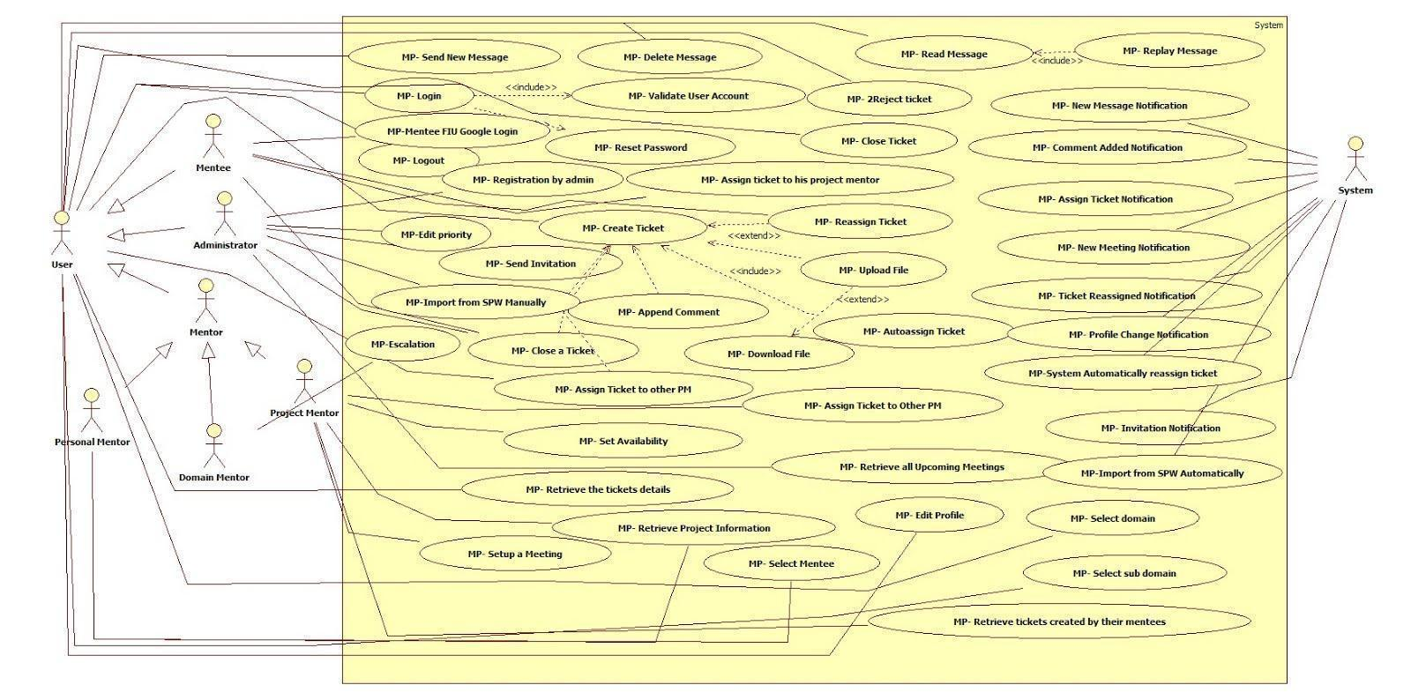

**CP-UDC-02: Remote Judge**

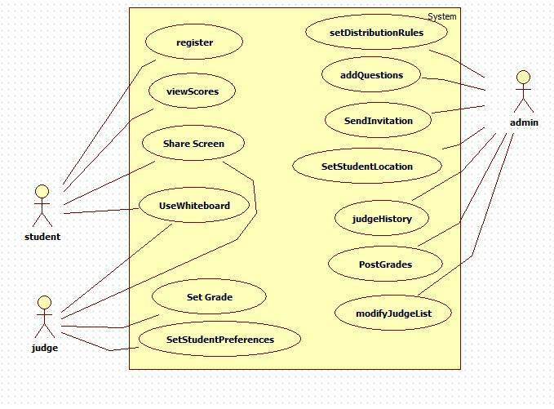

**6.2.2 Use Case Diagrams for Version 3**

**CPv3-UDC-01: Mentor Application**

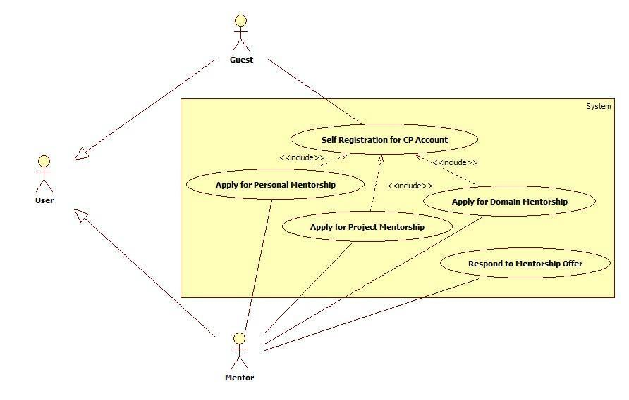

**CPv3-UDC-02: Admin Dashboard**

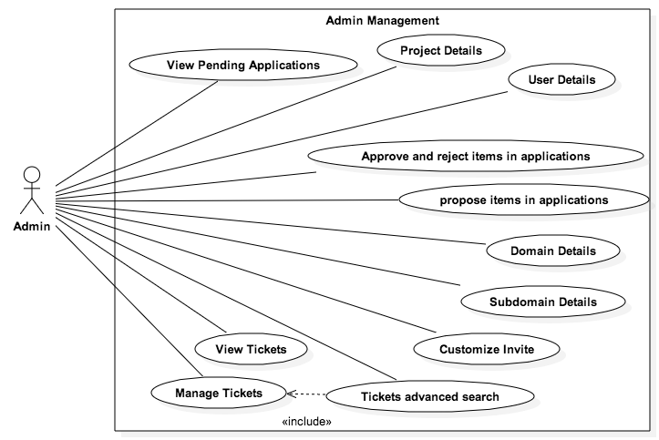

CPv3-UDC-03: Mentor Module Version 3

**6.2.3 Use Case Diagrams for Version 5**

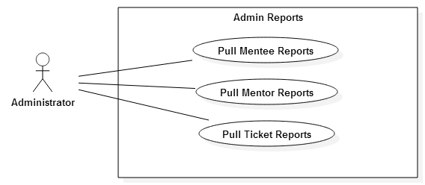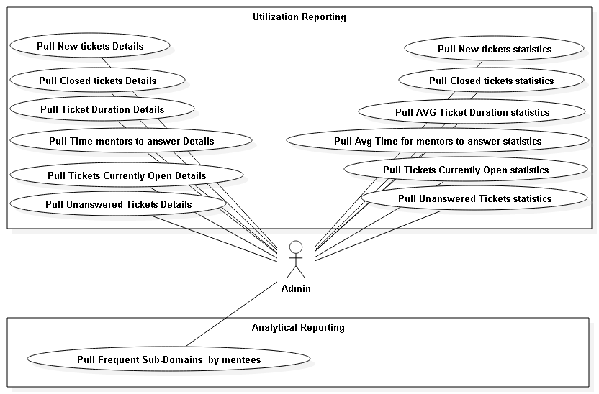

## 6.3 Appendix C – Static UML diagram

**6.3.1 Static UML Diagrams from before Version 3**

**CP-SUML-01: Mentoring**

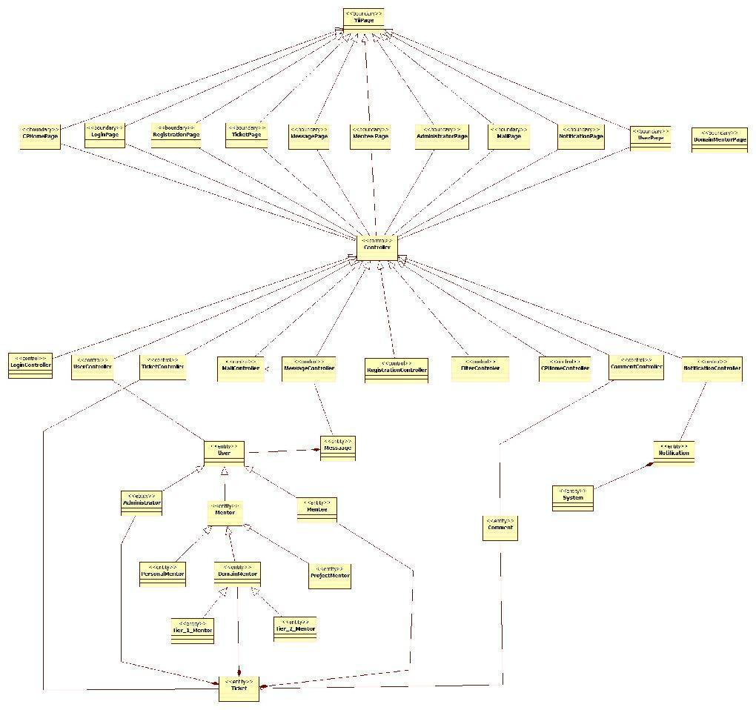

**CP-SUML-02: Remote Judge**

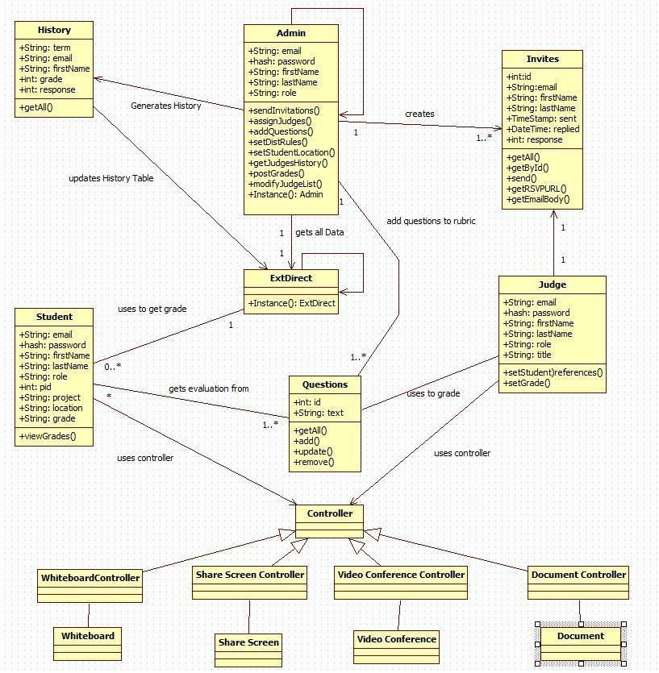

**6.3.2 Static UML Diagrams Version 3**

**CPv3-SUML-01: Mentor Application**

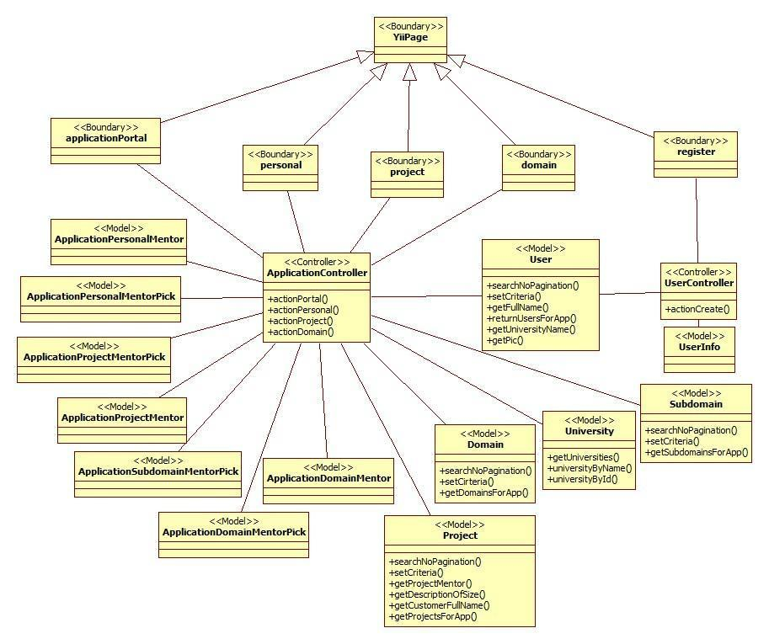

**CPv3-SUML-02: Admin Dashboard**

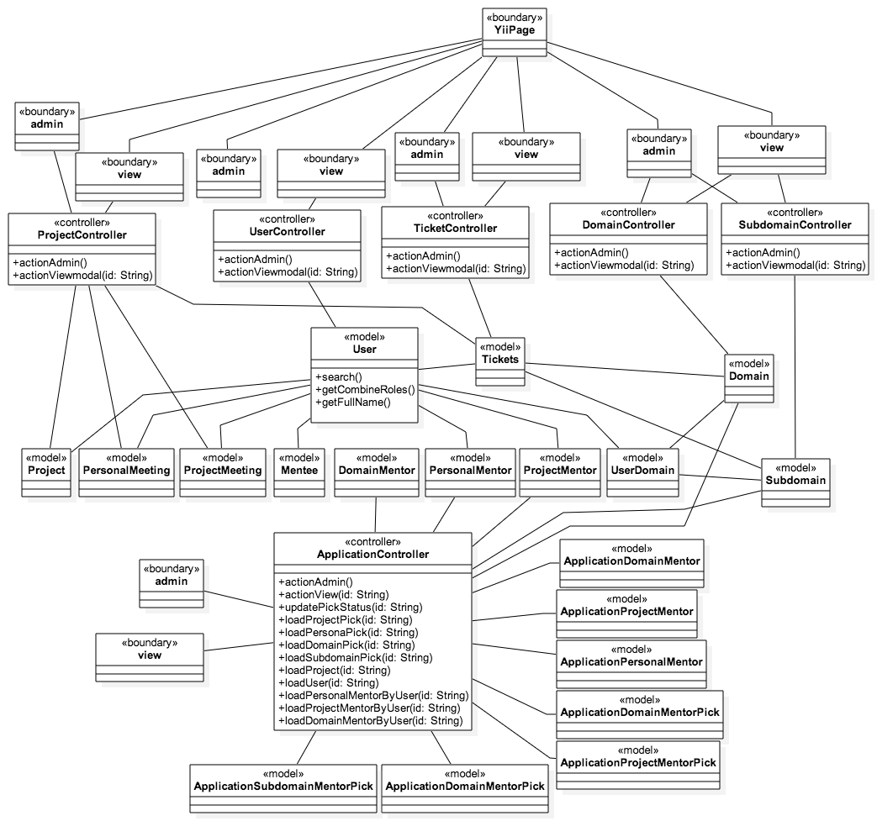

**6.3.3 Static UML Diagrams Version 5**

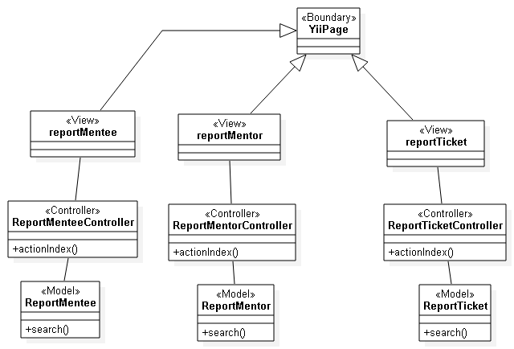

**CPv5-SUML-01: Admin Reports**

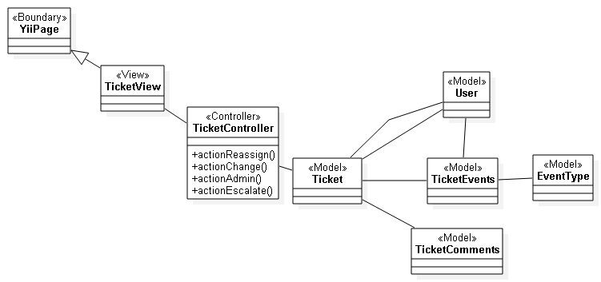

**CPv5-SUML-02: Ticket Events Class Diagram**

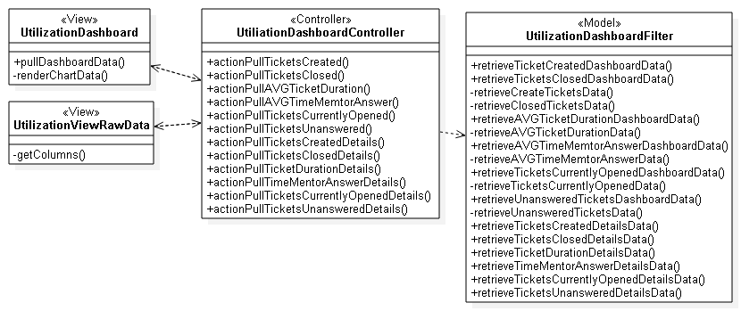

**CPv5-SUML-03: Utilization Dashboard Class Diagram**

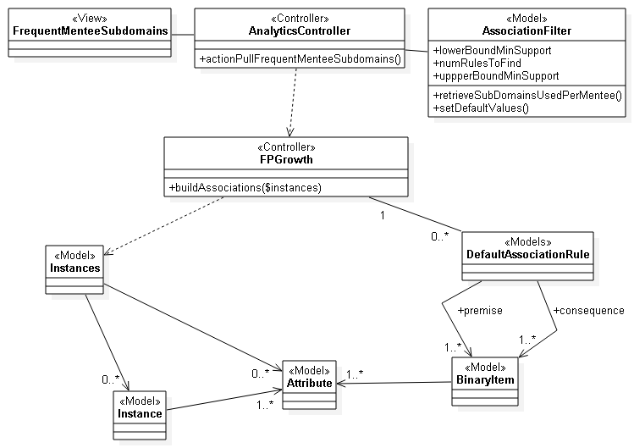

**CPv5-SUML-04: Frequent Mentee Sub-Domain Class Diagram**

## 6.4 Appendix D – Dynamic UML diagram

**6.4.1 Collaborative Platform version 1 & 2**

**CP001 - Setup a meeting from SPW**

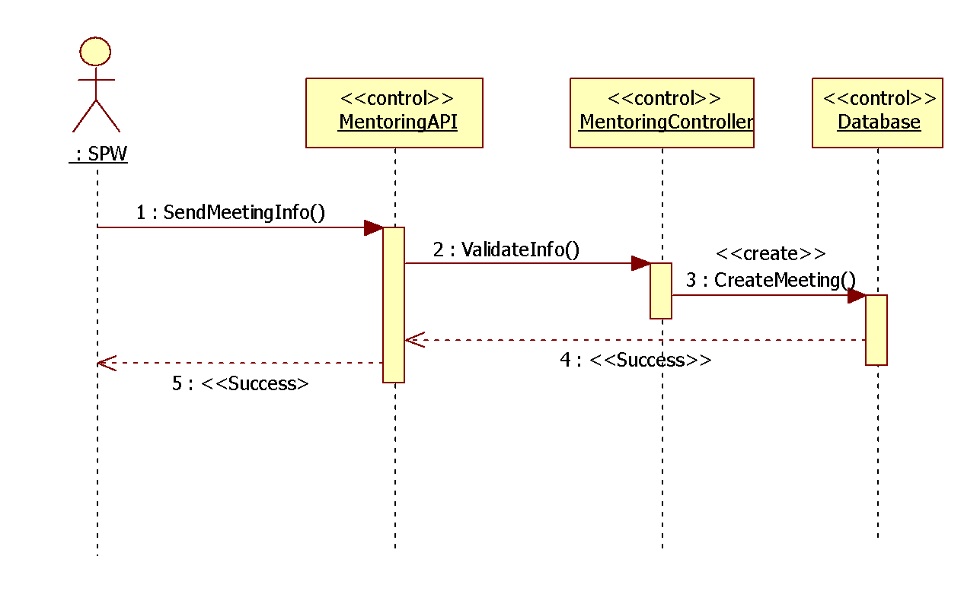

**CP005 – Register**

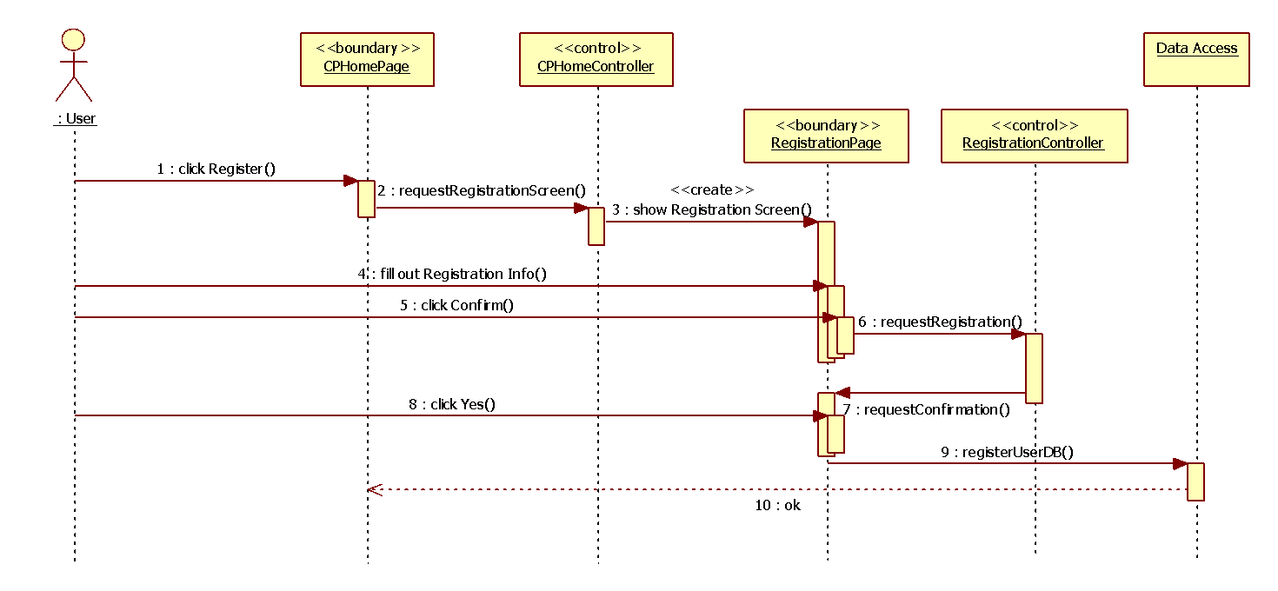

**CP-006 User Login**

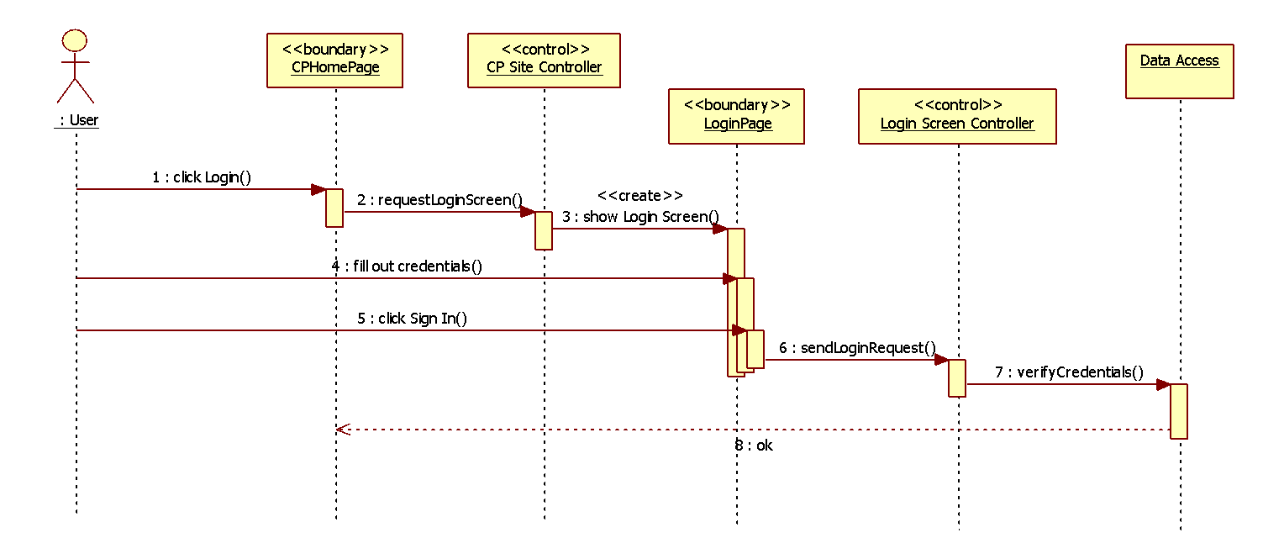

**CP-007 User Logout**

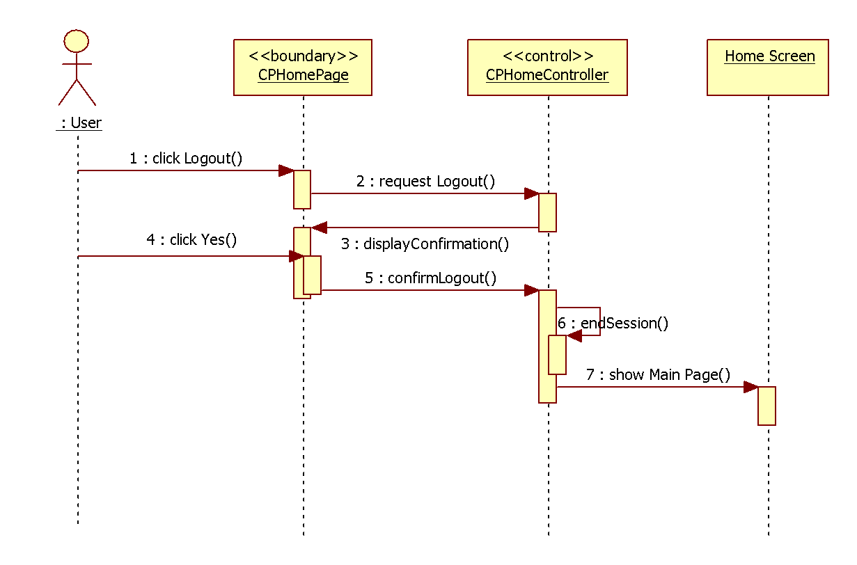

**CP-008 Reset Password**

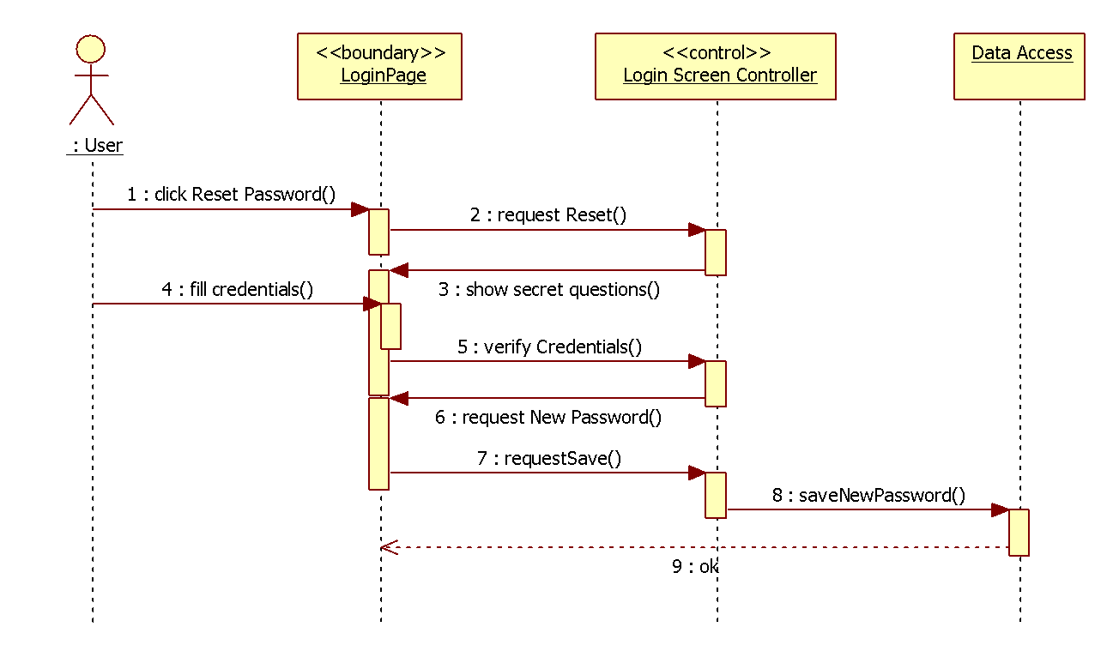

**CP-009 Add Domain**

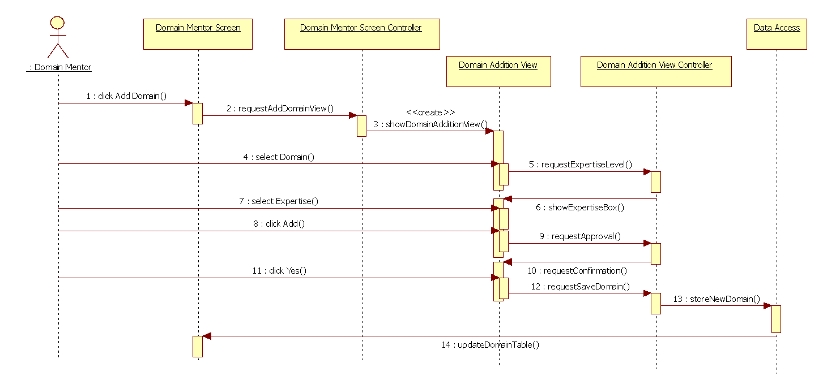

**CP-010 Retrieve project information from the SPW**

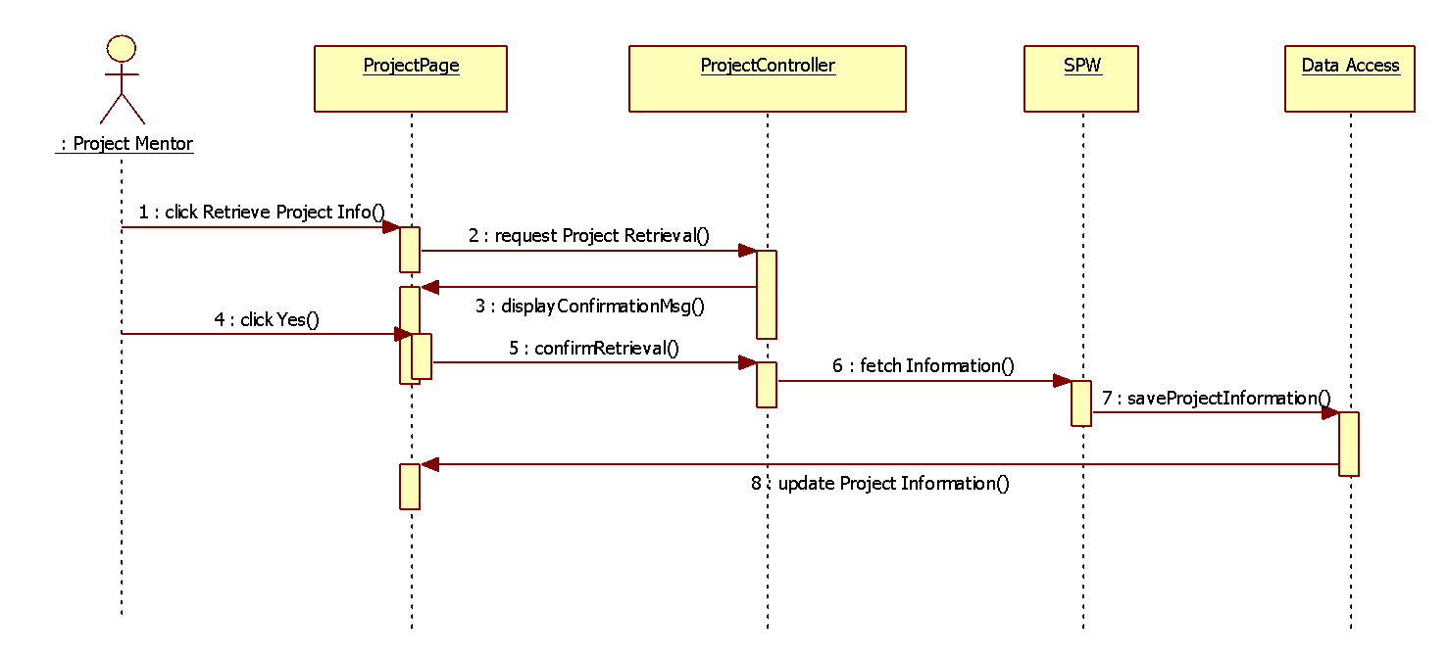

**CP-011 Create a question for a specific ticket.**

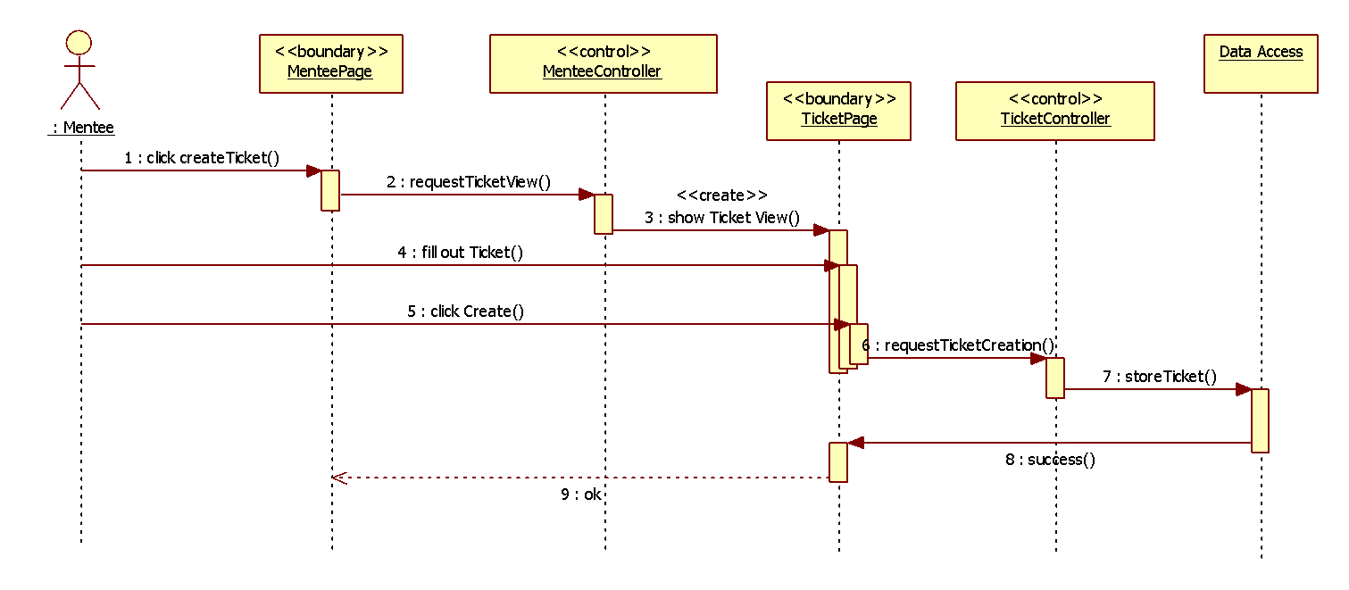

**CP-012 Retrieve skill-set/domain expertise from their Linkedln account**

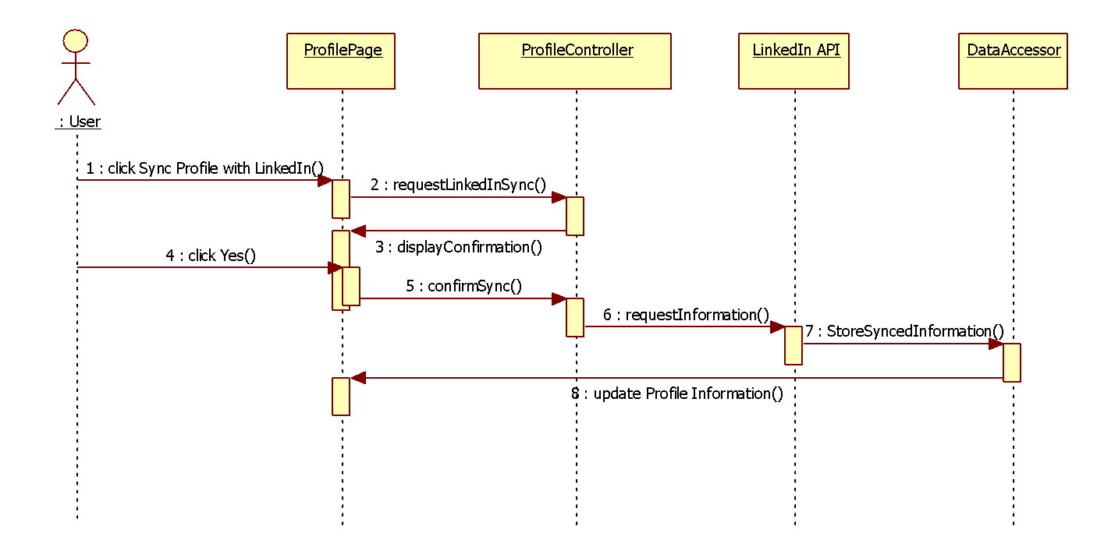

**CP-013 Matching tickets**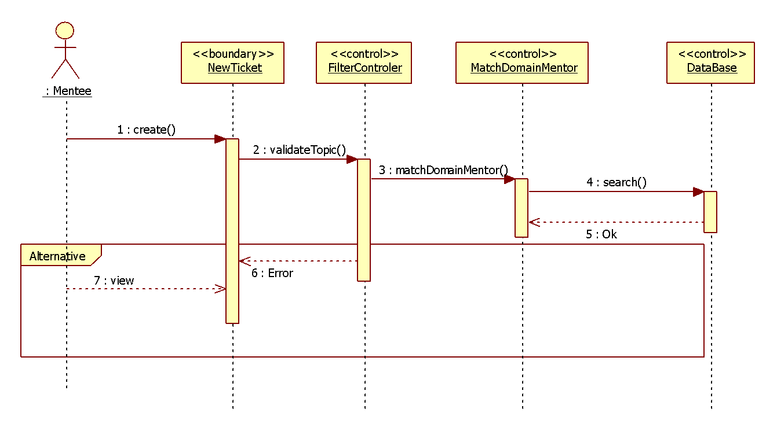

**CP-014 Assign ticket**

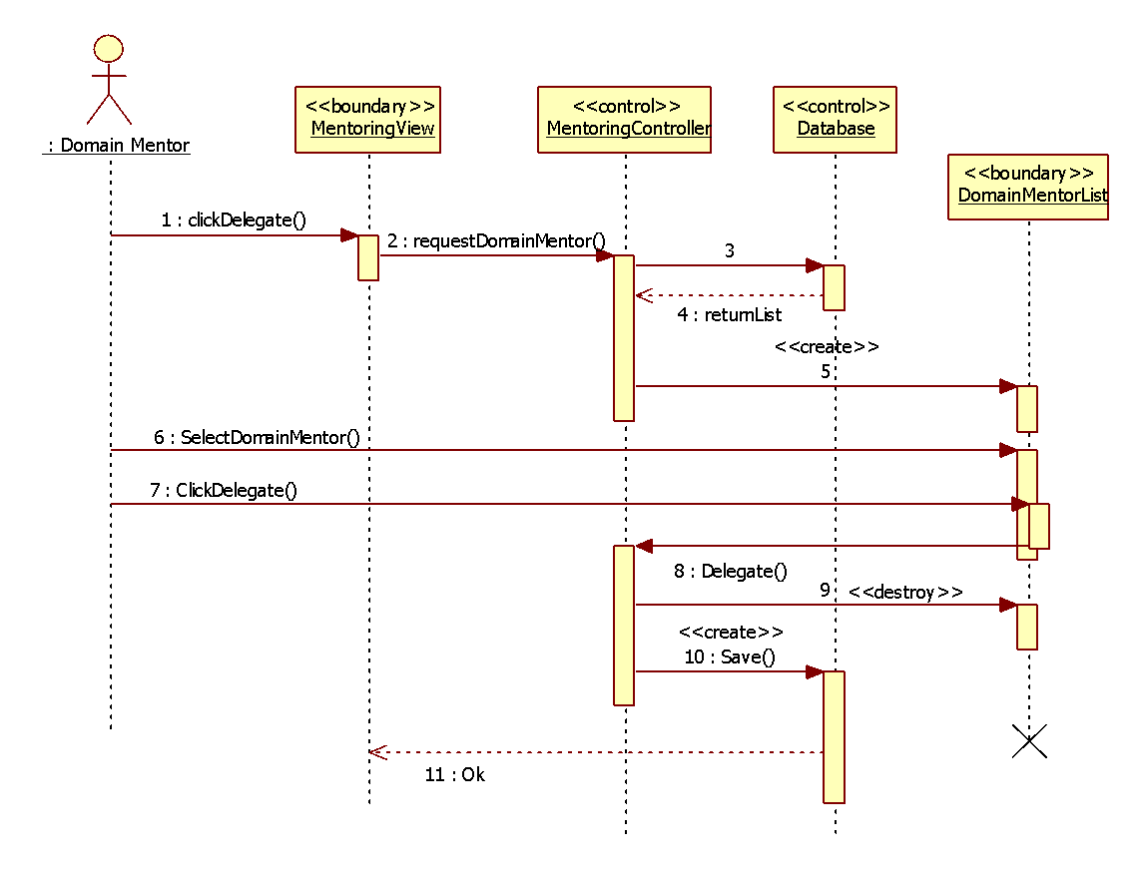

**CP-015 Append comment to a ticket**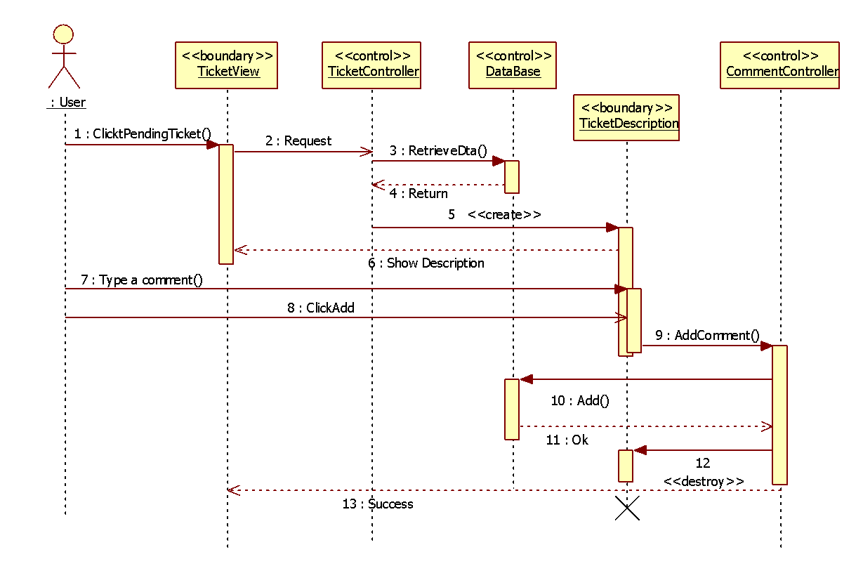

**CP-016 Attach file to a ticket**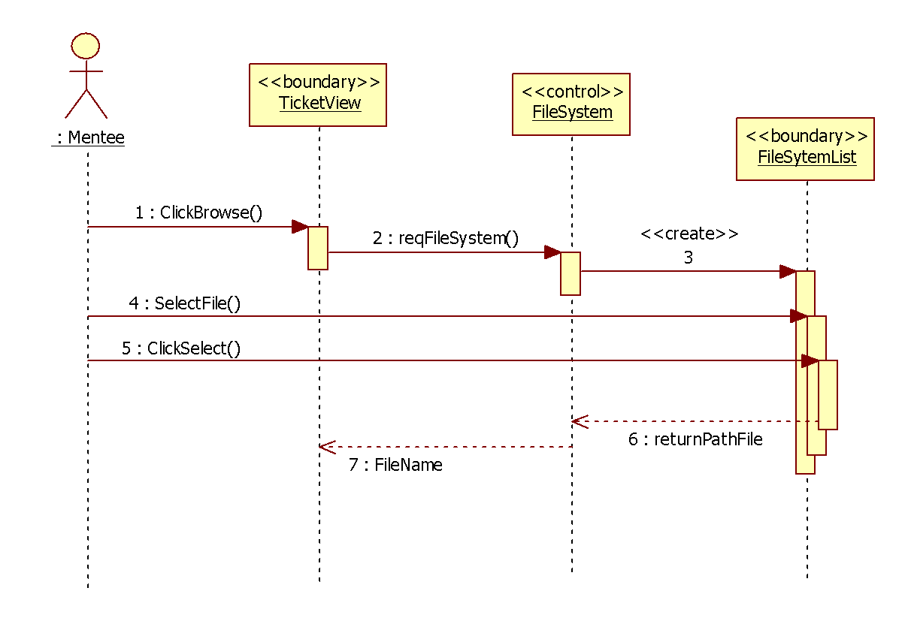

**CP-017 Send new message**

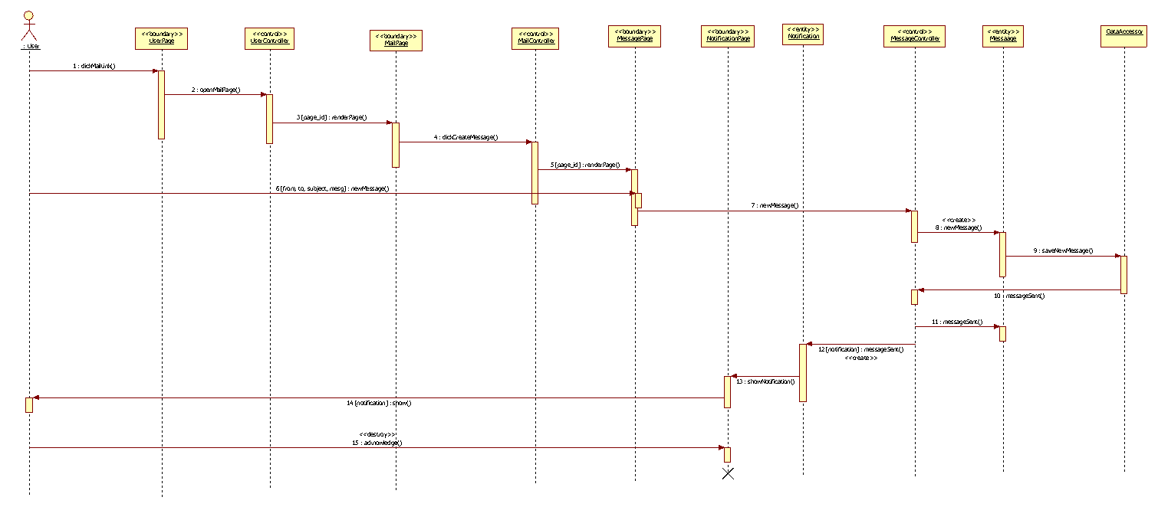

**CP-018 Read message**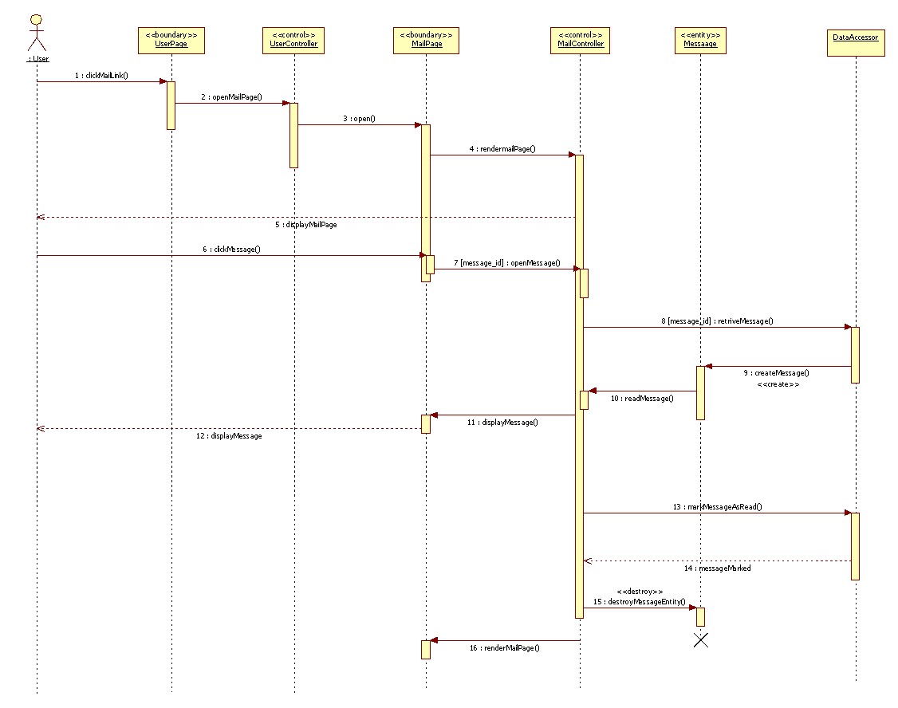

**CP-019 Delete Message**

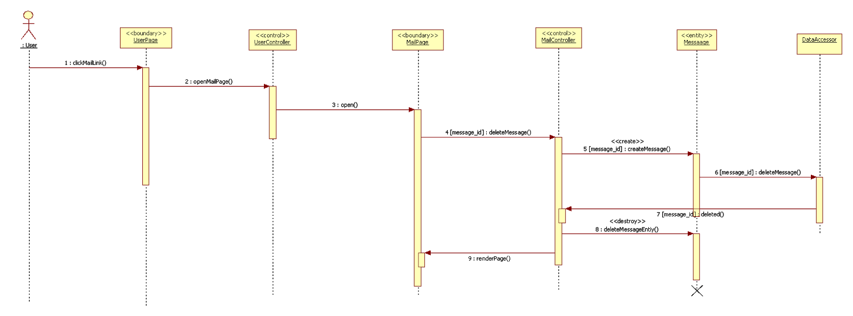

**CP-020 New Message Notification**

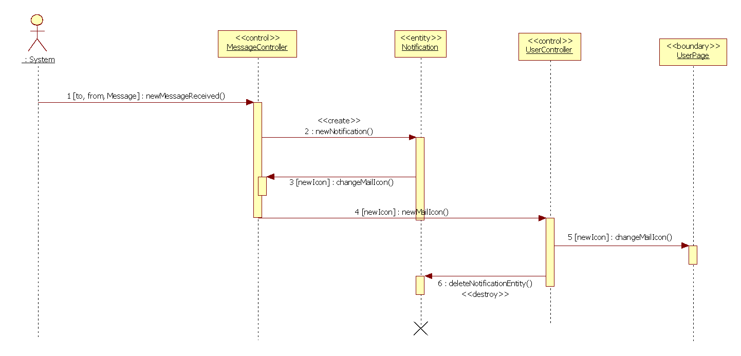

**CP-021 Drop a ticket**

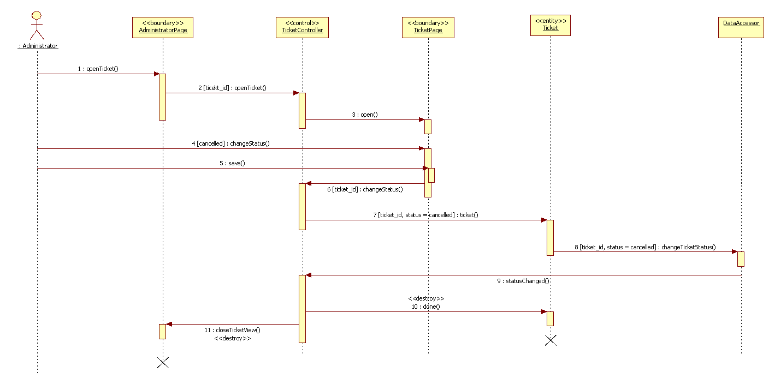

**CP-022 Ticket Due Notification**

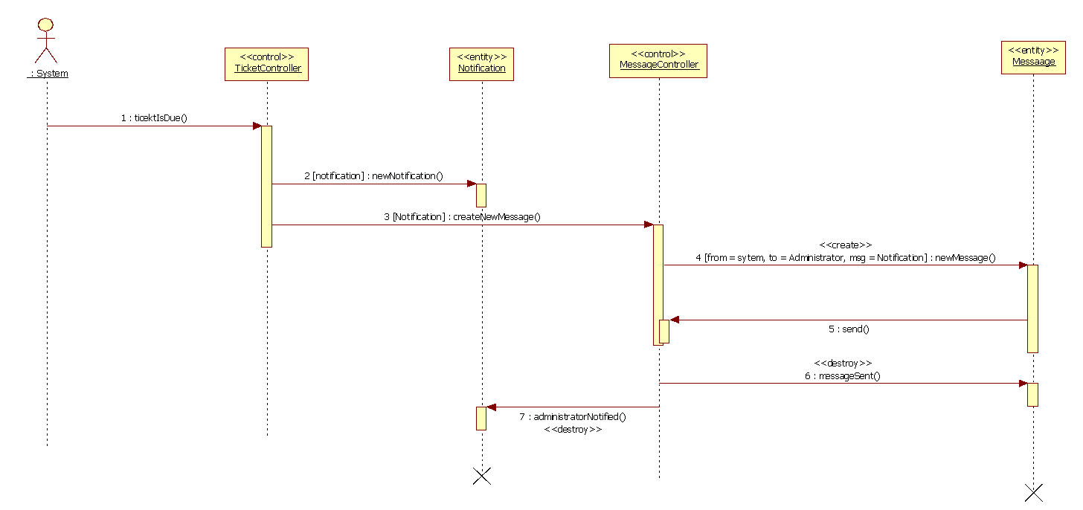

**CP-023 Close a ticket**

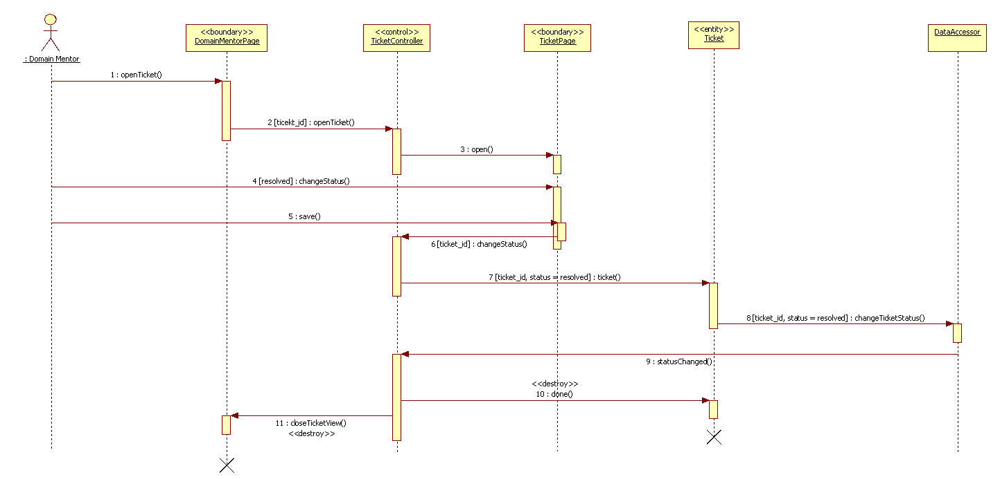

**CP-024 Comment Added Notification**

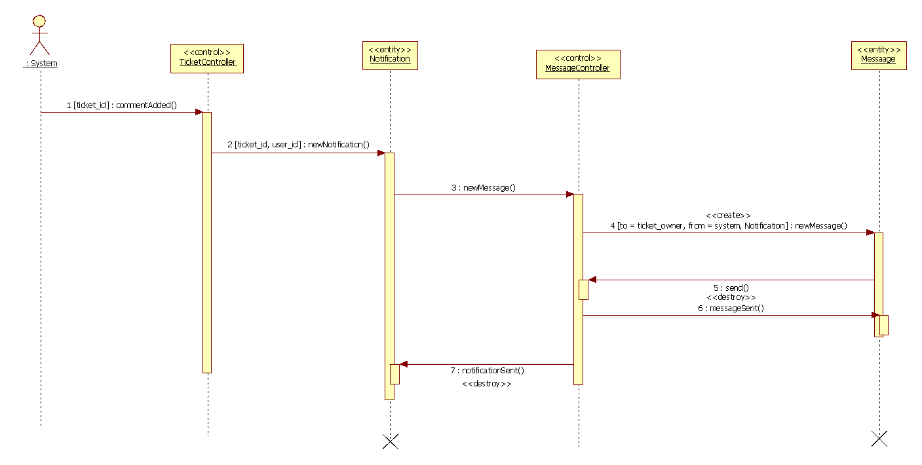

**CP-025 Accept Answer**

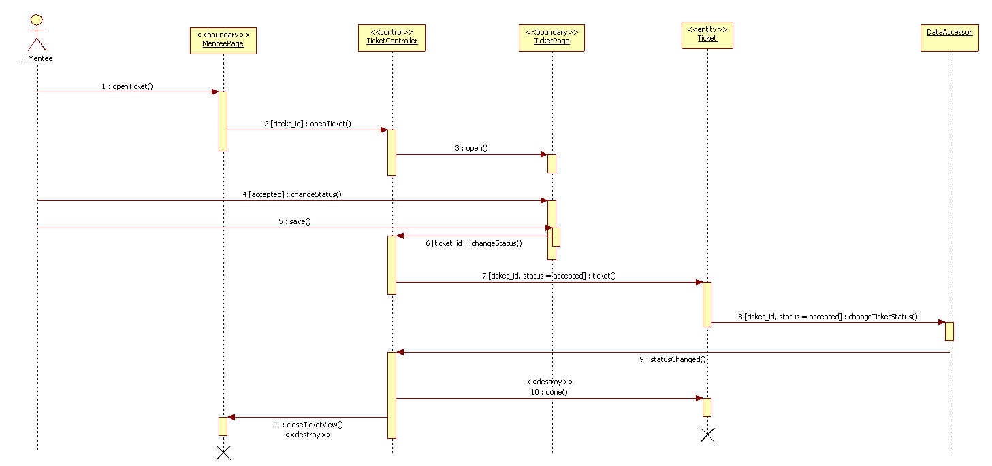

**CP-026 Decline Answer**

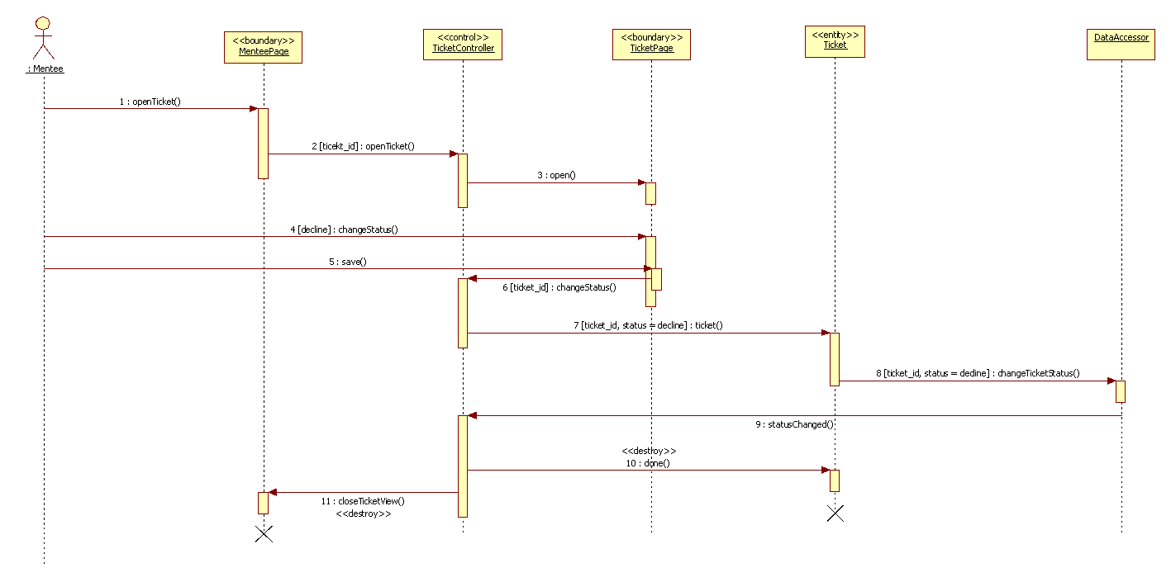

**CP-027 Get Rubric**

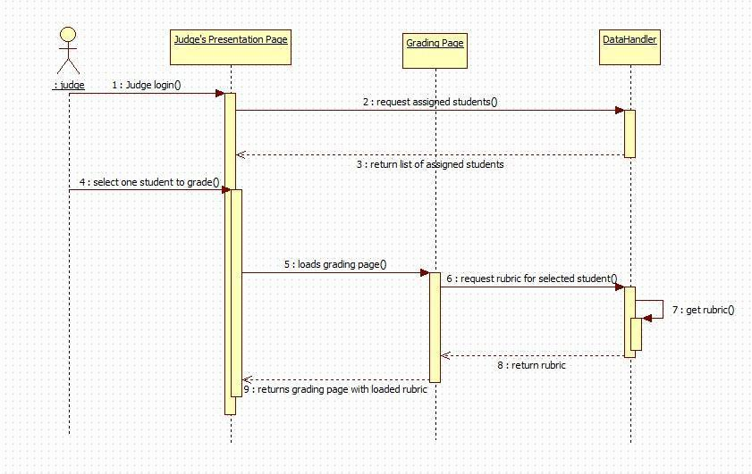

**CP-028 Post Grades**

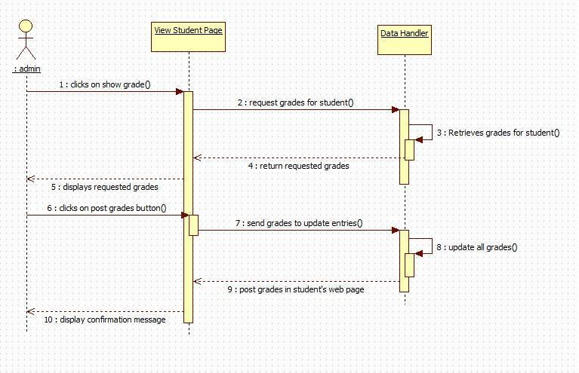

**CP-029 Send Invitation**

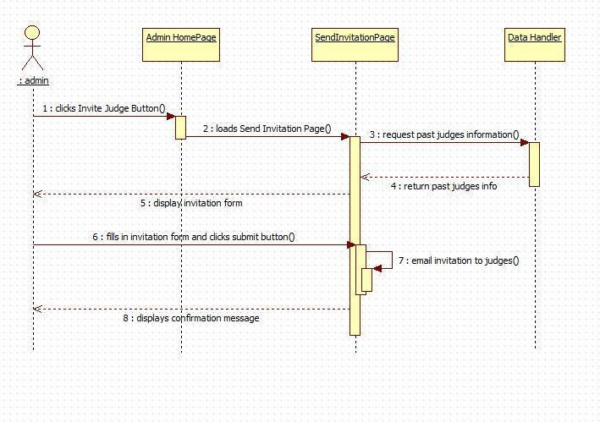

**CP-030 Set student preferences**

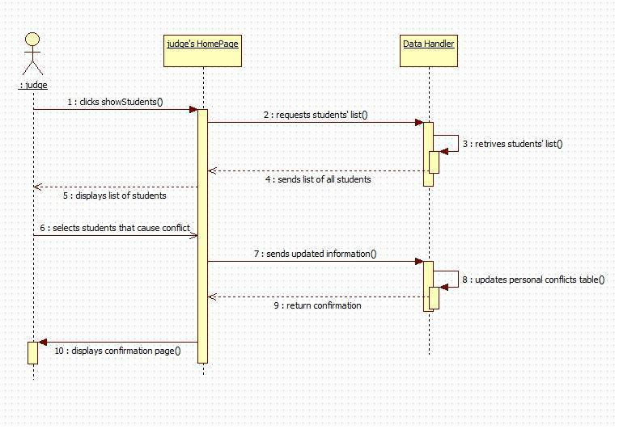

**CP-031 Show Power Point**

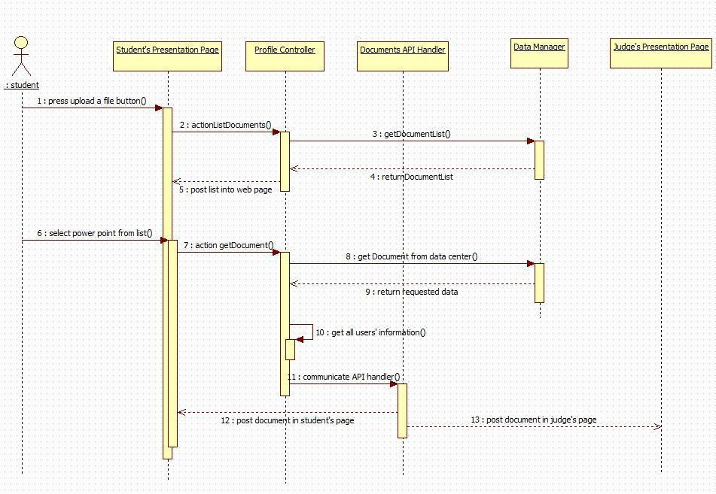

**CP-032 Use video conference**

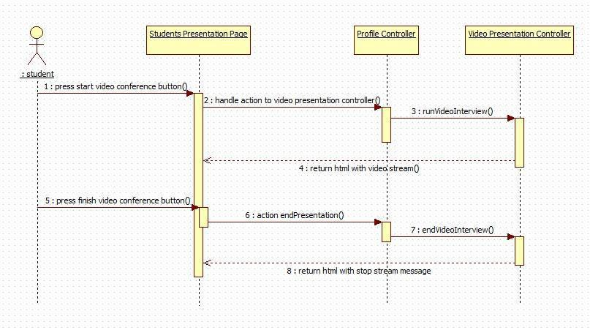

**CP-033 Use Whiteboard**

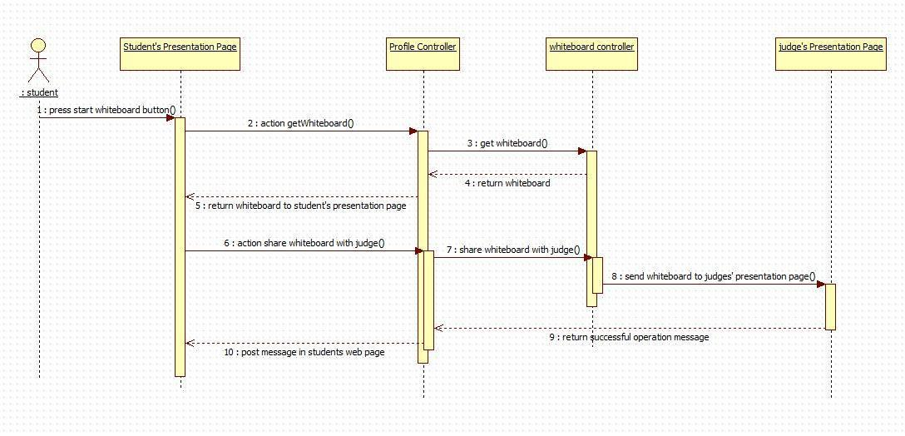

**CP-034 Escalate Ticket**

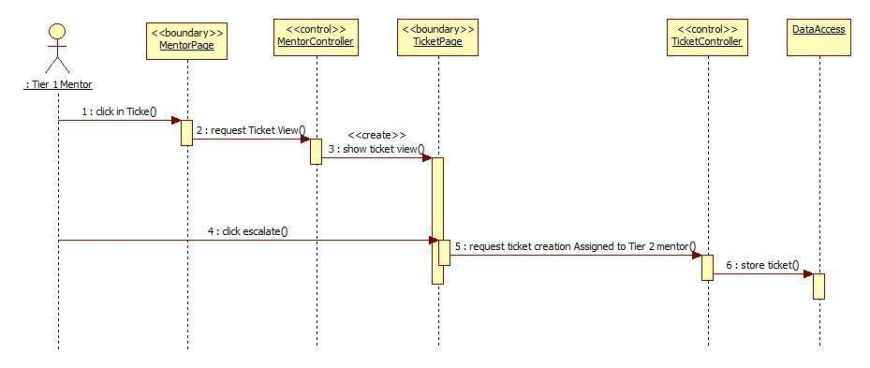

**CP-035 Automatically reassign ticket**

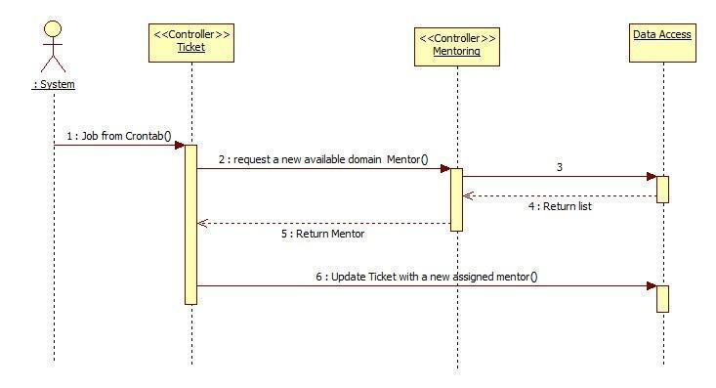

**CP-037 Edit Priority**

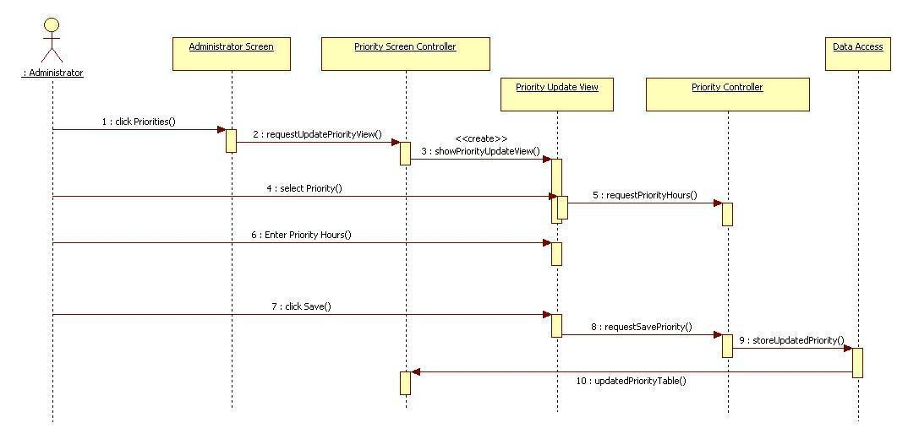

**CP-038 MP-Import data from SPW automatically**

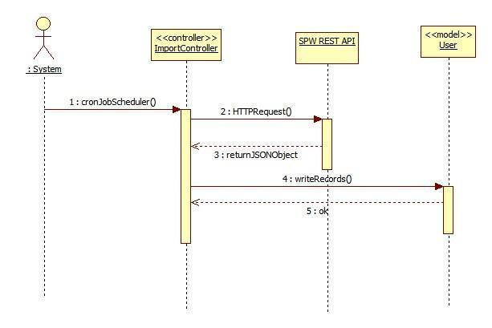

**CP-039 Import data from SPW Manually**

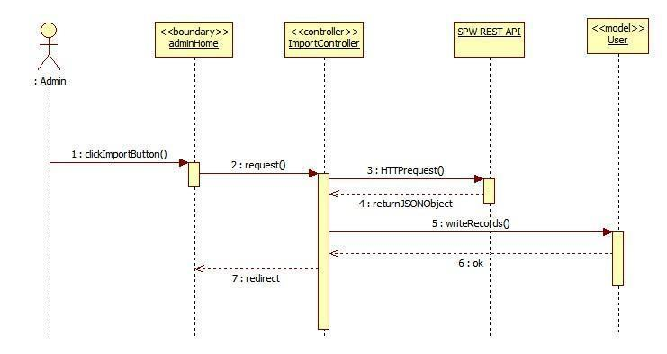

**CP-040 Allow the admin to register mentors**

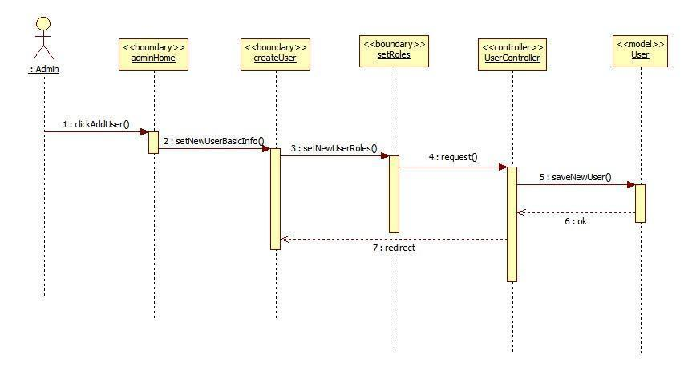

**6.4.2 Sequence Diagrams for Collaborative Platform Version 3**

**CPv3-001 Self Registration for Collaborative Platform**

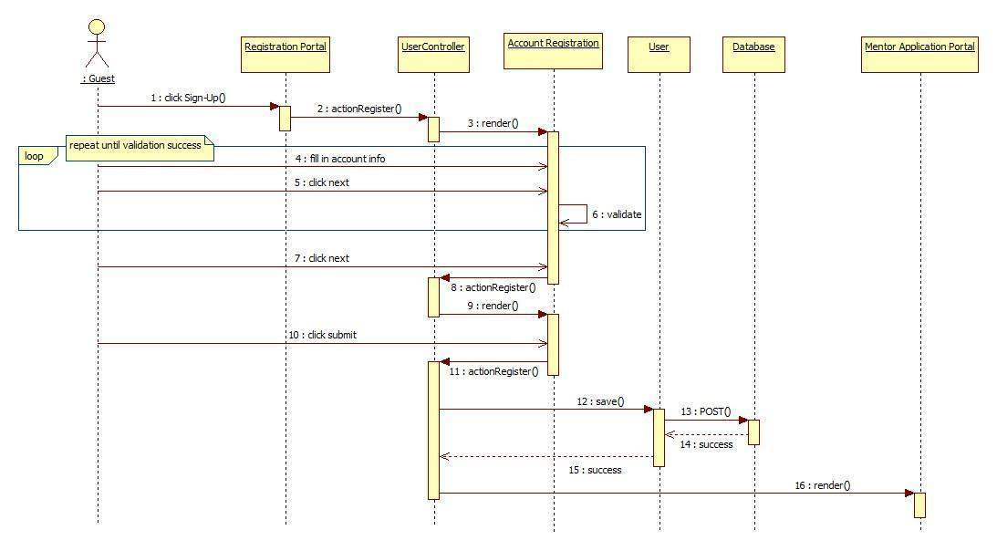

**CPv3-002 Apply for Personal Mentorship**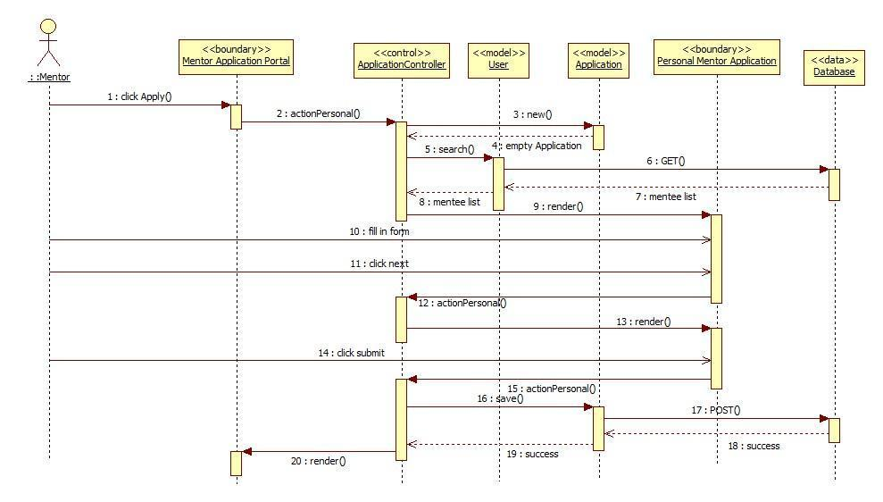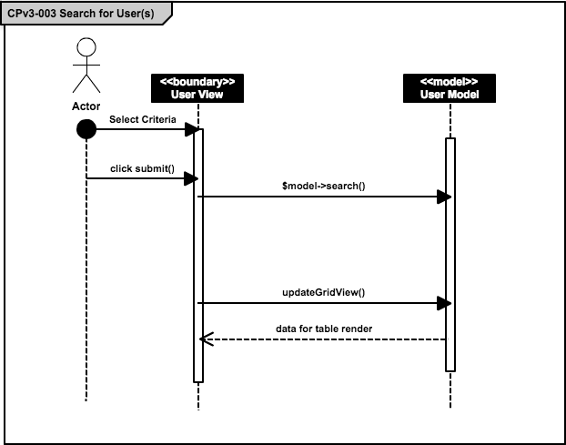

CPv3-004 Apply for Project Mentorship

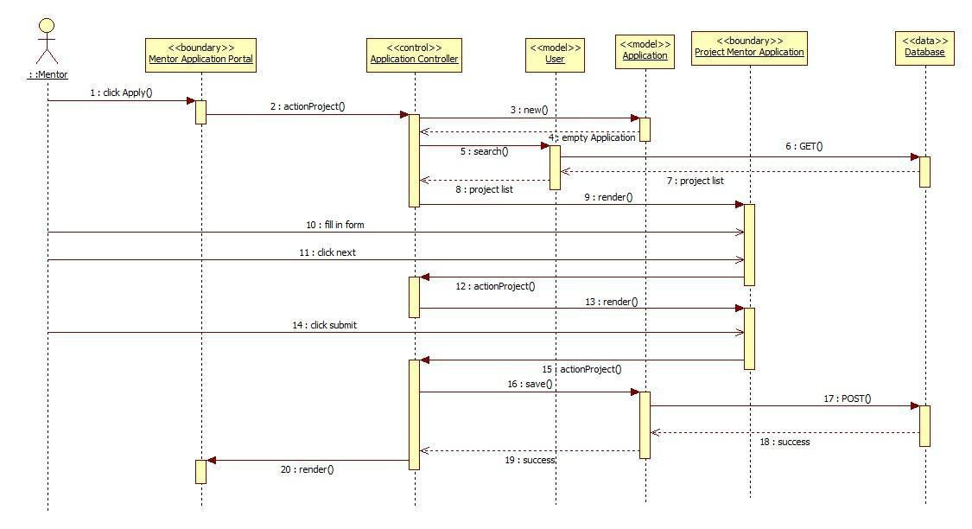

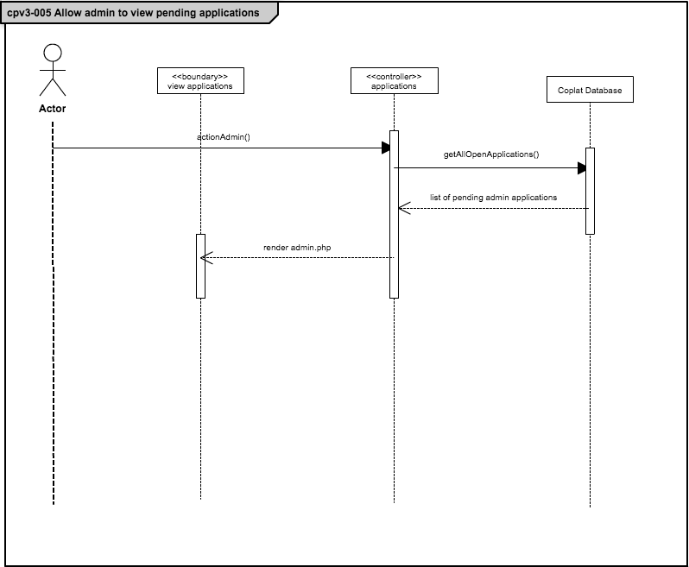

CPv3-006 Apply for Domain Mentorship

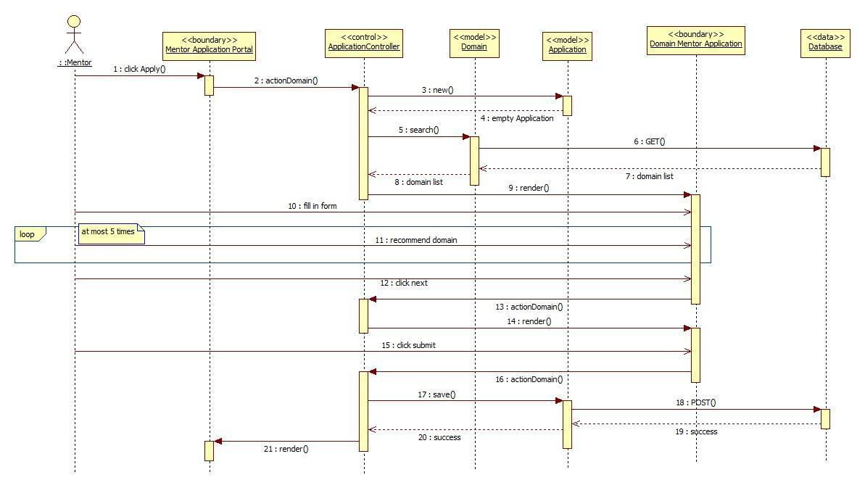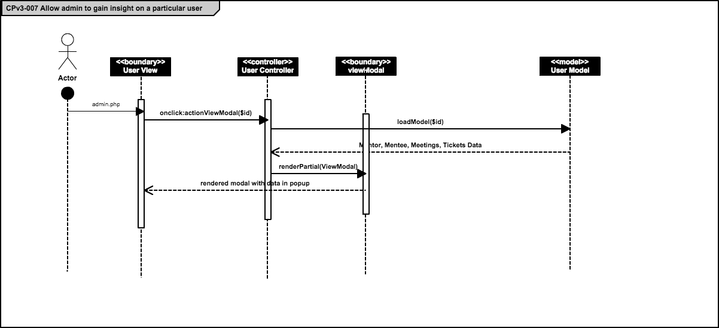

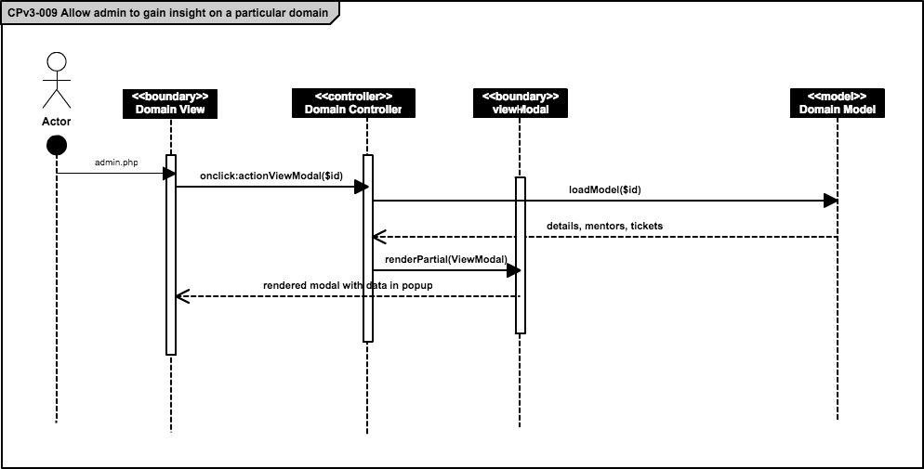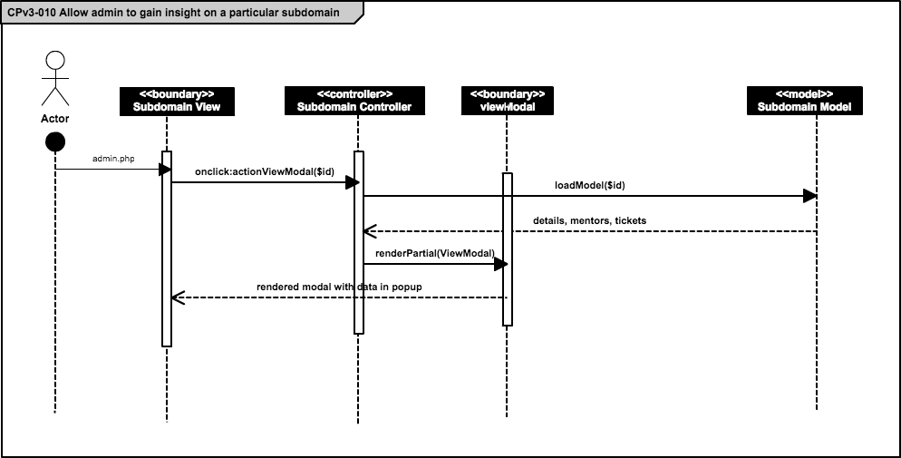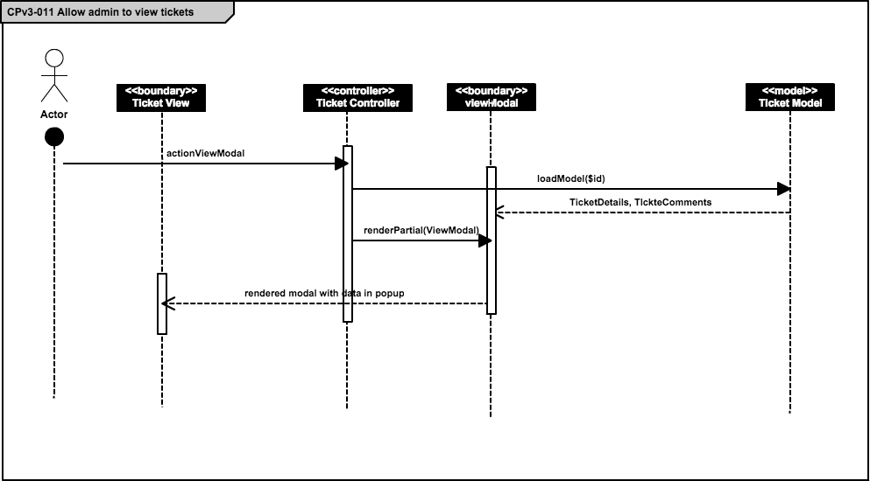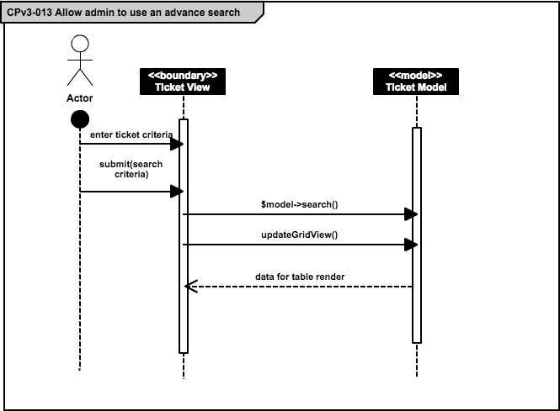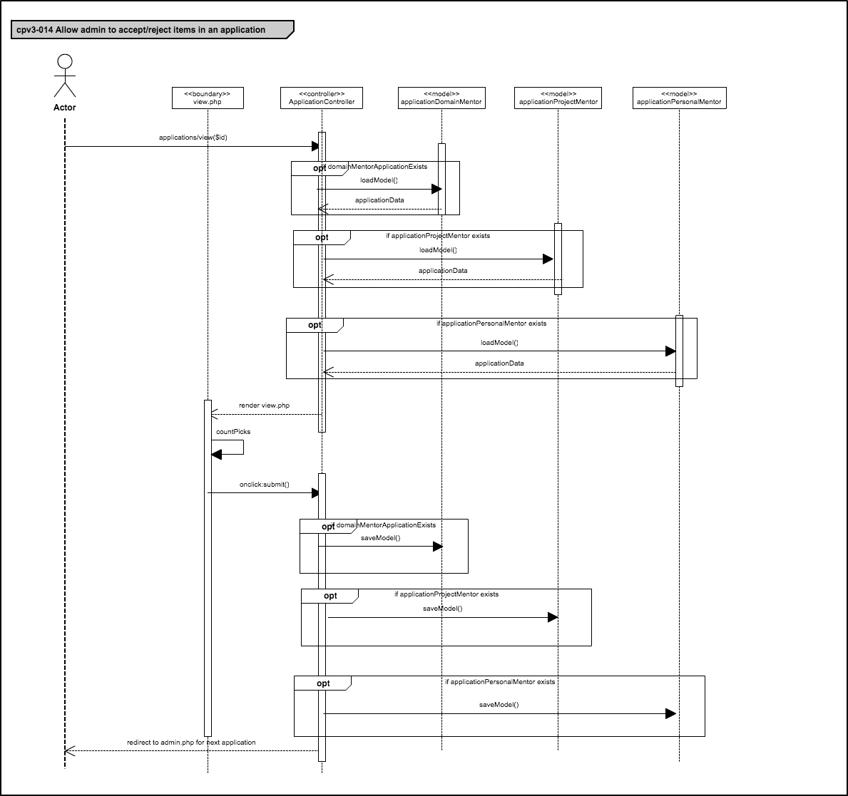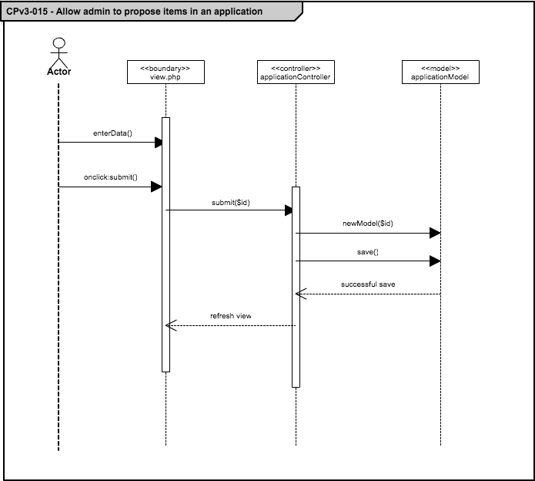

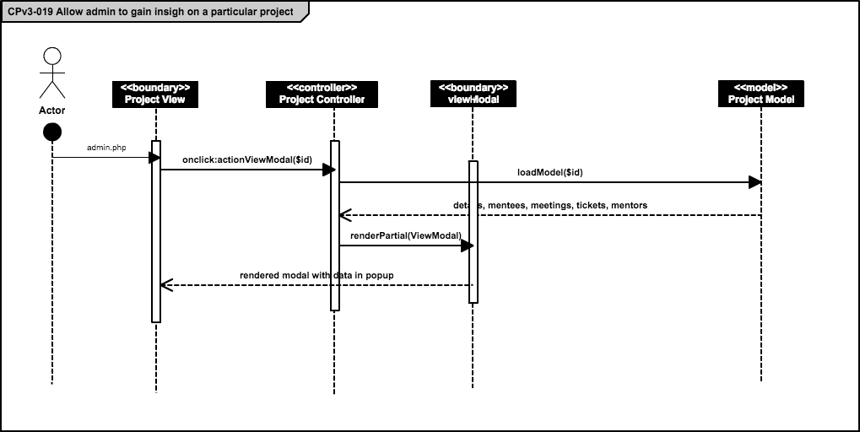

**6.4.3 Sequence Diagrams for Collaborative Platform Version 5**

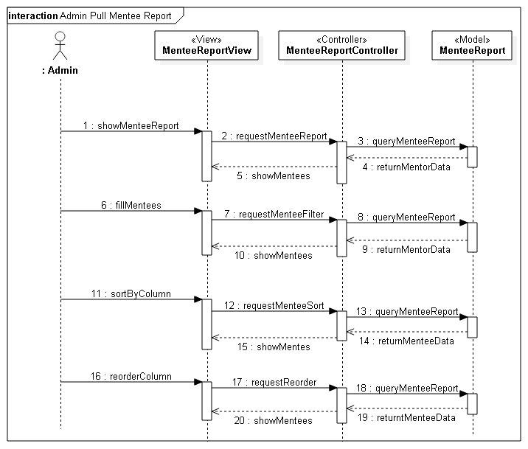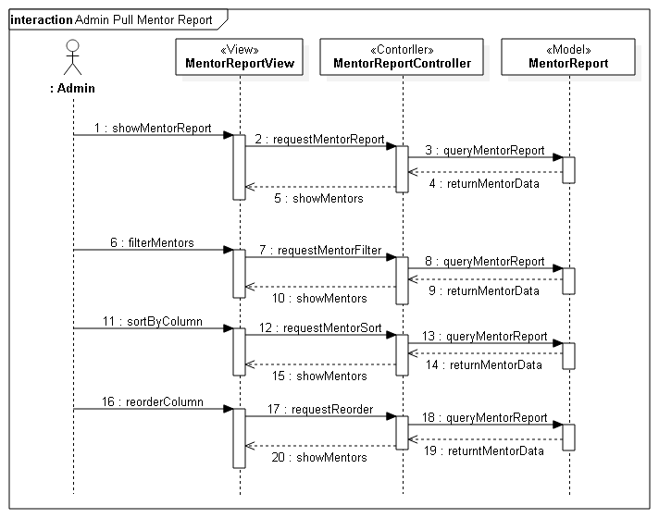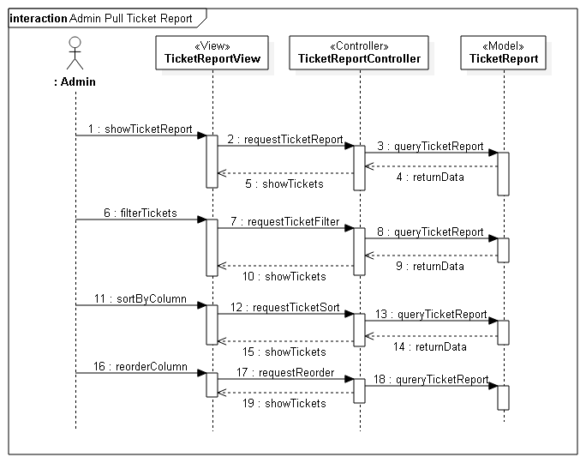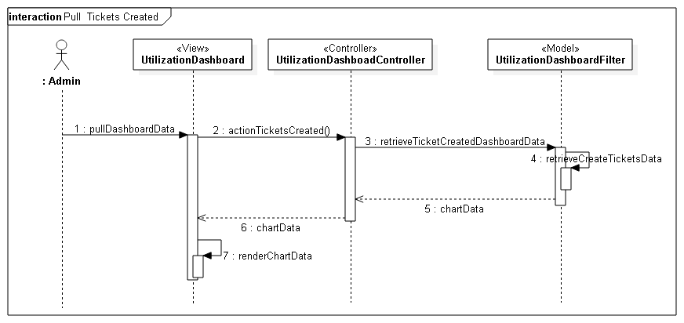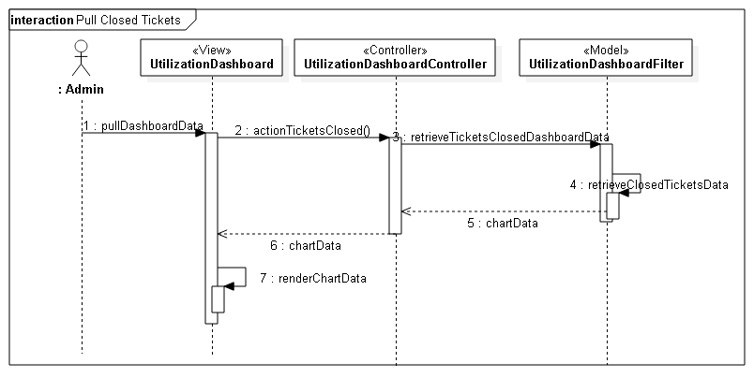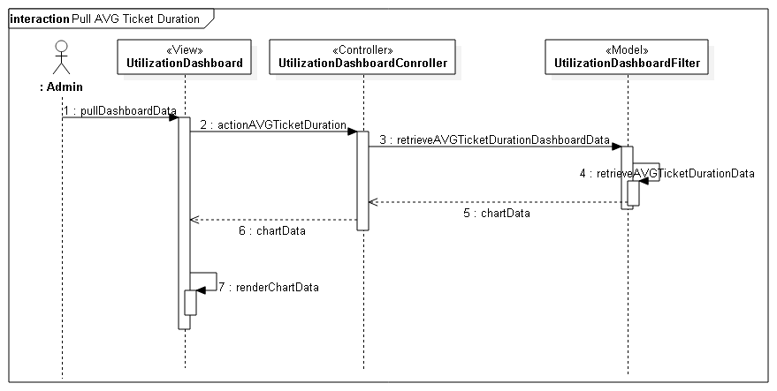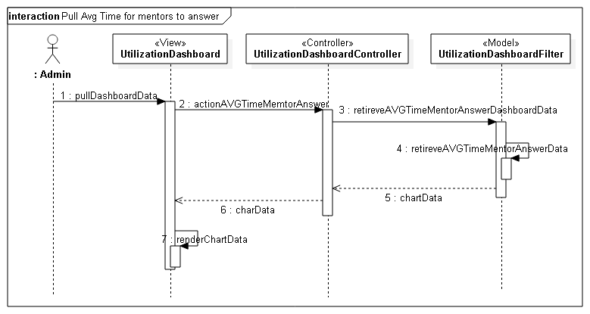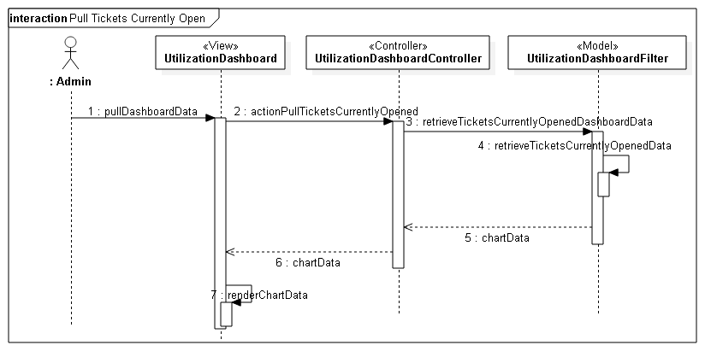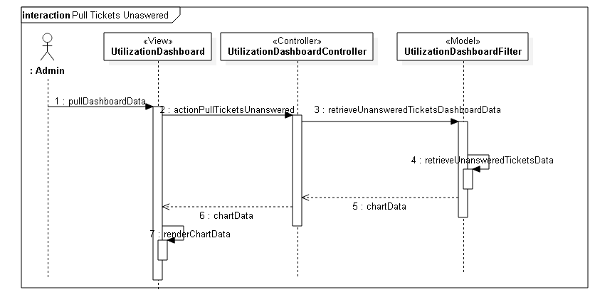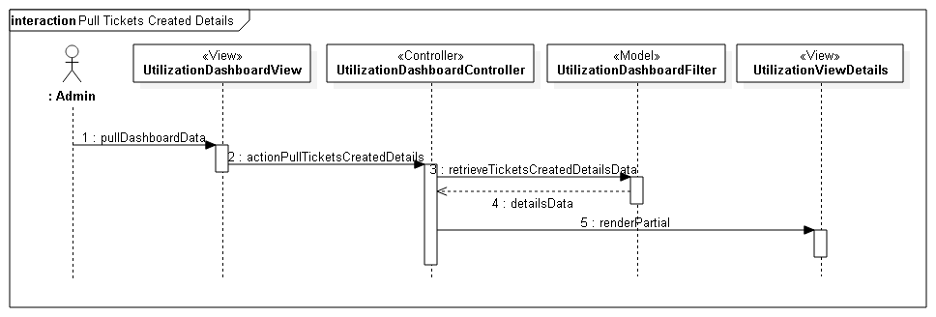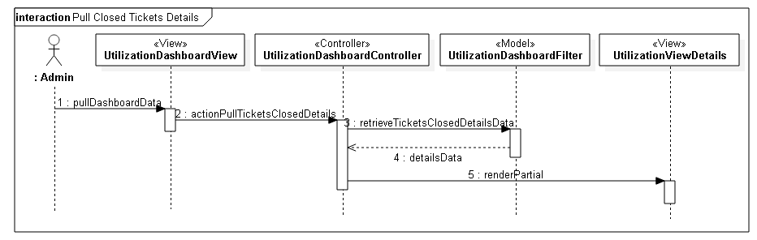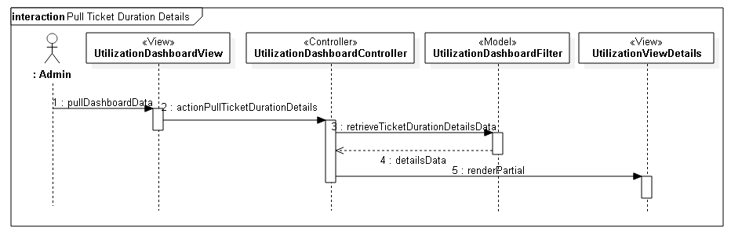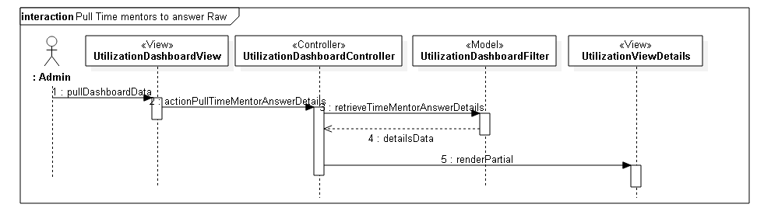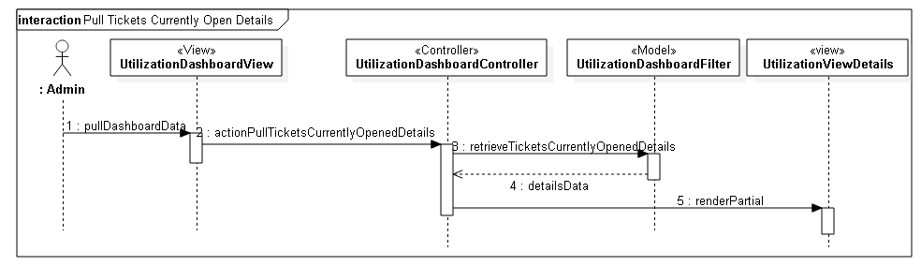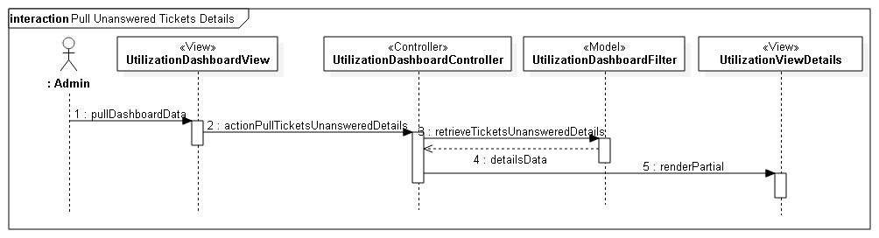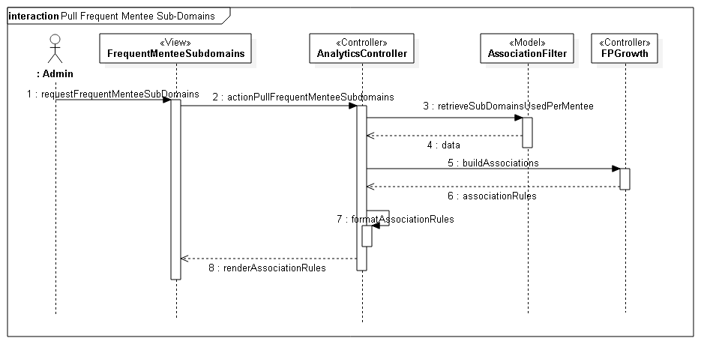

## 6.5 Appendix E – User Interface Design

**6.5.1 UI Design for Collaborative Platform version 1**

Registration – Username, password and Roles

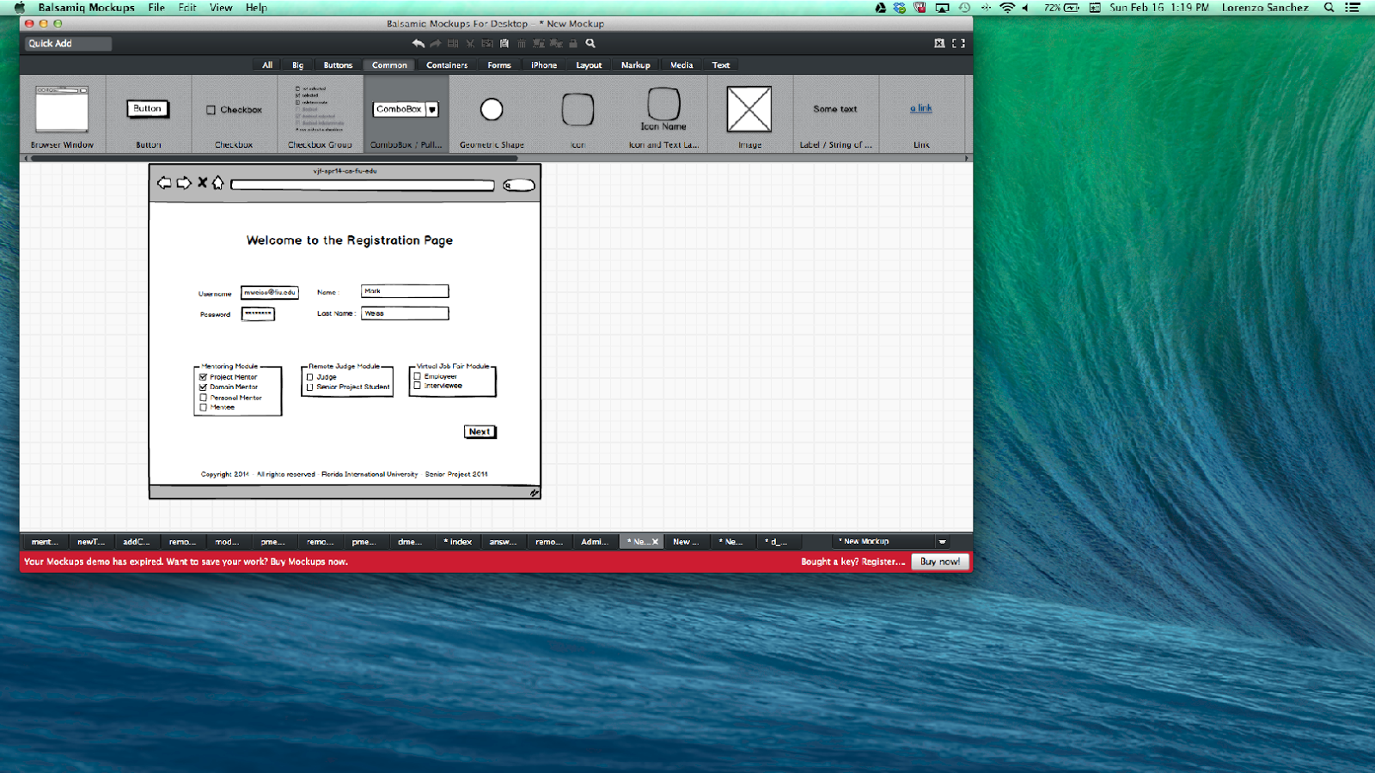

Registration Project Mentor – LinkedIn or Edit

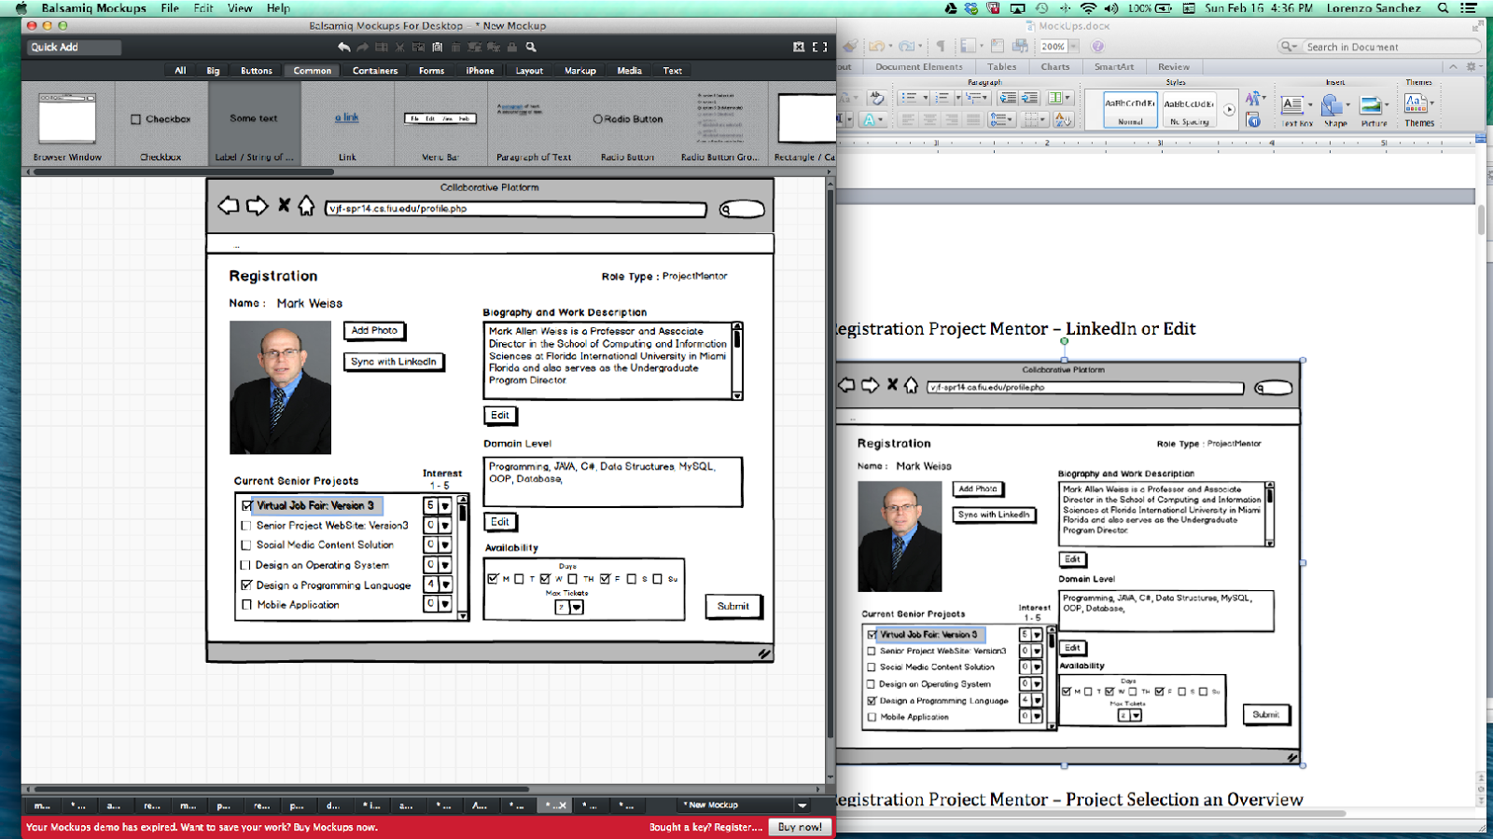

Registration Project Mentor – Project Selection an Overview

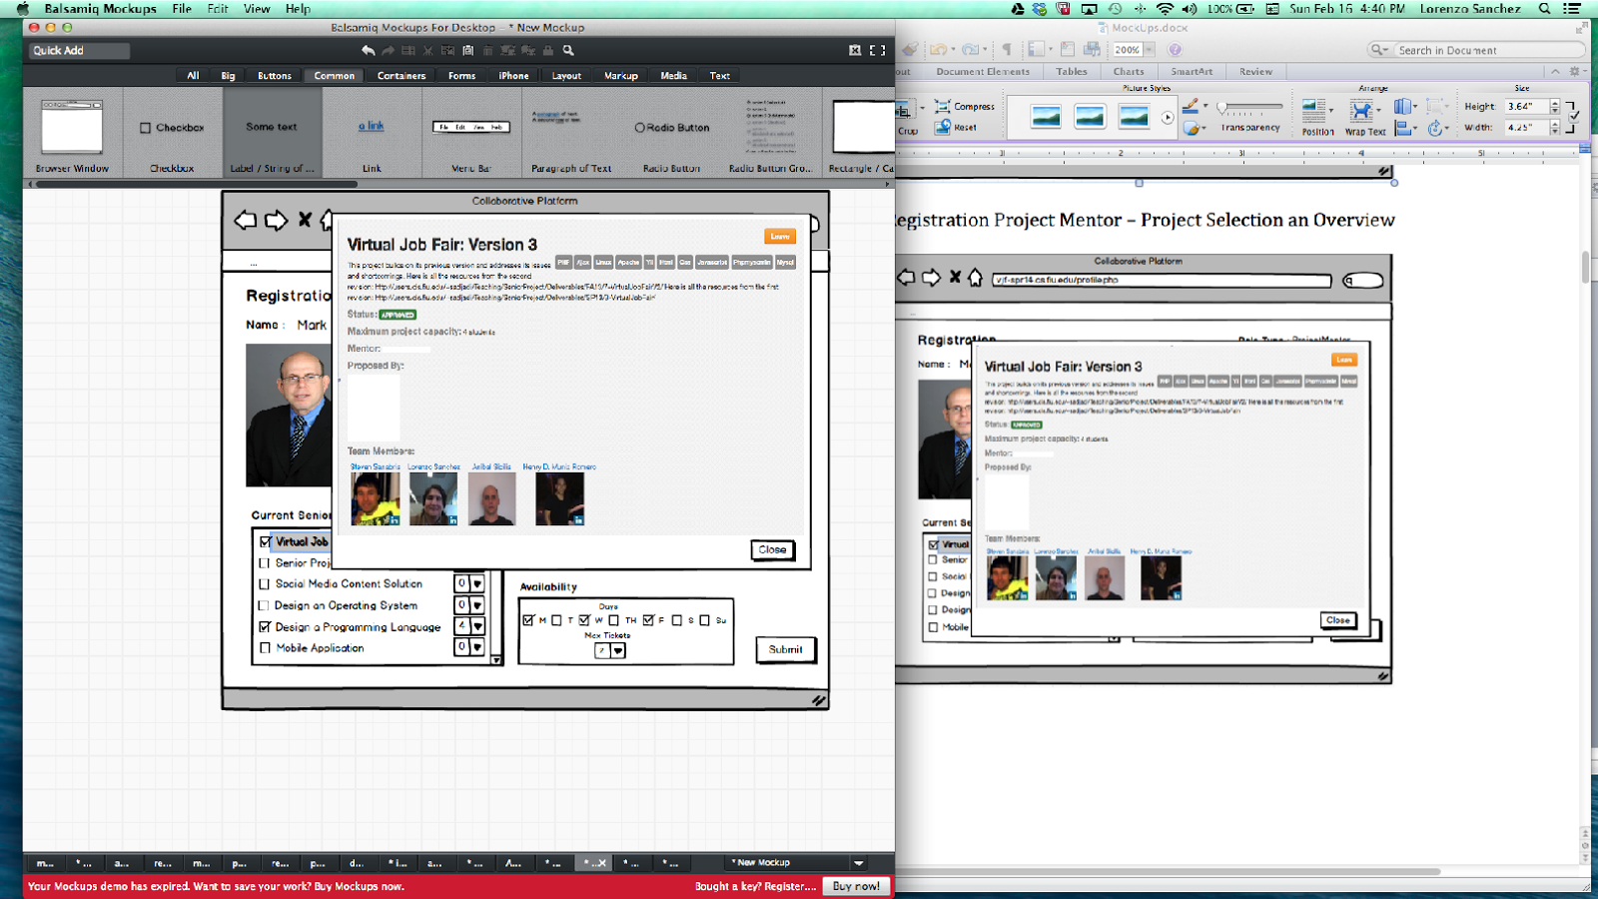

Registration - Domain Mentor – LinkedIn or Edit

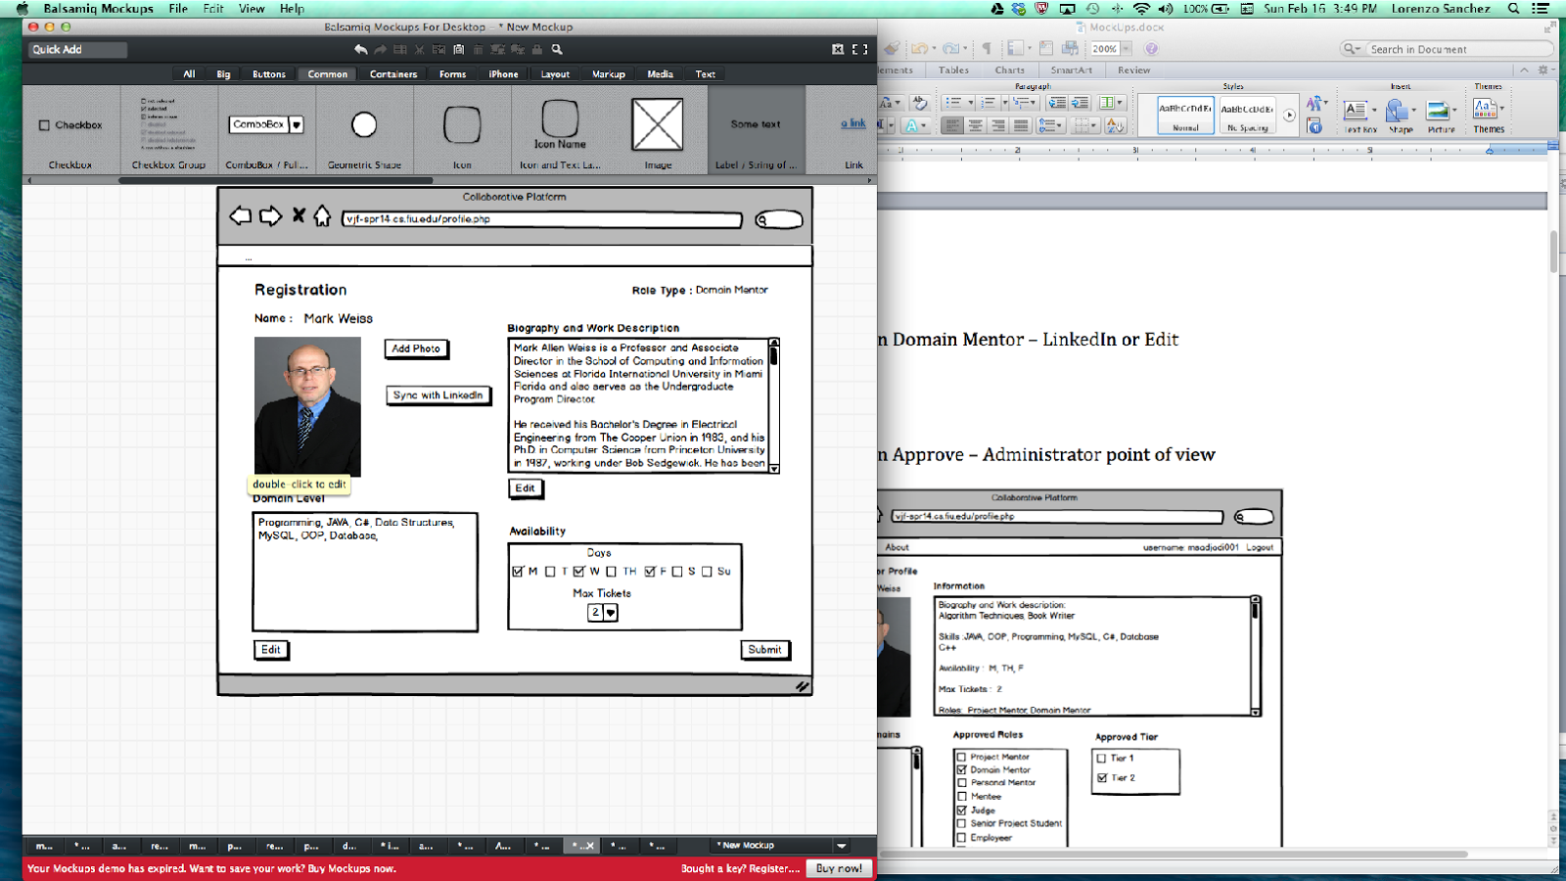

Registration - Personal Mentor – Linkedln or Edit

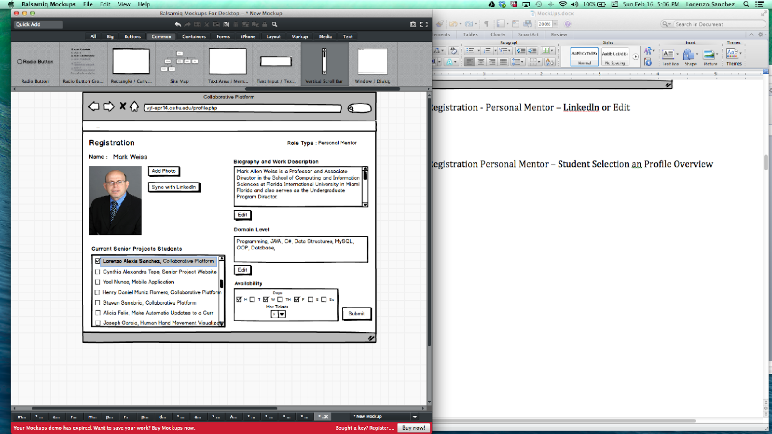

Registration Personal Mentor – Student Selection an Profile Overview

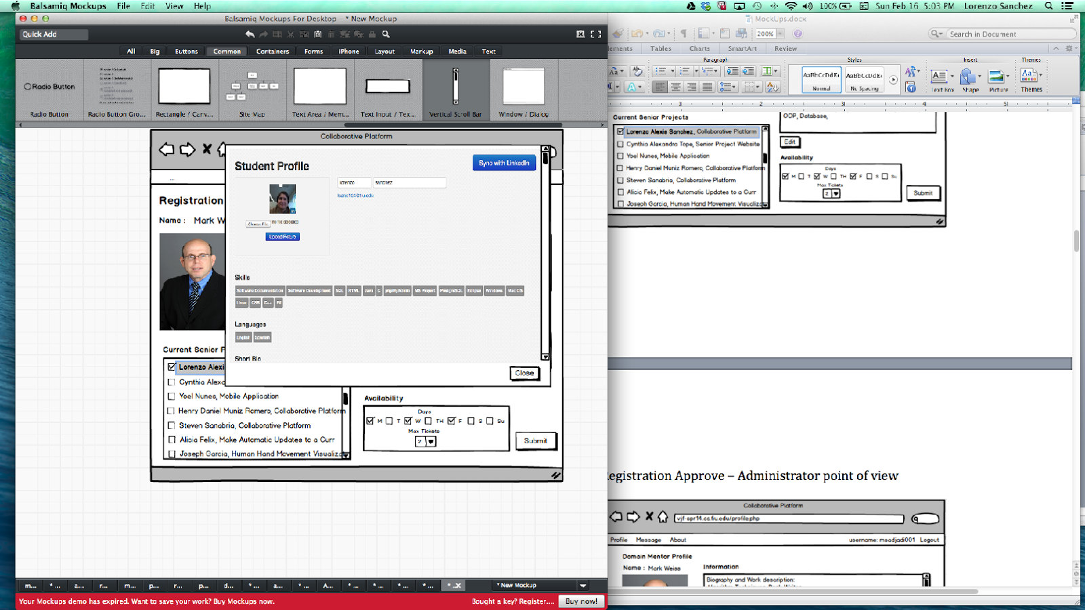

Registration Approve – Administrator point of view

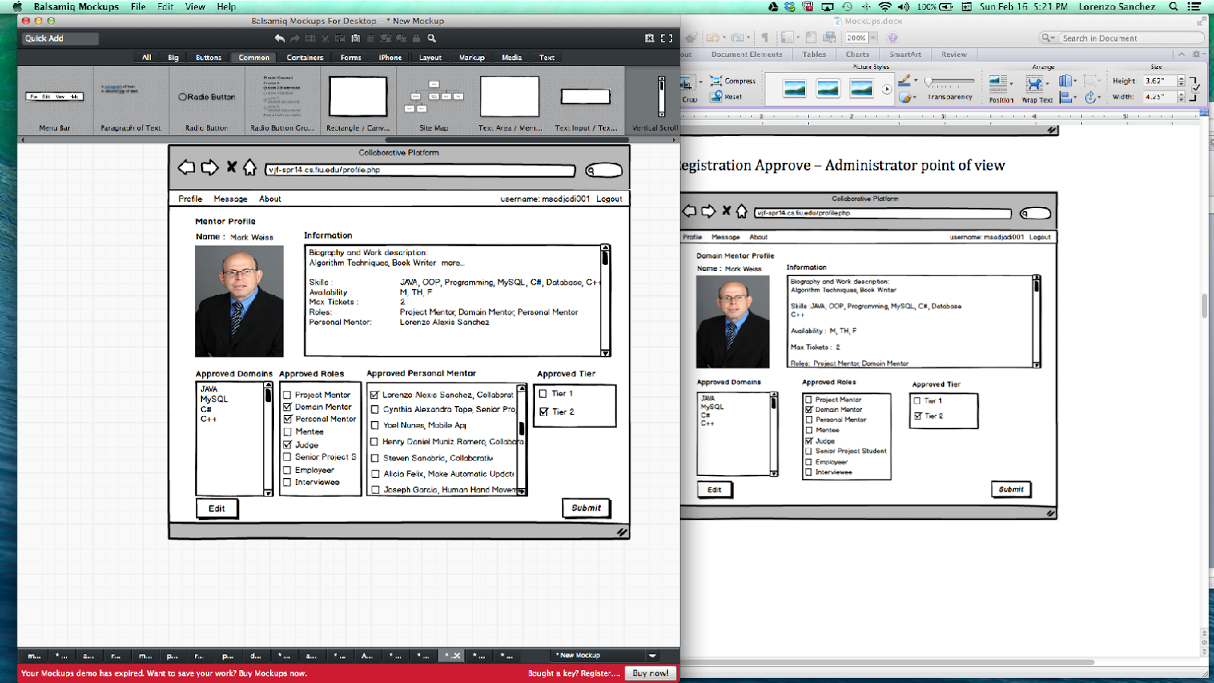

Registration – Accept or Decline – Mentor point of view



Login Home Page

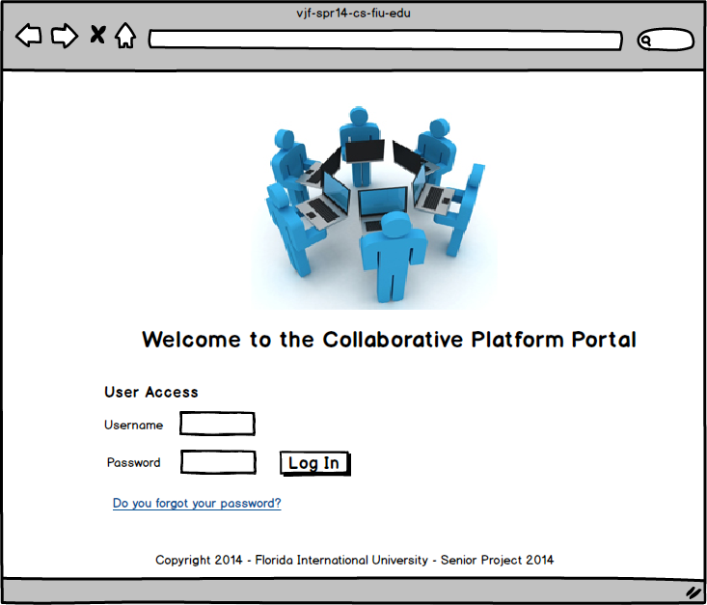

Mentoring Module

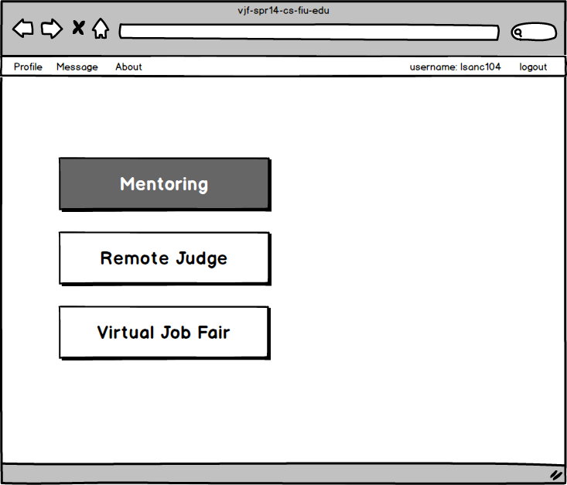

Mentoring Sub-modules – Project Mentor

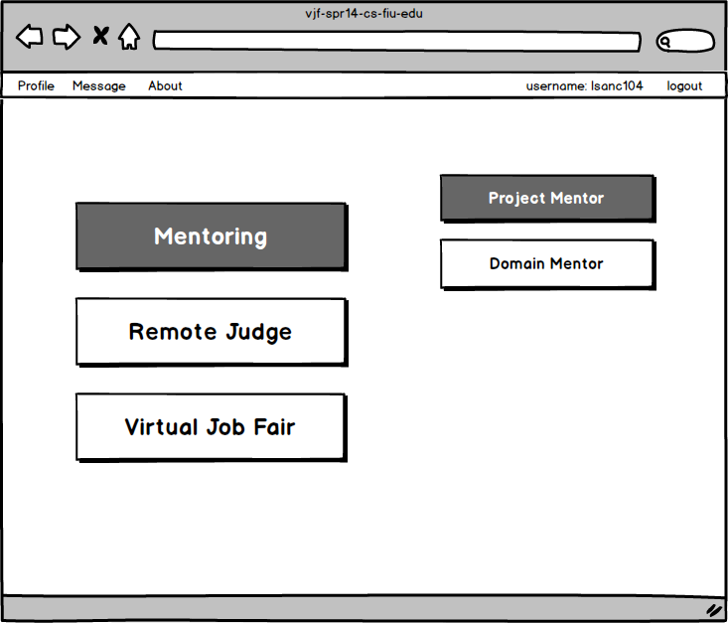

Project Mentor Chat Room– Student and Mentor View

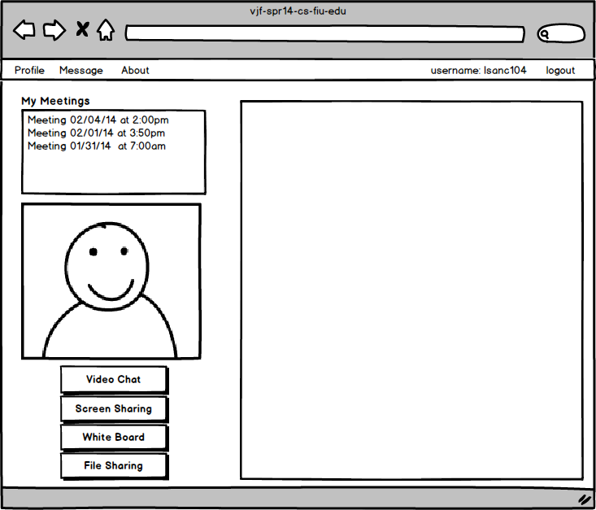

Mentoring Sub-modules – Project Mentor

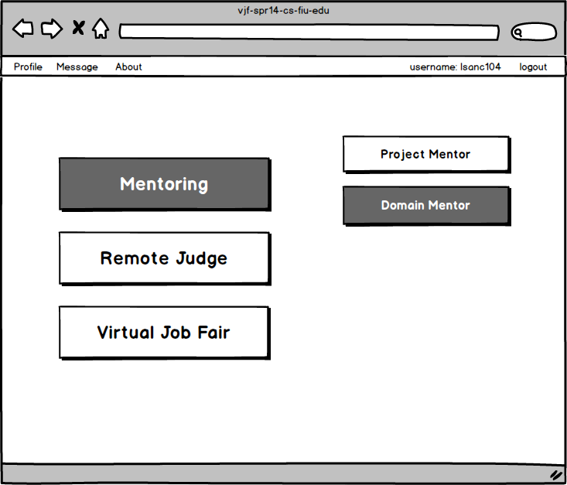

Administrator/Head Mentor Ticket View

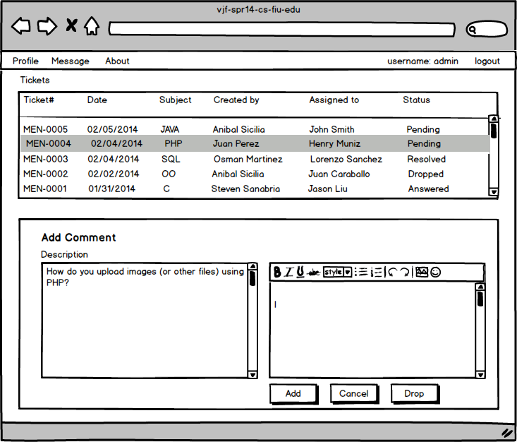

Mentee View

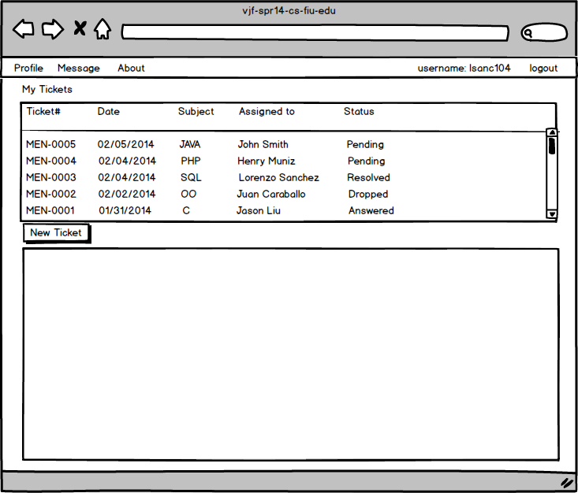

Append Comment to a ticket

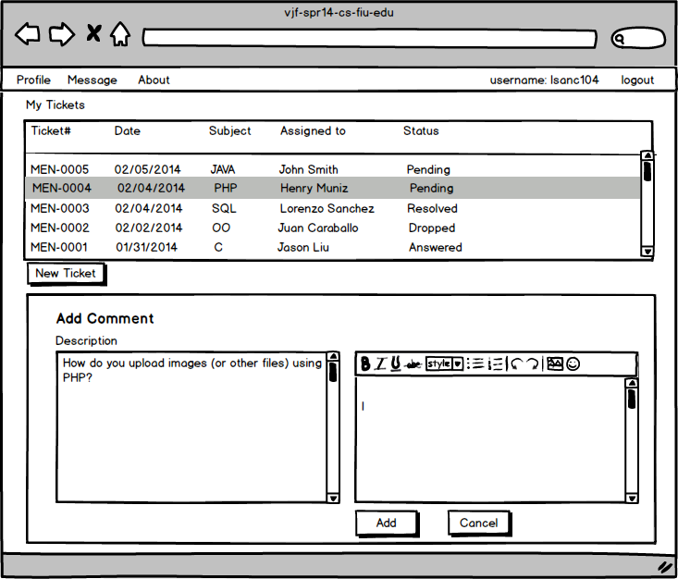

New Ticket

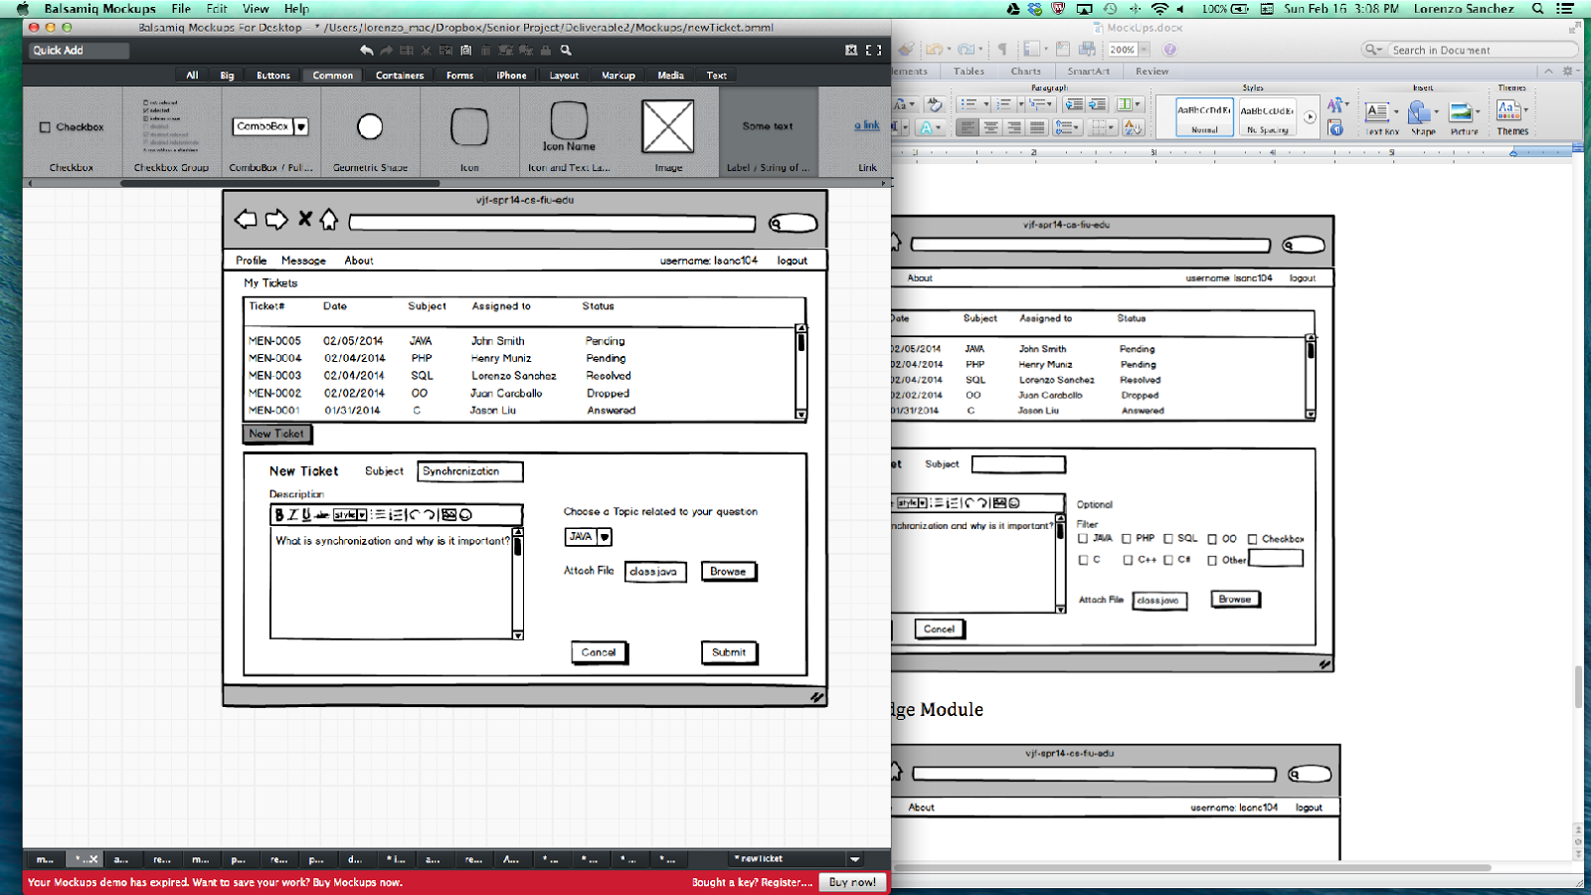

Domain Mentor – Ticket View

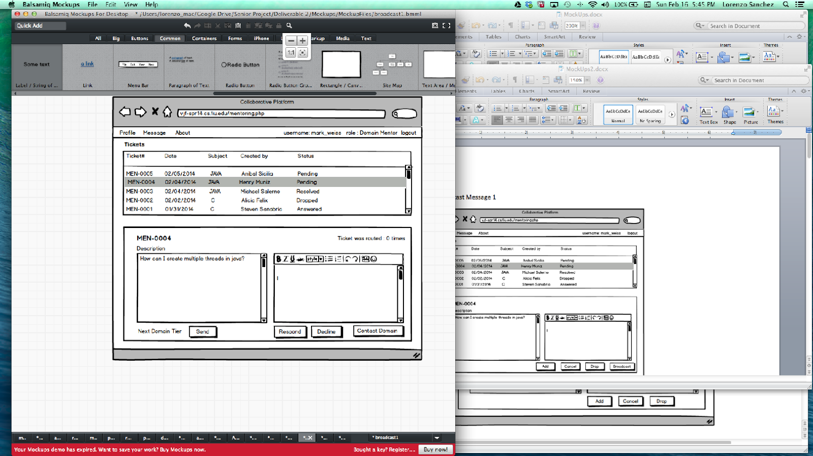

Domain Mentor – Other Domain Contact

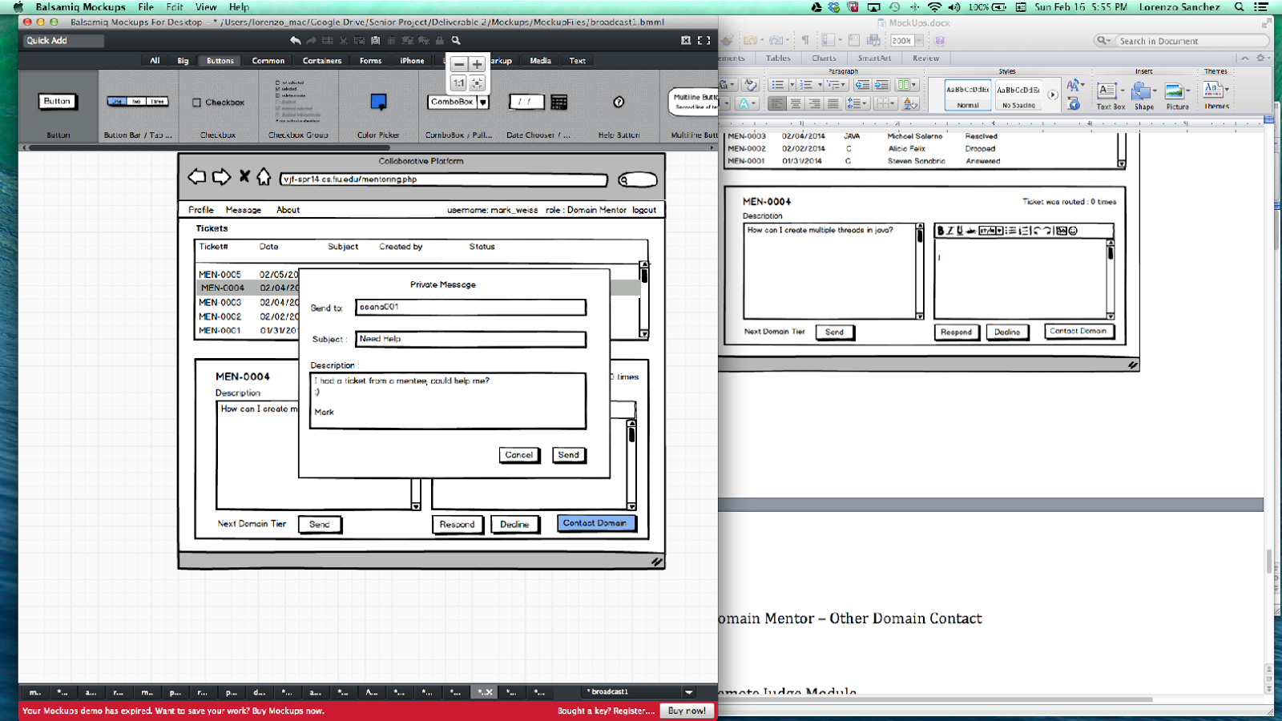

Remote Judge Module

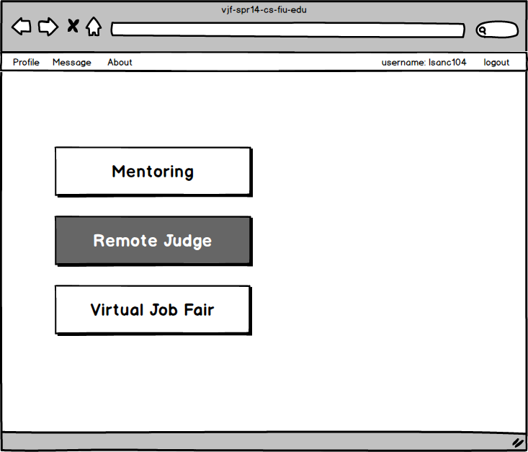

Judge points of view

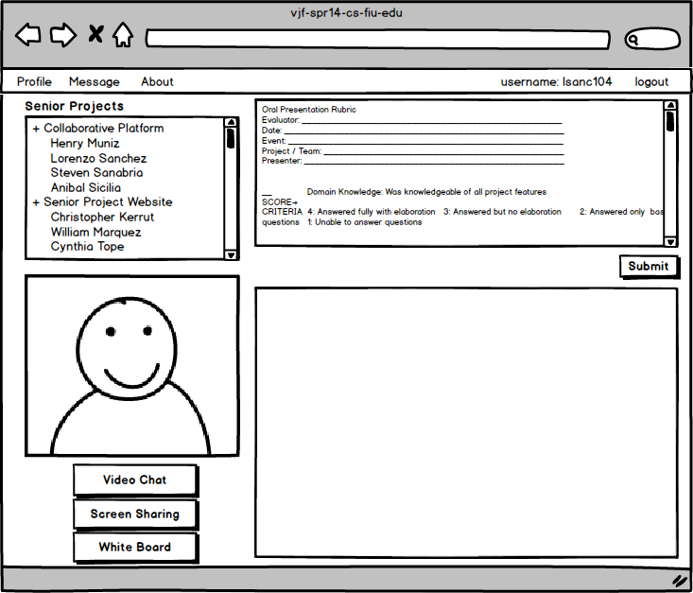

Student point of view

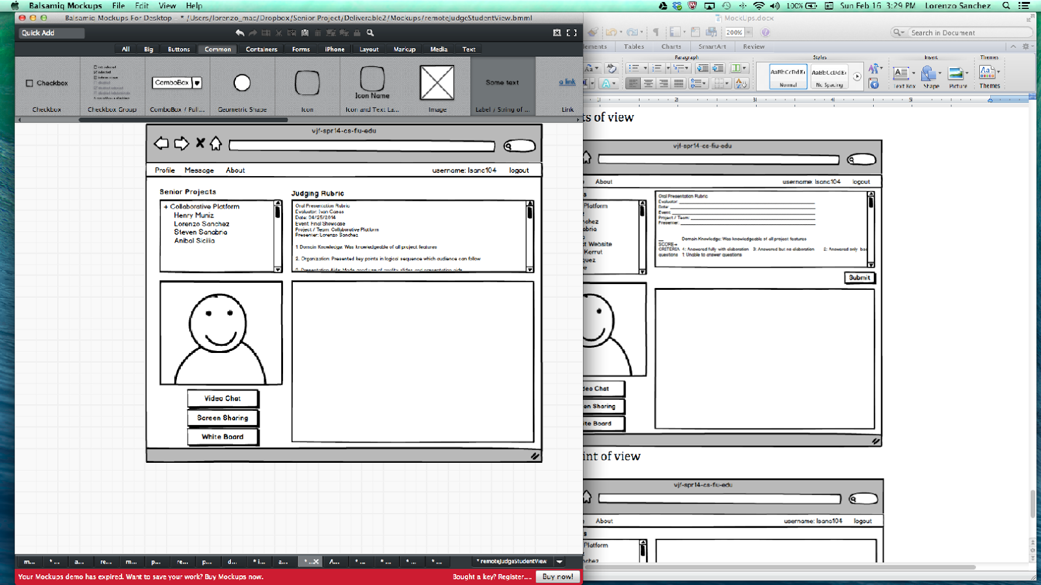

**6.5.2 UI Design for Collaborative Platform version 2**

**Access and Registration**

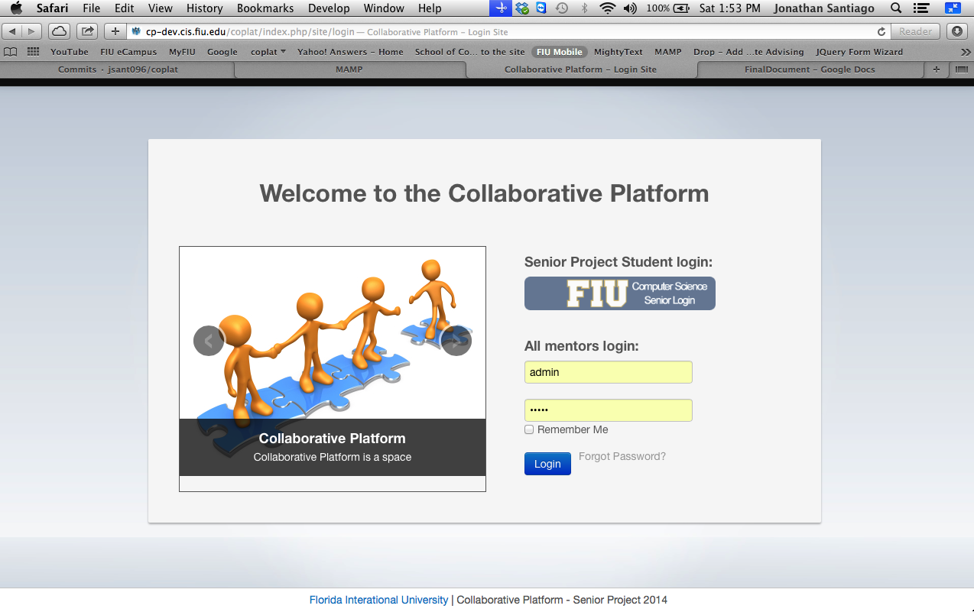**Figure 1 Login Page**

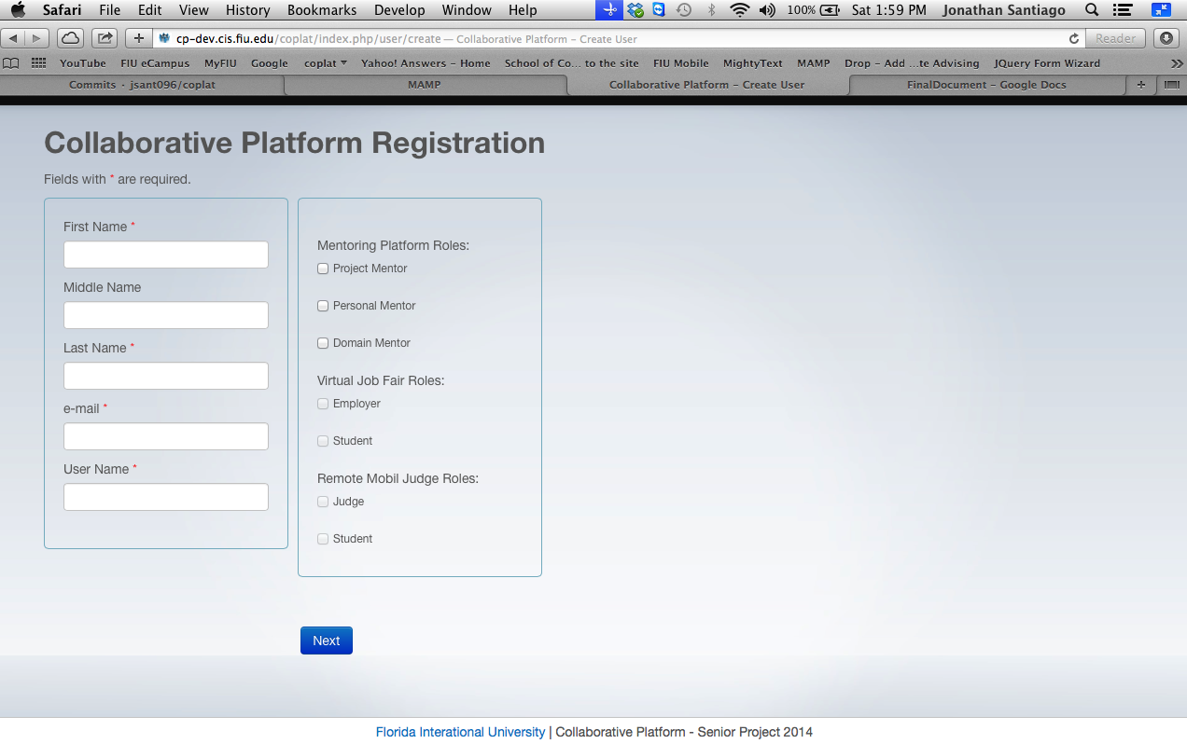

**Figure 2 Registration Page**

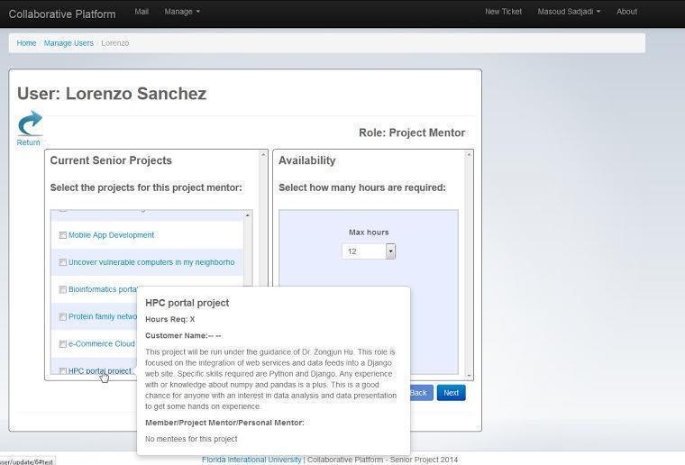

**Figure 2.1 Registration Page**

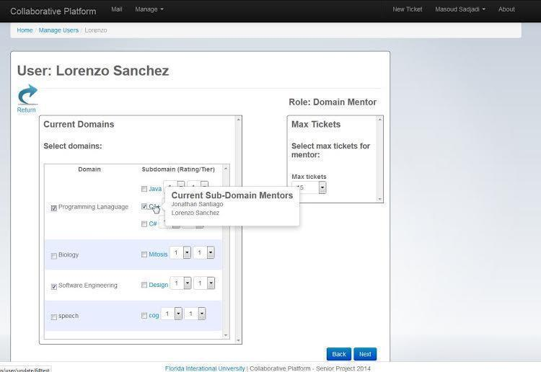

**Figure 2.2 Registration Page**

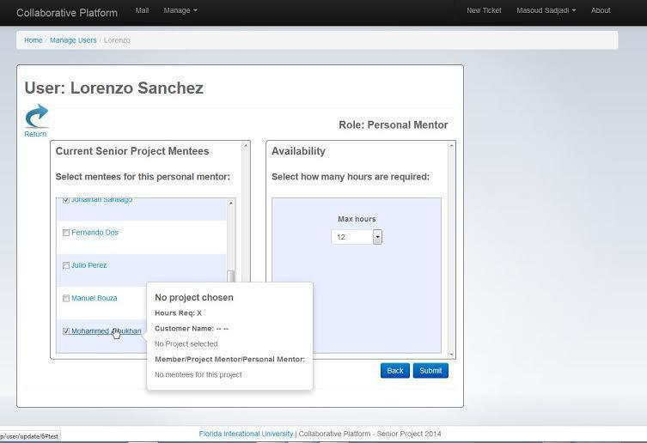**Figure 2.3 Registration**

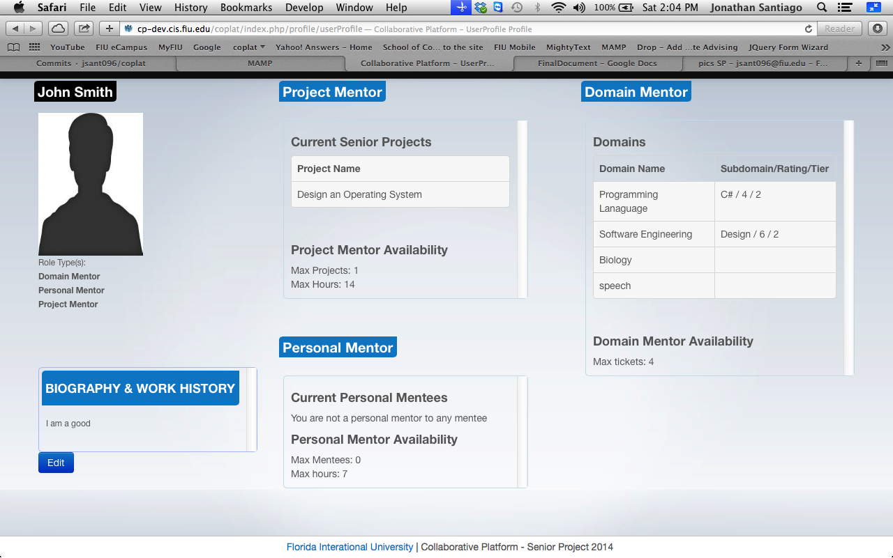

**Figure 3 Profile View**

**6.5.3 UI Design for Collaborative Platform version 3**

**Mentor Applications**

**Figure M1 - New Mentor Landing Page**

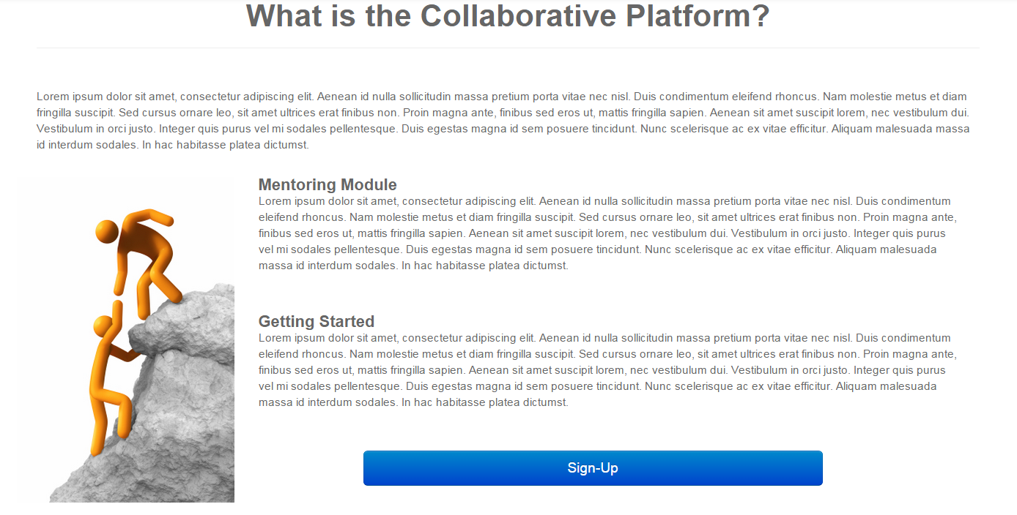**Figure M2 - Account Registration**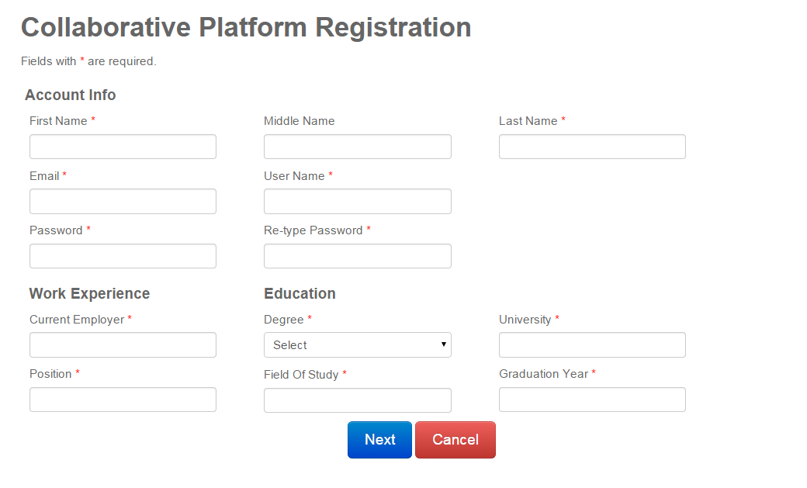

**Figure M3 - Account Registration Errors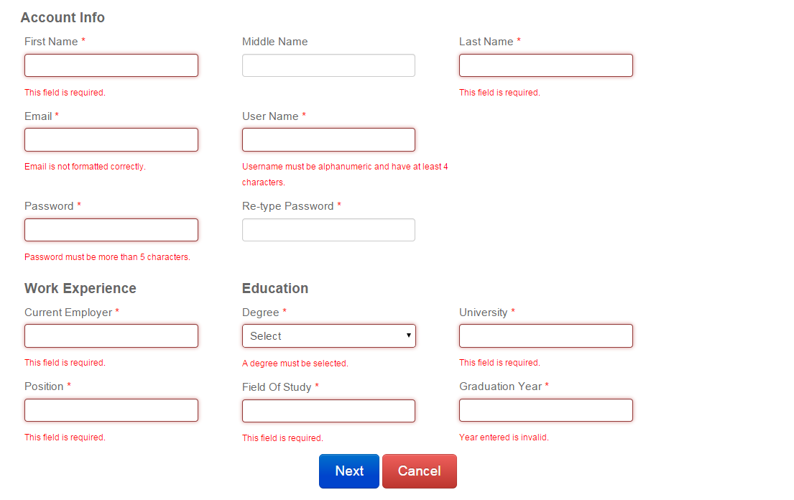Figure M4 - Account Registration Verification**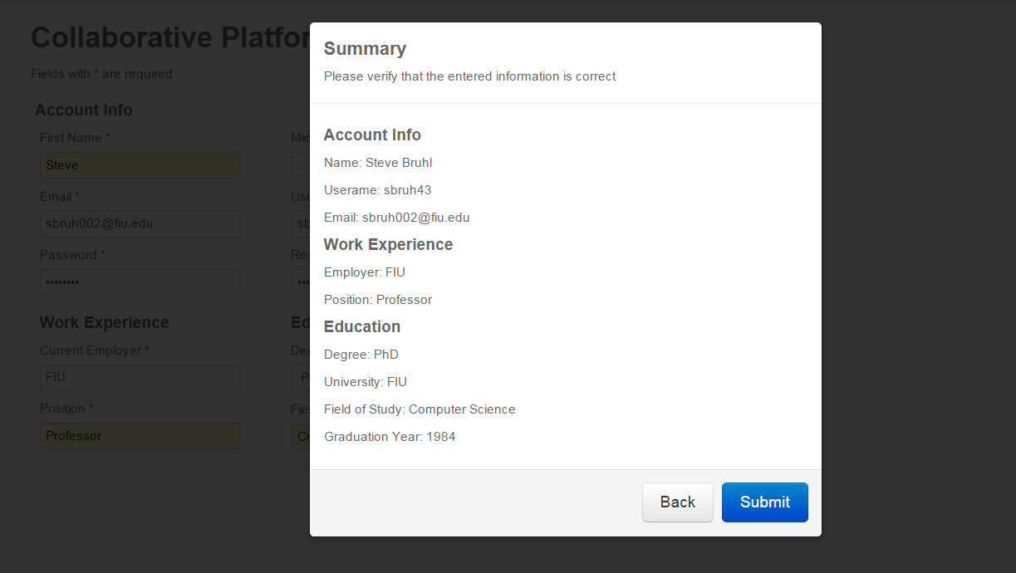

**Figure M5 - Mentor Application Portal**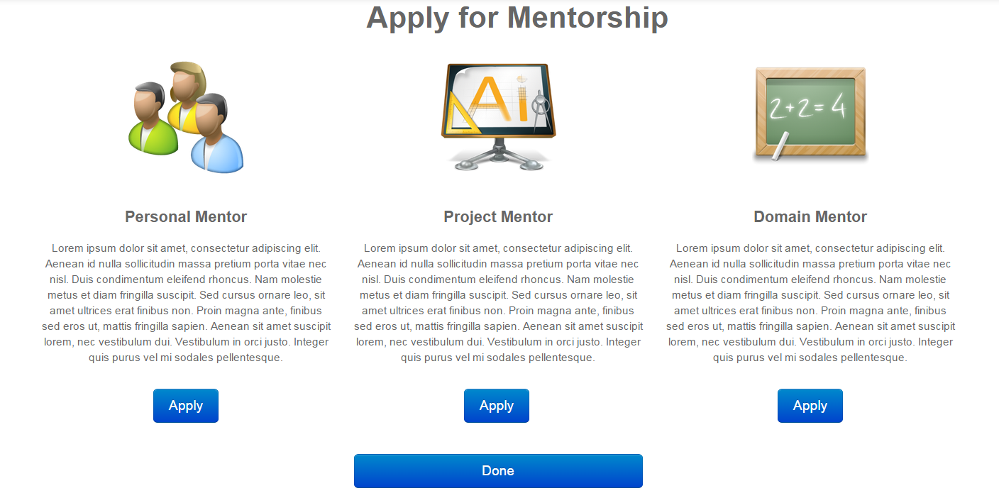

**Figure M6 - Personal Mentor Application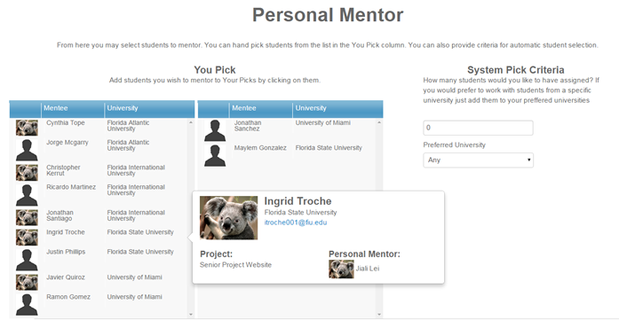Figure M7 - Personal Mentor Application Verification**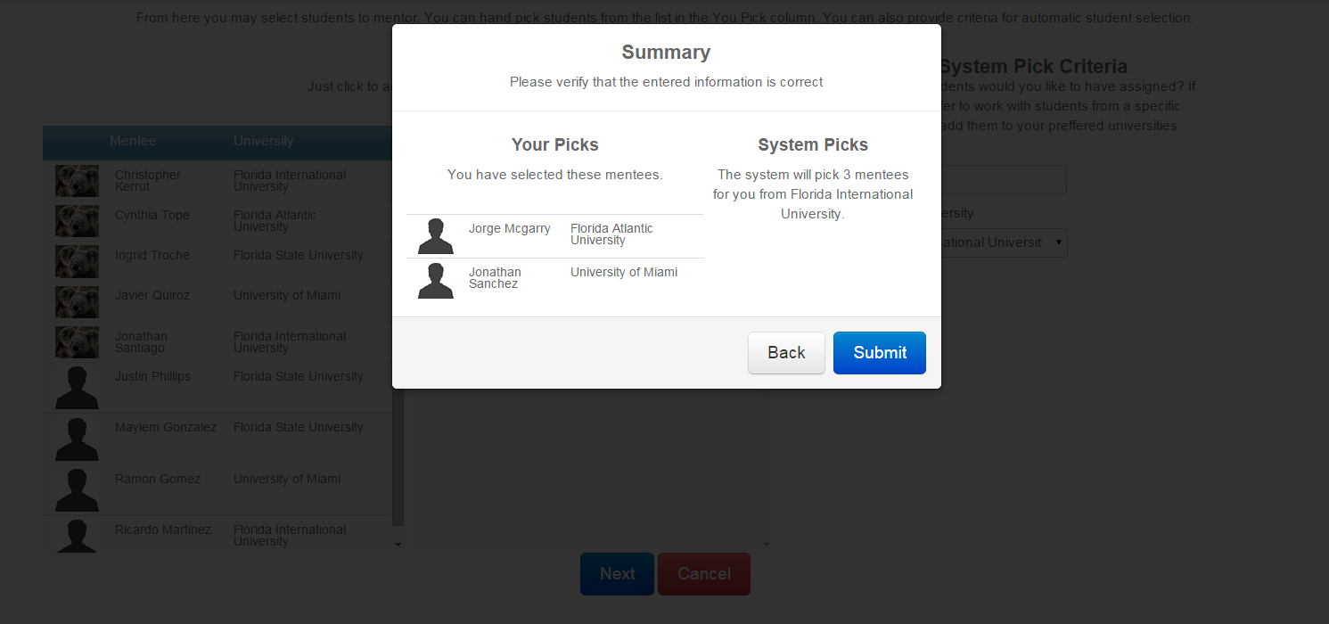

**Figure M8 - Project Mentor Application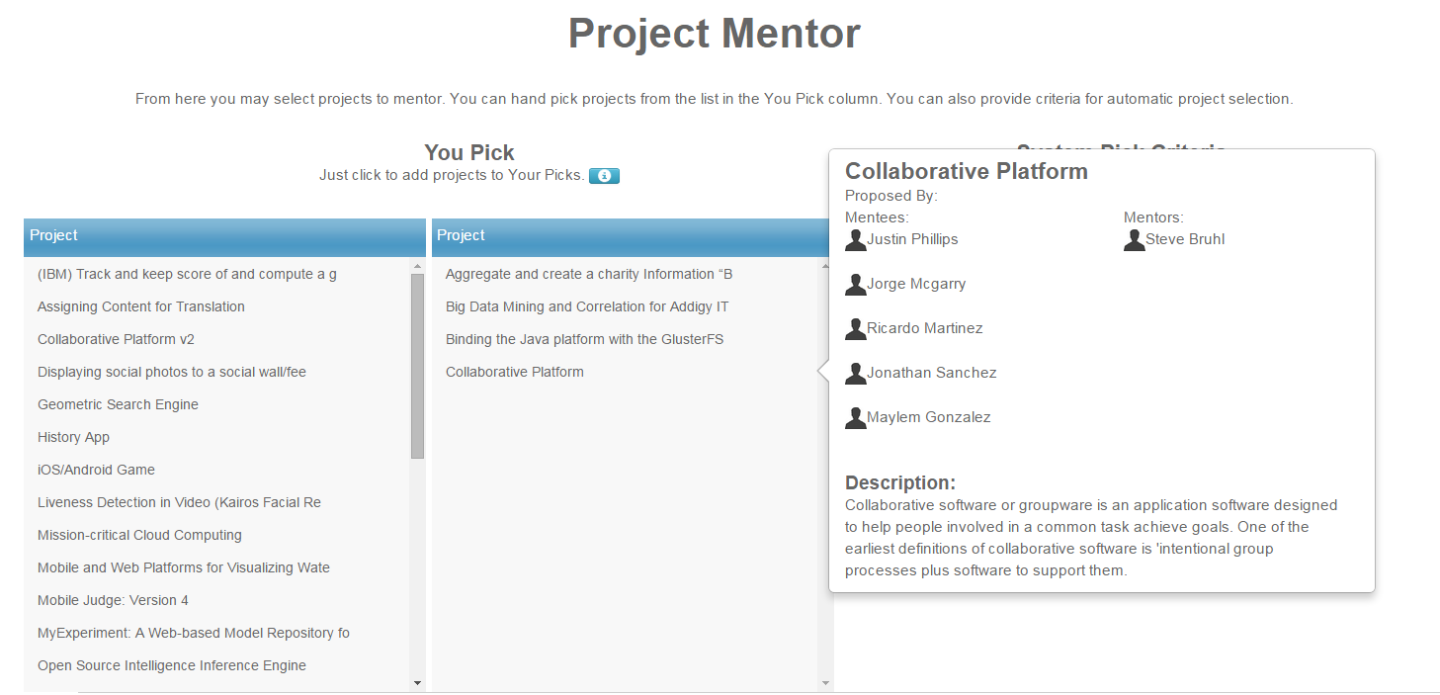Figure M9 - Project Mentor Application Verification**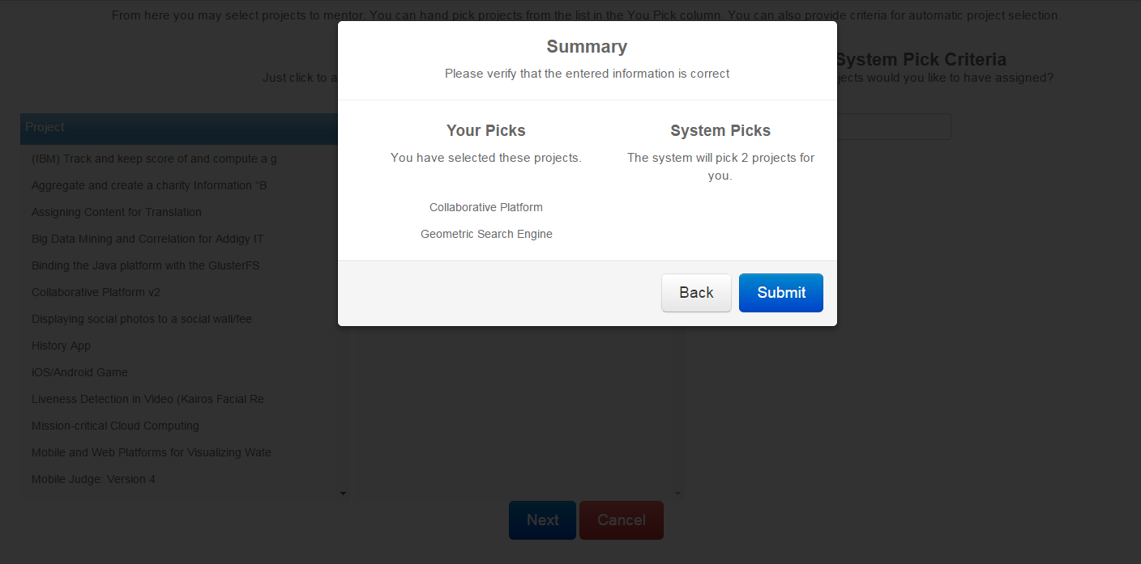

**Figure M10 - Domain Mentor Application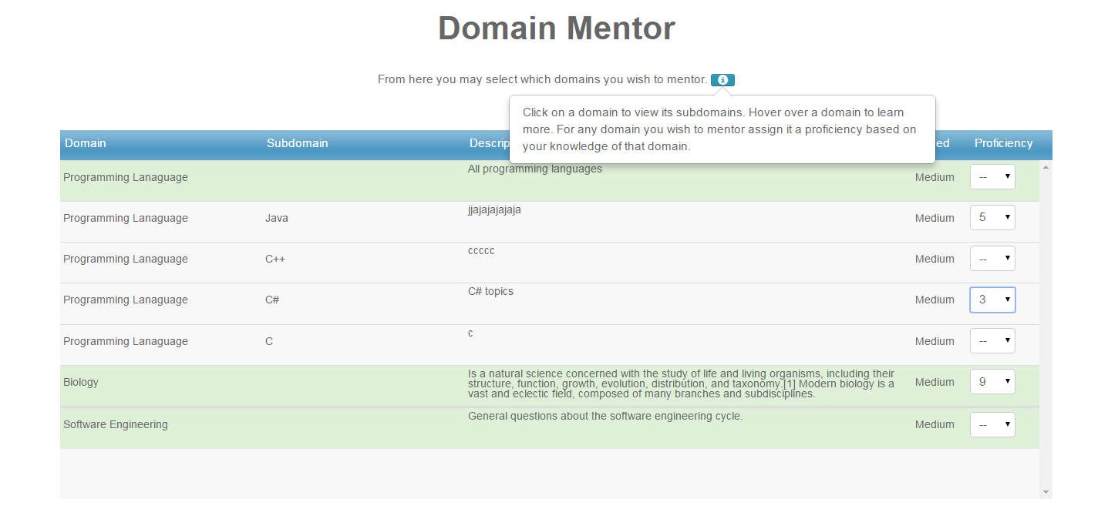Figure M11 - Domain Mentor Application Verification**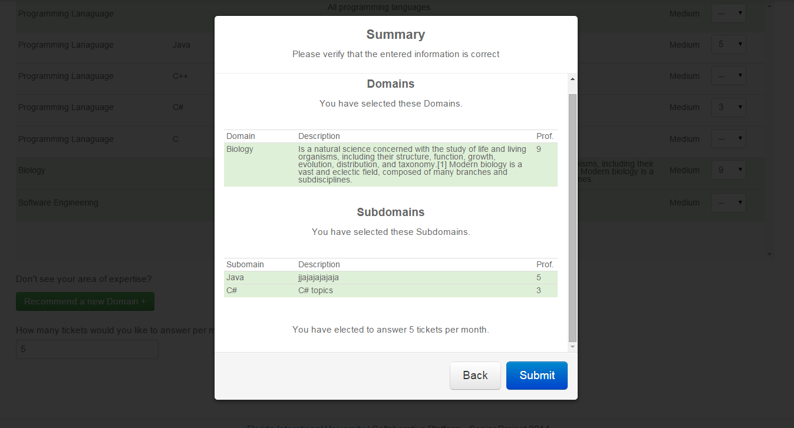

**Admin Management**

**Figure A1 - Manage Users**

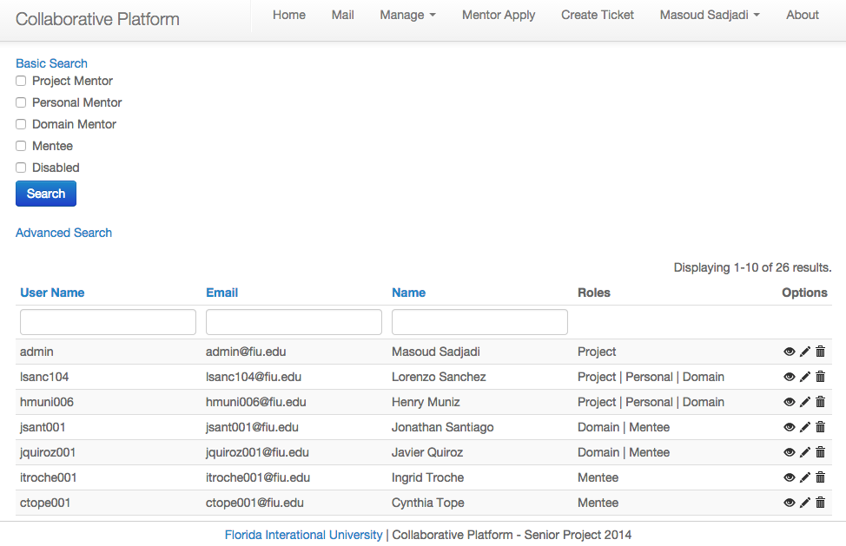

**Figure A2 - User Details**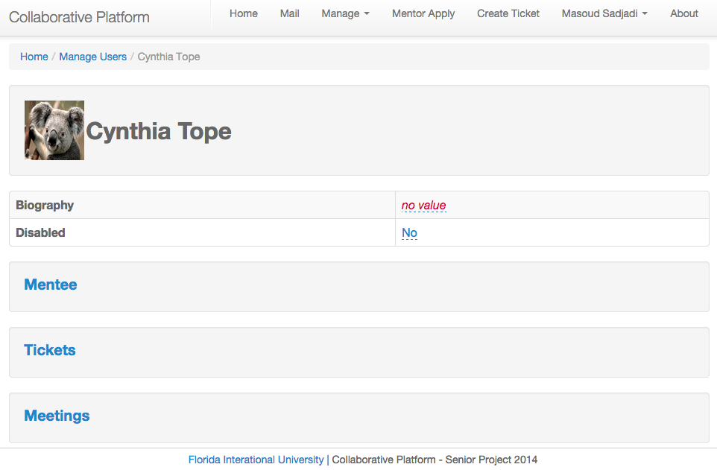

Figure A3 - Project Details

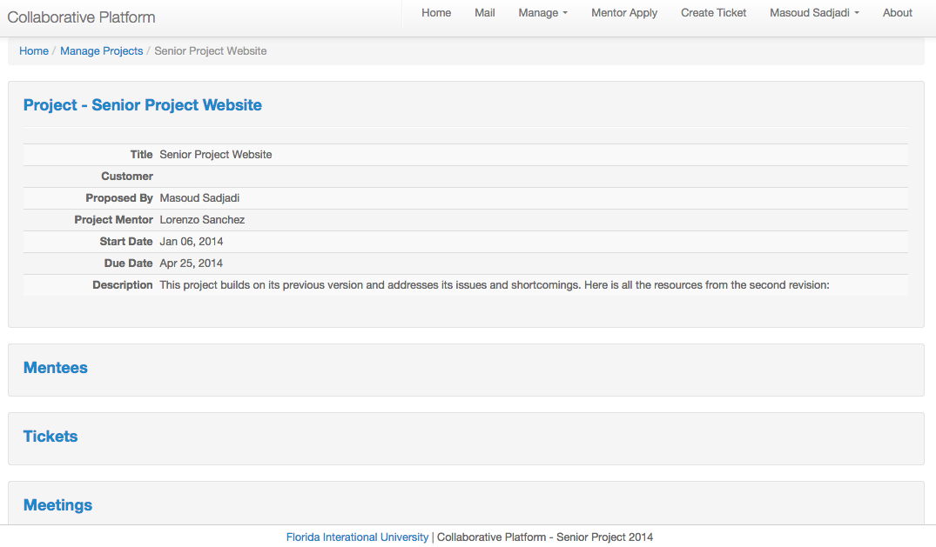

Figure A4 - View Domains/Subdomains

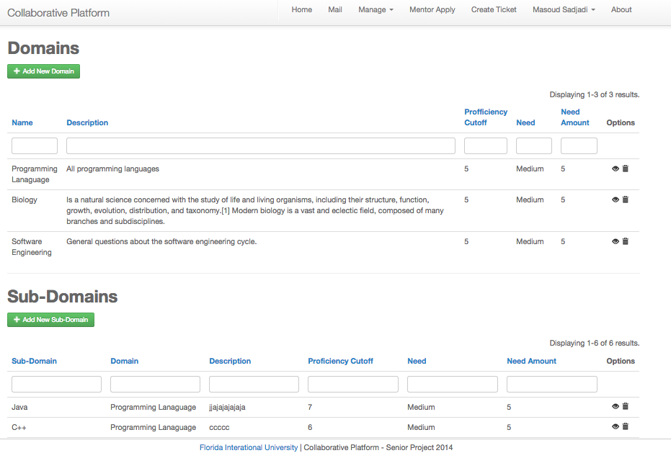

Figure A5 - Domain Details

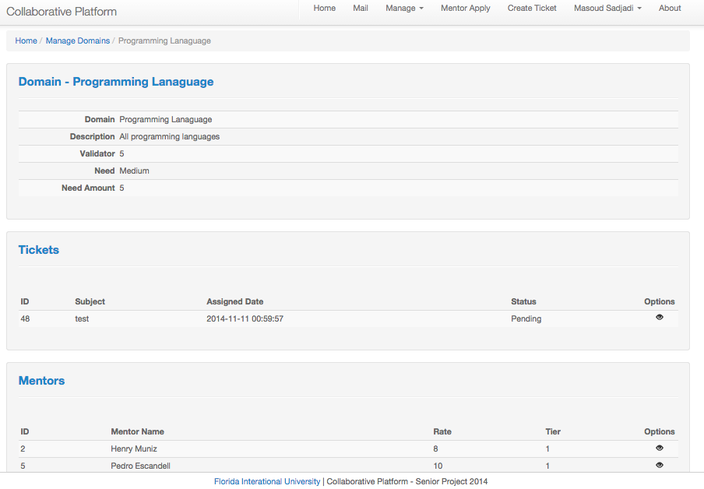

Figure A6 - Manage Tickets

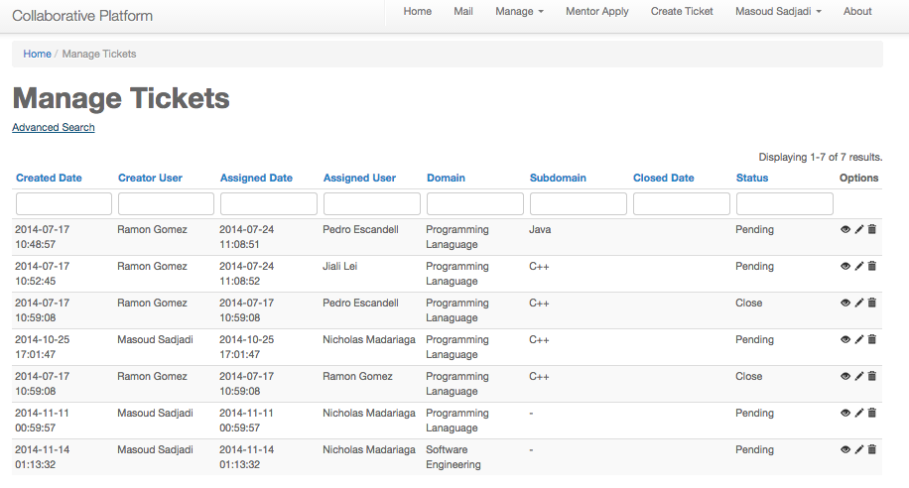

Figure A7 - Manage Tickets (Advanced Search)

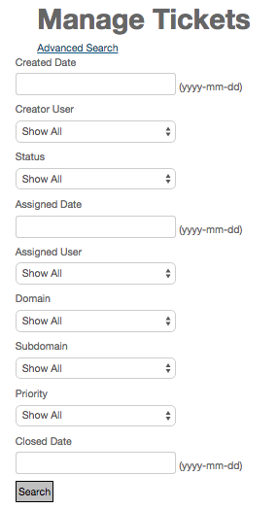

Figure A8 - View Ticket Details 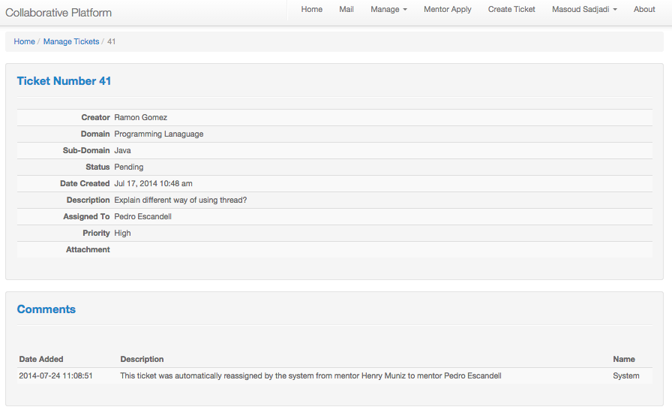

Figure A9 - Invite customization

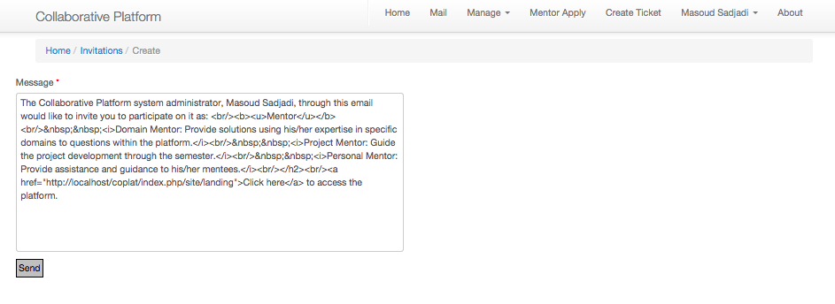

Figure A10 - Invite Details

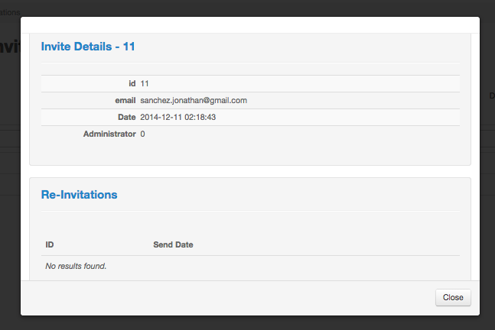

Figure A11 - Manage Applications

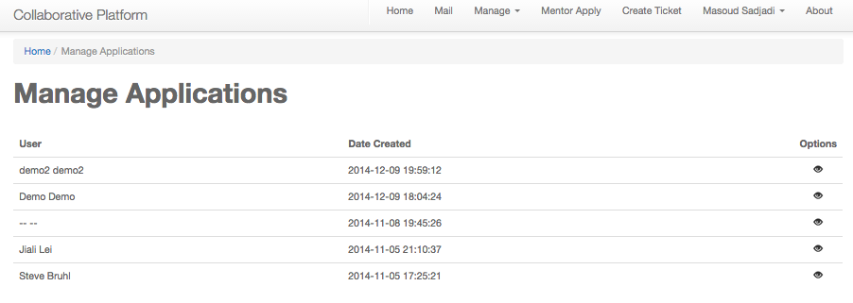

Figure A12 - Application Detail View

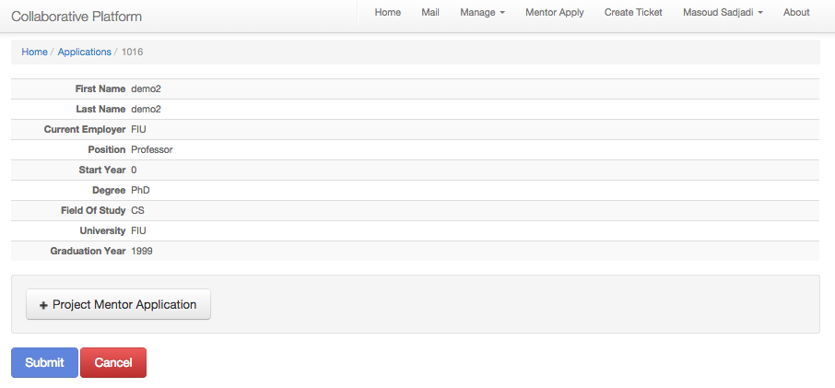

Figure A13 - Application (Accept/Reject)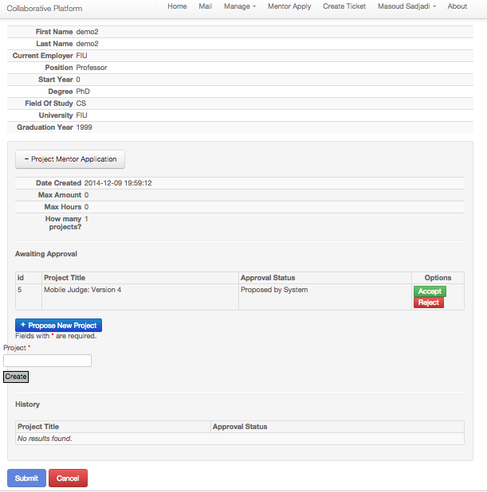

Figure A14 – Utilization Dashboard (Chart)

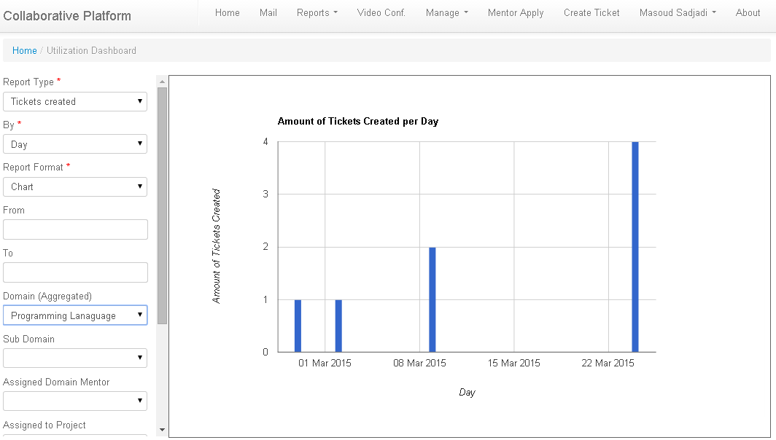

Figure A15 – Utilization Dashboard (Details)

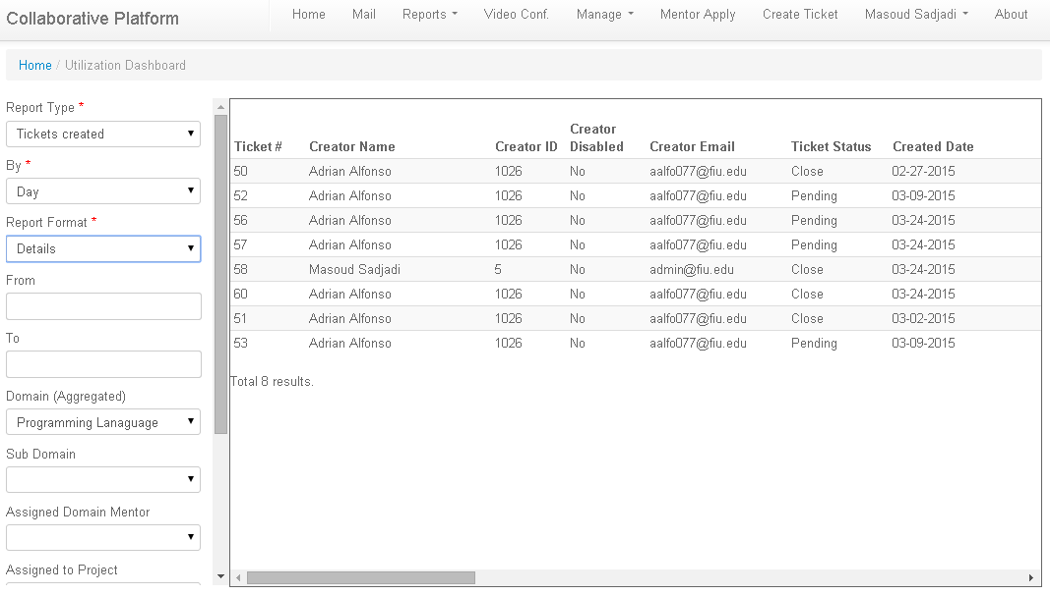

Figure A16 – Mentor Report

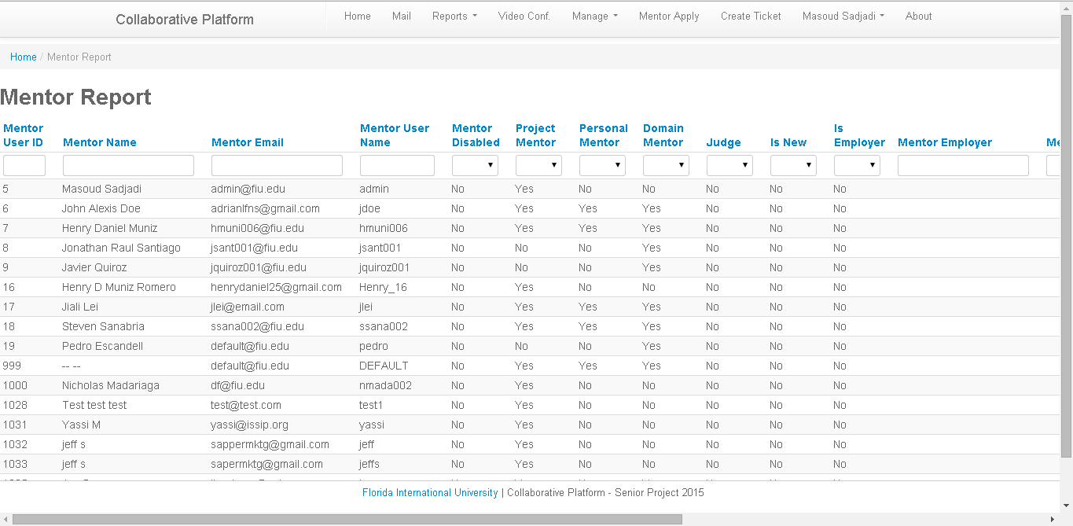

Figure A17 – Mentee Report

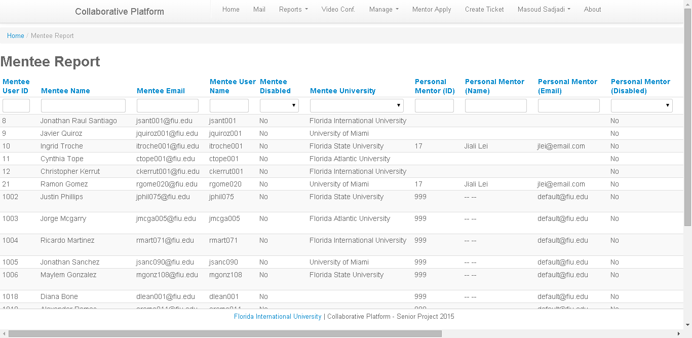

Figure A18 – Ticket Report

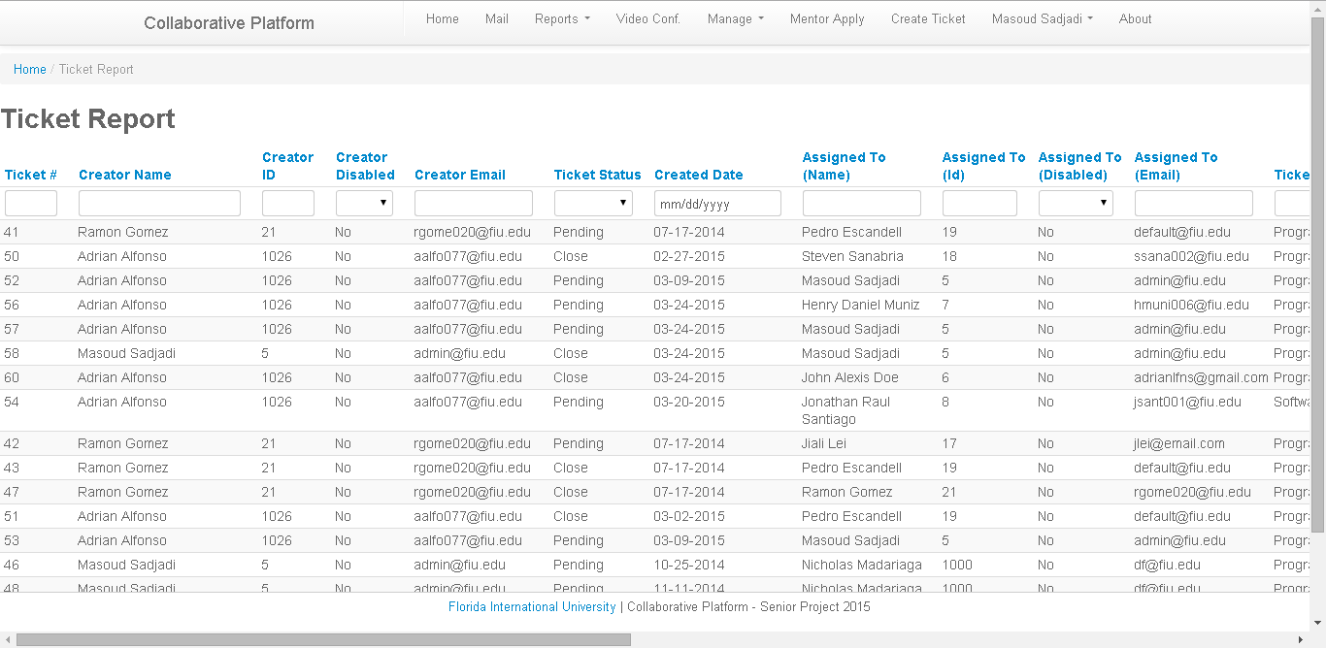

Figure A19– Frequent Mentee Sub-Domains

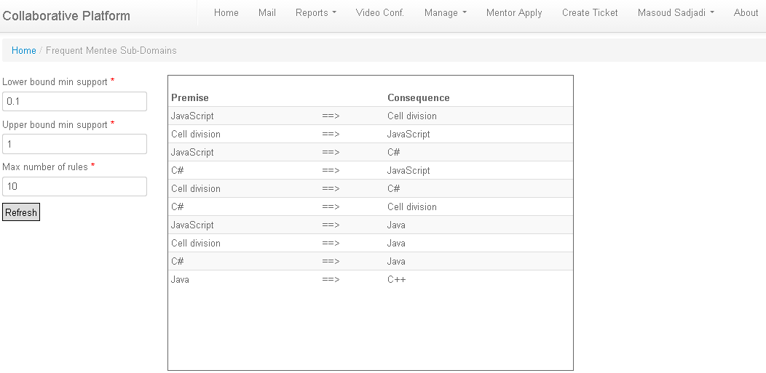

## 6.6 Appendix F – Diary of Meetings

|  |  |
| --- | --- |
| **Date:** | 2/1/14 |
| **Duration:** | 4 hours |
| **Participants:** | Lorenzo Sanchez, Anibal Sicilia, Henry Muniz, Steven Sanabria |
| **Summary of discussion:** | Discussed the requirements and possible use cases. Defined system actors. |

|  |  |
| --- | --- |
| **Date:** | 02/03/14 |
| **Duration:** | 1 hour |
| **Participants:** | Lorenzo Sanchez, Anibal Sicilia, Henry Muniz, Steven Sanabria  Prof. Caraballo, Dr. Masoud Sadjadi |
| **Summary of discussion:** | Discussing the structuring of the project and the scope. |

|  |  |
| --- | --- |
| **Date:** | 02/07/14 |
| **Duration:** | 1 hour (Conference Call) |
| **Participants:** | Lorenzo Sanchez, Anibal Sicilia, Henry Muniz, Steven Sanabria, Prof. Juan Caraballo |
| **Summary of discussion:** | Feedback on the scenarios of the each functional requirement. |

|  |  |
| --- | --- |
| **Date:** | 02/08/14 |
| **Duration:** | 5 hours |
| **Participants:** | Lorenzo Sanchez, Anibal Sicilia, Henry Muniz, Steven Sanabria |
| **Summary of discussion:** | Agenda:   * Scenarios and mockups * Use Case models * Functional and non-functional requirements |

|  |  |
| --- | --- |
| **Date:** | 02/11/14 |
| **Duration:** | 2 hours |
| **Participants:** | Lorenzo Sanchez, Anibal Sicilia, Henry Muniz, Steven Sanabria |
| **Summary of discussion:** | Agenda:   * Scenarios check * Use Case models * Sequence Diagrams |

|  |  |
| --- | --- |
| **Date:** | 02/12/14 |
| **Duration:** | 1 hours (Conference Call) |
| **Participants:** | Lorenzo Sanchez, Anibal Sicilia, Henry Muniz, Steven Sanabria, Prof. Juan Caraballo |
| **Summary of discussion:** | Feedback on Requirement Document Draft 2. |

|  |  |
| --- | --- |
| **Date:** | 02/13/14 |
| **Duration:** | 2 hours (Conference Call) |
| **Participants:** | Lorenzo Sanchez, Anibal Sicilia, Henry Muniz, Steven Sanabria, Prof. Juan Caraballo |
| **Summary of discussion:** | Feedback on Scenarios, System flow, more feedback on Requirement Document Draft 2. |

|  |  |
| --- | --- |
| **Date:** | 02/15/14 |
| **Duration:** | 5 hours |
| **Participants:** | Lorenzo Sanchez, Anibal Sicilia, Henry Muniz, Steven Sanabria. |
| **Summary of discussion:** | Work on mentoring scenarios, UML diagrams and system mockups |

**Summer 2014**

|  |  |
| --- | --- |
| **Date:** | 5/15/14 2:40 pm |
| **Duration:** | 1 hour and a half |
| **Participants:** | Jonathan Santiago, Ramon Gomez, Mohammed HAlbukhari, Jesus Jordan.  Prof. Caraballo |
| **Summary of discussion:** | To review the documentation as team. |

|  |  |
| --- | --- |
| **Date:** | 5/15/14 8:00 pm |
| **Duration:** | 1 hour and a half |
| **Participants:** | Jonathan Santiago, Ramon Gomez, Mohammed HAlbukhari, Jesus Jordan.  Prof. Caraballo |
| **Summary of discussion:** | To review the system requirements. |

|  |  |
| --- | --- |
| **Date:** | 5/17/14 |
| **Duration:** | 12 hour |
| **Participants:** | Jonathan Santiago, Ramon Gomez, Mohammed HAlbukhari |
| **Summary of discussion:** | Set up the system |

|  |  |
| --- | --- |
| **Date:** | 5/15/14 8:00 pm |
| **Duration:** | 1 hour and a half |
| **Participants:** | Jonathan Santiago, Ramon Gomez, Mohammed HAlbukhari, Jesus Jordan.  Prof. Caraballo |
| **Summary of discussion:** | To review the system requirements. |
| **Date:** | 5/20/14 |
| **Duration:** | 2 hour and a half |
| **Participants:** | Jonathan Santiago, Ramon Gomez, Mohammed HAlbukhari |
| **Summary of discussion:** | Discuss the requirement within the members of the team |

|  |  |
| --- | --- |
| **Date:** | 5/22/14 |
| **Duration:** | 2 hour and a half |
| **Participants:** | Jonathan Santiago, Ramon Gomez, Mohammed HAlbukhari, Jesus Jordan.  Prof. Sadjadi |
| **Summary of discussion:** | To clarify the system requirements. |

|  |  |
| --- | --- |
| **Date:** | 5/30/14 |
| **Duration:** | 1 hour and a half |
| **Participants:** | Ramon Gomez, Jesus Jordan.  Prof. Caraballo |
| **Summary of discussion:** | Basic scenarios in ticket workflow. |

|  |  |
| --- | --- |
| **Date:** | 5/31/14 |
| **Duration:** | 12 hour and a half |
| **Participants:** | Jonathan Santiago, Ramon Gomez. |
| **Summary of discussion:** | To Set GitLab. |
| **Date:** | 6/07/14 8:00 pm |
| **Duration:** | 4 hour and a half |
| **Participants:** | Jonathan Santiago, Ramon Gomez. |
| **Summary of discussion:** | To review the scheduling mechanism. |

|  |  |
| --- | --- |
| **Date:** | 6/16/14 8:00 pm |
| **Duration:** | 1 hour and a half |
| **Participants:** | Jonathan Santiago, Ramon Gomez.  Prof. Caraballo |
| **Summary of discussion:** | Ticket escalation process. |

|  |  |
| --- | --- |
| **Date:** | 6/24/14 8:00 pm |
| **Duration:** | 1 hour and a half |
| **Participants:** | Jonathan Santiago.  Prof. Caraballo |
| **Summary of discussion:** | To review the registration scenarios. |

|  |  |
| --- | --- |
| **Date:** | 7/5/14 |
| **Duration:** | 6 hour and a half |
| **Participants:** | Jonathan Santiago, Ramon Gomez. |
| **Summary of discussion:** | Documentation |
| **Date:** | 7/8/14 8:00 pm |
| **Duration:** | 1 hour and a half |
| **Participants:** | Jonathan Santiago, Ramon Gomez.  Prof. Caraballo |
| **Summary of discussion:** | To discuss user interface. |

|  |  |
| --- | --- |
| **Date:** | 7/12/14 |
| **Duration:** | 6 hour and a half |
| **Participants:** | Jonathan Santiago, Ramon Gomez. |
| **Summary of discussion:** | Documentation |

|  |  |
| --- | --- |
| **Date:** | 7/19/14 |
| **Duration:** | 8 hour and a half |
| **Participants:** | Jonathan Santiago, Ramon Gomez. |
| **Summary of discussion:** | Documentation |

|  |  |
| --- | --- |
| **Date:** | 7/20/14 |
| **Duration:** | 8 hour and a half |
| **Participants:** | Jonathan Santiago, Ramon Gomez. |
| **Summary of discussion:** | Documentation |

### Version 3

|  |  |
| --- | --- |
| **Date** | 09/03/2014 |
| **Location** | Telephone Conference |
| **Start** | 3:00 PM |
| **End** | 4:30 PM |
| **In Attendance** | Juan Caraballo, Nicholas Madariaga, Jonathan Sanchez |
| **Late** | N/A |
| **Agenda** | Get background information about the Collaborative Platform and gather specifications and requirements for the next iteration of the site. |
| **Summary of Discussion** | Discussed purpose, objective, goals, and future of the site as well as what specific requirements Juan is looking to get done for the next iteration. Juan advised on best ways to communicate with him and gave tips on the project itself. Primary goals for site at this time is to complete the Registration Process for a Mentor and once that is done we can focus on other areas like makeover of the site, e.g. Admin dashboard, email invite by admin to mentor, tweaking registration process for added function. These other features will be completed as time allows. |
| **Assigned Tasks** | Nick and Jonathan:   * Verify GitHub accounts * Create Google Drive for Docs * Create Trello account * Get the local version of the Collaborative Platform working |

|  |  |
| --- | --- |
| **Date** | 09/07/2014 |
| **Location** | Jonathan’s House |
| **Start** | 12:00 PM |
| **End** | 5:30 PM |
| **In Attendance** | Nicholas Madariaga, Jonathan Sanchez |
| **Late** | N/A |
| **Agenda** | Brainstorm the look of the site and come up with mockups. |
| **Summary of Discussion** | next meeting: 09/08 @ 9AM |
| **Assigned Tasks** | Nick and Jonathan:   * setup git on local system * type notes |

|  |  |
| --- | --- |
| **Date** | 09/08/2014 |
| **Location** | ECS 237 |
| **Start** | 9:00 AM |
| **End** | 3:00 PM |
| **In Attendance** | Nicholas Madariaga, Jonathan Sanchez |
| **Late** | N/A |
| **Agenda** | Begin Feasibility and Requirements Documents to get a rough draft version. |
| **Summary of Discussion** | Go over mockups for features we are implementing.  Rough Draft - Feasibility document  Rought Draft - Requirements document |
| **Assigned Tasks** | * update trello with mockups * update trello with rough draft of docs |

|  |  |
| --- | --- |
| **Date** | 09/10/2014 |
| **Location** | Telephone Conference |
| **Start** | 12:00 PM |
| **End** | 1:45 PM |
| **In Attendance** | Juan Caraballo, Nicholas Madariaga, Jonathan Sanchez |
| **Late** | N/A |
| **Agenda** | Get juan to sign up to trello to review mockups |
| **Summary of Discussion** | Overview of admin dashboard and suggested features:   * insight on domain knowledge and how many mentors are assigned * insight on tickets (pending, avg ticket response.. etc) * insight on specific mentor stats (assigned tickets, longest response, total mentors and breakdown) * insight on project or student (project meeting, breakdown of pending tickets by project name) * pending mentor approvals * active mentors in current month vs last month   Overview of Mentor Registration and suggested features:   * Mentor registration is all about workflow   1. Mentor receives invitation   2. Mentor creates account with coplat   3. Mentor applies for mentorships of his choice   4. The application is sent out for review   5. Admin approves application   6. Mentor confirms or denies admins changes * Give option to sign up via LinkedIn * Admins should see all applications from any one mentor at once   The mockups have no context for juan so he gave us examples on how to do that for each feature we’re working with.  Mentor Dashboard   * tabled for implementation after self-registration, admin management panel, and back and forth of approvals of roles between admin and mentor   Mentor Application Response from Admin.   * what will the mockup look like for mentor once applciation returns from admin |
| **Assigned Tasks** | * Create scenarios for mockups so they can have context and be ready to present that for next meeting - tomorrow 8:30AM |

|  |  |
| --- | --- |
| **Date** | 09/11/2014 |
| **Location** | Video Conference via Google Hangouts |
| **Start** | 8:30 AM |
| **End** | 11:20 AM |
| **In Attendance** | Juan Caraballo, Nicholas Madariaga, Jonathan Sanchez |
| **Late** | N/A |
| **Agenda** | Go over mockups alongside workflow |
| **Summary of Discussion** | The plan is to have two seperate entry points for logging in:   1. For users with existing accounts 2. For new users   Review of Mentor Registration mockups:   * Account Registration   + From here let users know how long their applications could potentially take * Mentor Application Hub   + Mixed with account registration or not? * Personal Mentor Application   + Needs re-arranging and add name hover * Project Mentor Application   + Add criteria to automation   + Make similar to personal mentor * Domain Mentor Application   + Display Domains in need of help   + Add how many questions per month * All Applications need some way of cancelling/going back/redo * Mockup for deny/approval email   Review of Admin dashboard mockups: |
| **Assigned Tasks** | Update and add mockups based on what was discussed during this meeting so we can run through them again during the next meeting. |

|  |  |
| --- | --- |
| **Date** | 09/12/2014 |
| **Location** | Video Conference via Google Hangouts |
| **Start** | 10:00 AM |
| **End** | 11:45 AM |
| **In Attendance** | Juan Caraballo, Nicholas Madariaga, Jonathan Sanchez |
| **Late** | N/A |
| **Agenda** | Go over mockups alongside workflow round 2 |
| **Summary of Discussion** |  |
| **Assigned Tasks** |  |

|  |  |
| --- | --- |
| **Date** | 09/14/2014 |
| **Location** | Jonathan’s House |
| **Start** | 1:30 PM |
| **End** | 3:30 PM |
| **In Attendance** | Nicholas Madariaga, Jonathan Sanchez |
| **Late** | N/A |
| **Agenda** | Dissect site, mockups, update trello. |
| **Summary of Discussion** | Continue to dissect site and try to understand the flow of information through the pages. |
| **Assigned Tasks** |  |

|  |  |
| --- | --- |
| **Date** | 09/16/2014 |
| **Location** | Video Conference via Google Hangouts |
| **Start** | 11:00 AM |
| **End** | 12:15 PM |
| **In Attendance** | Juan Caraballo, Nicholas Madariaga, Jonathan Sanchez |
| **Late** | N/A |
| **Agenda** | Review mockup revisions |
| **Summary of Discussion** | Additional changes suggested for mockups. Meeting tomorrow to review those changes as well. |
| **Assigned Tasks** | Revise Mockups |

|  |  |
| --- | --- |
| **Date** | 09/17/2014 |
| **Location** | Video Conference via Google Hangouts |
| **Start** | 3:30 PM |
| **End** | 4:30 PM |
| **In Attendance** | Juan Caraballo, Nicholas Madariaga, Jonathan Sanchez |
| **Late** | N/A |
| **Agenda** | Review mockups |
| **Summary of Discussion** | Mockups looked good but minor changes requested. Upload to trello in a way that the reader can see transitions and follow along. Get together and come up with final universal approval panel. |
| **Assigned Tasks** | Make the minor changes and get (Nick and Jonathan) get together to sort out the details for the universal approval panel. Meeting set for Thursday @ 12 PM. |

|  |  |
| --- | --- |
| **Date** | 09/18/2014 |
| **Location** | Video Conference via Google Hangouts |
| **Start** | 12:00 PM |
| **End** | 1:30 PM |
| **In Attendance** | Nicholas Madariaga, Jonathan Sanchez |
| **Late** | N/A |
| **Agenda** | Sort out the GUI for the universal approval panel |
| **Summary of Discussion** | We combined both mockups to create one universal approval panel. We also setup cp-dev.cs.fiu.edu and cp.cs.fiu.edu with the project and git. |
| **Assigned Tasks** | Upload mockups onto trello for mentor approval. Work on getting more knowledge on the technology used onthe website (Yii in particular). |

|  |  |
| --- | --- |
| Date | 09/22/2014 |
| Location | ECS 237 |
| Start | 10:00 AM |
| End | 3:00 PM |
| In Attendance | Nicholas Madariaga, Jonathan Sanchez |
| Late | N/A |
| Agenda | Prepare presentation material, review introduction of project, continue to work on features. |
| Summary of Discussion | Nick managed to get Register Page up. Jonathan made some changes to the pages and links added buttons on pages. We continued to mess around with Bootstrap and PHP. |
| Assigned Tasks | Continue to do tutorials for Yii and PHP. |

|  |  |
| --- | --- |
| Date | 9/28/14 |
| Location | Nick’s House |
| Start | 1PM |
| End | 7PM |
| In Attendance | Nicholas Madariaga, Jonathan Sanchez |
| Late | N/A |
| Agenda | Determine what we need to begin implementing our mockups |
| Summary of Discussion | We needed to make a few changes to the database:Added a tier column to the domain_mentor tableCreated several new tables to store mentor application dataUpdated our local db with new db and cp-dev.cs.fiu.eduWe worked on our git repository:We added a develop branch to keep all changes we have both made and approved.We then made two feature branches to store our individual progress as we goWe finally found a way to ignore files in a way that workedWe created a new model, controller and some views for mentor applications |
| Assigned Tasks | Jonathan - Improve the layout of existing admin viewsNick - Get self serve account creation working |

|  |  |
| --- | --- |
| Date | 09/29/14 |
| Location | ECS237 |
| Start | 9AM |
| End | 2PM |
| In Attendance | Nicholas Madariaga, Jonathan Sanchez |
| Late | N/A |
| Agenda | Work on Documentation |
| Summary of Discussion | Made revisions to all three documents. |
| Assigned Tasks | Continue working on Use Cases and Scearios |

|  |  |
| --- | --- |
| Date | 10/05/14 |
| Location | Google Hangounts |
| Start | 12PM |
| End | 1PM |
| In Attendance | Nicholas Madariaga, Jonathan Sanchez |
| Late | N/A |
| Agenda | Discuss implementation action plan |
| Summary of Discussion | We discussed what we had worked on up until before the meeting.We noticed that model relations could be automated through gii.We discussed some problems we were running into. |
| Assigned Tasks | Work on our assigned tasks and reconvene at 8PM to give an update on our progress |

|  |  |
| --- | --- |
| Date | 10/05/14 |
| Location | Google Hangounts |
| Start | 8PM |
| End | 9PM |
| In Attendance | Nicholas Madariaga, Jonathan Sanchez |
| Late | N/A |
| Agenda | Discuss todays progress |
| Summary of Discussion | We had not accomplished as much as we wanted due to unforeseen complications. We shared any discoveries we made about how the current system actually works and which parts of them can be reused. |
| Assigned Tasks | Continue working on our assigned tasks based on the new information we gathered about how our solution works.Reconvene tomorrow morning for another update and to prepare for our presentation. |

|  |  |
| --- | --- |
| Date | 10/06/14 |
| Location | ECS237 |
| Start | 10:30 AM |
| End | 2:45 PM |
| In Attendance | Nicholas Madariaga, Jonathan Sanchez |
| Late | N/A |
| Agenda | Discuss progress and yii framework and also prepare for todays presentation. |
| Summary of Discussion | Prepare for presentation and continue working on our individual features. We also merged our feature branch into the developer branch and had the dev server pull the features we’ve implemented so far. |
| Assigned Tasks | Continue to work on documentation and features. (Nick - Self Registration initial page), (jonathan - Modal for detailed view).Tomorrow Meeting to advance on individual features - 3:00 PM - 6:00 PM. |

|  |  |
| --- | --- |
| Date | 10/07/14 |
| Location | ECS237 |
| Start | 3:00 PM |
| End | 6:00 PM |
| In Attendance | Nicholas Madariaga, Jonathan Sanchez |
| Late | N/A |
| Agenda | Discuss progress, Yii research and Coding session. |
| Summary of Discussion | Still struggling with Yii framework. Learned some more about Yii but still not enough to get things working as we like. |
| Assigned Tasks | Keep studying how Yii works and try to code. |

|  |  |
| --- | --- |
| Date | 10/10/14 |
| Location | Jonathans House |
| Start | 12:00 PM |
| End | 4:00 PM |
| In Attendance | Nicholas Madariaga, Jonathan Sanchez |
| Late | N/A |
| Agenda | Discuss progress, Yii research and Coding session. |
| Summary of Discussion | Gained a better understanding of how Yii handles interactions between its parts. Still struggling with our code, specifically formatting. |
| Assigned Tasks | Keep studying and trying to get things working independently. Try to find Yiisus. |

|  |  |
| --- | --- |
| Date | 10/13/14 |
| Location | ECS237 |
| Start | 1:00 PM |
| End | 3:00 PM |
| In Attendance | Nicholas Madariaga, Jonathan Sanchez |
| Late | N/A |
| Agenda | Discuss progress, Yii research and Coding session. |
| Summary of Discussion | Discussed our findings. Some progress made but still nothing substantial. Begin panicking. |
| Assigned Tasks | Continue researching and trying to get our functions working. Never give up. |

|  |  |
| --- | --- |
| Date | 10/16/14 |
| Location | ECS237 |
| Start | 8:00 PM |
| End | 11:00 PM |
| In Attendance | Nicholas Madariaga, Jonathan Sanchez |
| Late | N/A |
| Agenda | Coding Session |
| Summary of Discussion | Major breakthroughs made on both our sections! User registration w/ personal info functional. Tickets advanced search functional. |
| Assigned Tasks | Continue to work on respective features. (Nick - Mentor Application Portal), (jonathan - Modal for detailed view).Plan to reconvene on Sunday 10/19/14 |

|  |  |
| --- | --- |
| Date | 10/19/14 |
| Location | ECS237 |
| Start | 12:30 PM |
| End | 6:00 PM |
| In Attendance | Nicholas Madariaga, Jonathan Sanchez |
| Late | N/A |
| Agenda | Coding Session |
| Summary of Discussion | Finalized our main features for this cycle. Implemented Mentor Application Portal. Started working on Personal Mentor App. Modals for admin view made functional. |
| Assigned Tasks | Continue to work on respective features. (Nicholas - Personal Mentor App) (Jonathan - Improve look of modals) |

|  |  |
| --- | --- |
| Date | 10/20/14 |
| Location | ECS237 |
| Start | 11:00 AM |
| End | 3:00 PM |
| In Attendance | Nicholas Madariaga, Jonathan Sanchez |
| Late | N/A |
| Agenda | Discuss progress and yii framework and also prepare for today’s presentation. |
| Summary of Discussion | Last minute touch ups made to our code. Merged our branches and pulled to the demo site. Work on some sequence diagrams. |
| Assigned Tasks | Continue to work on respective features. Finalize Feasibility Document |

|  |  |
| --- | --- |
| Date | 10/27/14 |
| Location | ECS237 |
| Start | 10:00 AM |
| End | 3:00 PM |
| In Attendance | Nicholas Madariaga, Jonathan Sanchez |
| Late | N/A |
| Agenda | Coding Session & Documentation |
| Summary of Discussion | Worked on respective features |
| Assigned Tasks | None |

|  |  |
| --- | --- |
| Date | 11/03/14 |
| Location | ECS237 |
| Start | 10:00 AM |
| End | 3:00 PM |
| In Attendance | Nicholas Madariaga, Jonathan Sanchez |
| Late | N/A |
| Agenda | Coding Session & Prepare for Presentation |
| Summary of Discussion | Worked on respective features |
| Assigned Tasks | None |

|  |  |
| --- | --- |
| Date | 11/10/14 |
| Location | ECS237 |
| Start | 12:00 PM |
| End | 3:00 PM |
| In Attendance | Nicholas Madariaga, Jonathan Sanchez |
| Late | N/A |
| Agenda | Coding Session & Documentation |
| Summary of Discussion | Worked on respective features |
| Assigned Tasks | None |

|  |  |
| --- | --- |
| Date | 11/17/14 |
| Location | ECS237 |
| Start | 11:00 AM |
| End | 3:00 PM |
| In Attendance | Nicholas Madariaga, Jonathan Sanchez |
| Late | N/A |
| Agenda | Coding Session |
| Summary of Discussion | Worked on respective features |
| Assigned Tasks | None |

|  |  |
| --- | --- |
| Date | 11/19/14 |
| Location | Google Plus |
| Start | 12:00 PM |
| End | 3:00 PM |
| In Attendance | Nicholas Madariaga, Jonathan Sanchez, Juan Caraballo |
| Late | N/A |
| Agenda | Update client on progress |
| Summary of Discussion | Recognized progress is being made, but also recognized we are falling behind |
| Assigned Tasks | Jonathan - Finish Admin Application View, Account Invites.Nick - Finish the Domain Mentor Application, More info on Hover |

|  |  |
| --- | --- |
| Date | 11/27/14 |
| Location | ECS237 |
| Start | 12:00 PM |
| End | 3:00 PM |
| In Attendance | Nicholas Madariaga, Jonathan Sanchez |
| Late | N/A |
| Agenda | Coding Session |
| Summary of Discussion | Hammered out more Coplat functionality |
| Assigned Tasks | None |

|  |  |
| --- | --- |
| Date | 12/08/14 |
| Location | ECS237 |
| Start | 11:00 AM |
| End | 5:00 PM |
| In Attendance | Nicholas Madariaga, Jonathan Sanchez |
| Late | N/A |
| Agenda | Senior Project Posters |
| Summary of Discussion | Work on posters. Collaborate on verbage. |
| Assigned Tasks | None |

|  |  |
| --- | --- |
| Date | 12/09/14 |
| Location | Google Plus |
| Start | 11:00 AM |
| End | 2:00 PM |
| In Attendance | Nicholas Madariaga, Jonathan Sanchez, Juan Caraballo |
| Late | N/A |
| Agenda | Do a full run through the registration process to look for bugs and recognize potential improvements |
| Summary of Discussion | Lots of progress since last time but some key functionality was missing |
| Assigned Tasks | Jonathan - Email Invites, Admin Proposals.Nick - Allow for multiple projects per mentor, Instruction popovers,Cosmetic improvements |

|  |  |
| --- | --- |
| Date | 12/10/14 |
| Location | Google Plus |
| Start | 11:00 AM |
| End | 2:00 PM |
| In Attendance | Nicholas Madariaga, Jonathan Sanchez, Juan Caraballo |
| Late | N/A |
| Agenda | Do another full run through the registration process to look for bugs and recognize potential improvements. |
| Summary of Discussion | Almost done missing one key feature |
| Assigned Tasks | Jonathan - App approval.Nick - Recommend Domain, Cosmetic improvements |

### ***Version 5 Spring 2015***

|  |  |
| --- | --- |
| **Date** | 01/19/2015 |
| **Location** | Conference Call |
| **Start** | 5:30 PM |
| **End** | 7:00 PM |
| **In Attendance** | Juan Caraballo, Jorge Travieso, Adrian Alfonso |
| **Late** | N/A |
| **Agenda** | Project Introduction |
| **Summary of Discussion** | An introduction to the project, the overall scope of work for this semester, and the expectations for us was discussed. |
| **Assigned Tasks** | * Get previous documentation and source code * Play with previous version of the application * Start collecting user stories * Identify bugs on previous versions |

|  |  |
| --- | --- |
| **Date** | 01/22/2015 |
| **Location** | Conference Call |
| **Start** | 5:30 PM |
| **End** | 7:00 PM |
| **In Attendance** | Juan Caraballo, Jorge Travieso, Adrian Alfonso, Robert Loredo |
| **Late** | N/A |
| **Agenda** | Capstone review of student storyboard |
| **Summary of Discussion** | User stories were reviewed |
| **Assigned Tasks** | * Create scenarios and mockups |

|  |  |
| --- | --- |
| **Date** | 01/23/2015 |
| **Location** | Conference Call |
| **Start** | 6:00 PM |
| **End** | 7:00 PM |
| **In Attendance** | Juan Caraballo, Jorge Travieso, Adrian Alfonso, Robert Loredo |
| **Late** | N/A |
| **Agenda** | Capstone review of student storyboard |
| **Summary of Discussion** | The carryover backlog was checked and the newly created user stories reviewed. The users stories were also redefined and expanded. |
| **Assigned Tasks** | * Expand user stories into scenarios to identify use cases, and create scenarios and UI mockups |

|  |  |
| --- | --- |
| **Date** | 01/27/2015 |
| **Location** | Conference Call |
| **Start** | 5:30 PM |
| **End** | 6:30 PM |
| **In Attendance** | Juan Caraballo, Jorge Travieso, Adrian Alfonso, Robert Loredo |
| **Late** | N/A |
| **Agenda** | Capstone review of student storyboard |
| **Summary of Discussion** | Reviewed new expanded users stories and UI mockups. Reviewed newly edited carryover backlog. |
| **Assigned Tasks** | * Split up scenarios into many user stories. * Assign tasks to stories. |

|  |  |
| --- | --- |
| **Date** | 01/29/2015 |
| **Location** | Conference Call |
| **Start** | 5:30 PM |
| **End** | 6:30 PM |
| **In Attendance** | Juan Caraballo, Jorge Travieso, Adrian Alfonso |
| **Late** | Jorge Travieso, Adrian Alfonso |
| **Agenda** | Capstone review of student storyboard |
| **Summary of Discussion** | Confirmed that we are going to be working on the reporting tool for now, and the analytics part would be postponed. The refined use cases were checked and confirmed. We were prepared to start sprint 1. |
| **Assigned Tasks** | * Assign use stories to sprint 1 and create tasks. |

|  |  |
| --- | --- |
| **Date** | 02/13/2015 |
| **Location** | Conference Call |
| **Start** | 5:30 PM |
| **End** | 7:30 PM |
| **In Attendance** | Juan Caraballo, Robert Loredo, Jorge Travieso, Adrian Alfonso |
| **Late** | N/A |
| **Agenda** | Sprint #1 Review |
| **Summary of Discussion** | * Reviewed the work done during Sprint #1. * Planned user stories were accepted. * Collected New Requirements * Planned Sprint #2 User Stories |
| **Assigned Tasks** | * Assign use stories to sprint 2 and create tasks. Meet with Robert the following week to brainstorm about the UX of the meetings and analytics module. |
| **Date** | 02/18/2015 |
| **Location** | Conference Call |
| **Start** | 5:30 PM |
| **End** | 6:30 PM |
| **In Attendance** | Robert Loredo, Jorge Travieso, Adrian Alfonso |
| **Late** | N/A |
| **Agenda** | Technical Specification |
| **Summary of Discussion** | * Brainstormed on how to improve the User Experience of the meetings views. * Defined what we want to do with the analytics platform. |
| **Assigned Tasks** | * Add new UX elements that we are missing in the current template such as popovers and instructions. * Research for analytics open source tools. |

|  |  |
| --- | --- |
| **Date** | 02/27/2015 |
| **Location** | Conference Call |
| **Start** | 5:30 PM |
| **End** | 6:30 PM |
| **In Attendance** | Juan Caraballo, Jorge Travieso, Adrian Alfonso |
| **Late** |  |
| **Agenda** | Sprint #2 Review |
| **Summary of Discussion** | * Reviewed the work done during Sprint #2. * Planned user stories were accepted. * Collected New Requirements * Planned Sprint #3 User Stories |
| **Assigned Tasks** | * Assign use stories to sprint 3 and create tasks. |

|  |  |
| --- | --- |
| **Date** | 03/13/2015 |
| **Location** | Conference Call |
| **Start** | 5:30 PM |
| **End** | 7:30 PM |
| **In Attendance** | Juan Caraballo, Jorge Travieso, Adrian Alfonso |
| **Late** |  |
| **Agenda** | Scenarios Discussion |
| **Summary of Discussion** | * We meet to discuss and redact the scenarios for the requirements, what is needed and how we are going to do it. |
| **Assigned Tasks** | * - Redact the scenarios discussed |

|  |  |
| --- | --- |
| **Date** | 03/20/2015 |
| **Location** | Conference Call |
| **Start** | 5:00 PM |
| **End** | 6:30 PM |
| **In Attendance** | Juan Caraballo, Jorge Travieso, Adrian Alfonso |
| **Agenda** | Sprint #3 Review |
| **Summary of Discussion** | * Reviewed the work done during Sprint #3. * Planned user stories were accepted. * Collected New Requirements * Planned Sprint #4 User Stories |
| **Assigned Tasks** | * Assign use stories to sprint 4 and create tasks. |

|  |  |
| --- | --- |
| **Date** | 04/03/2015 |
| **Location** | Conference Call |
| **Start** | 5:00 PM |
| **End** | 6:00 PM |
| **In Attendance** | Juan Caraballo, Jorge Travieso, Adrian Alfonso |
| **Late** |  |
| **Agenda** | Sprint #4 Review |
| **Summary of Discussion** | * Reviewed the work done during Sprint #4. * Planned user stories were accepted. * Collected New Requirements * Planned Sprint #5 User Stories |
| **Assigned Tasks** | * Assign use stories to sprint 5 and create tasks. |

# References

**Mobile Judge V1**

<http://users.cis.fiu.edu/~sadjadi/Teaching/SeniorProject/Deliverables/SP13/7-MobileJudge/>

**Mobile Judge V2**

<http://users.cis.fiu.edu/~sadjadi/Teaching/SeniorProject/Deliverables/FA13/4-MobileJudgeV2/>

**Virtual Job Fair V1**

<http://users.cis.fiu.edu/~sadjadi/Teaching/SeniorProject/Deliverables/SP13/3-VirtualJobFair/>

**Virtual Job Fair V2**

<http://users.cis.fiu.edu/~sadjadi/Teaching/SeniorProject/Deliverables/FA13/7-VirtualJobFairV2/>

**Mentor Module V1**

<http://users.cis.fiu.edu/~sadjadi/Teaching/SeniorProject/Deliverables/SP14/02-CollaborativePlatform.rar>

**Mentor Module V2**

<http://users.cis.fiu.edu/~sadjadi/Teaching/SeniorProject/Deliverables/SU14/02-CollaborativePlatformV2.zip>